IEEE P802.11
Wireless LANs
LB266 CR for 9.4.1.70
Date: 2022-07-26
Author(s):
Name | Affiliation | Address | Phone | Email
Jinyoung Chun | LG Electronics | 19, Yangjae-daero 11gil, Seocho-gu, Seoul 137-130, Korea |  | jiny.chun@lge.com
Dongguk Lim |  |  |  | dongguk.lim@lge.com
Eunsung Park |  |  |  | esung.park@lge.com
Jinsoo Choi |  |  |  | js.choi@lge.com
Wook Bong Lee | Samsung |  |  | wookbong.lee@samsung.com
Arik Klein | Huawei |  |  | arik.klein@huawei.com

Abstract
This submission proposes CR for 11 CIDs: 10804, 10805, 10806, 12000, 12212, 12213, 12214, 12298, 12299, 12593, and 12594
All the changes are based on P802.11be D2.1.

Revisions:
- Rev 0: Initial version of the document.
- Rev 1: Based on discussion in Joint CC, change some CRs.
- Rev 2: add the SP result about larger than 8 SS

CID 10804, 10805, 10806, 12212, and 12213
CID | Clause | PP.LL | Comment | Proposed Change | Resolution
10804 | 9.4.1.70 | 183.49 | Since Max Nss and the max number of MU-MIMO users are equal to 8, the bits for the Nc index and Nr index should be modified to 3. | Change the bit for Nc index and Nr index to 3 | Rejected  We have enogh reserved room for other usages. So it's better to keep the format unchanged.
10805 | 9.4.1.70 | 184.18 | Since Max Nss is 8, for indication of the Nc index, 3 bit can be used similar to HE. So the bit for the Nc index should be changed with 3bit and the text related to value above 7 is not needed. | Delete the text " Nc Index subfield values above 7 are reserved." in the NC index row. | Rejected  We have enogh reserved room for other usages. So it's better to keep the format unchanged.
10806 | 9.4.1.70 | 184.22 | Similar to the Nc index, the Nr index is also indicated by using 3bit. So, to clarify it, the description for the value of the Nr index should be modified. | Change " The values 0 and 8-15 are reserved." to "The value 0 is reserved. " | Rejected  We have enogh reserved room for other usages. So it's better to keep the format unchanged.
12212 | 9.4.1.70 | 183.39 | Nc and Nr are extended to 4 bits without any justification. Either we mention explicitly that Nss > 8 is being supported or we should keep Nc amd Nr sizes of 3 bits as in HE | As in comment | Rejected  We have enogh reserved room for other usages. So it's better to keep the format unchanged.
12213 | 9.4.1.70 | 184.10 | Its unclear why we need Nc and Nr Index values larger than 7. Either we mention explicitly that Nss > 8 is being supported or we should keep Nc and Nr Index values as in HE | As in comment | Rejected  We have enogh reserved room for other usages. So it's better to keep the format unchanged.
Background
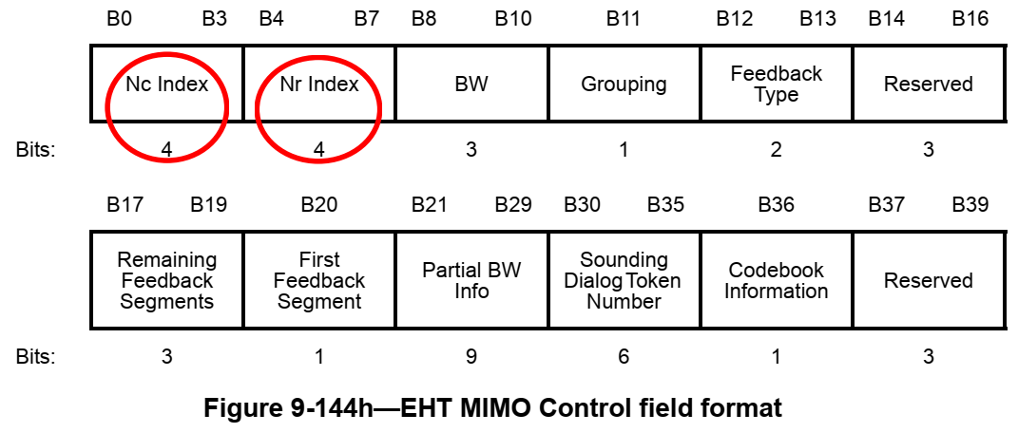

CID 12000
CID | Clause | PP.LL | Comment | Proposed Change | Resolution
12000 | 9.4.1.70 | 185.23 | Based on the bandwidth, the feedback resolution bandwidth is determined. Hence, the Resolution bit is not necessary in the Partial BW Info subfield. | Remove the Resolution bit in the Partial BW Info field. | Rejected  It's better to keep the format unchanged. And the Resolution bit helps to know the feedback resolution directly.
Background:
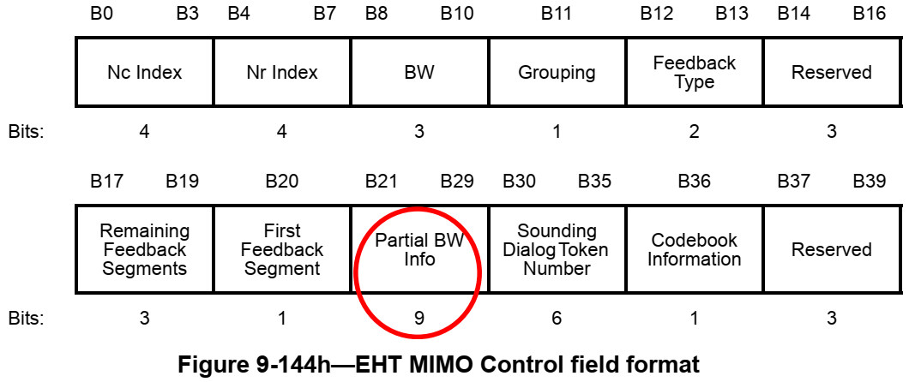

CID 12214, 12298, 12299, 12593, and 12594
CID | Clause | PP.LL | Comment | Proposed Change | Resolution
12214 | 9.4.1.70 | 184.34 | Ng values and codebook size were designed for up to 8 Nss. As we plan to support more Nss it's required to provide more Ng values and codebook sizes. Or at least define a placeholder for new values | As in comment | Rejected  The group discussed and ran SPs in both PHY ad-hoc and Joint conference call regarding whether TGbe needs to support 16 SS or not and decided not to. The SP is shown here: " Do you agree that 802.11be shall not define operation with more than 8 spatial streams and that the format of all subfields related to spatial streams shall remain unchanged (i.e. no changing the number of bits)?" and the result in PHY ad-hoc was 22Y, 4N, 5A while the result in Joint was 51Y, 12N, 26A".
12298 | 9.4.1.70 | 184.37 | Define Ng option(s) larger than 16 so that feedback overhead can be further reduced | Define larger Ng (e.g. Ng=32) so that sounding feedback overhead is reduced | Rejected  Larger Ng than 16 brings performance degradation. Please search contributions about ‘feedback overhead’, ‘subcarrier grouping’, etc in 11be Mentor or bring the other performance results.
12299 | 9.4.1.70 | 184.44 | For certain specific scenarios (e.g. DL MU-MIMO with a large number of streams, such as 15 or above, when the number of Tx antennas reported upon is 16) more bits are required for angle quantization in the BFR, otherwise there is a non-negligible loss in link performance | Define another option for quantization bits, e.g. (9,11) to support cases with 15 or more spatial streams | Rejected  The group discussed and ran SPs in both PHY ad-hoc and Joint conference call regarding whether TGbe needs to support 16 SS or not and decided not to. The SP is shown here: " Do you agree that 802.11be shall not define operation with more than 8 spatial streams and that the format of all subfields related to spatial streams shall remain unchanged (i.e. no changing the number of bits)?" and the result in PHY ad-hoc was 22Y, 4N, 5A while the result in Joint was 51Y, 12N, 26A".
12593 | 9.4.1.70 | 185.23 | According to the current text "The Partial BW Info field is defined as in Figure 9-80b....". However, this is a subfield in the MIMO Control field | Please revise the sentence as follows: "This subfield is defined as in figure 9-80b...." | Revised  Agree with the commenter and the changes are reflected the below.  Instructions to the editor:  Please make the changes as shown in doc 11-22/1194r2, below CID 12594.
12594 | 9.4.1.70 | 185.27 | According to the current text, the bitmap Partial BW Info subfield in the MIMO Control field indicates each resolution bandwidth that the beamformer is requesting feedback". However, as part of the Beamforming Report, the MIMO Control field should describe the content of the measured feedback that was actually done by the beamformee. Thus, it should indicate each resolution bandwidth that the beamformee has included a feedback in the current BFR.  If the MIMO Control field will keep indicating the parameters requested by the beamformer - a case of a mismatch between the Beamformer request and the beamformee report will never be discovered - causing the beamformer to use erroneous feedback parameters in such a case. | Revise the text as follows: " The Feedback Bitmap subfield indicates each resolution bandwidth for which the beamformee includes a feedback" | Revised  Agree with the commenter. But “a” feedback is unclear. So let’s make the change like “ that the beamformee is reporting feedback”  Instructions to the editor:  Please make the changes as shown in doc 11-22/1194r2, below CID 12594.

Instructions to the editor: Please make the following changes in Table 9-127a (P187L22) of P802.11be D2.1.

Table 9-127a—EHT MIMO Control field encoding
Partial BW Info | This subfield is defined as in Figure 9-80b (Partial BW Info subfield format). The Resolution bit indicates the feedback resolution bandwidth. Set to 0 to indicate resolution of 20 MHz if the BW subfield is set to 0 to 3. Set to 1 to indicate resolution of 40 MHz if the BW subfield is set to 4. The Feedback Bitmap subfield indicates each resolution bandwidth that the beamformee is reporting feedback. Each bit in the Feedback Bitmap subfield is set to 1 if the feedback on the corresponding bandwidth is reported, and is set to 0 otherwise.

