IEEE P802.11
Wireless LANs
LB266 CR for 9.4.1.70
Date: 2022-07-26
Author(s):
Name | Affiliation | Address | Phone | Email
Jinyoung Chun | LG Electronics | 19, Yangjae-daero 11gil, Seocho-gu, Seoul 137-130, Korea |  | jiny.chun@lge.com
Dongguk Lim |  |  |  | dongguk.lim@lge.com
Eunsung Park |  |  |  | esung.park@lge.com
Jinsoo Choi |  |  |  | js.choi@lge.com
Wook Bong Lee | Samsung |  |  | wookbong.lee@samsung.com

Abstract
This submission proposes CR for 11 CIDs: 10804, 10805, 10806, 12000, 12212, 12213, 12214, 12298, 12299, 12593, and 12594
All the changes are based on P802.11be D2.1.

Revisions:
- Rev 0: Initial version of the document.

CID 10804, 10805, 10806, 12212, and 12213
CID | Clause | PP.LL | Comment | Proposed Change | Resolution
10804 | 9.4.1.70 | 183.49 | Since Max Nss and the max number of MU-MIMO users are equal to 8, the bits for the Nc index and Nr index should be modified to 3. | Change the bit for Nc index and Nr index to 3 | Discussion 1
10805 | 9.4.1.70 | 184.18 | Since Max Nss is 8, for indication of the Nc index, 3 bit can be used similar to HE. So the bit for the Nc index should be changed with 3bit and the text related to value above 7 is not needed. | Delete the text " Nc Index subfield values above 7 are reserved." in the NC index row. | Discussion 1
10806 | 9.4.1.70 | 184.22 | Similar to the Nc index, the Nr index is also indicated by using 3bit. So, to clarify it, the description for the value of the Nr index should be modified. | Change " The values 0 and 8-15 are reserved." to "The value 0 is reserved. " | Discussion 1
12212 | 9.4.1.70 | 183.39 | Nc and Nr are extended to 4 bits without any justification. Either we mention explicitly that Nss > 8 is being supported or we should keep Nc amd Nr sizes of 3 bits as in HE | As in comment | Discussion 1
12213 | 9.4.1.70 | 184.10 | Its unclear why we need Nc and Nr Index values larger than 7. Either we mention explicitly that Nss > 8 is being supported or we should keep Nc and Nr Index values as in HE | As in comment | Discussion 1

Discussion 1: Do you support to reduce the size of Nc Index and Nr Index to 3 bits in EHT MIMO Control field?
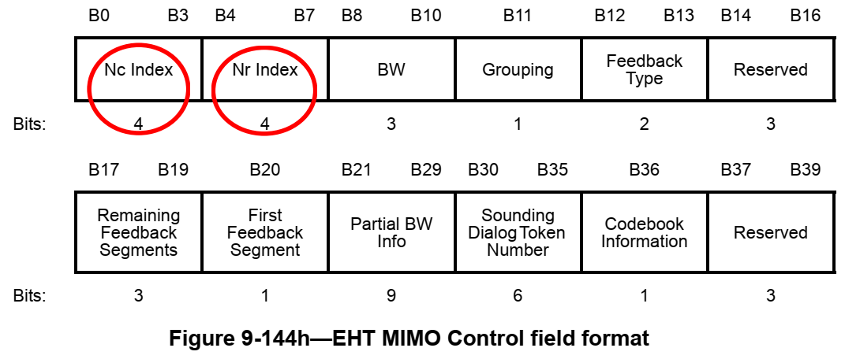

CID 12000
CID | Clause | PP.LL | Comment | Proposed Change | Resolution
12000 | 9.4.1.70 | 185.23 | Based on the bandwidth, the feedback resolution bandwidth is determined. Hence, the Resolution bit is not necessary in the Partial BW Info subfield. | Remove the Resolution bit in the Partial BW Info field. | Discussion 2

Discussion 2: Do you support to reduce the size of Partial BW Info to 8 bits in EHT MIMO Control field?
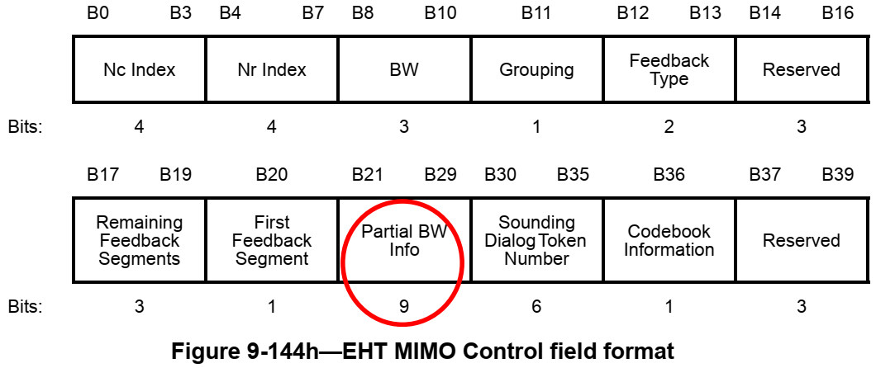
- Issue: Based on the bandwidth, the feedback resolution bandwidth is determined. When the bandwidth of the EHT NDP Announcement frame is less than 320MHz, the Rosolution bit B0 is set to 0 to indicate a reolution of 20MHz. When the bandwidth of the PPDU carrying the EHT NDP Annoucement frame is equal to 320MHz, the Resolution bit B0 is set to 1 to indicate a resolution of 40MHz. Hence, the Resolution bit is not necessary in the Partial BW Info subfield.

CID 12214, 12298, 12299, 12593, and 12594
CID | Clause | PP.LL | Comment | Proposed Change | Resolution
12214 | 9.4.1.70 | 184.34 | Ng values and codebook size were designed for up to 8 Nss. As we plan to support more Nss it's required to provide more Ng values and codebook sizes. Or at least define a placeholder for new values | As in comment | Rejected  More spatial streams than 8 are not supported in 11be.
12298 | 9.4.1.70 | 184.37 | Define Ng option(s) larger than 16 so that feedback overhead can be further reduced | Define larger Ng (e.g. Ng=32) so that sounding feedback overhead is reduced | Rejected  Larger Ng than 16 brings performance degradation. Please search contributions in 11be mentor.
12299 | 9.4.1.70 | 184.44 | For certain specific scenarios (e.g. DL MU-MIMO with a large number of streams, such as 15 or above, when the number of Tx antennas reported upon is 16) more bits are required for angle quantization in the BFR, otherwise there is a non-negligible loss in link performance | Define another option for quantization bits, e.g. (9,11) to support cases with 15 or more spatial streams | Rejected  More spatial streams than 8 are not supported in 11be.
12593 | 9.4.1.70 | 185.23 | According to the current text "The Partial BW Info field is defined as in Figure 9-80b....". However, this is a subfield in the MIMO Control field | Please revise the sentence as follows: "This subfield is defined as in figure 9-80b...." | Accepted
12594 | 9.4.1.70 | 185.27 | According to the current text, the bitmap Partial BW Info subfield in the MIMO Control field indicates each resolution bandwidth that the beamformer is requesting feedback". However, as part of the Beamforming Report, the MIMO Control field should describe the content of the measured feedback that was actually done by the beamformee. Thus, it should indicate each resolution bandwidth that the beamformee has included a feedback in the current BFR.  If the MIMO Control field will keep indicating the parameters requested by the beamformer - a case of a mismatch between the Beamformer request and the beamformee report will never be discovered - causing the beamformer to use erroneous feedback parameters in such a case. | Revise the text as follows: " The Feedback Bitmap subfield indicates each resolution bandwidth for which the beamformee includes a feedback" | Revised  Agree with the commenter. But “a” feedback is unclear. So let’s make the change like “ that the beamformee is reporting feedback”  Instructions to the editor:  Please make changes to "The Feedback Bitmap subfield indicates each resolution bandwidth that the beamformee is reporting feedback" in Table 9-127a (P187L27).
Background: Partial BW Info subfield in EHT MIMO Control field
