IEEE P802.11
Wireless LANs
Resolutions for Implicit Measurement Setup Termination
Date: August 22, 2022
Author(s):
Name | Affiliation | Address | Phone | Email
Pei Zhou | OPPO |  |  | zhoupei1@oppo.com
Chaoming Luo
Solomon Trainin | Qualcomm

Abstract
This submission proposes resolutions to implicit measurement setup termination related CIDs 51, 175, 203, 568, 569, 634, 635, 636, 637, 638, 639 and 911. The text used as reference is 802.11bf D0.2.

Revisions:
- Rev 0: Initial version of the document.
- Rev 1: Minor changes to NOTE.
- Rev 2: Revised based on teleconference on August 23rd and offline discussions.
- Rev 3: Revised based on teleconference on August 25th.

Explicit sensing measurement setup termination related CIDs:
CID | Clause | Page | Comment | Proposed Change | Resolution
634 | 11.21.18.8 | 72.24 | The MS Termination frame can only terminate one or all MS(s). | Change the text to "A sensing initiator may initiate termination of one or all sensing measurement setups by transmitting a Sensing Measurement Setup Termination frame to a sensing responder, and vice versa." | Revised.  Agree in principal. The whole sentence is rewritten.  The changes are shown in 11-22-1172-03-00bf-resolutions-for-implict-measurement-setup-termination
203 | 11.21.18.8 | 72.23 | Remove the parentheses of "or sensing responder" | As in comment. | Revised.  Similar comment to CID 634. The whole sentence is rewritten.  The change is shown in 11-22-1172-03-00bf-resolutions-for-implict-measurement-setup-termination
911 | 11.21.18.8 | 72.42 | The sensing measurement termination is per one Measurement Setup ID. One Measurement Setup ID may contain multiple sensing responders. If one sensing measurement ID is terminated, does that imply all sensing responders associated with this sensing measurement ID has to terminate the sensing measurement associated with this sensing measurement ID. If it is the case, please indicate it. Otherwise, the sensing initiator may communicate only one sensing responder if other sensing reponders associated with this measurement setup ID is not informed of termination | Specify when any sensing responder or sensing initiator terminate the sensing measurement setup with a sensing measurement setup ID, all sensing responders (or the sensing initiator) should be notified of this termination | Revised.  Termination frame is a pairwise and by default applies to one device. If AP wants to terminate the MS ID completely it would need to send frame to each responder separately.  The changes are shown in 11-22-1172-03-00bf-resolutions-for-implict-measurement-setup-termination
Implicit sensing measurement setup termination related CIDs:
CID | Clause | Page | Comment | Proposed Change | Resolution
51 | 11.21.18.8 | 72.29 | Implicit sensing measurement setup termination is not defined. | Please add the detailed implicit sensing measurement setup termination procedure. | Revised.  Detailed implicit sensing measurement setup termination procedure is added.  The changes are shown in 11-22-1172-03-00bf-resolutions-for-implict-measurement-setup-termination
175 | 11.21.18.8 | 72.29 | "inactivity time" is not defined | Define the term "inactivity time" | Revised.  Detailed implicit sensing measurement setup termination procedure is added.  The changes are shown in 11-22-1172-03-00bf-resolutions-for-implict-measurement-setup-termination
568 | 11.21.18.8 | 72.29 | The meaning of "predefined inactivity time" is not defined. please define what is the " predefined inactivity time " | As in comment. | Revised.  Detailed implicit sensing measurement setup termination procedure is added.  The changes are shown in 11-22-1172-03-00bf-resolutions-for-implict-measurement-setup-termination
569 | 11.21.18.8 | 72.30 | Define the procedure or protocol which uses the specific time for the sensing measurement termination. | As in comment. | Revised.  Detailed implicit sensing measurement setup termination procedure is added.  The changes are shown in 11-22-1172-03-00bf-resolutions-for-implict-measurement-setup-termination
Editorial CIDs:
CID | Clause | Page | Comment | Proposed Change | Resolution
635 | 11.21.18.8 | 72.29 | Change "the sensing measurement setup" to "a sensing measurement setup" | As commented. | Rejected.  The original sentence is removed, since detailed implicit sensing measurement setup termination procedure is added.  The changes are shown in 11-22-1172-03-00bf-resolutions-for-implict-measurement-setup-termination
636 | 11.21.18.8 | 72.32 | Change "The sensing initiator and the sensing responder can release the resources they allocated to store the sensing measurement setup after the termination of the sensing measurement setup." to "After termination of a sensing measurement setup, the sensing initiator and the sensing responder can release the corresponding resources they allocated." | As commented. | Rejected.  As suggested by offline discussion “listing all resources to be removed, it is a bad design if they don’t and we don’t need to teach them right design”, this sentence adds no effective information to the draft. Thus, the referred sentence is removed.  The changes are shown in 11-22-1172-03-00bf-resolutions-for-implict-measurement-setup-termination
637 | 11.21.18.8 | 72.36 | Change "the sensing measurement setup" to "a sensing measurement setup" | As commented. | Revised.  Agree with the commenter. But the whole sentence is rewritten according to offline discussion.  The changes are shown in 11-22-1172-03-00bf-resolutions-for-implict-measurement-setup-termination
638 | 11.21.18.8 | 72.38 | Change "when sensing measurement setup is terminated" to "when the corresponding sensing measurement setup is terminated" | As commented. | Rejected.  The original sentence is rewritten according to offline discussion. No need to make any modification as indicated in this comment.  The changes are shown in 11-22-1172-03-00bf-resolutions-for-implict-measurement-setup-termination
639 | 11.21.18.8 | 72.42 | Change "any sensing measurement instance (TB or Non-TB) corresponding to the terminated sensing measurement setup" to "any sensing measurement instance corresponding to a terminated sensing measurement setup" | As commented. | Rejected.  The original sentence is rewritten according to offline discussion. No need to make any modification as indicated in this comment.  The changes are shown in 11-22-1172-03-00bf-resolutions-for-implict-measurement-setup-termination

TGbf Editor: Please revise clause 11.21.18.8 (Sensing measurement termination) as below.

11.21.18.8 Sensing measurement setup(#132) termination

After it is established (see 11.21.18.4) a sensing measurement setup is terminated either explicitly or implicitly. Under the explicit sensing measurement setup termination, a STA uses the Sensing Measurement Setup Termination frame for the sensing measurement setup termination. Under the implicit sensing measurement setup termination, the sensing measurement setup(s) is terminated after the expiration of the measurement setup expiry timer. (#51, #175, #568, #569)

Sensing measurement setup(s) may be terminated explicitly at any time by either the sensing initiator or the sensing responder by transmitting an individually addressed Sensing Measurement Setup Termination frame. (#203, #634)

The explicit sensing measurement setup termination is initiated by issuing an MLME-SENSMSMTTERMINATION.request primitive. Upon reception of an MLME-SENSMSMTTERMINATION.request primitive, the STA shall initiate the termination of sensing measurement setup(s) by transmitting the Sensing Measurement Setup Termination frame with the RA field set to the MAC address indicated in the primitive. The STA that initiates the termination of sensing measurement setup(s), shall issue an MLME-SENSMSMTTERMINATION.confirm primitive upon completion of the transmission of the Sensing Measurement Setup Termination frame and terminate the indicated sensing measurement setup(s). The STA that receives the Sensing Measurement Setup Termination frame addressed to it, shall issue an MLME-SENSMSMTTERMINATION.indication primitive and shall terminate the indicated sensing measurement setup(s).

NOTE—Sensing measurement setup termination only applies to the measurement setup(s) between the peer STAs of the Sensing Measurement Setup Termination frame exchange and not to the other sensing responders with the same Measurement Setup ID. (#911)

For the implicit sensing measurement setup termination of the measurement setup, the sensing initiator and the sensing responder shall use the measurement setup expiry timer. The measurement setup expiry timer maintains the measurement setup identified with the Measurement Setup ID between the sensing initiator and the sensing responder. The measurement setup expiry timer shall be set to the Measurement Setup Expiry value at
- the success of the procedure specified in 11.21.18.4 (Sensing measurement setup)
- the first exchange is completed in the TB sensing measurement instance (see 11.21.18.6)
- the exchange is completed in the non-TB sensing measurement instance (see 11.21.18.7).

NOTE—Provide behavior describing that AP shall assign polling to a device that participates only in NDPA sounding phase without needing to report.

Upon expiry of the measurement setup expiry timer, the sensing initiator and sensing responder shall terminate the sensing measurement setup and issues an MLME-SENSMSMTTERMINATION.confirm primitive to the SME. (#51, #175, #568, #569)

Once the sensing measurement setup between a sensing initiator and a sensing responder is terminated, the sensing responder shall not participate in any sensing measurement instance associated with the Measurement Setup ID of a(#637) terminated measurement setup.

TGbf Editor: Please revise Figure 9-1002av (Sensing Measurement Parameters field format) as below and add the following descriptions.
The format of the Sensing Measurement Parameters field is defined in Figure 9-1002av (Sensing Measurement Parameters field format(#224, #255, #587, #837, #902, #488)).

 | Sensing Transmitter | Sensing Receiver | Sensing Measurement Report Requested | Sensing Measurement Report Type | Measurement Setup Expiry Exponent | TBD
Bits: | 1 | 1 | 1 | TBD | 4 | TBD
Figure 9-1002av— Sensing Measurement Parameters field format(224, #255, #587, #837, #902, #488, #51, #175, #568, #569)

The Measurement Setup Expiry Exponent subfield contains an unsigned integer. It is encoded according to the conventions in 9.2.2 (Conventions).

The Measurement Setup Expiry value is equal to 2(Measurement Setup Expiry Exponent + 8) ms. It is a time after which the Measurement setup is terminated, if there are no frame exchange sequences (see 11.21.18.8 Sensing measurement setup termination).(#51, #175, #568, #569)

TGbf Editor: Please revise subclause 6.3.134.6 (MLME-SENSMSMTTERMINATION.request) as below.
6.3.134.6 MLME-SENSMSMTTERMINATION.request

6.3.134.6.1 Function

This primitive requests the transmission of a Sensing Measurement Setup Termination frame to a peer STA.

6.3.134.6.2 Semantics of the service primitive(#51, #175, #568, #569)

The primitive parameters are as follows:
MLME-SENSMSMTTERMINATION.request(
PeerSTAAddress,
MeasurementSetupID,
TerminationAllTBMeasurementSetups,
TerminationAllnon-TBMeasurementSetups,
TB/non-TBMeasurementSetupType
)

Name | Type | Valid range | Description
PeerSTAAddress | MAC address | Any valid individual MAC address | Specifies the address of the peer MAC entity (either the sensing responder or the sensing initiator) to which the Sensing Measurement Setup Termination frame is to be transmitted.
MeasurementSetupID | Integer | As defined in Figure 9-1138b (Measurement Setup ID field format) | Together with the TB/non-TB Measurement Setup Type parameter, specify the Measurement Setup(s) to be terminated.  This parameter is reserved if the Termination All TB Measurement Setups parameter or the Termination All non-TB Measurement Setups parameter is set to 1.
TerminationAllTBMeasurementSetups | Integer | 0-1 | If set to 1, terminates all Measurement Setup IDs assigned by an AP for the TB measurement instance.  If set to 0, does not terminate all Measurement Setup IDs assigned by an AP for the TB measurement instance.
TerminationAllnon-TBMeasurementSetups | Integer | 0-1 | If set to 1, terminates all Measurement Setup IDs assigned by a non-AP STA for the non-TB measurement instance.  If set to 0, does not terminate all Measurement Setup IDs assigned by a non-AP STA for the non-TB measurement instance.
TB/non-TBMeasurementSetupType | Integer | 0-1 | Indicates, if equal to 0, that the Measurement Setup ID is assigned by an AP for the TB measurement instance and, if equal to 1, that the Measurement Setup ID is assigned by a non-AP STA for the non-TB measurement instance.  This parameter is reserved if the Termination All TB Measurement Setups parameter or the Termination All non-TB Measurement Setups parameter is set to 1.

6.3.134.6.3 When generated

This primitive is generated by the SME to request that a Sensing Measurement Setup Termination frame be sent to a peer STA to terminate sensing measurement setup(s).

6.3.134.6.4 Effect of receipt

On receipt of this primitive, the MLME constructs a Sensing Measurement Setup Termination frame and causes it to be transmitted to the peer MAC address.

TGbf Editor: Please revise subclause 6.3.134.7 (MLME-SENSMSMTTERMINATION.indication) as below.
6.3.134.7 MLME-SENSMSMTTERMINATION.indication

6.3.134.7.1 Function

This primitive indicates that a Sensing Measurement Setup Termination frame has been received requesting the termination of sensing measurement setup(s), and the corresponding Ack frame has been transmitted.

6.3.134.7.2 Semantics of the service primitive(#51, #175, #568, #569)

The primitive parameters are as follows:
MLME-SENSMSMTTERMINATION.indication(
PeerSTAAddress,
MeasurementSetupID,
TerminationAllTBMeasurementSetups,
TerminationAllnon-TBMeasurementSetups,
TB/non-TBMeasurementSetupType
)

Name | Type | Valid range | Description
PeerSTAAddress | MAC address | Any valid individual MAC address | Specifies the address of the peer MAC entity (either the sensing responder or the sensing initiator) from which the Sensing Measurement Setup Termination frame was received.
MeasurementSetupID | Integer | As defined in Figure 9-1138b (Measurement Setup ID field format) | Together with the TB/non-TB Measurement Setup Type parameter, specify the terminated Measurement Setup(s) provided by the peer MAC entity.  This parameter is reserved if the Termination All TB Measurement Setups parameter or the Termination All non-TB Measurement Setups parameter is set to 1.
TerminationAllTBMeasurementSetups | Integer | 0-1 | If set to 1, terminates all Measurement Setup IDs assigned by an AP for the TB measurement instance.  If set to 0, does not terminate all Measurement Setup IDs assigned by an AP for the TB measurement instance.
TerminationAllnon-TBMeasurementSetups | Integer | 0-1 | If set to 1, terminates all Measurement Setup IDs assigned by a non-AP STA for the non-TB measurement instance.  If set to 0, does not terminate all Measurement Setup IDs assigned by a non-AP STA for the non-TB measurement instance.
TB/non-TBMeasurementSetupType | Integer | 0-1 | Indicates, if equal to 0, that the Measurement Setup ID is assigned by an AP for the TB measurement instance and, if equal to 1, that the Measurement Setup ID is assigned by a non-AP STA for the non-TB measurement instance.  This parameter is reserved if the Termination All TB Measurement Setups parameter or the Termination All non-TB Measurement Setups parameter is set to 1.

6.3.134.7.3 When generated

This primitive is generated by the MLME when a Sensing Measurement Setup Termination frame is received.

6.3.134.7.4 Effect of receipt

On receipt of this primitive, the SME should operate according to the procedure in 11.21.18 (WLAN sensing procedure).

TGbf Editor: Please revise subclause 6.3.134.8 (MLME-SENSMSMTTERMINATION.confirm) as below.
6.3.134.8 MLME-SENSMSMTTERMINATION.confirm

6.3.134.8.1 Function

This primitive confirms that the sensing measurement setup(s) are terminated explicitly when the Sensing Measurement Setup Termination frame has been received by the peer STA to which it was sent, or that the sensing measurement setup(s) are terminated implicitly as the result of the measurement setup expiry timer expired.(#51, #175, #568, #569)

6.3.134.8.2 Semantics of the service primitive(#51, #175, #568, #569)

The primitive parameters are as follows:
MLME-SENSMSMTTERMINATION.confirm(
PeerSTAAddress,
MeasurementSetupID,
TerminationAllTBMeasurementSetups,
TerminationAllnon-TBMeasurementSetups,
TB/non-TBMeasurementSetupType
)

Name | Type | Valid range | Description
PeerSTAAddress | MAC address | Any valid individual MAC address | Specifies the address of the peer MAC entity (either the sensing responder or the sensing initiator) with which the sensing measurement setup termination process was attempted.
MeasurementSetupID | Integer | As defined in Figure 9-1138b (Measurement Setup ID field format) | Together with the TB/non-TB Measurement Setup Type parameter, specify the terminated Measurement Setup(s).  This parameter is reserved if the Termination All TB Measurement Setups parameter or the Termination All non-TB Measurement Setups parameter is set to 1.
TerminationAllTBMeasurementSetups | Integer | 0-1 | If set to 1, terminates all Measurement Setup IDs assigned by an AP for the TB measurement instance.  If set to 0, does not terminate all Measurement Setup IDs assigned by an AP for the TB measurement instance.
TerminationAllnon-TBMeasurementSetups | Integer | 0-1 | If set to 1, terminates all Measurement Setup IDs assigned by a non-AP STA for the non-TB measurement instance.  If set to 0, does not terminate all Measurement Setup IDs assigned by a non-AP STA for the non-TB measurement instance.
TB/non-TBMeasurementSetupType | Integer | 0-1 | Indicates, if equal to 0, that the Measurement Setup ID is assigned by an AP for the TB measurement instance and, if equal to 1, that the Measurement Setup ID is assigned by a non-AP STA for the non-TB measurement instance.  This parameter is reserved if the Termination All TB Measurement Setups parameter or the Termination All non-TB Measurement Setups parameter is set to 1.

6.3.134.8.3 When generated

This primitive is generated by the MLME that the sensing measurement setup(s) are terminated explicitly when an Ack frame corresponding to the Sensing Measurement Setup Termination frame is received from the peer STA, or that the sensing measurement setup(s) are terminated implicitly as the result of the measurement setup expiry timer expired.

6.3.134.8.4 Effect of receipt

On receipt of this primitive, the SME uses the information contained within the notification.

TGbf Editor: Please also change “Any valid ID” in Valid range column to “As defined in Measurement Setup ID field” in P31L31 and P32L13 in draft 0.2.
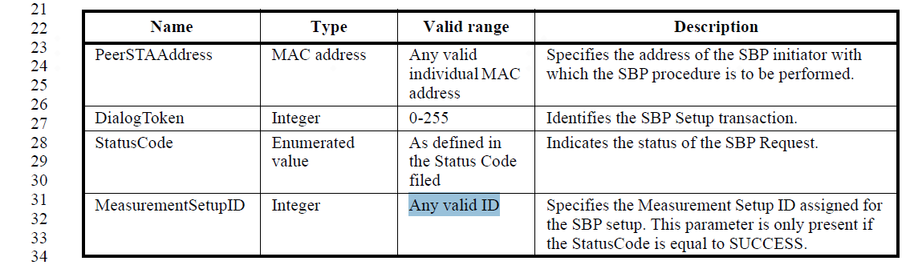

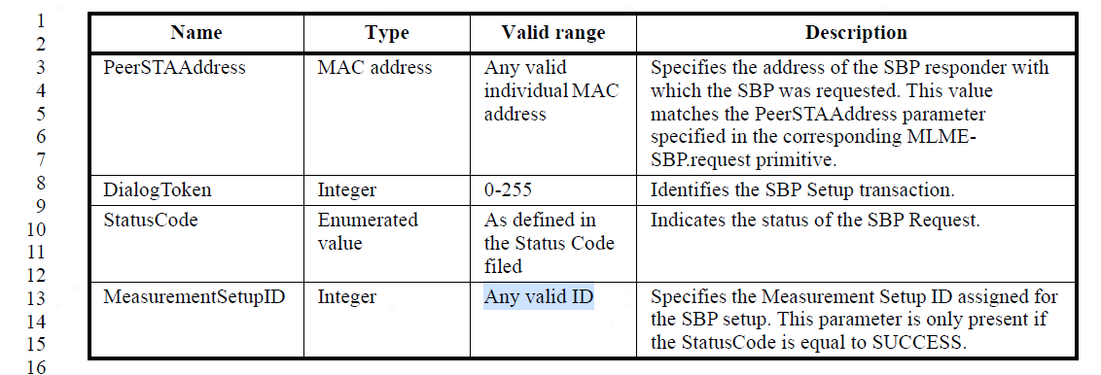

SP

Do you support the proposed resolutions to the following CIDs in 22/1172r3 and incorporate the text changes into the latest TGbf draft:
CID 51, 175, 203, 568, 569, 634, 635, 636, 637, 638, 639, 911?

Y/N/A

