IEEE P802.11
Wireless LANs
Resolutions for CIDs Related to Measurement Setup ID and Termination: Part 2
Date: July 22, 2022
Author(s):
Name | Affiliation | Address | Phone | Email
Pei Zhou | OPPO |  |  | zhoupei1@oppo.com
Lei Huang
Chaoming Luo

Abstract
This submission proposes resolutions for CIDs 132, 138, , 184, 275 and. The text used as reference is 802.11bf D0.2.

Revisions:
- Rev 0: Initial version of the document.
- Rev 1: Revised based on online and offline discussions. The text used as reference is changed to 802.11bf D0.2.
- Rev 2: Revised based on online discussions.

Comment:
184 | 9.6.7.49 | 57.47 | We probably do not need at least a whole octet for the measurement setup ID, so we should move the measurement setup ID field into the DMG Sensing Measurement setup Element and Sensing Measurement Parameters Element. Moreover, the measurement setup ID should better go together with the corresponding measurement setup parameters, therefore this field should more be a part of the parameters element rather than being a parallel field. | Make "Measurement Setup ID" field a subfield within DMG Sensing Measurement Setup Element and Sensing Parameters Element. | Rejected.  Measurement Setup ID field was deleted from DMG Sensing Measurement Setup element. It is kept as a parallel field. Please refer to the motion passed CR doc.: 11-22-0944-02-00bf CC40-comments DMG comments resolution part two
Discussion:
In the motion passed CR doc.: 11-22-0944-02-00bf CC40-comments DMG comments resolution part two, Measurement Setup ID field was still kept as a parallel field with DMG Sensing Measurement Setup element. In addition, Measurement Setup ID field was removed from DMG Sensing Measurement Setup element. In order to keep the Sensing Measurement Setup Request frame format and DMG Sensing Measurement Setup Request frame format consistent, this comment is rejected.
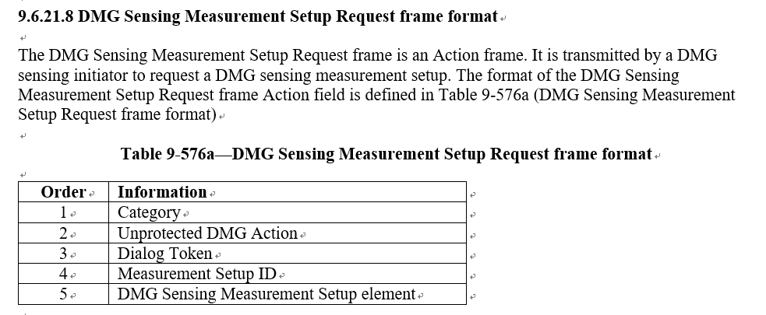
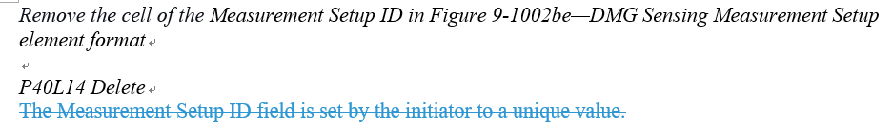

Comments:
132 | 11.21.18.8 | 72.21 | "Sensing measurement termination". Should this be "Sensing measurement setup termination"? | See comment | Revised.  “Setup” is added to the title of clause 11.21.18.8 Sensing measurement setup termination.  The change is shown in 11-22-1170-02-00bf-resolutions-for-ms-id-and-termination-part-2
275 | 11.21.18.8 | 72.24 | A sensing responder may transmit termination frame with MSID of measurement setup to a sensing initiator to initiate measurement setup ternimation, and the sensing responder may be a STA that participant the sensing measurement initiated by a AP, meamwhile the AP is a SBP responder, so the sensing responder transmits measurement setup frame may trigger SBP termination, please put note here, a sensing responder that is a STA participants a sensing measurement initiated by a SBP AP may trigger a SBP termination. | as in comment | Rejected.  In sensing responder’s perspective, it only terminates TB measurement setup. Whether this action will trigger an SBP termination depends on AP’s decision. The suggested note is unnecessary.
634  (defer) | 11.21.18.8 | 72.24 | The MS Termination frame can only terminate one or all MS(s). | Change the text to "A sensing initiator may initiate termination of one or all sensing measurement setups by transmitting a Sensing Measurement Setup Termination frame to a sensing responder, and vice versa." | Revised.  Agree in principal. But the proposed text is also unclear. The changes are shown in 11-22-1170-02-00bf-resolutions-for-ms-id-and-termination-part-2
911  (defer) | 11.21.18.8 | 72.42 | The sensing measurement termination is per one Measurement Setup ID. One Measurement Setup ID may contain multiple sensing responders. If one sensing measurement ID is terminated, does that imply all sensing responders associated with this sensing measurement ID has to terminate the sensing measurement associated with this sensing measurement ID. If it is the case, please indicate it. Otherwise, the sensing initiator may communicate only one sensing responder if other sensing reponders associated with this measurement setup ID is not informed of termination | Specify when any sensing responder or sensing initiator terminate the sensing measurement setup with a sensing measurement setup ID, all sensing responders (or the sensing initiator) should be notified of this termination | Revised.  Termination frame is a pairwise and by default applies to one device. If AP wants to terminate the MS ID completely it would need to send frame to each responder separately.  The changes are shown in 11-22-1170-02-00bf-resolutions-for-ms-id-and-termination-part-2

TGbf Editor: Please revise subclause 11.21.18.8 (Sensing measurement termination) as follows.

11.21.18.8 Sensing measurement setup(#132) termination
Sensing measurement setup(s) may be terminated at any time by either the sensing initiator or the sensing responder by transmitting a Sensing Measurement Setup Termination frame. (#634)
Note: Sensing measurement setup termination only applies to the measurement setup(s) between the peer STAs of the Sensing Measurement Setup Termination frame exchange and not to the other sensing responders with the same Measurement Setup ID. (#911)

Comments:
138 | 11.21.18.1 | 58.55 | "A sensing measurement instance is active until terminated in a sensing measurement setup termination". A sensing measurement instance cannot be terminated, we terminate the sensing measurement setup. Once, the sensing measurement setup is terminated, no sensing measurement instances take place based on the operation parameters of this sensing measurement. | This sentence may be revised to" A sensing measurement instance is active and is associated with the operational attributes of the sensing session setup until this sensing session setup is terminated" | Revised.  A sensing measurement instance is active until the sensing measurement report is obtained. The proposed sentence is not accurate.  The change is shown in 11-22-1170-02-00bf-resolutions-for-ms-id-and-termination-part-2
139  (defer) | 11.21.18.1 | 64.56 | "In the sensing  session termination, a sensing session is terminated." This sentence is redundant and adds no information to the draft. | Remove this sentence or add a clear definition for what is "sensing session termination" | Revised.  The change is shown in 11-22-1170-02-00bf-resolutions-for-ms-id-and-termination-part-2

TGbf Editor: Pleases revise subclause 11.21.18.1 (Overview) as follows.

11.21.18 WLAN sensing procedure

11.21.18.1 Overview
….
In the sensing session setup, a sensing session is established, and in the sensing measurement setup, operational parameters associated with sensing measurement instance(s) are set(#429, #665, #848, #852, #853, #854, #856, #858, #859, #841). One or more sensing measurement setups may be established between a sensing initiator and a sensing responder. A sensing measurement instance is a time interval when sensing measurements are obtained, and it can be one of two variants(#605): Trigger-based (TB) sensing measurement instance (see 11.21.18.6 (TB sensing measurement instance))(#186) or non-TB sensing measurement instance (see 11.21.18.7 (Non-TB sensing measurement instance))(#186). A sensing measurement setup(#138) is active until terminated in a sensing measurement setup termination. A sensing session is active until terminated in a sensing session termination.(#139)

