IEEE P802.11
Wireless LANs

LB266 CR on CID 12138, 12139, 12140
Date: 2022-07-20
Author(s):
Name | Affiliation | Address | Phone | email
Yapu Li | OPPO |  |  | liyapu1@oppo.com
Lei Huang | OPPO

Abstract
This submission contains proposed comment resolutions to the following CID on P802.11be D2.0.

CID 12138, 12139, 12140

Revisions:

- Rev 0: Initial version of the document.
-

CID 12138

CID | Page.  Line | Clause | Comment | Proposed Change | Resolution
12138 | 547.47 | 36.2.1 | "each assigned RU" should be changed to "each assigned RU or MRU" | as in comment | Accepted

CID 12139

CID | Page.  Line | Clause | Comment | Proposed Change | Resolution
12139 | 549.28 | 36.2.2 | "HE NDPs" should be changed to "HE sounding NDPs" at P549L28 and P549L34 | as in comment | Accepted

CID 12140

CID | Page.  Line | Clause | Comment | Proposed Change | Resolution
12140 | 557.25 | 36.2.2 | 1x, 2x and 4x-EHT-LTF are allowed for EHT TB PPDU. However, only 2x and 4x-EHT-LTF are allowed for EHT MU PPDU. For EHT_LTF_TYPE, it is better to split the case Format = EHT_MU and the case Format = EHT_TB. | as in comment | Revised  Agree in principle.  Instructions to the editor:  Please make the changes to the spec as shown in 11/22-1169r0
Discussion

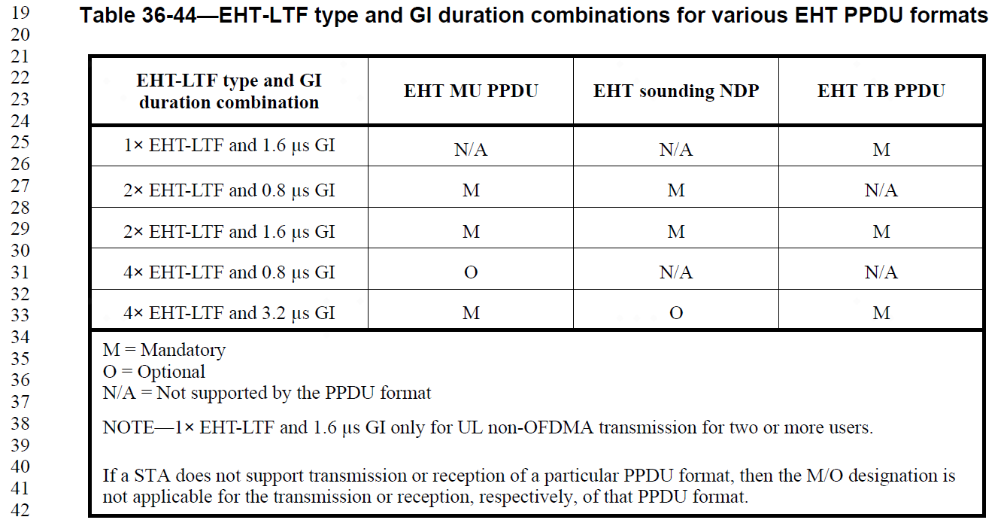

TGbe editor:
Please make the following changes in Page 557 Line23-30:

Parameter | Condition | Value | TXVECTOR | RXVECTOR
EHT_LTF_TYPE | FORMAT is EHT_MU | Indicates the type of EHT-LTF. Enumerated type:  2×EHT-LTF indicates a 2× EHT-LTF. 4×EHT-LTF indicates a 4× EHT-LTF.  See 36.3.12.10 (EHT-LTF). | Y | Y
 | FORMAT is EHT_TB | Indicates the type of EHT-LTF. Enumerated type:  1×EHT-LTF indicates a 1× EHT-LTF. 2×EHT-LTF indicates a 2× EHT-LTF. 4×EHT-LTF indicates a 4× EHT-LTF.  See 36.3.12.10 (EHT-LTF). | Y | Y
 | Otherwise | Not present.

