IEEE P802.11
Wireless LANs
Resolutions for CIDs Related to Measurement Setup ID and Termination: Part 1
Date: July 31, 2022
Author(s):
Name | Affiliation | Address | Phone | Email
Pei Zhou | OPPO |  |  | zhoupei1@oppo.com

Abstract
This submission proposes resolutions for CIDs 11, 46, 75, 76, 77, 80, 260, 261, 378, 492, 515 and 518.
The text used as reference is 802.11bf D0.2.

Revisions:
- Rev 0: Initial version of the document.
- Rev 1: Fix some typos.
- Rev 2: Motion 100 text is further revised based on offline discussion with Ali.
- Rev 3: Revised based on online and offline discussions. The text used as reference is changed to 802.11bf D0.2.
- Rev 4: Measurement Setup ID field is changed to Measurement Setup ID Indicator field.
- Rev 5: Change Measurement Setup ID Information field to Measurement Setup Termination Control field. Keep Measurement Setup ID field as it is according to offline discussions.

Comments:
CID | Clause | Page | Comment | Proposed Change | Resolution
75 | 9.6.7.49 | 57.53 | Measurement Setup ID field size | In 9.3.1.25.5 (and other places) the Measurement Setup ID is 1 octet (8 bits).  However in 9.6.7.49 it is TBD. If the technical decision is that it is 8 bits then this should be in all places. | Revised.  The size of MS ID is temporarily set to 1 octet (8 bits). It can be changed based on future contributions. The change is shown in 11-22-1168-05-00bf-resolutions-for-ms-id-and-termination-part-1
76 | 9.6.7.50 | 58.11 | Measurement Setup ID field size | In 9.3.1.25.5 (and other places) the Measurement Setup ID is 1 octet (8 bits).  However in 9.6.7.50 it is TBD. If the technical decision is that it is 8 bits then this should be in all places. | Revised.  The size of MS ID is temporarily set to 1 octet (8 bits). It can be changed based on future contributions. The change is shown in 11-22-1168-05-00bf-resolutions-for-ms-id-and-termination-part-1
260 | 9.6.7.49 | 57.53 | In the figure Figure 9-1002bn the length of the Measurement Setup ID is 8bits for DMG, but in figure 9-1138a the length of the MSID is TBD, please make it consistent | as in comment | Revised.  The size of MS ID is temporarily set to 1 octet (8 bits). It can be changed based on future contributions. The change is shown in 11-22-1168-05-00bf-resolutions-for-ms-id-and-termination-part-1
261 | 9.6.7.49 | 58.11 | In the figure Figure 9-1002bn the length of the Measurement Setup ID is 8bits for DMG, but in figure 9-1138b the length of the MSID is TBD, please make it consistent | as in comment | Revised.  The size of MS ID is temporarily set to 1 octet (8 bits). It can be changed based on future contributions. The change is shown in 11-22-1168-05-00bf-resolutions-for-ms-id-and-termination-part-1
378 | 9.6.7.49 | 57.56 | The size of Measurement setup ID should be determined as proper value (e.g., 4/8bits) | As in the comment. | Revised.  The size of MS ID is temporarily set to 1 octet (8 bits). It can be changed based on future contributions. The change is shown in 11-22-1168-05-00bf-resolutions-for-ms-id-and-termination-part-1
515 | 9.6.7.49 | 57.49 | The Measurement setup ID is used to identify assigned sensing measurement parameters for the sensing measurement instance. So, it can be simply defined by using the numbering. and for that, 2 or 3ibt can be allocated. | Define the size of the Measurement setup ID. For example, 2 or 3bit can be used. | Revised.  The size of MS ID is temporarily set to 1 octet (8 bits). It can be changed based on future contributions. The change is shown in 11-22-1168-05-00bf-resolutions-for-ms-id-and-termination-part-1
518 | 9.6.7.49 | 58.12 | In Figure 9-1138b, for the Measurement setup ID, we can be allocated the 1 octet and a part of the bit among the 8bit can be used for the measurement setup ID. | Replace "TBD" with "1" in figure 9-1138b and add the reserved bit after measurement setup ID field | Revised.  The size of MS ID is temporarily set to 1 octet (8 bits). It can be changed based on future contributions. The change is shown in 11-22-1168-05-00bf-resolutions-for-ms-id-and-termination-part-1

TGbf Editor: Please revise Figure 9-1138a (Sensing Measurement Setup Request frame Action field format) in draft 0.2 as follows.
 | Category | Public Action | Dialog Token | Measurement Setup ID | Sensing Measurement Parameters Element
Octets: | 1 | 1 | 1 | 1 | TBD
Figure 9-1138a—Sensing Measurement Setup Request frame Action field format(#75, #260, #378, #515)

TGbf Editor: Please revise Figure 9-1138b (Measurement Setup ID field format) in draft 0.2 as follows.
 | Measurement Setup ID
Octets: | 1
Figure 9-1138b— Measurement Setup ID field format(#76, #261, #518)

TGbf Editor: Please also change the length of Measurement Setup ID field to 1 octet (or 8 bits) in the following places.
P72L18 (Figure 9-1139h— SBP Response frame Action field format) in draft 0.2,
P72L54 (Figure 9-1139i— SBP Termination frame Action field format) in draft 0.2.

Comments:
11 | 9.6.7.52 | 59.57 | The measurement setup ID information field is not defined | Measurement Setup ID field must be defined as the measurement setup ID forhte link for which the measurement setup is to be terminated. | Revised.  Measurement Setup ID Information Field is already revised according to Motion 100 (doc.: 11-22/798r2) and draft 0.2. The change is shown in 11-22-1168-05-00bf-resolutions-for-ms-id-and-termination-part-1
46 | 9.6.7.52 | 59.57 | The Measurement Setup ID Information field in Measurement Setup Termination frame is TBD. | More details need to be defined. A submission is needed to resolve this. | Revised.  Measurement Setup ID Information Field is already revised according to Motion 100 (doc.: 11-22/798r2) and draft 0.2. The change is shown in 11-22-1168-05-00bf-resolutions-for-ms-id-and-termination-part-1
77 | 9.6.7.52 | 59.42 | Measurement Setup ID (Information) name and field size | In 9.3.1.25.5 (and other places) the Measurement Setup ID is 1 octet (8 bits).  However in 9.6.7.52 it is names "Measurement Setup ID Information" TBD. If the technical decision is that these are the same then name should be fixed (remove the "Information") and it is 8 bits.  Note that the name is also in additional places below the table. | Revised.  Measurement Setup ID Information Field is already revised according to Motion 100 (doc.: 11-22/798r2) and draft 0.2. The change is shown in 11-22-1168-05-00bf-resolutions-for-ms-id-and-termination-part-1
80 | 9.6.7.52 | 59.41 | Field name should not be TBD | Field shall have a descriptive name or Reserved. | Revised.  According to offline discussion the TBD field is defined as Measurement Setup Termination Control field. The change is shown in 11-22-1168-05-00bf-resolutions-for-ms-id-and-termination-part-1
492 | 9.6.7.52 | 59.40 | What is the last TBD field for in Figure 9-1139e? Delete it for D1.0, or specify it if there is any specific proposal needed for efficient termination. | As in comment. | Revised.  According to offline discussion the TBD field is defined as Measurement Setup Termination Control field. The change is shown in 11-22-1168-05-00bf-resolutions-for-ms-id-and-termination-part-1
Discussion:
In motion 100 and draft 0.2, three termination control bits (i.e., Termination All TB Measurement Setups, Termination All non-TB Measurement Setups and TB/non-TB Measurement Setup Type) are aggregated with the Measurement Setup ID as shown below.
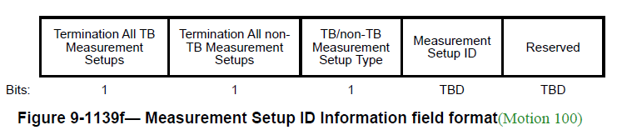
As discussed before, we can set the upper bound of the length of Measurement Setup ID to 5 bits. In this case, we need to redefine the Measurement Setup ID field format as shown blow.
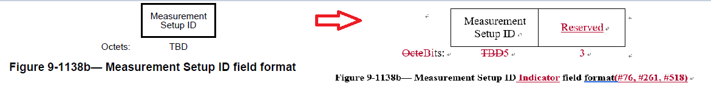
In order to avoid the “same name” issue of “Measurement Setup ID subfield” and “Measurement Setup ID field”, we have to rename the “Measurement Setup ID subfield” in a lot of elements/frames. For example, change the “Measurement Setup ID field” to “Measurement Setup ID Indicator field” in Sensing Measurement Setup Request frame as show below (this kind of change is shown in rev 4 of this CR doc.).
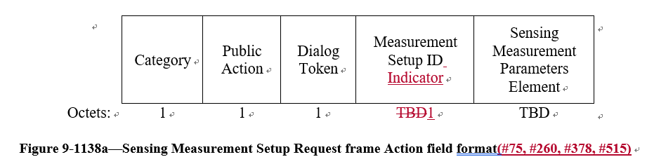
However, a simpler way is that we leave the length of Measurement Setup ID field as 1 octet (8 bits) at present (until we have the finalized length), and move the three termination control bits into a separate field “Measurement Setup Termination Control field” in the termination frame. Please note that one octet does not impact the PPDU length. Then, other elements/frames (in both sub-7GHz and DMG) containing the Measurement Setup ID field can keep unchanged.
End of Discussion.
TGbf Editor: Please revise subclause 9.6.7.52 (Sensing Measurement Setup Termination frame format) in draft 0.2 as follows.
The Sensing Measurement Setup Termination frame is used to terminate sensing measurement setup(s)(Motion 100). The format of the Sensing Measurement Setup Termination frame Action field is defined in Figure 9-1139e (Sensing Measurement Setup Termination frame Action field format(Motion 100)).

 | Category | Public Action | Dialog Token | Measurement Setup ID | Measurement Setup Termination Control
Octets: | 1 | 1 | 1 | 1 | 1
Figure 9-1139e— Sensing Measurement Setup Termination frame Action field format(Motion 100)(#80, #492)

The Category field is defined in 9.4.1.11 (Action field).

The Public Action field is defined in 9.6.7.1 (Public Action frames).

The Dialog Token field is defined in 9.4.1.12 (Dialog Token field) and set by the requesting sensing STA.

The Measurement Setup ID field combined with Measurement Setup Termination Control field indicates the identifier(s) of the sensing measurement setup(s) to be terminated. The Measurement Setup ID field is defined in Figure 9-1138b (Measurement Setup ID field format). The format of the Measurement Setup Termination Control field is shown in Figure 9- 1139f (Measurement Setup Termination Control field format(Motion 100))(Motion 100).

 | Termination All TB Measurement Setups | Termination All non-TB Measurement Setups | TB/non-TB Measurement Setup Type |  | Reserved
Bits: | 1 | 1 | 1 |  | 5
Figure 9-1139f – Measurement Setup Termination Control field format(Motion 100)

(Motion 100)The Terminate All TB Measurement Setups subfield is set to 1 to indicate that the STA requests to terminate all sensing measurement setups established in the TB case. The Terminate All TB Measurement Setups subfield is set to 0 to indicate that the STA does not request to terminate all the sensing measurement setups established in the TB case. If the Terminate All TB Measurement Setups subfield is set to 1, the TB/non-TB Measurement Setup Type subfield and the Measurement Setup ID field are reserved.

(Motion 100)The Terminate All non-TB Measurement Setups subfield is set to 1 to indicate that the STA requests to terminate all sensing measurement setups established in the non-TB case. The Terminate All non-TB Measurement Setups subfield is set to 0 to indicate that the STA does not request to terminate all the sensing measurement setups established in the non-TB case. If the Terminate All non-TB Measurement Setups subfield is set to 1, the TB/non-TB Measurement Setup Type subfield and the Measurement Setup ID field are reserved.

(Motion 100)If the Terminate All TB Measurement Setups subfield and the Terminate All non-TB Measurement Setups subfield are both set to 0, the TB/non-TB Measurement Setup Type subfield indicates the Measurement Setup ID contained in the Measurement Setup ID field is assigned to TB or non-TB case. The TB/non-TB Measurement Setup Type subfield is set to 0 to indicate that the Measurement Setup ID contained in Measurement Setup ID field is assigned by an AP for the TB measurement instance; and set to 1 to indicate the Measurement Setup ID contained in Measurement Setup ID field is assigned by a non-AP STA for the non-TB measurement instance.(#80, #492)

