IEEE P802.11
Wireless LANs
LB266 CR on 9.4.1.71
Date: 2022-07-26
Author(s):
Name | Affiliation | Address | Phone | Email
Jinyoung Chun | LG Electronics | 19, Yangjae-daero 11gil, Seocho-gu, Seoul 137-130, Korea |  | jiny.chun@lge.com
Dongguk Lim |  |  |  | dongguk.lim@lge.com
Eunsung Park |  |  |  | esung.park@lge.com
Jinsoo Choi |  |  |  | js.choi@lge.com
Wook Bong Lee | Samsung |  |  | wookbong.lee@samsung.com

Abstract
This submission proposes comment resolutions for the 6 CIDs: 11628, 11687, 12365, 12595, 12596, and 12597.
All the changes are based on P802.11be D2.1.

Revisions:
- Rev 0: Initial version of the document.

CID 11628
CID | Clause | PP.LL | Comment | Proposed Change | Resolution
11628 | 9.4.1.71 | 185.62 | Clarification of lowest and highest frequency for the MRU case should be added | Change text to "from the lowest frequency to the highest frequency (in case of MRU the lowest frequency stands for the lowest frequency of first RU and the highest frequency stands for the highest frequency of the last RU)" | Revised  There’s no definition of channel matrix element in not only 11be but also 11REVme. And subcarrier indices are described below in the same subclause. So it’s better to remove the description of ‘channel matrix element’ and ‘subcarrier index’ here to clarify.  Instructions to the editor:  Please make the changes as shown in doc 11-22/1131r0, below CID 11628.

Instructions to the editor: Please make the following changes in P187L62 of P802.11be D2.1.

9.4.1.71 EHT Compressed Beamforming Report field

The EHT Compressed Beamforming Report field carries the average SNR of each spatial stream and compressed beamforming feedback matrices V for use by a transmit beamformer to determine steering matrices Q, as described in 10.34.3 (Explicit feedback beamforming) and 19.3.12.3 (Explicit feedback beamforming).

The size of the EHT Compressed Beamforming Report field depends on the values in the EHT MIMO Control field. The EHT Compressed Beamforming Report field contains EHT compressed beamforming report information or successive (possibly zero-length) portions thereof in the case of segmented EHT compressed beamforming/CQI report (see 35.7.4 (Rules for generating segmented feedback)). EHT compressed beamforming report information is included in the EHT compressed beamforming/CQI report if the Feedback Type subfield in the EHT MIMO Control field indicates SU or MU.

The EHT Compressed Beamforming Report information contains matrix angles in order shown in Table 9-71 (Order of angles in the compressed beamforming feedback matrix when used in a non-S1G band), and an explanation of how these angles are generated from the beamforming feedback matrix V is given in 19.3.12.3.6 (Compressed beamforming feedback matrix), where is the Nc is the number of columns in a compressed beamforming feedback matrix determined by the Nc Index subfield of the EHT MIMO Control field, and Nr is the number of rows in a compressed beamforming feedback matrix determined by the Nr Index subfield of the EHT MIMO Control field.

CID 11687 and 12365
CID | Clause | PP.LL | Comment | Proposed Change | Resolution
11687 | 9.4.1.71 | 188.36 | Please unify the expressions of "80 MHz subblock" and "80 MHz" to "80 MHz frequency subblock". | Please refer to the comment. | Accepted
12365 | 9.4.1.71 | 186.09 | Is Equation (9-1) the correct reference? In REVme1.3, equation 9-1 is for scaling factor, doesn't seem correct. Please check and correct if needed. | Please check and use the correct equation. | Revised  Now the equation number is (9-3) in REVme D1.3.  And for easy search, it’s better to add the reference subcluase.  Instructions to the editor:  Please make the changes from ‘Equation (9-1)’ to ‘Equation (9-3) (see 9.4.1.49 (VHT Compressed Beamforming Report field)’ in P188L09.
Background:
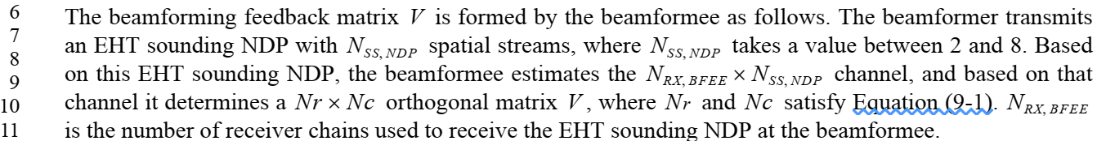

CID 12595, 12596 and 12597
CID | Clause | PP.LL | Comment | Proposed Change | Resolution
12595 | 9.4.1.71 | 188.40 | The following text states that: "otherwise the compressed beamforming information related to subcarrier indices of 242-tone RU for each 20 MHz indicated by Partial BW Info subfield is included in the feedback report". However this text applies only to the case where the Sounding NDP BW is not greater than 160MHz, this the feedback resolution is 20MHz subchannel resolution.  Please add this clarification to the cited text. | As in comment | Revised  Agree with the commenter and add some text for 40MHz subchannel resolution as below.  Instructions to the editor:  Please make the changes as shown in doc 11-22/1131r0, below CID 12597.
12596 | 9.4.1.71 | 188.40 | With regard to the following text: "otherwise the compressed beamforming information related to subcarrier indices of 242-tone RU for each 20 MHz indicated by Partial BW Info subfield is included in the feedback report" - what is the expected encoding for the case where the NDP Sounding BW is greater than 160 MHz, so the resolution is 40MHz subchannel? | Please add the following text immediately after the cited text, as follows:" In case the Sounding NDP BW is greater than 160 MHz, the compressed beamforming information related to subcarrier indices of 484-tone RU for each 40 MHz indicated by Partial BW Info subfield is included in the feedback report" | Revised  Agree with the commenter and add some text for the case of 40MHz subchannel as below.  Instructions to the editor:  Please make the changes as shown in doc 11-22/1131r0, below CID 12597.
12597 | 9.4.1.71 | 188.40 | With regard to the following text: "otherwise the compressed beamforming information related to subcarrier indices of 242-tone RU for each 20 MHz indicated by Partial BW Info subfield is included in the feedback report". What is the expected reported feedback in case a specific 20MHz subchannel is indicated as a disabled channel in the Disabled Subchannel bitmap in the Beacon?! | Please add the text to each of the following cases:  Case 1 - the feedback resolution is 20MHz subchannel.  Case 2 - the feedback resolution is 40MHz subchannel. | Revised  Agree with the commenter and add some text for the case of 40MHz subchannel as below.  Instructions to the editor:  Please make the changes as shown in doc 11-22/1131r0, below CID 12597.
Background: Table right before the below paragraphs:
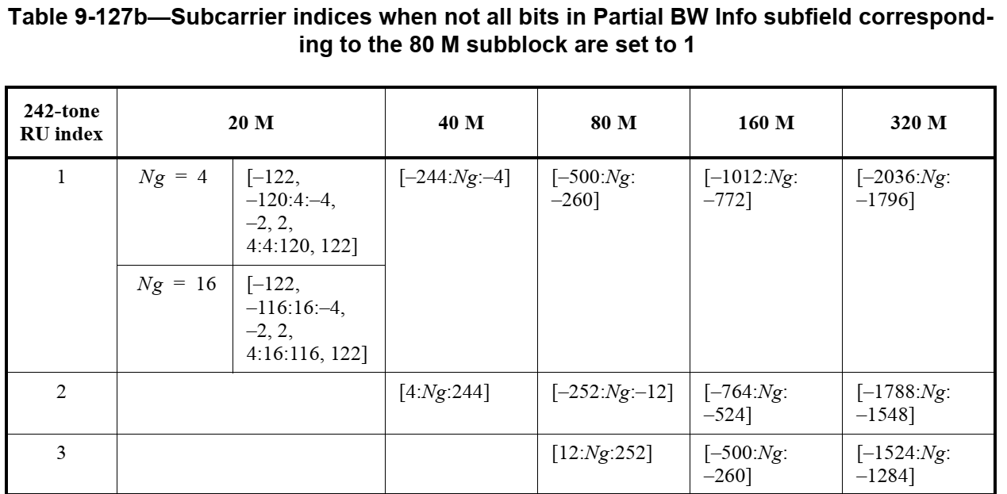

Instructions to the editor: Please make the following changes in P190L36~43 of 802.11be D2.0:

For an EHT NDP Announcement frame of bandwidth 20 MHz or 40 MHz, the subcarrier indices of 242-tone RU for each 20 MHz indicated in the Partial BW Info subfield is included in the feedback report.

For an EHT NDP Announcement frame of bandwidth larger than or equal to 80 MHz, in each 80 MHz subblock, if the Partial BW Info subfield indicates the feedback of the entire 80 MHz (all the bits corresponding to the 80 MHz subblock are set to 1), the compressed beamforming information related to subcarrier indices of the corresponding 996-tone RU (see Table 9-127c and 9-127d) is included in the feedback; otherwise the compressed beamforming information related to subcarrier indices of 242-tone RU for each 20 MHz (see Table 9-127b) indicated by Partial BW Info subfield is included in the feedback report in case the bandwidth of EHT sounding NDP is 80 MHz or 160 MHz, and the compressed beamforming information related to subcarrier indices of two 242-tone RUs for each 40 MHz (see Table 9-127b) indicated by Partial BW Info subfield is included in the feedback report in case the bandwidth of EHT sounding NDP is greater than 160 MHz.

