IEEE P802.11
Wireless LANs
LB 266 Resolution for CIDs related to Figure 35-3
Date: July 13, 2022
Author(s):
Name | Affiliation | Address | Phone | email
Abhishek Patil | Qualcomm Inc |  |  | appatil@qti.qualcomm.com
Gaurang Naik
George Cherian
Alfred Asterjadhi
Duncan Ho
Yanjun Sun
Abdel Karim

Abstract
This submission proposes resolutions for following 10 CIDs received for TGbe LB266:
13624 13515 12260 12261 12788 10668 10669

Revisions:
- Rev 0: Initial version of the document.

TGbe editor: The baseline for this document is 11be D2.0

Interpretation of a Motion to Adopt

A motion to approve this submission means that the editing instructions and any changed or added material are actioned in the TGbe Draft. This introduction is not part of the adopted material.

Editing instructions formatted like this are intended to be copied into the TGbe Draft (i.e., they are instructions to the 802.11 editor on how to merge the text with the baseline documents).

TGbe Editor: Editing instructions preceded by “TGbe Editor” are instructions to the TGbe editor to modify existing material in the TGbe draft. As a result of adopting the changes, the TGbe editor will execute the instructions rather than copy them to the TGbe Draft.

CID | Commenter | Clause | Pg/Ln | Comment | Proposed Change | Resolution
13605 | Rubayet Shafin | 35.3.2.2 | 408.50 | Regarding Figure 35-3, the Common Info field doesn't start with MLD MAC Address anymore. It starts with Common Info Length. Please also update the figure description accordingly in P408L58. | Please update the figure accordingly. | Revised  Agree with the comment. Figure 35-3 was updated to show the Common Info Length field and the description text was updated accordingly.  TGbe editor, please update Figure 35-3 as shown in doc 11-22/1125r0 tagged 13605
13345 | Liwen Chu | 35.3.2.2 | 408.26 | Common Info field format is not right. Update it per subclause 9 | As in comment | Revised  Figure 35-3 was updated as a resolution to CID 13605 to align with format described in clause 9  TGbe editor: please apply the same resolution as CID 13605
13891 | Ming Gan | 35.3.2.2 | 408.58 | Length field in the common info is missing | add the description for length field | Revised  Figure 35-3 was updated as a resolution to CID 13605 and shows the Common Info Length field.  TGbe editor: please apply the same resolution as CID 13605
13606 | Rubayet Shafin | 35.3.2.2 | 408.50 | In Figure 35-3, the reserved bits in the Multi-Link Control field needs to be reflected, at least by using some horizontal dots. | As in comment | Accepted  TGbe editor: for convenience, the proposed change is shown in doc 11-22/1125r0 tagged 13606
13607 | Rubayet Shafin | 35.3.2.2 | 408.50 | In Figure 35-3, the "MAC Address Present" subfield in the STA Control field should be replaced with " STA MAC Address Present" subfield. | As in comment | Accepted  TGbe editor: for convenience, the proposed change is shown in doc 11-22/1125r0 tagged 13607
13608 | Rubayet Shafin | 35.3.2.2 | 408.50 | Regarding Figure 35-3, STA Info field should start with STA Info Length subfield, not with STA MAC Address subfield. | Please update the figure accordingly. | Revised  Agree with the comment. Figure 35-3 was updated to show the STA Info Length field and the description text was updated accordingly.  TGbe editor, please update Figure 35-3 as shown in doc 11-22/1125r0 tagged 13608
13344 | Liwen Chu | 35.3.2.2 | 408.38 | STA Info format is not right. Update it per subclause 9 | As in comment | Revised  Figure 35-3 was updated as a resolution to CID 13608 to align with format described in clause 9  TGbe editor: please apply the same resolution as CID 13608
13611 | Rubayet Shafin | 35.3.2.2 | 408.54 | It would be good to explicitly mention that the figure expands the Per-STA profile for STA-x. | As in comment | Revised  Agree with the comment. The description text was updated to clarify that the profile for STA x is expanded in the figure.  TGbe editor, please make changes as shown in doc 11-22/1125r0 tagged 13611
12511 | Jeongki Kim | 35.3.2.2 | 408.59 | In Figure 35-3, unlike STA Info field, Presence Bitmap subfield of the Multi-Link Control field is used to indicate which fields is present in Common Info portion. Use the clear term there instead of the subfields. | change "the subfields in the Multi-Link Control field." to "the Presence Bitmap subfield in the Multi-Link Control field." | Revised  Agree with the comment. The description text was updated to clarify that the subfields within Presence Bitmap field indicate which fields are present in the Common Info field.  TGbe editor, please make changes as shown in doc 11-22/1125r0 tagged 13611
11771 | Osama Aboulmagd | 35.3.2.2 | 408.35 | In Figure 35-3 the box starting with Link ID box, where does this box belong in the main picture. Is it an extension of the first box? | as in comment | Rejected  The comment fails to identify the exact issue. The figure shows that the Link ID subfield is part of the STA Control field.

35.3.2.2 Advertisement of complete or partial per-link information
TGbe editor: Please replace Figure 35-3 with the one shown below:
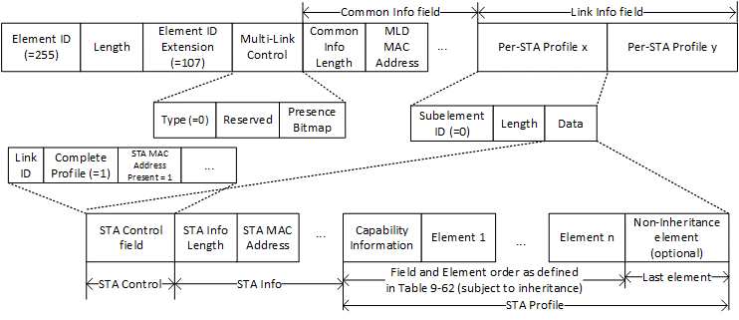
Figure 35-3—Example of Basic Multi-Link element in an Association Request frame[13605, 13606, 13607, 13608]
TGbe editor: Please update the text following Figure 35-3 as shown below:
In Figure 35-3 (Example of Basic Multi-Link element in an Association Request frame), a STA affiliated with a non-AP MLD transmits an Association Request frame which includes a Basic Multi-Link element that carries the complete profile of two other STAs affiliated with its non-AP MLD (STA x and STA y). The figure expands the Per-STA profile for [13611]STA x. The Type subfield of the Multi-Link Control field is set to 0 to indicate that the Multi-Link element is a Basic Multi-Link element. The Common Info field carries information that applies to the MLD level as described in 9.4.2.312.2 (Basic Multi-Link element). In this example, only the [13605]Common Info Length and MLD MAC Address fields are shown. However, there can be other fields present in the Common Info field whose presence is signaled via the subfields [12511]carried within the Presence Bitmap field of the Multi-Link Control field. Each Per-STA Profile subelement in the Link Info field carries the complete profile, with inheritance applied, of a reported STA affiliated with the non-AP MLD. Each Per-STA Profile subelement carries the STA Control field followed by the STA Info field and the STA Profile field. In this example, only the [13608]STA Info Length and STA MAC Address fields are shown. However, there can be other subfields present in the STA Info field whose presence is signaled via the subfields in the STA Control field. The STA Profile field carries variable number of fields and elements in the order defined in Table 9-62 (Association Request frame body) with inheritance applied (see 35.3.2.4 (Inheritance in a per-STA profile)).

