IEEE P802.11
Wireless LANs
LB266 CR on EHT PHY Introduction-1
Date: 2022-07-11
Author(s):
Name | Affiliation | Address | Phone | email
Kanke Wu | Qualcomm Inc |  |  | kankew@qti.qualcomm.com
Bin Tian | Qualcomm Inc

Abstract
This submission proposes resolutions for the following 9 comments from CC36 in P802.11be D2.0:
12132, 12533, 12178, 12179, 13206, 12528, 12135, 12137, 12136

This proposed text changes in this document are based on TGbe Draft 2.0

Revisions:

- Rev 0: Initial version of the document.

.

CID 12132, 12533

CID | Clause | Page.Line | Comment | Proposed Change | Resolutions
12132 | 36.1.1 | 541.23 | OFDM PHY is defined in Clause 17 instead of Clause 16 | Change "the OFDM PHY defined in Clause 16" to "the OFDM PHY defined in Clause 17". | ACCEPTED
12533 | 36.1.1 | 541.22 | The PHY defined by Clause 16 is not OFDM PHY as stated in the sentence. | change "OFDM PHY" to "DSSS PHY" or Change the Clause number if it is applicable. | ACCEPTED  Note to the editor: the change required for this CID is identical to 12132

CID 12178

CID | Clause | Page.Line | Comment | Proposed Change | Resolution
12178 | 36.1.1 | 541.41 | The text "with the total across all users not exceeding eight spatial streams." does not read well. Suggest to change to "with the total number of spatial streams across all users not exceeding eight" | as in the comment. | ACCEPTED

CID 12179,13206, 12528

CID | Clause | Page.Line | Comment | Proposed Change | Resolution
12179 | 36.1.1 | 542.22 | The language used in the first bullet "The STA supports..." is inconsistent the second/third bullet "The STA declares support". Suggest to change the first bulllet to "The STA declares support of transmission and reception in channel bandwidths greater than 20 MHz" | as in the comment. | ACCEPTED
13206 | 36.1.1 | 542.22 | The first bullet "The STA supports..." is inconsistent the second&third bullet "The STA declares support". | please makes the three bullets consistance | REVISED.  The CID is resolved by accepting CID 12179
12528 | 36.1.1 | 542.25 | "LDPC coding (transmit and receive) in all supported EHT PPDU types, RU and MRU sizes, and  number of spatial streams if a STA satisfies any of the following conditions-The STA declares support for at least one of EHT-MCSs 10, 11, 12, and 13 (transmit and  receive)." -Here mcs 14 is not mentioned. | In section 36.3.13.3.3 , page 706 and line number 5, it is mentioned that LDPC coding is mandatory if STA supports mcs 14. Please rectify accordingly | REVISED.  The reason MCS 14 was not mentioned in the current sentence is because it overlaps with support for bandwidths greater than or equal to 20MHz case.  However, adding MCS 14 here would make it explicit and more consistent.  Instruction to the editor: At P542L25 please make the following change:  The STA declares support for at least one of EHT-MCSs  10, 11, 12, 13, and 14 (transmit and receive).

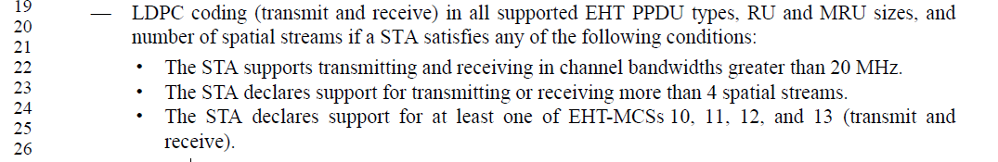

CID 12135

CID | Clause | Page.Line | Comment | Proposed Change | Resolution
12135 | 36.1.1 | 542.52 | An EHT STA which is not 20 MHz only non-AP STA shall supoort 40 MHz and 80 MHz channel widths and all RU and MRU sizes and locations applicable to the 40 MHz and 80 MHz channel widths in the 5 GHz and 6 GHz bands (transmit and receive). | insert the following bullet at P542L52:  "40 MHz and 80 MHz channel widths and all RU and MRU sizes and locations applicable to the 40 MHz and 80 MHz channel widths in the 5 GHz and 6 GHz bands (transmit and receive) if the STA is not a 20 MHz-only non-AP STA."  delete the following bullet at P543L36  "40 MHz and 80 MHz channel widths and all RU and MRU sizes and locations applicable to the 40 MHz and 80 MHz channel widths in the 5 GHz band (transmit and receive)."  change at P543L38  "40 MHz, 80 MHz, and 160 MHz channel widths and all RU and MRU sizes and locations applicable to the 40 MHz, 80 MHz, and 160 MHz channel widths in the 6 GHz bands (transmit and receive)." to "160 MHz channel widths and all RU and MRU sizes and locations applicable to the 160 MHz channel widths in the 6 GHz bands (transmit and receive)."  delete the following bullet at P544L47  "40 MHz and 80 MHz channel widths and all RU and MRU sizes and locations applicable to the 40 MHz and 80 MHz channel widths in the 5 GHz and 6 GHz band (transmit and receive) except for 20 MHz-only non-AP EHT STA." | ACCEPTED

Page 542,
EHT STA shall support
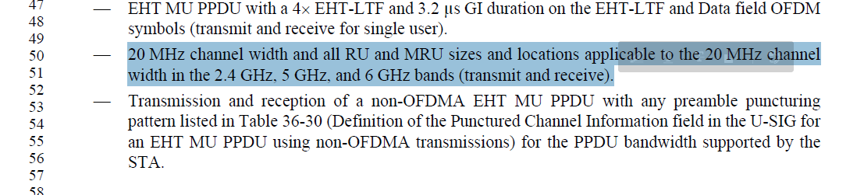

Page 543
EHT AP shall support
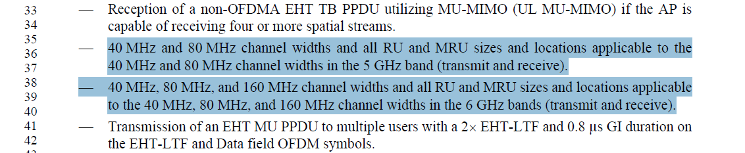
Page 544
A non-AP EHT STA shall support
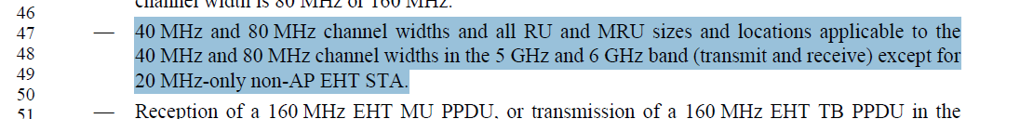

CID 12137

CID | Clause | Page.Line | Comment | Proposed Change | Resolution
12137 | 36.1.1 | 543.12 | "single user transmission" and "transmit and receive" in the same sentence cause a bit confusion. It is better to reword these three bullets for easy of understanding | change "Single user transmission using EHT MU PPDU with a 4xEHT-LTF and 0.8 Î¼s GI duration on the EHT-LTF and Data field OFDM symbols (transmit and receive)." to "EHT MU PPDU addressed to a single user and with a 4xEHT-LTF and 0.8 Î¼s GI duration on the EHT-LTF and Data field OFDM symbols (transmit and receive)." | REVISED  Need to specify this is for non-OFDMA transmission.  Instruction to the editor:  change "Single user transmission using EHT MU PPDU with a 4xEHT-LTF and 0.8 Î¼s GI duration on the EHT-LTF and Data field OFDM symbols (transmit and receive)." to "EHT MU PPDU using non-OFDMA addressed to a single user and with a 4xEHT-LTF and 0.8 us GI duration on the EHT-LTF and Data field OFDM symbols (transmit and receive)."
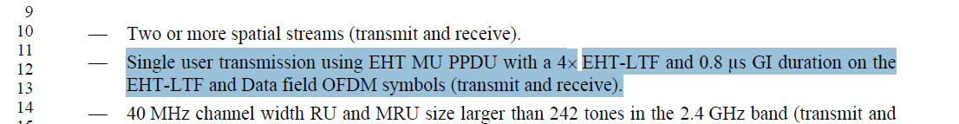

CID 12136

CID | Clause | Page.Line | Comment | Proposed Change | Resolution
12136 | 36.1.1 | 543.15 | It is better to reword these three bullets for easy of understanding | change "40 MHz channel width RU and MRU size larger than 242 tones in the 2.4 GHz band (transmit and receive)" to "40 MHz channel width and all RU and MRU sizes larger than 242 tones in the 2.4 GHz band (transmit and receive).  change "160 MHz channel width RU and MRU size larger than 996 tones in the 5 GHz band (transmit and receive)." to "160 MHz channel width and all RU and MRU sizes larger than 996 tones in the 5 GHz band (transmit and receive)"  change "320 MHz channel width RU and MRU size larger than 996 tones in the 6 GHz band (transmit and receive)" to "320 MHz channel width and all RU and MRU sizes larger than 996 tones in the 6 GHz band (transmit and receive). | ACCEPTED
