IEEE P802.11
Wireless LANs
TGbd D5.0 Comment Resolution related to MIB variable definition
and misc
Date: 2022-7-11
Author(s):
Name | Affiliation | Address | Phone | email
Hiroyuki Motozuka | Panasonic | 600 Saedo-cho, Tsuzuki-ku, Yokohama, Kanagawa, Japan |  | motozuka.hiroyuki@jp.panasonic.com
Abstract
This submission proposes resolution to the following CIDs received during 11bd D5.0 Recirculation SA Ballot.

4 CIDs 6026, 6027, 6033, 6038

Revision history:
r0 Initial version
r1 Edited during TGbd session in July plenary. Modified proposed change for CID6038. Added notes for 6026, 6027, yet to be agreed, based on discussion during the session.
r2 Modified proposed resolution for CIDs 6026 and 6027, suggesting use of “dot11NGVImplemented” and “dot11NONNGVRadioEnvironmentImplemented”

CIDs 6026, 6027 (dot11NGVActivated, dot11NONNGVRadioEnvironmentSupported)

CID | Page.Line | Comment | Proposed Change | Proposed Resolution
6026 | 135.26 | Confusing name of MIB variable. This should be implemented. | Replace "dot11NGVActivated" with "dot11NGVImplemented" throughout. | Revised  Discussion:  TGbd D5.0 Annex C defines this variable as read-write control variable that can be written by external entity. Discussion was held in TGbd and the group reached consensus that the variable should not be changed during operation; i.e. the variable should be read-only.  In 802.11-15/0355r13 (https://mentor.ieee.org/802.11/dcn/15/11-15-0355-13-0arc-mib-truthvalue-usage-patterns.docx), it is recommended that “dot11<XXX>Implemented” is used for static implementation capability, and “dot<XXX>Activated” is used for dynamic operational capability.  Thus, we believe dot<XXX>Implemented is appropriate for the purpose. To follow the practices in the past amendments, e.g. dot11HEOptionImplemented, dot11S1GOptionImplemented, etc., we suggest “dot11NGVOptionImplemented” for this purpose.  As this variable appears in the ANA database, the database entry must be modified as well.  TGbd Editor:  - Change “dot11NGVActivated” as control variable to “dot11NGVOptionImplemented” as capability variable in its definition in Annex C as in https://mentor.ieee.org/802.11/dcn/22/11-22-1065-02-00bd-tgbd-d5-0-cr-related-to-mib-variable-definition-and-misc.docx under CID 6026,  - replace “dot11NGVActivated” with “dot11NGVOptionImplemented” throughout the draft (P19L37, P19L38, P19L39, P23L44, P24L58, P25L22, P25L63, P27L15, P31L43, P39L60, P44L63, P51L18, P61L28), and  - make a request for changing the variable name on ANA database.
6027 | 135.26 | Confusing name of MIB variable. It says supported but then content says it is a control variable. Use a consistent term. | Replace "dot11NONNGVRadioEnvironmentSupported" with "dot11NONNGVRadioEnvironmentActivated" throughout. | Revised  Discussion  TGbd D5.0 Annex C defines this variable as read-write control variable that can be written by external entity. Discussion was held in TGbd and the group reached consensus that the variable should not be changed during operation; i.e. the variable should be read-only.  Thus “dot11NONNGVRadioEnvironmentImplemented” is appropriate to represent the capability.  As this variable appears in the ANA database, the database entry must be modified as well.  TGbd Editor:  - Change “dot11NONNGVRadioEnvironmentSupported” as control variable to “dot11NONNGVRadioEnvironmentImplemented” as capability variable in its definition in Annex C as in https://mentor.ieee.org/802.11/dcn/22/11-22-1065-02-00bd-tgbd-d5-0-cr-related-to-mib-variable-definition-and-misc.docx under CID 6027,  - please replace "dot11NONNGVRadioEnvironmentSupported" with "dot11NONNGVRadioEnvironmentImplemented" throughout the draft (P23L44, P25L65, P27L16 (Please double-check the occurrences)), and  - please make request for ANA database to apply the change on the variable name.  (On “dot11StationConfigEntry” and “TGbd” sheets in ANA database: https://mentor.ieee.org/802.11/dcn/11/11-11-0270-62-0000-ana-database.xls or newer revision)

Proposed change to Annex C

TGbd Editor: Please replace dot11NGVActivated and dot11NONNGVRadioEnvironmentSupported with dot11NGVOptionImplemented and dot11NONNGVRadioEnvironmentImplemented, respectively, at P135L18-19 as follows:

Change Dot11StationConfigEntry as follows:

Dot11StationConfigEntry ::= SEQUENCE
{
…,
dot11NONNGVRadioEnvironmentImplemented TruthValue,
dot11NGVOptionImplemented TruthValue,
dot11RadioEnvironmentMeasurementPeriod Unsigned32,
dot11VirtualCSonOCBSecondaryImplemented TruthValue,
dot11StationMeasurementPeriod Unsigned32
}

TGbd Editor: Please change the following definition for dot11NGVActivated

dot11NGVActivated OBJECT-TYPE
SYNTAX TruthValue
MAX-ACCESS read-write
STATUS current
DESCRIPTION
"This is a control variable. It is written by an external management
entity or the SME. Changes take effect as soon as practical in the implementations.
A STA uses the NGV features when this attribute is true. This
STA also has dot11OCBActivated equal to true."
DEFVAL { false }
::= { dot11StationConfigEntry 203}

to the definition for dot11NGVOptionImplemented as follows (#6026):

dot11NGVOptionImplemented OBJECT-TYPE
SYNTAX TruthValue
MAX-ACCESS read-only
STATUS current
DESCRIPTION
" This is a capability variable.
Its value is determined by device capabilities.

This attribute, when true, indicates that the STA supports NGV features. This
STA also has dot11OCBActivated equal to true."
::= { dot11StationConfigEntry 203}

TGbd Editor: Please change the following definition for dot11NONNGVRadioEnvironmentSupported

dot11NONNGVRadioEnvironmentSupported OBJECT-TYPE
SYNTAX TruthValue
MAX-ACCESS read-write
STATUS current
DESCRIPTION
"This is a control variable. It is written by an external management
entity or the SME. Changes take effect as soon as practical in the implementations.
A non-NGV STA supports the radio environment transmit vector
and the radio environment status vector when this attribute is true. This
STA also has dot11OCBActivated equal to true."
DEFVAL { false }
::= { dot11StationConfigEntry 219}

to the definition for dot11NONNGVRadioEnvironmentImplemented as follows (#6027):

dot11NONNGVRadioEnvironmentImplemented OBJECT-TYPE
SYNTAX TruthValue
MAX-ACCESS read-only
STATUS current
DESCRIPTION
" This is a capability variable.
Its value is determined by device capabilities.

A non-NGV STA supports the radio environment transmit vector
and the radio environment status vector when this attribute is true."
::= { dot11StationConfigEntry 219}

TGbd Editor: Please replace dot11NGVActivated and dot11NONNGVRadioEnvironmentSupported with dot11NGVOptionImplemented and dot11NONNGVRadioEnvironmentImplemented, respectively, at P139L19,L21 as follows:

dot11NGVComplianceGroup OBJECT-GROUP
OBJECTS {
dot11NGVOptionImplemented,
dot11RadioEnvironmentMeasurementPeriod,
dot11VirtualCSonOCBSecondaryImplemented,
dot11NONNGVRadioEnvironmentImplemented,
dot11StationMeasurementPeriod }
STATUS current
DESCRIPTION
"Attributes that configure the NGV Group for IEEE Std 802.11."
::= { dot11Groups 125 }

(Informative) The other occurrences of dot11NGVActivated and dot11NONNGVRadioEnvironmentSupported in 11bd D5.0

P19L37, P19L38, P19L39
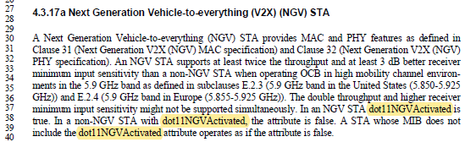

5.2.3 MA-UNITDATA.request
5.2.3.2 Semantics of the service primitive

P23L44
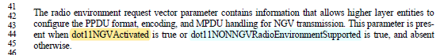

P24L58
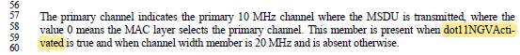

P25L22
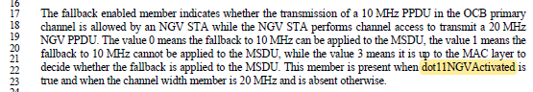

5.2.4 MA-UNITDATA.indication
5.2.4.2 Semantics of the service primitive

P25L63
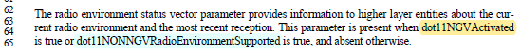

5.2.5 MA-UNITDATA-STATUS.indication
5.2.5.2 Semantics of the service primitive

P27L15
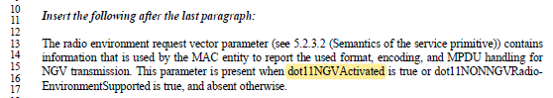

6.3.129.2 MLME-RADIOENVIRONMENT.request

P31L43
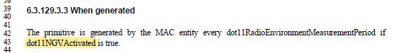

9.4.2.298 Ranging Parameters element

P39L60(in Table 9-322h23fb)
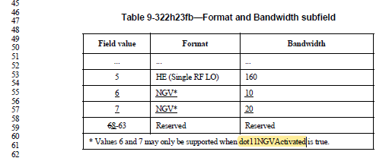

P44L63
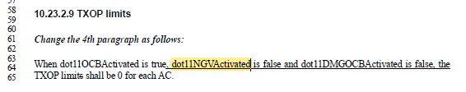
Note: The text above has further change regarding CID#6033 in this submission below.

P51L18
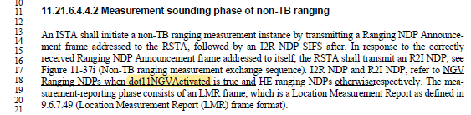

P61L28
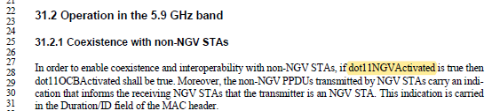

CID 6033 (MIB references in TXOP limits rule)

CID | Page.Line | Comment | Proposed Change | Proposed Resolution
6033 | 44.64 | dot11DMGOCBActivated is not present in the 5G9. Please fix the inconsistency. | Remove "dot11DMGOCBActivated". | Revised  Discussion  dot11OCBActivated can be set to true for a DMG STA operating OCB, in which dot11DMGOCBActivated is set to true, thus “dot11DMGOCBActivated” should not be removed from this statement.  As the commenter pointed out, it is likely the parameter is not present for 5G9 STAs. Although it is described, in clause 4 of 11bd draft, “A STA whose MIB does not include the dot11DMGOCBActivated attribute operates as if the attribute is false,” description in clause 4 may not be regarded as normative spec. For complete description and clarification, we propose to change “false” to “false or not present” in the concerned text.  TGbd Editor:  Please change “dot11NGVActivated is false and dot11DMGOCBActivated is false” to “dot11NGVActivated is false or not present and dot11DMGOCBActivated is false or not present” at P44L64 in TGbd draft.

When dot11OCBActivated is true, dot11NGVActivated is false or not present and dot11DMGOCBActivated is false or not present, the TXOP limits shall be 0 for each AC.

CID 6038 (Description related to EDMG)

CID | Page.Line | Comment | Proposed Change | Proposed Resolution
6038 | 19.16 | Not clear if the STA may or may not be an eDMG. Here it says it follows the rules for EDMG but in the entry sentence it says might be a DMG. From a quick check of the draft the eDMG seems to be present but generally by accident. So I am thinking it is a typo. | Delete all occurrences of EDMG from the TGbd draft (that are related to TGbd). | Revised  Discussion  DMG related description in TGbd draft are written so that they can be applied to EDMG STA as well as DMG=non-EDMG STA. For example, subclause 11.18 specifies types of control frames that are not transmitted OCB, including frames defined in 11ay. The MLME SAP primitives and DMG OCB Parameters field in DMG Beacon, for example, carry EDMG-related capability information so that the STAs can exchange EDMG capabilities that may be utilized for communication and/or discovery OCB.  For clarification, we propose text change for the general description on subclause 4.3.17.  TGbd Editor:  Please remove “or EDMG” from the last sentence of the 1st paragraph in 4.3.17 (P19L16) and add a new sentence “A DMG STA operating OCB might support EDMG features.” at the end of the paragraph.

A STA with dot11OCBActivated equal to true might operate as a DMG STA. A DMG STA with dot11DMGOCBActivated equal to true supports the MAC and MLME functions defined in Clause 31.3 (Operation in the 60 GHz band) in addition to the MAC functions defined in Clause 10 (MAC sublayer functional description) and the MLME functions defined in Clause 11 (MLME) for DMG STAs. A DMG STA operating OCB might support EDMG features.

References
[1] Draft P802.11bd D5.0
[2] IEEE802.11-15/0355r13, “MIB TruthValue usage patterns” https://mentor.ieee.org/802.11/dcn/15/11-15-0355-13-0arc-mib-truthvalue-usage-patterns.docx

