IEEE P802.11
Wireless LANs
LB266 CR for 9.4.2.313.5 EHT PPE Thresholds Field
Date: 2022.07.12
Author(s):
Name | Company | Address | Phone | email
Mengshi Hu | Huawei Technologies | H3, Huawei Base, Bantian, Longgang, Shenzhen, Guangdong, China, 518129 |  | humengshi@huawei.com
Ross Jian Yu
Ming Gan
Shimi Shilo
Abstract
This submission contains the proposed comment resolutions of the following 5 CIDs in 22/0971 IEEE 802.11be LB266 comments, for the subclause 9.4.2.313.5 EHT PPE Thresholds Field.

CIDs 10394, 10399, 10401, 10812, 11234.

Revision Notes
R0 | Initial revision

CID 10394
Page.  Line | Clause Number | Comment | Proposed Change | Resolution
247.21 | 9.4.2.313.5 | Change "that is used to indicate" into "indicating" | Change "that is used to indicate" into "indicating" | ACCEPTED

Discussion:
The NSS_PE subfield contains an unsigned integer NSS_PE indicating the scope of NSSn for the PPETmax NSSn RUb subfields and PPET8 NSSn RUb subfields in the PPE Thresholds Info field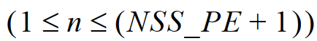.

Note to the Editor: The proposed descprition by the commenter is simpler than the original description.
Discussion ends.

CID 10399 & 10812 & 10401
Page.  Line | Clause Number | Comment | Proposed Change | Resolution
248.45  (CID 10399) | 9.4.2.313.5 | Suggest also adding the descriptions of 160 MHz and 320 MHz PPDU using EHT-MCS 14. | Add descriptions showing that the indices here don't consider the DCM. | REVISED.  Agree with the commenter.  Instructions to the editor:  Please make the changes as shown under CID 10401 in 11-22/1064r0.
248.45  (CID 10812) | 9.4.2.313.5 | MCS14 is applied to 80/160/320MHz PPDU. so, how to set the RU allocation index should be described for the 160 or 320MHz PPDU using MCS14.add the text for that to clarify it. | As in the comment. | REVISED.  Agree with the commenter.  Instructions to the editor:  Please make the changes as shown under CID 10401 in 11-22/1064r0.
248.45  (CID 10401) | 9.4.2.313.5 | Please clarify the indices doesn't consider the DCM. In other words, these indices are the initial indices. | Add descriptions showing that the indices here don't consider the DCM. | REVISED.  Agree with the commenter.  Instructions to the editor:  Please make the changes as shown under CID 10401 in 11-22/1064r0.

Instructions to the editor: please make the following changes to Line 45, Page 248 in the subclause 9.4.2.313.5 EHT PPE Thresholds field in D2.0 as shown below:

The RU allocation index for each RU allocation size is defined in Table 9-401o (RU allocation index). For RU allocation index 2, 3, and 4, more than one RU or MRU shares the same RU allocation index. The initial RU allocation indices for the 80 MHz, 160 MHz, and 320 MHz PPDUs using EHT-MCS 14 are equal to 2, 3, and 4, respectively, where the initial RU allocation indices are the indices without considering the effect of DCM (see 35.14 (Nominal packet padding values selection rules) for details).

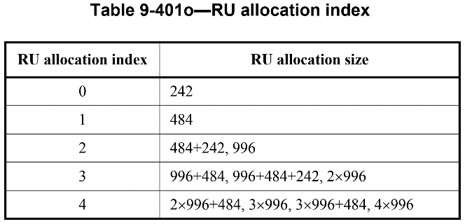
Discussion:
The following text is in the subclause 35.14 Nominal packet padding values selection rules:
If EHT-MCS 14 is applied, the RU allocation indices (b + DCM) for the 80 MHz, 160 MHz, and 320 MHz PPDUs are equal to 3, 3, and 4, respectively.
Discussion ends.

CID 11234
Page.  Line | Clause Number | Comment | Proposed Change | Resolution
248.11 | 9.4.2.313.5 | "as defined in Figure 9-401..." This is a table. | Change to "as defined in Table 9-401..." | ACCEPTED.
Discussion:
Each PPETmax NSSn RUb and PPET8 NSSn RUb subfield contains an integer as defined in Table 9-401n (Constellation index), which is used to compute the nominal packet padding value (see Table 35-6 (PPE thresholds per PPET8 and PPETmax)).
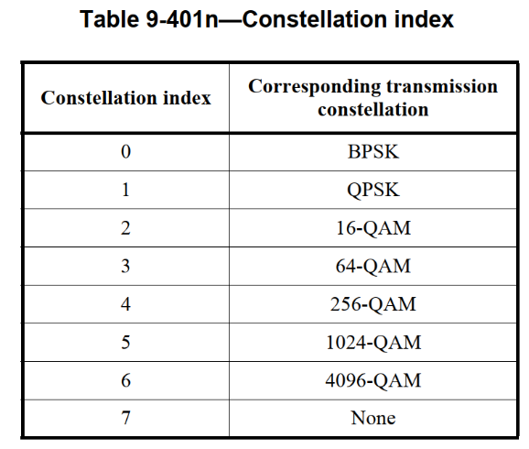
Discussion ends.

