IEEE P802.11
Wireless LANs
LB266 CR on More Data Ack
Date: 2022.07.05
Author(s):
Name | Company | Address | Phone | email
Guogang Huang | Huawei Technologies | F3-6-A124, Huawei Base, Bantian, Longgang, Shenzhen, Guangdong, China, 518129 |  | huangguogang1@huawei.com
Yuchen Guo
Yunbo Li
Yousi Lin
Ming Gan
Abstract
This submission contains proposed comment resolutions to comments on P802.11be D2.0.

CID 12317 is resolved.

Revisions:

- Rev 0: Initial version of the document.
- Rev 1-4: Make some changes on text
- Rev 5: Make the changes based on received comments
- Update the description of More Data subfield under the TID-to-link mapping

CID | Commenter | Page.  Line | Clause Number | Comment | Proposed Change | Resolution
12317 | Guogang Huang | 181 | 9.4.1.17 | To reduce the delay, the More Data subfield in the Ack and Blockblock frames can be used to indicate whether there are pending traffic which need to be transmitted to the AP as soon as possible. Then the AP can do the RDG operation, TXOP sharing or trigger the STA's uplink transmission. | As in comment | REVISED  Agreed in principle. The proposed More Data Ack can improve the delay performance of packets.  Instructions to the editor:  Please make the changes to the spec as shown in 11/22-1043r5

Discussion:

Consider the following scenario, the AP obtains a TXOP to deliver the downlink frames. Meanwhile, one or more destination STAs may also have one or more delay-sensitive packets which needs to be sent to the AP as soon as possible. Normally, this STA has to wait the end of the current TXOP and then initiates the channel access by using the EDCA. This will degrade the delay performance.
In order to reduce the delay, the More Data subfield in the Ack and Blockblock frames can be used to indicate whether there are frames which need to be transmitted to the AP as soon as possible. Then the AP can send a trigger frame to get the buffer status.

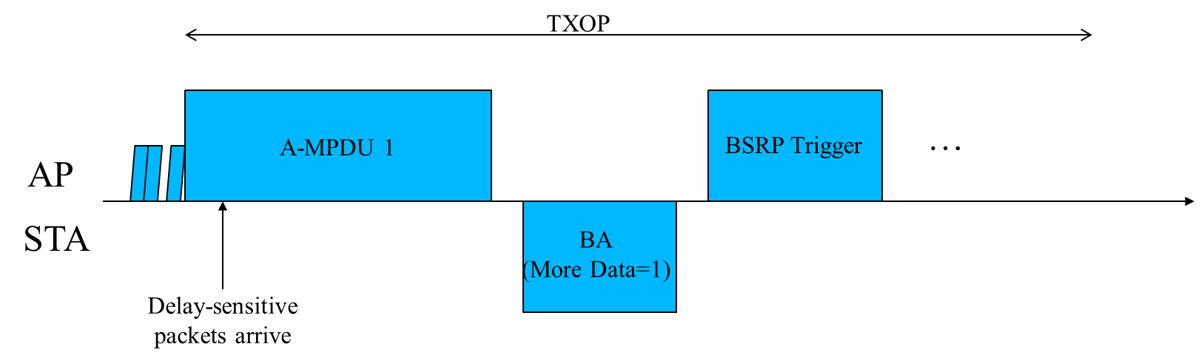

- More Data subfield
TGbe editor: Insert the following paragraph after the second paragraph of this subclause as follows:
An EHT STA optionally sets the More Data subfield in individually addressed Ack and BlockAck frames to 1 to indicate that it has one or more pending frames for an EHT AP that is the intended recipient of the Ack or BlockAck. An EHT STA indicates it supports generating and processing the More Data subfield equal to 1 in these control response frames by setting the More Data Ack subfield to 1 in the QoS Info field of elements it includes in frames transmitted to the EHT AP.

When an EHT AP receives an individually addressed Ack or BlockAck frame from its associated EHT STA with the More Data subfield set to 1, it should send a trigger frame with sufficient resources to allow the solicited non-AP STA sending at least one QoS Null frame that carries an HT Control field.
        - Use of More Data subfield by an MLD
TGbe editor: Insert the following paragraphs after the last paragraph of this subclause as follows:
A non-AP MLD optionally uses the More Data subfield as defined in 9.2.4.1.8 (More Data subfield) in individually addressed Ack and BlockAck frames transmitted by one of its affiliated non-AP STA to an AP affiliated with its associated AP MLD to indicate that one or more frames are buffered at the non-AP MLD for the AP MLD and correspond only to Data frames for the AP MLD with TIDs that are mapped to this link by the most recent UL TID-to-link mapping (negotiated TID-to-link mapping or default mode mapping, see 35.3.7.1 (TID-to-link mapping)) or Management frames for the AP MLD or for an AP affiliated with the AP MLD.

When an AP affiliated with an AP MLD receives an individually addressed Ack or BlockAck frame from its associated non-AP STA affiliated with an AP MLD with the More Data subfield set to 1 and a default mapping is negotiated between them, then at least one of any AP affiliated with the AP MLD should send a trigger frame with sufficient resources to allow the solicited non-AP STA sending at least one QoS Null frame that carries an HT Control field.

When an AP affiliated with an AP MLD receives an individually addressed Ack or BlockAck frame from its associated non-AP STA affiliated with an AP MLD with the More Data subfield set to 1 and a non-default mapping is negotiated between them, then at least one of any AP affiliated with the AP MLD that is operating on the link (receiving link) or another link to which any TIDs that is mapped to the link (receiving link) is also mapped should send a trigger frame with sufficient resources to allow the solicited non-AP STA sending at least one QoS Null frame that carries an HT Control field.
9.4.1.17 QoS Info field
TGbe editor: Change the following paragraph as follows:
(11ax)An HE AP sets the More Data Ack subfield to 1 to indicate that it can generate individually addressed Ack and BlockAck frames with the More Data bit in the Frame Control field equal to 1; otherwise, the AP sets the More Data Ack subfield to 0. For a non-HE AP, the More Data Ack subfield is reserved. An AP MLD sets the More Data Ack subfield to 1 to indicate that it can generate and process individually addressed Ack and BlockAck frames with the More Data bit in the Frame Control field equal to 1; otherwise, the AP MLD sets the More Data Ack subfield to 0.

TGbe editor: Change the following paragraph as follows:
Non-AP non-HE STAs set the More Data Ack subfield to 1 to indicate that they can process Ack frames with the More Data bit in the Frame Control field equal to 1 and remain in the awake state. Non-AP HE STAs set the More Data Ack subfield to 1 to indicate that they can process Ack and BlockAck frames with the More Data bit in the Frame Control field equal to 1 and remain in the awake state. Non-AP STAs set the More Data Ack subfield to 0 otherwise.(11ax) A non-AP MLD sets the More Data Ack subfield to 1 to indicate that it can generate and process Ack and BlockAck frames with the More Data bit in the Frame Control field equal to 1; Otherwise the non-AP MLD set the More Data Ack subfield to 0.

