IEEE P802.11
Wireless LANs
LB266 CR on More Data Ack
Date: 2022.07.05
Author(s):
Name | Company | Address | Phone | email
Guogang Huang | Huawei Technologies | F3-6-A124, Huawei Base, Bantian, Longgang, Shenzhen, Guangdong, China, 518129 |  | huangguogang1@huawei.com
Yuchen Guo
Yunbo Li
Yousi Lin
Ming Gan
Abstract
This submission contains proposed comment resolutions to comments on P802.11be D2.0.

CID 12317 is resolved.

Revisions:

- Rev 0: Initial version of the document.
- Rev 1-4: Make some changes on text

CID | Commenter | Page.  Line | Clause Number | Comment | Proposed Change | Resolution
12317 | Guogang Huang | 181 | 9.4.1.17 | To reduce the delay, the More Data subfield in the Ack and Blockblock frames can be used to indicate whether there are pending traffic which need to be transmitted to the AP as soon as possible. Then the AP can do the RDG operation, TXOP sharing or trigger the STA's uplink transmission. | As in comment | REVISED  Agreed in principle. The proposed More Data Ack can improve the delay performance of packets.  Instructions to the editor:  Please make the changes to the spec as shown in 11/22-1043r4

Discussion:

Consider the following scenario, the AP obtains a TXOP to deliver the downlink frames. Meanwhile, one or more destination STAs may also have one or more delay-sensitive packets which needs to be sent to the AP as soon as possible. Normally, this STA has to wait the end of the current TXOP and then initiates the channel access by using the EDCA. This will degrade the delay performance.
In order to reduce the delay, the More Data subfield in the Ack and Blockblock frames can be used to indicate whether there are pending packets which need to be transmitted to the AP as soon as possible. Then the AP can immediately do the RDG operation, TXOP sharing or trigger the STA's uplink transmission.

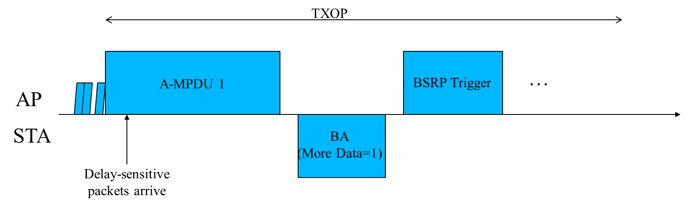

- More Data subfield
TGbe editor: Insert the following paragraph after the second paragraph of this subclause as follows:
An EHT STA optionally sets the More Data subfield in individually addressed Ack and BlockAck frames to 1 to indicate that it has one or more pending frames for an EHT AP that is the intended recipient of the Ack or BlockAck. An EHT STA indicates it supports generating and processing the More Data subfield equal to 1 in these control response frames by setting the More Data Ack subfield to 1 in the QoS Info field of elements it includes in frames transmitted to the EHT AP.

When the EHT AP that indicates support by processing such an indication by setting the More Data Ack subfield to 1 receives an Ack or BlockAck frame with the More Data subfield equal to 1, then one of the following operations may be initiated:
- The EHT AP may send a Trigger frame to trigger the corresponding STA’s uplink transmission.
- The EHT AP may allocate the remaining TXOP to the corresponding STA by sending a MU-RTS TXS Trigger frame with TXOP Sharing Mode subfield equal to 2.
- The EHT AP may allocate the remaining TXOP to the corresponding STA by setting the RDG/More PPDU subfield in a CAS Control subfield to 1.
When an EHT STA that indicates support by processing such an indication by setting the More Data Ack subfield to 1 receives an Ack or BlockAck frame with the More Data subfield equal to 1, then one of the following operations may be initiated:
- The EHT STA may allocate the remaining TXOP to the corresponding STA by setting the RDG/More PPDU subfield in a CAS Control subfield to 1 if it is the TXOP holder.
- The EHT STA remains in the awake state if it is in PS mode.

9.4.1.17 QoS Info field
TGbe editor: Change the following paragraph as follows:
(11ax)An HE AP sets the More Data Ack subfield to 1 to indicate that it can generate individually addressed Ack and BlockAck frames with the More Data bit in the Frame Control field equal to 1; otherwise, the AP sets the More Data Ack subfield to 0. For a non-HE AP, the More Data Ack subfield is reserved. An EHT AP sets the More Data Ack subfield to 1 to indicate that it can generate and process individually addressed Ack and BlockAck frames with the More Data bit in the Frame Control field equal to 1; otherwise, the EHT AP sets the More Data Ack subfield to 0.

TGbe editor: Change the following paragraph as follows:
Non-AP non-HE STAs set the More Data Ack subfield to 1 to indicate that they can process Ack frames with the More Data bit in the Frame Control field equal to 1 and remain in the awake state. Non-AP HE STAs set the More Data Ack subfield to 1 to indicate that they can process Ack and BlockAck frames with the More Data bit in the Frame Control field equal to 1 and remain in the awake state. Non-AP STAs set the More Data Ack subfield to 0 otherwise.(11ax) Non-AP EHT STAs set the More Data Ack subfield to 1 to indicate that they can generate and process Ack and BlockAck frames with the More Data bit in the Frame Control field equal to 1. Non-AP STAs set the More Data Ack subfield to 0 otherwise.

