IEEE P802.11
Wireless LANs
Wireless Next Generation (WNG) Standing Committee
Meeting Minutes for July-2022 Montreal Hybrid Meeting
Date: July 14, 2022
Author(s):
Name | Affiliation | Address | Phone | email
Lei Wang | Futurewei | 2220 Central Expressway, Santa Clara, CA 95050, USA | +1-858-205-7286 | Lei.wang1@futurewei.com
Jim Lansford | Qualcomm | 7775 N Topeka Ave  Cascade, CO 80809, USA | +1-719-286-8660 | Jim.lansford@ieee.org
Abstract
Meeting Minutes for the WNG SC meetings held in mixed-mode with in-person meeting in Montreal, Canda, and with electronic meeting access, on July12th and July 14th, 2022.
WNG Meeting Session #1: July 12th, 2022, 10:30am to 12:30pm ET

Chair: Jim Lansford (Qualcomm)
Vice Chair & Secretary: Lei Wang (Futurewei)

Meeting Agenda:
The meeting agenda for WNG 2022-July meeting is shown below, and also published in the agenda document:
https://mentor.ieee.org/802.11/dcn/22/11-22-0845-01-0wng-agenda-for-wng-sc-2022-july.pptx
- Call Meeting to Order
- Agenda approval
- Attendance reminder
- Documentation reminder
- Announcements
- Approval of Previous meeting minutes
  - Minutes from May 2022 WNG Meeting
- Presentations
  - Tuesday 12 July 2022, 10:30-12:30 EDT and 19:30-21:30 EDT
  - Thursday 14 July 2022, 13:30-15:30 EDT
- Plans for September 2022
- Adjourn

In addition, the detailed agenda for the three WNG meeting sessions with presentations for each session is included in the agenda file, and also as shown below:

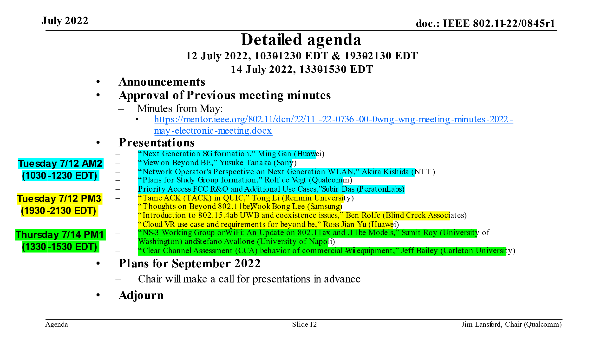

Meeting Minutes:
- Chair called the meeting to order at 10:32am ET on Tuesday, July 12th, 2022, and showed the group the agenda file.
- Chair reminded the group to record the attendance of this meeting by using the IEEE Attendance Tool. The link to the attendance tool is also provided in the chat window of the electronic meeting.
- Agenda approval:
https://mentor.ieee.org/802.11/dcn/22/11-22-0845-01-0wng-agenda-for-wng-sc-2022-july.pptx
- The agenda was approved by unanimous consent.
- Chair also noted the affiliation FAQ, anti-trust FAQ, ethics code, IEEE 802.11 policies and procedures, and IEEE 802 policies and procedures.
- Chair covered the voting rules for WNG SC, being a standing committee.
- Approval of previous meeting minutes for May WNG meeting.
  - Minutes from 2022-May WNG Meeting
https://mentor.ieee.org/802.11/dcn/22/11-22-0736-00-0wng-wng-meeting-minutes-2022-may-electronic-meeting.docx
  - The 2022-May WNG SC meeting minutes was approved by unanimous consent.
- Attendance:
  - In the meeting room: ~ 123.
  - Webex meeting: 318 (at the peak).
  - IMAT attendance: 351.

- Presentation #1: “Next Generation SG formation,” Ming Gan (Huawei)
https://mentor.ieee.org/802.11/dcn/22/11-22-1083-01-0wng-next-generation-sg-formation.pptx
  - Ming presented the contribution remotely.
  - Summary of Discussion
    - Chair asked the presenter if he would like to run the Straw Poll (SP) now or later, considering there are similar SPs in other presentations. The presenter agreed to run the SP later.
    - Clarified that the operation in sub-7GHz bands and above 45GHz bands is under the framework of Multi-Link Operation (MLO), not about band switch. Traffic steering would be possible, similar to what 11be does, with possible refinement or enhancement.
    - Commented on that “reliability” is missing in the SP text, although it was mentioned in the presentation contents.
    - Asked that if the presenter have looked at the preamble performance. The answer was it needs further study.
    - Chair stopped the discussion due to time limit, and suggested people still in the queue to reach out to the presenter for offline discussion.

- Presentation #2: “View on Beyond BE,” Yusuke Tanaka (Sony)
https://mentor.ieee.org/802.11/dcn/22/11-22-0961-00-0wng-network-operator-s-perspective-on-next-generation-wlan.pptx
  - Tanaka-san presented the contribution in-person.
  - Summary of Discussion
    - Commented and appreciated that the presentation supports “long-range”.

- Presentation #3: “Network Operator's Perspective on Next Generation WLAN,” Akira Kishida (NTT)
https://mentor.ieee.org/802.11/dcn/22/11-22-0961-00-0wng-network-operator-s-perspective-on-next-generation-wlan.pptx
  - Kishida-san presented the contribution remotely
  - Summary of Discussion
    - Clarified that the Wi-Fi / 6G integration mentioned in this presentation is mainly at upper layers, which needs to define interfaces / features for upper layers.
    - Discussed what’re the most important KPIs, e.g., reliability, power consumption, etc., and agreed that it needs further discussed in the to-be-formed post-11be study group.
    - Commented that voice communication should be also included in the diagram on slide 8 for Wi-Fi and 6G, in addition to data.

- Presentation #4: “Plans for Study Group formation,” Rolf de Vegt (Qualcomm)
https://mentor.ieee.org/802.11/dcn/22/11-22-0708-02-0wng-beyond-be-next-step.pptx
  - Rolf presented the contribution in-person.
  - Summary of Discussion
    - Asked and discussed multiple questions/issues as listed below, and suggested to have further discussions for all of those questions/issues in the to-be-formed post-11be study group:
      - project plan, cadences, release plan, etc.
      - reduce power consumption from both STA and AP
      - 11be r2 vs. this post-11be proposal
      - Name of this proposed group
      - KPIs, e.g., how to measure reliability
      - Range extension
      - Target time for starting a Task Group
      - Some specific words in the SP text, e.g., “connectivity”, “manageability”, “latencies”, “may”, etc.
    - WG chair, Dorothy, informed the group that a study group, lifetime is 12 months (includes one extension).
  - Straw Poll:
“Do you support the formation of Ultra High Reliability SG (UHR SG) to develop a Project Authorization Request (PAR) and a Criteria for Standards Development (CSD) for a new 802.11 MAC/PHY amendment. The Study Group will investigate technology which may improve reliability of WLAN connectivity, reduce latencies, increase manageability, increase throughput including at different SNR levels, and reduce device level power consumption.
With a target start of the task group in May 2023”
    - Summary of Discussion:
      - none
    - Straw Poll Result:
      - 219 yes, 16 no, 3 abstain, 58 no-answer

- Presentation #5: Priority Access- FCC R&O and Additional Use Cases,” Subir Das (Peraton Labs)
https://mentor.ieee.org/802.11/dcn/22/11-22-1074-01-0wng-priority-access-fcc-r-o-and-additional-use-cases.pdf
  - Subir presented the contribution in-person.
  - Summary of Discussion
    - Clarified there are 5 levels of priority services, well-defined in WPS spec, with simple classifications.
    - Clarified that the priority access won’t stop on-going transmission.

- Recessed at 12:28pm ET.

WNG Meeting Session #2: July 12th, 2022, 7:30pm to 9:30pm ET

Chair: Jim Lansford (Qualcomm)
Vice Chair & Secretary: Lei Wang (Futurewei)

Meeting Agenda:
The meeting agenda for WNG 2022-July meeting is published in the agenda document:
https://mentor.ieee.org/802.11/dcn/22/11-22-0845-01-0wng-agenda-for-wng-sc-2022-july.pptx

Meeting Minutes:
- Chair called the meeting to order at 7:32pm ET on Tuesday, July 12th, 2022.
- Chair reminded the group to record the attendance of this meeting by using the IEEE Attendance Tool. The link to the attendance tool is also provided in the chat window of the electronic meeting.
- Chair also noted the affiliation FAQ, anti-trust FAQ, ethics code, IEEE 802.11 policies and procedures, and IEEE 802 policies and procedures.
- Chair covered the voting rules for WNG SC, being a standing committee.
- Chair showed the list of presentations scheduled for this WNG session:
  - “Tame ACK (TACK) in QUIC,” Tong Li (Renmin University)
  - “Thoughts on Beyond 802.11be,” Wook Bong Lee (Samsung)
  - “Introduction to 802.15.4ab UWB and coexistence issues,” Ben Rolfe (Blind Creek Associates)
  - “Cloud VR use case and requirements for beyond be,” Ross Jian Yu (Huawei)
- Attendance:
  - In the meeting room: 81.
  - Webex meeting: 238 (at the peak).
  - IMAT attendance: 334.

- Presentation #6: “Tame ACK (TACK) in QUIC,” Tong Li (Renmin University)
https://mentor.ieee.org/802.11/dcn/22/11-22-1061-00-0wng-tame-ack-tack-in-quic.pptx
  - Tong Li presented the contribution remotely.
  - Summary of Discussion
    - Clarified that the ACK discussed in this contribution is at transport layer, not at data link / MAC layer.
    - Pointed out that IEEE 802.11 is working on MAC / PHY layers.
    - Commented that slide 8 does not consider error rate and asked if any insights on the error rate. The answer was that the losses are not considered in the formula, as there were too many options of handling losses.
    - Commented that, considering the performance in the user space, TACK could introduce more delays.

- Presentation #7: “Thoughts on Beyond 802.11be,” Wook Bong Lee (Samsung)
https://mentor.ieee.org/802.11/dcn/22/11-22-0932-00-0wng-thoughts-on-beyond-802-11be.pptx
  - WookBong presented the contribution in-person.
  - Summary of Discussion
    - Commented virtual BSS on slide 8, very different architecture, works in theory, not sure how it works in practice.
    - Discussed that the goal of virtual BSS is to address the sticky client problem, while there are alternative solutions, e.g., MLO.
    - Discussed the concept of scheduling-only channel, the associated challenges in unlicensed bands, and the use of 6GHz band with MLO to target “schedule only” access.
    - Discussed peak throughput vs area throughput for each SNR level; and possible technologies to help medium to low SNR throughput, e.g., spatial reuse, reduce interference, given STA location to increase performance, etc.

- Presentation #8: “Introduction to 802.15.4ab UWB and coexistence issues,” Ben Rolfe (Blind Creek Associates)
https://mentor.ieee.org/802.11/dcn/22/11-22-1081-01-0wng-overview-of-802-15-4ab-coexistence.pptx
  - Ben presented the contribution in-person.
  - Summary of Discussion
    - Discussed how to use 802.11 Coex SC (Coexistence Standing Committee) as the platform for 802.11 and 802.15 to develop processes/mechanisms for coexistence, e.g., involve in some measurement studies to get repeatable/reliable results, plus analytic studies and simulations, and kicking off cooperative and collaborative work, etc.
    - Discussed the main reasons for NB (Narrow Band) UWB, e.g., explore existing protocols and current industry standards for improvements; use NB not only for control channel, also for traffic for very short transmissions and synchronization.
    - Clarified that “Narrow” means 5MHz / 10MHz, and low data rates mean 200kbps / 2Mbps.

- Presentation #9: “Cloud VR use case and requirements for beyond be,” Ross Jian Yu (Huawei)
https://mentor.ieee.org/802.11/dcn/22/11-22-0952-00-0wng-cloud-vr-use-case-and-requirements.pptx
  - Ross presented the contribution remotely.
  - Summary of Discussion
    - Discussed how to map the KPI numbers on slide 11 to PHY/MAC requirements, e.g., calculate them by using some percentage, do experiments, etc. Will need further study.
    - Clarified that the throughput numbers on Slide 9 are not the typical PHY layer rates, instead, they are data rates above PHY.
    - Clarified that the “Study Group” mentioned on Slide 15 refers to the to-be-established be-beyond study group.
    - Discussed that source/channel coding is challenging for 802.11 and may need to change the existing structure to support it.

- Recessed at 9:22pm ET.

WNG Meeting Session #3: July14th, 2022, 1:30pm to 3:30pm ET

Chair: Jim Lansford (Qualcomm)
Vice Chair & Secretary: Lei Wang (Futurewei)

Meeting Agenda:
The meeting agenda for WNG 2022-July meeting is published in the agenda document:
https://mentor.ieee.org/802.11/dcn/22/11-22-0845-01-0wng-agenda-for-wng-sc-2022-july.pptx

Meeting Minutes:
- Chair called the meeting to order at 1:33pm ET on Thursday, July 14th, 2022.
- Chair reminded the group to record the attendance of this meeting by using the IEEE Attendance Tool. The link to the attendance tool is also provided in the chat window of the electronic meeting.
- Chair also noted the affiliation FAQ, anti-trust FAQ, ethics code, IEEE 802.11 policies and procedures, and IEEE 802 policies and procedures.
- Chair covered the voting rules for WNG SC, being a standing committee.
- Chair showed the list of presentations scheduled for this WNG session:
  - “NS-3 Working Group on WiFi: An Update on 802.11ax and .11be Models,” Sumit Roy (University of Washington) and Stefano Avallone (University of Napoli)
  - “Clear Channel Assessment (CCA) behavior of commercial Wi-Fi equipment,” Jeff Bailey (Carleton University)
- Attendance:
  - In the meeting room: ~50
  - Webex meeting: 137 (at the peak)
  - IMAT attendance tool: 155

- Presentation #10: “NS-3 Working Group on WiFi: An Update on 802.11ax and .11be Models,” Sumit Roy (University of Washington) and Stefano Avallone (University of Napoli)
Part-I: https://mentor.ieee.org/802.11/dcn/22/11-22-1072-01-0wng-ns-3-wifi-working-group-update-on-802-11ax-be-models.pptx
Part-II: https://mentor.ieee.org/802.11/dcn/22/11-22-1068-01-0wng-ns-3-working-group-on-wifi-an-update-on-802-11ax-and-11be-models.pptx
  - Sumit presented Part-I of the contribution, i.e., 22/1072r1, remotely.
  - Stefano presented Part-II of the contribution, i.e., 22/1068r1, remotely.
  - Summary of Discussion
    - Clarified that, on Slide 7 of 22/1072r1, the number of antennas impacts on the choices of special streams.
    - Clarified that the work to improve and speed up the simulations is in progress, although not yet mentioned.
    - Clarified that multiple AP coordination has been implemented in NS3 by using their own protocols, as there is no standardized protocol, i.e., no standard spec yet.
    - Informed that the contributors and their teams are working on papers for publication; and invited offline discussions.
    - Questioned if the contributors also consider doing simulations for other 802.11 projects, e.g., 11bf, 11be, etc, in addition to 11ax as reported in the contributions. The answers include: the current project is for academic research, targeting to catch-up with standards development as quickly as possible and eventually to aligned with the standards; if there are needs for the project to support specific features, the project team can discuss separately.

- Presentation #11: “Clear Channel Assessment (CCA) behavior of commercial Wi-Fi equipment,” Jeff Bailey (Carleton University)
https://mentor.ieee.org/802.11/dcn/22/11-22-0998-00-0wng-clear-channel-assessment-cca-behavior-of-commerical-wi-fi-equipment.pptx
  - Jeff presented the contribution in-person.
  - Summary of Discussion
    - Clarified that the traffic is UDP and AP#1 does CCA to transmit Wi-Fi traffic.
    - Questioned if delay impact has been considered. The answer was not yet, and will be considered in future.
    - Commented that similar cases have been observed, dwelling time is long, transmission is long, causing a large delay, locking the channel.
    - Clarified that the Wi-Fi device has been modified to output CCA internal states.
    - Clarified that the ACK packets have not been investigated yet.
    - Clarified that NB signal is not deferred and Wi-Fi data will get hit; and still need further investigation.
    - Discussed the sensitivity to bandwidth, have done some preliminary work, still need further study.
    - WNG Chair, Jim, suggested that Coex SC (Coexistence Standing Committee) may be interested in this study.

- Plans for September 2022:
  - Call for contributions: WNG chair will issue a call for contributions before 802.11 interim meeting in September 2022.
- Any other business: none.
- Adjourned at 3:15pm ET.

