IEEE P802.11
Wireless LANs
LB266 Comment Resolutions
for 36.3.2.5 20 MHz operating non-AP EHT STAs
Date: 2022-07-10
Author(s):
Name | Affiliation | Address | Phone | Email
Eunsung Park | LG Electronics | 19, Yangjae-daero 11gil, Seocho-gu, Seoul 137-130, Korea |  | esung.park@lge.com
Dongguk Lim |  |  |  | dongguk.lim@lge.com
Jinyoung Chun |  |  |  | jiny.chun@lge.com
Jinsoo Choi |  |  |  | js.choi@lge.com

Abstract
This submission proposes a resolution for the following 12 CIDs:
10824, 11205, 11206, 11236, 11342, 12016, 12146, 12185, 12199, 12200,
12869, 13208

Revisions:
- Rev 0: Initial version of the document.

Interpretation of a Motion to Adopt

A motion to approve this submission means that the editing instructions and any changed or added material are actioned in the TGbe D2.0 Draft. This introduction is not part of the adopted material.

Editing instructions formatted like this are intended to be copied into the TGbe D2.0 Draft (i.e. they are instructions to the 802.11 editor on how to merge the text with the baseline documents).

TGbe Editor: Editing instructions preceded by “TGbe Editor” are instructions to the TGbe editor to modify existing material in the TGbe draft. As a result of adopting the changes, the TGbe editor will execute the instructions rather than copy them to the TGbe Draft.

CID 10824, 11205, 11236, 11342, 12016, 12146, 12185, 12199, 12869, 13208
CID | Clause | PP.LL | Comment | Proposed Change | Resolution
10824 | 36.3.2.5 | 600.27 | The blank is missing in the following text "supportthe reception " | Correct it | Revised  TGbe editor:  Change “supportthe” to “support the”.
11205 | 36.3.2.5 | 600.27 | Typo: split "supportthe" into two words "support the" | As in comment | Accepted  Note - Resolution is the same as that of CID 10824.
11236 | 36.3.2.5 | 600.27 | "A 20  MHz operating non-AP EHT STA may supportthe". Need a space between support and the | Add a space between "support" and "the" | Accepted  Note - Resolution is the same as that of CID 10824.
11342 | 36.3.2.5 | 600.27 | Add a space after support . "supportthe" | as in the comment | Accepted  Note - Resolution is the same as that of CID 10824.
12016 | 36.3.2.5 | 600.27 | Change "~ supportthe ~" to "~ support the ~". | As in comment. | Accepted  Note - Resolution is the same as that of CID 10824.
12146 | 36.3.2.5 | 600.27 | a space in "supportthe" is missing | as in comment | Revised  TGbe editor:  Change “supportthe” to “support the”.  Note - Resolution is the same as that of CID 10824.
12185 | 36.3.2.5 | 600.27 | There a space missing in "supportthe". Need to change to "support the". | as in the comment. | Accepted  Note - Resolution is the same as that of CID 10824.
12199 | 36.3.2.5 | 600.26 | Add spacing between 'support' and 'the', now they are erroneously combined into a single word. | Add spacing between 'support' and 'the'. | Accepted  Note - Resolution is the same as that of CID 10824.
12869 | 36.3.2.5 | 600.27 | Change "support the" to "supportthe". |  | Accepted  Note - Resolution is the same as that of CID 10824.
13208 | 36.3.2.5 | 600.27 | Missing space for "supportthe". | support the | Accepted  Note - Resolution is the same as that of CID 10824.
Discussion
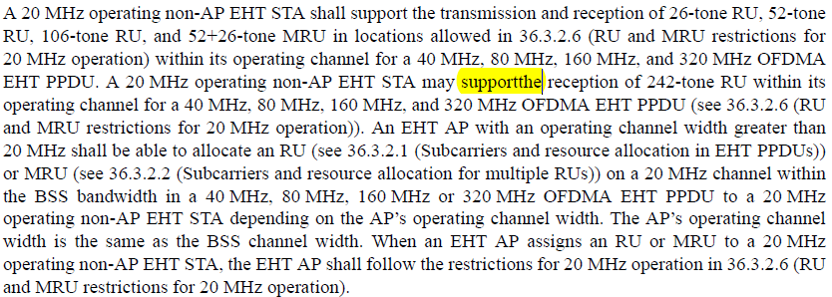

CID 11206, 12200
CID | Clause | PP.LL | Comment | Proposed Change | Resolution
11206 | 36.3.2.5 | 600.49 | 20MHz nonprimary channel is not unique | Replace "the nonprimary 20 MHz channel" with "a nonprimary 20 MHz channel" | Accepted
12200 | 36.3.2.5 | 600.48 | Change 'an' to 'a' before '20 MHz operating...' | Replace 'an 20 MHz' with 'a 20 MHz'. | Accepted
Discussion
