IEEE P802.11
Wireless LANs
11be D2.0 CR for Table 35-7
Date: 2022-07-08
Author(s):
Name | Affiliation | Address | Phone | email
Po-Kai Huang | Intel
Johannes Berg

Qinghua Li
Juan Fang
Hao Song
Robert Stacey
Abstract
This submission proposes resolutions for the following CIDs:

11057, 12012, 12874, 13448

Revisions:
- Rev 0: Initial version of the document.

Interpretation of a Motion to Adopt

A motion to approve this submission means that the editing instructions and any changed or added material are actioned in the TGbe D2.0 Draft. This introduction is not part of the adopted material.

Editing instructions formatted like this are intended to be copied into the TGbe D2.0 Draft. (i.e. they are instructions to the 802.11 editor on how to merge the text with the baseline documents).

TGbe Editor: Editing instructions preceded by “TGbe Editor” are instructions to the TGbe editor to modify existing material in the TGbe draft. As a result of adopting the changes, the TGbe editor will execute the instructions rather than copy them to the TGbe Draft.

CID | Commenter | Clause | P.L | Comment | Proposed Change | Resolution
11057 | Po-Kai Huang | 35.16.1 | 531.45 | Setting in Table 35-7 needs improvement. Specifically, it is specified in Table 9401I that the presence of EHT-MCS Map depends on the setting of B2 of the Supported Channel Width Set field in the HE PHY Capabilities Information field. This means that B2 has to be specified exactly as 0 or 1 in every case to make sure that there will be no parsing issues in the future. B3 needs to be clarified to be 0 as well in 5/6 GHz under 160 MHz and 320 MHz since 80+80 is not supported in EHT. Finally, Clairfy B1, B3 to be 0 under 2.4 GHz and B0 to be 0 in 5/6 GHz. | Specify B2 of Supported Channel Width Set subfield in the HE Capabilities element under 2.4 GHz as always 0. clarify B3 is to 0 as well in 5/6 GHz under 160 MHz and 320 MHz since 80+80 is not supported in EHT. Finally, Clairfy B1, B3 to be 0 under 2.4 GHz and B0 to be 0 in 5/6 GHz. | Accepted -
12012 | Eunsung Park | 35.16.1 | 532.21 | 20 MHz only STA was defined in 6 GHz band and in that case B1 should be 0 in the Supported Channel Width Set subfield. | Change "Set B1 to 1, ~" to "Set B1 to 0, ~". | Accepted -
12874 | Zinan Lin | 35.16.1 | 532.21 | In Table 35-7, when operating band is 6 GHz, B1 B2 B3 = 1 0 0 in the Supported Channel Width Set subfield in the HE Capabilitieis elements indicates the maximum supported channel width either 20 MHz or 80 MHz. How the AP differentiate the maximum supported channel width is 20 MHz or 80 MHz? | when the operating band is 6 GHz and the maximum supported channel width is 20 MHz, Set B1 to 0, B2 to 0, B3 to 0 in the Supported Channel Width Set subfield in the HE Capabilities element | Accepted -
13448 | Liwen Chu | 35.16.1 | 532.21 | Change "Set B1 to 1, B2 to 0, B3 to 0" to "Set B1 to 0, B2 to 0, B3 to 0" | As in comment | Accepted -

Discussion:
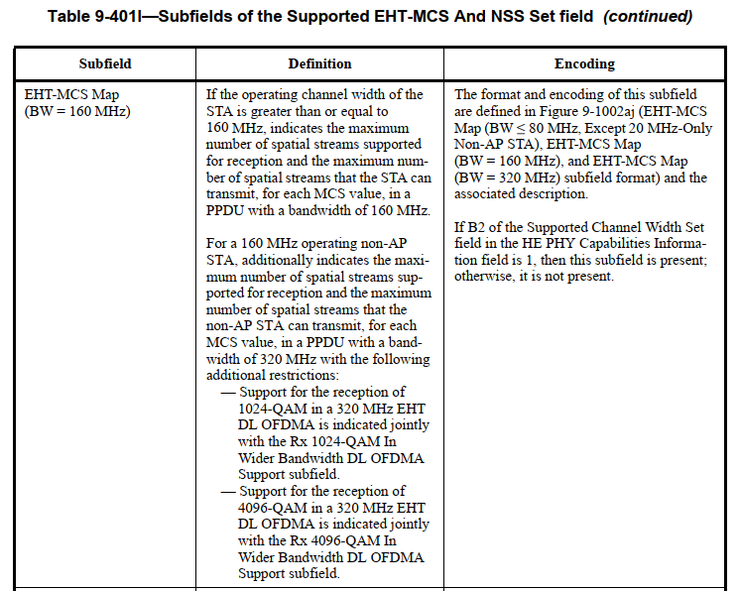

Proposed Change –

Table 35-7 – Indication of supported channel widths by an EHT STA
Operating Band | Maximum supported channel width | Supported Channel Width Set subfield in the HT Capabilities element | Supported Channel Width Set and the Extended NSS BW Support subfields in the VHT Capabilities element  (See Table 9-311) | Supported Channel Width Set subfield in the HE Capabilities element | Support For 320 MHz in 6 GHz subfield in the EHT Capabilities element
2.4 GHz | 20 MHz | 0 | N/A | Set B0 to 0,  B1 to 0,  B2 to 0,  B3 to 0(#11057) | 0
2.4 GHz | 40 MHz | 1 | N/A | Set B0 to 1,  B1 to 0,  B2 to 0,  B3 to 0(#11057) | 0
5 GHz | 20 MHz  (See NOTE) | 0 | Set to indicate support for up to 80 MHz | Set B0 to 0,  B1 to 0,  B2 to 0,  B3 to 0(#11057) | 0
5 GHz | 80 MHz | 1 | Set to indicate support for up to 80 MHz | Set B0 to 0,  B1 to 1,  B2 to 0,  B3 to 0(#11057) | 0
5 GHz | 160 MHz | 1 | Set to indicate support for up to 160 or 80+80 MHz | Set B0 to 0,  B1 to 1,  B2 to 1,  B3 to 0(#11057) | 0
6 GHz | 20 MHz (See NOTE) | N/A | N/A | Set B0 to 0, (#11057) B1 to 0(#12012, #12874, #13448), B2 to 0,  B3 to 0 | 0
6 GHz | 80 MHz | N/A | N/A | Set B0 to 0,  B1 to 1,  B2 to 0,  B3 to 0(#11057) | 0
6 GHz | 160 MHz | N/A | N/A | Set B0 to 0,  B1 to 1,  B2 to 1,  B3 to 0(#11057) | 0
6 GHz | 320 MHz | N/A | N/A | Set B0 to 0,  B1 to 1,  B2 to 1,  B3 to 0(#11057) | 1
NOTE – This corresponds to the 20 MHz-only non-AP EHT STA. An EHT AP does not use this setting.

