IEEE P802.11
Wireless LANs
LB 266 Resolution for CIDs related to MLO MBSSID
Date: July 13, 2022
Author(s):
Name | Affiliation | Address | Phone | email
Abhishek Patil | Qualcomm Inc |  |  | appatil@qti.qualcomm.com
Gaurang Naik
George Cherian
Alfred Asterjadhi
Duncan Ho
Yanjun Sun
Abdel Karim

Abstract
This submission proposes resolutions for following 7 CIDs received for TGbe LB266:
13624 13515 12260 12261 12788 10668 10669

Revisions:
- Rev 0: Initial version of the document.
- Rev 1: Minor update to the figure and text in resolution column

TGbe editor: The baseline for this document is 11be D2.0

Interpretation of a Motion to Adopt

A motion to approve this submission means that the editing instructions and any changed or added material are actioned in the TGbe Draft. This introduction is not part of the adopted material.

Editing instructions formatted like this are intended to be copied into the TGbe Draft (i.e., they are instructions to the 802.11 editor on how to merge the text with the baseline documents).

TGbe Editor: Editing instructions preceded by “TGbe Editor” are instructions to the TGbe editor to modify existing material in the TGbe draft. As a result of adopting the changes, the TGbe editor will execute the instructions rather than copy them to the TGbe Draft.

CID | Commenter | Clause | Pg/Ln | Comment | Proposed Change | Resolution
13624 | Rubayet Shafin | 11.1 | 303.04 | Support for Multiple BSSID capability should be mandatory for non-AP EHT STA. This should clearly specified. | As in comment | Revised  An EHT STA is also an HE STA (see clause 4.3.16a. Therefore, it is mandatory for a non-AP EHT STA to support multiple BSSID capability. A NOTE was added to clause 35.16.1 to explicitly state this.  TGbe editor, please add the following NOTE after the 1st paragraph (“If the peer AP is operating as an EMA AP …”) in 35.16.1 Basic EHT BSS Operation: “A non-AP EHT STA is also a non-AP HE STA (see 4.3.16a). Support for multiple BSSID capability is mandatory for a non-AP HE STA (see 11.1.3.8.1) and therefore, support for multiple BSSID capability is also mandatory for a non-AP EHT STA.”
13515 | Amelia Andersdotter | 35.3.20 | 470.46 | There is an "AP" missing before "corresponding nontransmitted BSSID", I think. Otherwise, this would be read that the BSSID can be affiliated with an AP MLD, but it should be APs that are affiliated with AP MLDs. | Change to "An AP corresponding to the transmitted BSSID shall not include a Basic Multi-Link element in the Nontransmitted BSSID Profile subelement of a Multiple BSSID element unless the AP corresponding to the nontransmitted BSSID is affiliated with an AP MLD. | Accepted
12260 | Stephen McCann | AA.1 | 871.29 | missing article in "between multiple BSSID set" | Change to "between a multiple BSSID set" | Revised  Agree with the comment. Added ‘a’ for co-hosted set as well.  TGbe editor, please update the cited sentence as: “In addition, this annex also provides examples illustrating the relationship between a multiple BSSID set, a co-hosted BSSID set, and multi-link operation.”
12261 | Stephen McCann | AA.2 | 871.49 | There are several typos in this sentence. | Change to "This helps an associated non-AP STA to save power by not having to wake up from a doze state, to listen to beacons other than the DTIM beacons and receive any updates to its associated profile." | Accepted
12788 | Romain GUIGNARD | AA.3 | 871.58 | In the figures, 3 MLDs are depicted (MLD 1, MLD 2, MLD 3). Does the index of MLD correspond to the value of the MLD ID field convey in the RNR? | Could you please provide the relation with MLD ID in this section? | Revised  The issue highlighted by the comment occurs because the MLDs are identified by numbers. The intention of the illustration was not to show how the MLD ID will be advertised in the RNR. Besides each link will advertise a different MLD ID, therefore we can’t tag a single MLD ID in the box representing each MLD. To address the confusion, the MLDs are no longer numbered but rather assigned an alphabet  TGbe editor, please update Figure AA6 and AA7 as shown in doc 11-22/1007r2 tagged as 12788
10668 | Abhishek Patil | AA.3 | 872.08 | Update the figures and description to explain the relationship between DS/ESS/SSID for each AP MLD. | As in comment | Revised  Agree with the comment. The figures were updated as stated in the comment  TGbe editor, please update Figure AA6 and AA7 as shown in doc 11-22/1007r2 tagged as 10668
10669 | Abhishek Patil | AA.3 | 872.12 | Since each AP in an MBSSID set inherits the same Op/Cap elements (see 9.4.2.45), all APs in the MBSSID set on channel 3 will be EHT APs. In addition, an EHT AP is always affiliated with an AP MLD (see 35.3.1). Therefore, show a 4th AP MLD to which BSSID-C is affiliated with. | As in comment | Revised  Agree with the comment. The figure was updated as stated in the comment  TGbe editor, please update Figure AA6 as shown in doc 11-22/1007r2 tagged as 10669

AA.3 Example illustrating the relationship between multi-link operation and multiple BSSID set or co-hosted BSSID set
TGbe editor: Please replace Figure AA6 with the one shown below:
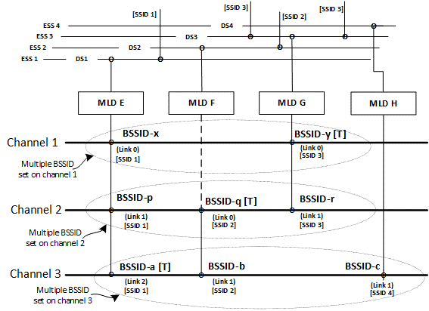
Figure AA-6—Example of affiliated APs from different multiple BSSID sets[12788, 10668, 10669]
[12788]Figure AA-6 (Example of affiliated APs from different multiple BSSID sets) illustrates that APs corresponding to BSSID-x and BSSID-y belong to the same multiple BSSID set on channel 1 and are affiliated with different AP MLDs (MLD E and MLD G, respectively). On channel 1, AP-y, affiliated with MLD G, corresponds to the transmitted BSSID (depicted as BSSID-y [T]) for the multiple BSSID set on channel 1. On channel 2, there are three APs that belong to the same multiple BSSID set and each is affiliated with a different AP MLD. AP-q, affiliated with MLD F, corresponds to the transmitted BSSID (depicted as BSSID-q [T]) for the multiple BSSID set on channel 2. On channel 3, there are three APs which belong to the same multiple BSSID set and are affiliated with different MLDs. AP-a, affiliated with MLD E, corresponds to the transmitted BSSID (depicted as BSSID-a [T]) for the multiple BSSID set on channel 3. [10669]AP-c is affiliated with AP MLD H and is the only AP affiliated with MLD H. This could be due to ML Reconfiguration operation (as described in 35.3.6 (Multi-Link reconfiguration)). Each AP MLD independently assigns a Link ID to its affiliated APs (shown as “(Link n)” in the example). [10668]Furthermore, each AP affiliated with the same AP MLD is part of the same ESS (shown as “ESS n” in this example), is connected to the same DS (shown as “DS n” in this example), and advertises the same SSID (shown as “[SSID n]” in this example) in its Beacon and Probe Response frames.
TGbe editor: Please replace Figure AA7 with the one shown below:
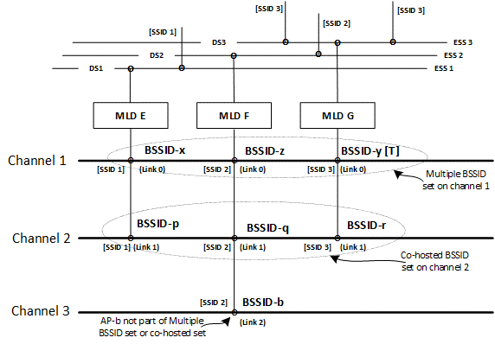
Figure AA-7—Example of affiliated APs belonging to a multiple BSSID set, a co-hosted BSSID set, and neither of these two cases[12788, 10668]
[12788]As seen from Figure AA-7 (Example of affiliated APs belonging to a multiple BSSID set, a co-hosted BSSID set, and neither of these two cases), APs corresponding to BSSID-x, BSSID-z, and BSSID-y belong to the same multiple BSSID set on channel 1 and are affiliated with different AP MLDs (MLD E, MLD F, and MLD G, respectively). On channel 1, AP-y, affiliated with MLD G, corresponds to the transmitted BSSID (depicted as BSSID-y [T]) for the multiple BSSID set on channel 1. The three APs on channel 2, AP-p, AP-q, and AP-r, belong to the same co-hosted BSSID set and each is affiliated with a different AP MLD, MLD E, MLD F, and MLD G, respectively. On channel 3, there is a single AP (AP-b) that is affiliated with MLD F. Each AP MLD independently assigns a Link ID to its affiliated APs (shown as “(Link n)” in this example). [10668]Furthermore, each AP affiliated with the same AP MLD is part of the same ESS (shown as “ESS n” in this example), is connected to the same DS (shown as “DS n” in this example), and advertises the same SSID (shown as “[SSID n]” in this example) in its Beacon and Probe Response frames.

