IEEE P802.11
Wireless LANs
LB 266 Resolution for CIDs related to frame exchange during MLO discovery & association
Date: August 8, 2022
Author(s):
Name | Affiliation | Address | Phone | email
Abhishek Patil | Qualcomm Inc |  |  | appatil@qti.qualcomm.com
Gaurang Naik
George Cherian
Alfred Asterjadhi
Duncan Ho
Yanjun Sun
Abdel Karim

Abstract
This submission proposes resolutions for following 11 CIDs received for TGbe LB266:
10313 13630 12994 13523 13359 12343 13358 10852 13687 13895 13688

Revisions:
- Rev 0: Initial version of the document.
- Rev 1: updated to indicate ‘green’ tagged CIDs per chair’s guidance
  - Updated baseline to D2.1

TGbe editor: The baseline for this document is 11be D2.1

Interpretation of a Motion to Adopt

A motion to approve this submission means that the editing instructions and any changed or added material are actioned in the TGbe Draft. This introduction is not part of the adopted material.

Editing instructions formatted like this are intended to be copied into the TGbe Draft (i.e., they are instructions to the 802.11 editor on how to merge the text with the baseline documents).

TGbe Editor: Editing instructions preceded by “TGbe Editor” are instructions to the TGbe editor to modify existing material in the TGbe draft. As a result of adopting the changes, the TGbe editor will execute the instructions rather than copy them to the TGbe Draft.

CID | Commenter | Clause | Pg/Ln | Comment | Proposed Change | Resolution
10313 | Michael Montemurro | 35.3.4.6 | 418.34 | The non-AP MLD is not just gathering information, its trying to discover an AP MLD. | At cited location, change "gather information about" to "discover" | Revised  Agree in principle. The cited paragraph is modified to clearly mention that the non-AP MLD is discovering the AP MLD and its affiliated AP(s) before performing ML setup with the AP MLD. A few editorial fixes were made along the way.  TGbe editor: Please make changes as shown in 11-22/1006r1 tagged 10313
13630 | Rubayet Shafin | 35.3.4.6 | 418.54 | The sentence is not complete | Please revise as "..that of an AP affiliated with an AP MLD..." | Revised  Agree in principle. The cited sentence is updated as proposed by the comment.  TGbe editor: Please make changes as shown in 11-22/1006r1 tagged 13630
12994 | Chunyu Hu | 35.3.4.6 | 419.44 | Change "operating the channel" to "operating on the channel" in the Fig 35-8 caption. Same for Fig 35-9. | As in comment | Revised  Agree with the comment. The typo is fixed in the figure capture for Figures 35-8 & 35-9  TGbe editor: Please make changes as shown in 11-22/1006r1 tagged 13630
13523 | Mark Hamilton | 35.3.4.6 | 419.33 | Authentication is always an exchange of at least two frames (as noted by the double-arrows). | Add "s" to make it "Authentication frames [U]". Same in the next figure at P420.24. | Accepted  Note to TGbe editor, the changes are shown as part of the updated figures 35-8 & 35-9
13359 | Liwen Chu | 35.3.4.6 | 419.29 | ML Probe Request can have broadcast address in R1 | Change [U] to [UB] or clarify that U is based on R1 and R3. | Revised  Agree in principle. The figure is updated to show that an ML probe request can be individually addressed or sent to broadcast address. Same changes made to figure 35-9.  TGbe editor: Please make changes to figures 35-8 & 35-9 as shown in 11-22/1006r1 tagged 13359
12343 | Atsushi Shirakawa | 35.3.4.6 | 420.40 | Need more detailed description for "[CB] Conditionally broadcast" in Figre35-8 ? Although its meaning is that Probe Response frame may be sent as Unicast or Broadcast depending on condition, what is difference from "[UB] Unicast or Broadcast" | We should make it clear what is "conditionally broadcast" | Revised  Agree in principle. The figure is updated to provide details on what cB means (i.e., lists the condition when the frame is sent to broadcast address). Same changes made to figure 35-9.  TGbe editor: Please make changes to figure 35-8 & 35-9 as shown in 11-22/1006r1 tagged 12343
13358 | Liwen Chu | 35.3.4.6 | 418.31 | Figure 35- gives all the possible methods to acquire AP MLD's infomration. Figure 35-9 gives some method to figure out AP MLD's infomration. | Change figure 35-9 to show all the methods. | Revised  Agree in principle. The figure 35-9 is updated to be consistent with figure 35-8 (i.e., to show all the possible methods to discover AP MLD and its affiliated AP(s)).  TGbe editor: Please make changes to figure 35-9 as shown in 11-22/1006r1 tagged 13358
10852 | Jinsoo Choi | 35.3.4.6 | 420.28 | Shouldn't the arrow for (re)Association Response frame [U] start from AP T (TXBSSID) rather than AP n (nonTXBSSID)? | Correct the figure accordingly. | Rejected  In a multiple BSSID set, if the intended AP corresponds to a nonTxBSSID, the (Re)Association Response frame is sent by the AP corresponding to the nonTxBSSID. Only the Probe Response and Beacon frames originate from the TxBSSID.
13687 | Yunbo Li | 35.3.4.6 | 420.46 | Even RNR and ML element are carried in different Beacon frame, the Link ID for a reported AP shall keep the same. Below sentence is not necessary. "When a Beacon or Probe Response frame transmitted by an AP (that could be a transmitted BSSID in a multiple BSSID set) includes both a Reduced Neighbor Report element and a Basic Multi-Link element carrying one or more Per-STA Profile subelement(s), and if both elements carry information about the same reported AP (that is affiliated with an AP MLD), then the transmitting AP sets the value of the Link ID subfield contained in the per-STA profile carried in the Basic Multi-Link element corresponding to the reported AP to the same value as the value carried in the Link ID subfield contained in the MLD Parameters field of the Reduced Neighbor Report element, corresponding to that reported AP." | remove this sentence, or do the modification to make it broader, instead of only applies to the case when both RNR and ML element are carried in the same frame. | Rejected  The cited paragraph highlights an important aspect regarding the usage of link ID. The RNR IE is always present in Beacon and Probe Response frame and includes one or more reported APs. However, Basic ML IE carried in a Beacon frame, or a non-ML Probe Response frame does not include per-STA profile unless the DFS conditions in 35.3.11 are met, therefore the ‘If’ condition is needed.
13895 | Ming Gan | 35.3.4.6 | 420.56 | Change "of the reported AP" to "with which the reported AP is affiliated" | Change "of the reported AP" to "with which the reported AP is affiliated" | Revised  Agree with the comment. The proposed changes are made with some editorial changes.  TGbe editor, the change is shown in doc 11-22/1006r1 tagged 13895
13688 | Yunbo Li | 35.3.4.6 | 420.56 | "the MLD of the reported AP" => "the MLD that the reported AP affiliated" | Change "the MLD of the reported AP" to "the MLD that the reported AP affiliated" | Revised  Agree with the comment. Same resolution as CID 13895  TGbe editor, the change is shown in doc 11-22/1006r1 tagged 13895

35.3.4.6 Frame exchange sequences during MLO discovery and multi-link setup
TGbe editor: Please update the contents of this subclause including updating figures 35-8 & 35-9 as shown below:
[10313]A non-AP MLD is expected to discover an AP MLD and affiliated AP(s) of interest before initiating a multi-link setup with the AP MLD. The non-AP MLD can use one or a combination of the following methods for discovering the AP MLD and affiliated AP(s) of interest:
- Through each of its affiliated STA(s), perform passive scanning by following the procedure defined in 11.1.4.2 (Passive scanning) or active scanning by following the procedure defined in 11.1.4.3 (Active scanning and probing procedures).
- Through one of its affiliated STA, transmit a Multi-Link probe request on any link that the AP MLD is operating on, with the frame addressed to the affiliated AP operating on that link, to obtain information about the AP MLD and its affiliated AP(s) by following the procedure defined in 35.3.4.2 (Use of Multi-Link probe request and response).
The combination that the non-AP MLD selects to gather information is implementation dependent and can be based on criteria such as power consumption, single radio operation, reachability, etc. The non-AP MLD follows all the probing rules for the channel the Probe Request frame is sent on in the context of active scanning. For example, when performing active scanning on 6 GHz channels, it follows the rules specified in 26.17.2.3.3 (Non-AP STA scanning behavior).
[13630]NOTE 1—A non-AP MLD can discover basic information of an AP MLD or that of an AP affiliated with an AP MLD via other means such as BSS transition management (see 35.3.25 (BSS transition management for MLDs)). The frame exchange for gathering information of the AP MLD and its affiliated one or more APs, and for performing multi-link setup with the AP MLD will be the same as that described in this clause.
Figure 35-8 (Possible frame exchange sequences during MLO discovery and multi-link setup when the AP operating [12994]on the channel does not correspond to a nontransmitted BSSID) shows a possible frame exchange sequence performed, during discovery, between a STA affiliated with a non-AP MLD and an AP that does not correspond to a nontransmitted BSSID and is affiliated with an AP MLD.
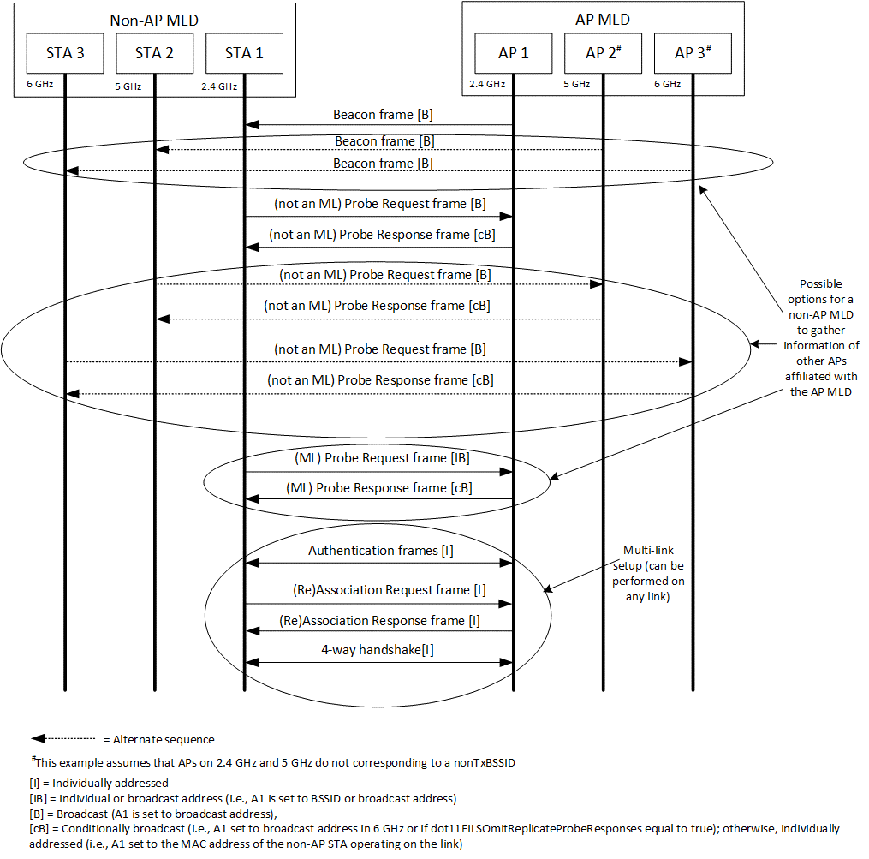
[13359, 12343]Figure 35-8—Possible frame exchange sequences during MLO discovery and multi-link setup when the AP operating [12994]on the channel does not correspond to a nontransmitted BSSID

Figure 35-9 (Possible frame exchange sequences during MLO discovery and multi-link setup when the AP operating [12994]on the channel corresponds to a nontransmitted BSSID) shows possible frame exchange sequences that are performed, during MLO discovery and multi-link setup, between a STA affiliated with a non-AP MLD and an AP affiliated with an AP MLD, that corresponds to a nontransmitted BSSID in a multiple BSSID set.

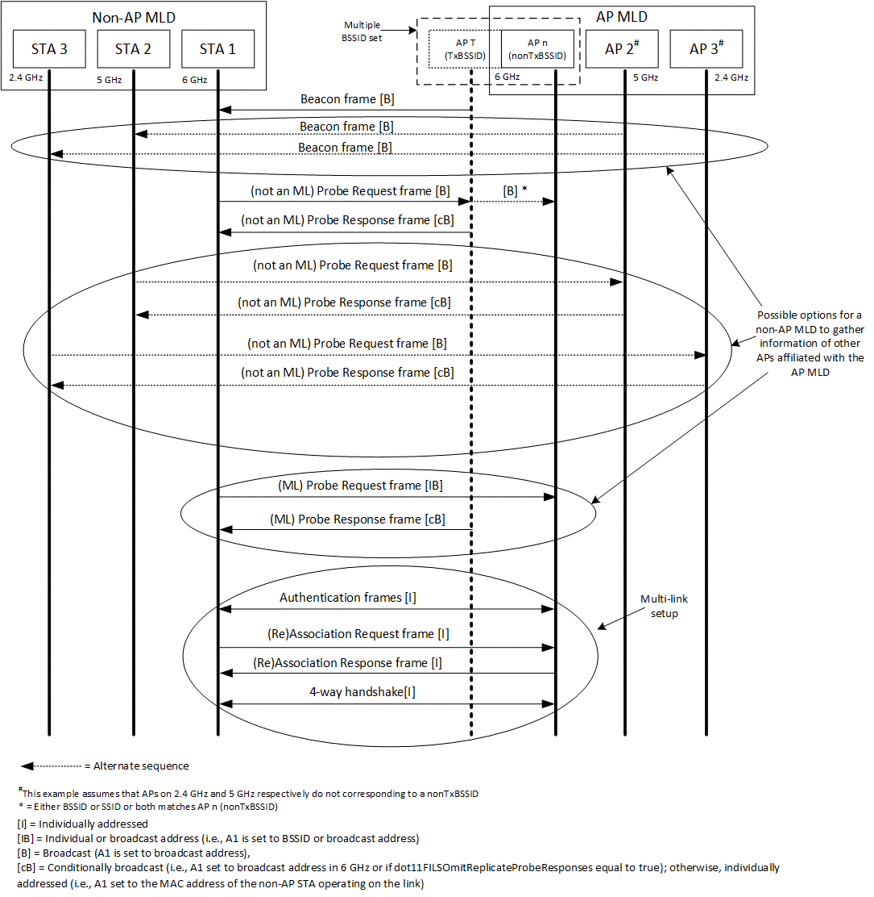
[13359, 12343, 13358]Figure 35-9—Possible frame exchange sequences during MLO discovery and multi-link setup when the AP operating [12994]on the channel corresponds to a nontransmitted BSSID
NOTE 2—An AP corresponding to the transmitted BSSID sends a Multi-Link probe response in response to a Multi-Link probe request directed to a nontransmitted BSSID in the multiple BSSID set (see 35.3.4.2 (Use of Multi-Link probe request and response)).
When a Beacon or Probe Response frame transmitted by an AP (that could be a transmitted BSSID in a multiple BSSID set) includes both a Reduced Neighbor Report element and a Basic Multi-Link element carrying one or more Per-STA Profile subelement(s), and if both elements carry information about the same reported AP (that is affiliated with an AP MLD), then the transmitting AP sets the value of the Link ID subfield contained in the per-STA profile carried in the Basic Multi-Link element corresponding to the reported AP to the same value as the value carried in the Link ID subfield contained in the MLD Parameters field of the Reduced Neighbor Report element, corresponding to that reported AP.
[13895]NOTE 3—The AP MLD ID subfield contained in the MLD Parameters field of the Reduced Neighbor Report element identifies the MLD with which the reported AP is affiliated (see 9.4.2.170.2 (Neighbor AP Information field)).

