IEEE P802.11
Wireless LANs
LB266 CR for 9.3.1.22.4
Date: 2022-07-07
Author(s):
Name | Affiliation | Address | Phone | Email
Yanjun Sun | Qualcomm
Steve Shellhammer
Alfred Asterjadhi
George Cherian
Abhishek Patil
Youhan Kim
Bin Tian
Duncan Ho
Gaurang Naik
Abdel Karim Ajami

Abstract

This submission proposes resolutions for the following CIDs for TGbe LB266: 13547, 10801

Revisions:
- Rev 0: Initial version of the document.

TGbe editor: Please note Baseline is IEEE 802.11-2020, 11ax D8.0, and 11be D2.0

CID | Commenter | Clause | Page | Comment | Proposed Change | Resolution
13547 | Jian Yu | 9.3.1.22.4 | 165.01 | Specify the range of starting spatial stream subfield. | As in comment | Revised  Agree with the commenter in principle. The maximum value is 7 based on the following text from subclause 36.1.1:  “In an MU-MIMO resource unit, there is support for up to eight users with up to four spatial streams per user with the total across all users not exceeding eight spatial streams.”  Tgbe editor please implement changes as shown in doc 11-22/1000r1 tagged as #13547
10801 | Dong Guk Lim | 9.3.1.22.4 | 165.14 | In Figure 9-92b, bit size for each subfield are wroing. It should be corrected. | As in the comment. | Revised  Figure 9-92b is correct. The SS Allocation subfield format is slightly different from the counterpart in the HE variant User Info field based on the following text on from subclause 36.1.1:  “In an MU-MIMO resource unit, there is support for up to eight users with up to four spatial streams per user with the total across all users not exceeding eight spatial streams.”  Clarifications have been added on the valid range of values for the subfield.  Tgbe editor please implement changes as shown in doc 11-22/1000r1 tagged as #13574, same as above

Interpretation of a Motion to Adopt

A motion to approve this submission means that the editing instructions and any changed or added material are actioned in the TGbe Draft. This introduction is not part of the adopted material.

Editing instructions formatted like this are intended to be copied into the TGbe Draft (i.e. they are instructions to the 802.11 editor on how to merge the text with the baseline documents).

TGbe Editor: Editing instructions preceded by “TGbe Editor” are instructions to the TGbe editor to modify existing material in the TGbe draft. As a result of adopting the changes, the TGbe editor will execute the instructions rather than copy them to the TGbe Draft.

9.3.1.22.1 EHT variant User Info field

TGbe editor: Please revise the following 2 paragraphs below Figure 9-92b (Starting from P165L18 in D2.0) as follows (track change enabled):

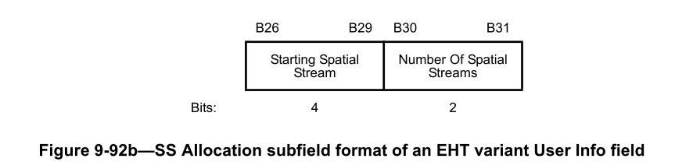

The Starting Spatial Stream subfield indicates the starting spatial stream and is set to the starting spatial stream minus 1 (see 26.5.2.3.3 (TXVECTOR parameters for HE TB PPDU response to Trigger frame)) with a maximum value of 7 (see 36.1.1 (Introduction to the EHT PHY)). The Starting Spatial Stream subfield values above 7 are reserved for a STA with dot11EHTBaseLineFeaturesImplementedOnly equal to true. The Starting Spatial Stream subfield is set to 0 if the corresponding RU or MRU is not allocated for MU-MIMO. (#13547).

The Number Of Spatial Streams subfield indicates the number of spatial streams, and is set to the number of spatial streams minus 1 with a maximum value of 3 (see 36.1.1 (Introduction to the EHT PHY))(#13547).

