IEEE P802.11
Wireless LANs
Comment Resolutions for CC40 11bf D0.1 SBP Resetup CIDs
Date: 2022-10-03
Author(s):
Name | Affiliation | Address | Phone | email
Rojan Chitrakar | Panasonic |  |  | Rojan.chitrakar@sg.panasonic.com
Rajat Pushkarna
Abstract
This submission proposes resolutions of comments received from TGbf comment collection 40 (TGbf Draft 0.1).
- CIDs: 301, 304, 321, 13 (4 CIDs)

Revisions:

- Rev 0: Initial version of the document.

- Introduction

Interpretation of a Motion to Adopt

A motion to approve this submission means that the editing instructions and any changed or added material are actioned in the TGbf Draft. The introduction and the explanation of the proposed changes are not part of the adopted material.

Editing instructions formatted like this are intended to be copied into the TGbf Draft (i.e., they are instructions to the 802.11bf editor on how to merge the text with the baseline documents).

TGbf Editor: Editing instructions preceded by “TGbf Editor” are instructions to the TGbf editor to modify existing material in the TGbf draft. As a result of adopting the changes, the TGbf editor will execute the instructions rather than copy them to the TGbf Draft.

CID | Commenter | Clause | Page | Line | Comment | Proposed Change | Resolution
301 | Rojan Chitrakar | 9.6.7.1 | 57 | 40 | The Sensing Initiator should be able to request for change of STAs/links or other attributes related to a sensing measurement setup without having to tear down the sensing measurement setup. | Allow the Sensing Measurement Request frame to also be used for change of attributes related to a sensing measurement setup. E.g., a single bit in the frame can indicate that the request if for re-setup (i.e., change of parameters) and not for a new sensing measurement setup, and if set to 1, the Sensing Measurement Request frame carries the Measurement Setup ID corresponding to the sensing measurement setup to be re-setup. | Revised.  Agree with the comment that The Sensing Initiator should be able to request for change of the operational parameters of a sensing measurement setup without having to tear down the sensing measurement setup.  TGbf editor to make the changes shown in IEEE 11-22-0989r0 under all headings that include CID 301.
304 | Rojan Chitrakar | 9.6.7.53 | 60 | 26 | The SBP Initiator should be able to request for change of STAs/links or other attributes related to the sensing measurements for an SBP procedure without having to tear down the entire SBP procedure and the corresponding sensing measurement setup(s). | Allow the SBP Request frame to also be used for change of STAs/links or other attributes related to the sensing measurements for an SBP procedure. E.g., a single bit in the frame can indicate that the request if for re-setup (i.e., change of parameters) and not for a new SBP setup, and if set to 1, the SBP Request frame carries the Measurement Setup ID corresponding to the SBP Procedure to be re-setup. | Revised.  Agree with the comment that the SBP Initiator should be able to request for change of the operational parameters of SBP procedure without having to tear down the SBP procedure.  TGbf editor to make the changes shown in IEEE 11-22-0989r0 under all headings that include CID 304.
321 | Rojan Chitrakar | 11.21.19.2 | 73 | 1 | The SBP Initiator should be able to request for change of STAs/links or other attributes related to the sensing measurements for an SBP procedure without having to tear down the entire SBP procedure and the corresponding sensing measurement setup(s). | Allow the SBP Request frame to also be used for change of STAs/links or other attributes related to the sensing measurements for an SBP procedure. E.g., a single bit in the frame can indicate that the request if for re-setup (i.e., change of parameters) and not for a new SBP setup, and if set to 1, the SBP Request frame carries the Measurement Setup ID corresponding to the SBP Procedure to be re-setup. Based on the new parameters, the SBP Responder can perform corresponding actions: e.g., perform new sensing measurement setup with a new STA, or terminate an existing sensing measurement setup with a STA, or perform re-setup of an existing sensing measurement setup etc. | Revised.  Agree with the comment that the SBP Initiator should be able to request for change of the operational parameters of SBP procedure without having to tear down the SBP procedure.  TGbf editor to make the changes shown in IEEE 11-22-0989r0 under all headings that include CID 321.
13 | Rajat Pushkarna | 11.21.19.1 | 72 | 58 | SBP procedure may be happening with a STA which is a non-stationary STA, in which case how does the SBP end? | A timeout or a non-response period shall be included in the SBP request frame, after which if the SBP initiator do not get a response may terminate the SBP procedure. | Revised.  Agree with the comment that The SBP Initiator should be able to terminate a SBP Request if it does not get receive a SBP Response within a known interval. However, instead of the interval being negotiated, a constant value known to both SBP Initiator and SBP Responder is more appropriate.  TGbf editor to make the changes shown in IEEE 11-22-0989r0 under all headings that include CID 13.
Baseline is D0.3.
SP: Do you agree to incorporate the changes provided in IEEE 11-22-0989r0 for the following CIDs to the next revision of 802.11bf draft: 301, 304, 321, 13?

Discussion:
As of 11bf D0.3, once a SBP procedure has been established, if the SBP Initiator intends to modify any of the SBP parameters (e.g., adding or deleting Sensing Responders etc.), or modify any of the Sensing Measurement parameters (e.g., change Sensing Channel Width, Ng, Nb etc.), the SBP Initiator needs to tear down (Terminate) the SBP procedure and the corresponding Sensing Measurement Setups and re-do the entire setup procedure with the new parameters, incurring unnecessary overhaed.

Let’s take the example below; SBP Initiator wants to add STA-4 to the list of Sensing Initiator of an existing SBP procedure (80 MHz) and at the same time increase the sensing measurement Channel Width (CW) from 80 MHz to 160 Mhz.

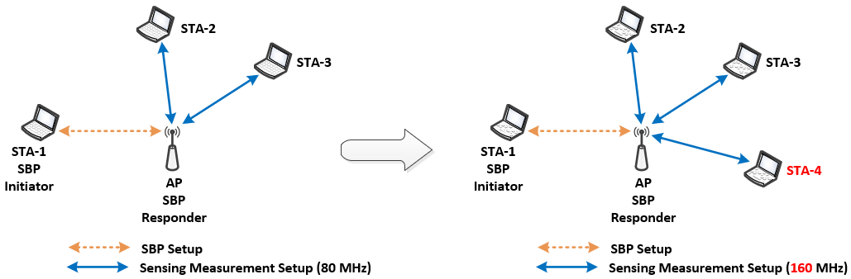

The steps involved may be summarized as below:

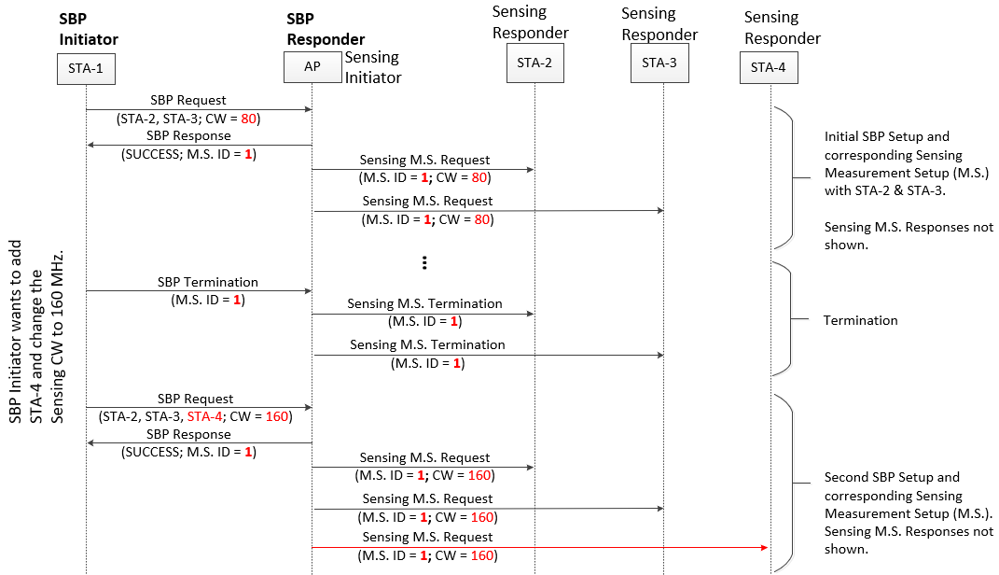

Proposal:
1. Modify the SBP Request frame as below (based on 22/1396r1):

 | Category | Public Action | Dialog Token | SBP  Re-Setup | Measurement Setup ID | SBP Parameters element | Sensing Measurement Parameters element
Bits: | 8 | 8 | 8 | 1 | 7 | 0 or variable | 0 or TBD
Figure 9-1139g— SBP Request frame Action field format

The SBP Re-Setup field is set to 1 to request modifications to an existing SBP procedure. Otherwise, it is set to 0.

If the SBP Re-Setup field is set to 1, the Measurement Setup ID indicates the SBP procedure to be modified. Otherwise, the field is reserved.

2. Modify the Sensing Measurement Setup Request frame as below:

 | Category | Public Action | Dialog Token | Sensing Measurement  Re-Setup | Measurement Setup ID | Sensing Measurement Parameters element
Bits: | 8 | 8 | 8 | 1 | 7 | TBD
Figure 9-1138a— Sensing Measurement Setup Request frame Action field format

The Sensing Measurement Re-Setup field is set to 1 to request modifications to an existing Sensing Measurement Setup. Otherwise, it is set to 0.
……
This would allow modifications to existing SBP procedure and corresponding Sensing Measurement Setups without the need for termination.

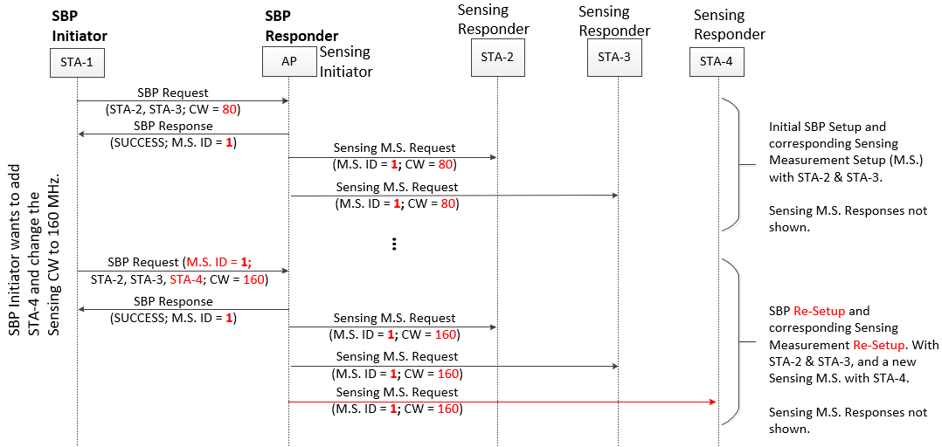
9.6.7.49 Sensing Measurement Setup Request frame format (CIDs 301)
TGbf editor: Modify the subclause as below (Track changes ON):

The Sensing Measurement Setup Request frame is transmitted by a sensing initiator to request a sensing
measurement setup. The format of the Sensing Measurement Setup Request frame Action field is defined in Figure 9-1138a (Sensing Measurement Setup Request frame Action field format).

 | Category | Public Action | Dialog Token | Measurement Setup Control | Sensing Measurement Parameters element
Octets: | 1 | 1 | 1 | 1 | TBD

Figure 9-1138a— Sensing Measurement Setup Request frame Action field format

The Category field is defined in 9.4.1.11 (Action field).

The Public Action field is defined in 9.6.7.1 (Public Action frames).

The Dialog Token field is defined in 9.4.1.12 (Dialog Token field)(#706).

The Measurement Setup Control field is defined in Figure 9-1138x (Sensing Measurement Setup Control field format).

 | Sensing Measurement  Re-Setup | Measurement Setup ID
Bits: | 1 | 7

Figure 9-1138x— Sensing Measurement Setup Control field format

The Sensing Measurement Re-Setup field is set to 1 to request modifications to the operational parameters corresponding to an existing Sensing Measurement Setup. Otherwise, it is set to 0.
If the Sensing Measurement Re-Setup field is equal to 0, the Measurement Setup ID field indicates a Measurement Setup ID that identifies assigned operational parameters in the Sensing Measurement Parameters Element to be used in the corresponding sensing measurement instances. If the Sensing Measurement Re-Setup field is set to 1, the Measurement Setup ID field indicates the Measurement Setup ID corresponding to sensing measurement instances whose operational parameters are to be updated with the parameters in the Sensing Measurement Parameters Element.
TGbf editor: Please delete Figure 9-1138b (Measurement Setup ID field format)

(based on 22/1396r1):
9.6.7.53 SBP Request frame format (CIDs 304, 321)

TGbf editor: Modify the subclause as below (Track changes ON):

The SBP Request frame allows a non-AP STA to invoke an SBP procedure (11.21.19 (SBP procedure)). The format of the SBP Request frame Action field is defined in Figure 9-1139g (SBP Request frame Action field format).

 | Category | Public Action | Dialog Token | SBP Control | SBP Parameters element | Sensing Measurement Parameters element
Octets: | 1 | 1 | 1 | 1 | variable | TBD
Figure 9-1139g— SBP Request frame Action field format

The Category field is defined in 9.4.1.11 (Action field).

The Public Action field is defined in 9.6.7.1 (Public Action frames).

The Dialog Token field is set to a nonzero value chosen by the STA sending the SBP request to identify the request/response transaction.

The SBP Control field is defined in Figure 9-1139x (SBP Control field format).

 | SBP  Re-Setup | Measurement Setup ID
Bits: | 1 | 7

Figure 9-1139x— SBP Control field format

The SBP Re-Setup field is set to 1 to request modifications to an existing SBP procedure. Otherwise, it is set to 0.

If the SBP Re-Setup field is equal to 1, the Measurement Setup ID field indicates the Measurement Setup ID corresponding to SBP procedure whose operational parameters are to be updated with the parameters in the Sensing Measurement Parameters Element.

The SBP Parameters element is defined in 9.4.2.330 (SBP Parameters element).

The Sensing Measurement Parameters element is defined in 9.4.2.317 (Sensing Measurement Parameters element).

11.21.19.2 SBP procedure setup (#13)

TGbf editor: Add the following paragraph to the end of the subclause:
(#13) If no SBP Response frame is received within TBD ms, or if an SBP Response frame is received with the StatusCode parameter equal to a value other than SUCCESS, the SBP Initiator shall consider the SBP request as unsuccessful.

