IEEE P802.11
Wireless LANs
Resolutions for Editorial Comments in CC40 - Part 5
Date: 2022-07-06
Author(s):
Name | Affiliation | Address | Phone | email
Claudio da Silva | Meta Platforms, Inc |  |  | claudiodasilva@fb.com
Abstract
This submission proposes resolutions to editorial comments submitted in CC40. The text used as reference is D0.1.

CIDs: 103, 104, 669, 54, 667, 222, 394, 402, 140, 804, 604, 805, 391, 224, 607, 36, 37, 38

CID | Clause | Page | Comment | Proposed change
103 | 11.21.20.1 | 75.06 | The 7 examples given in 11.21.20.1 (Figure 11-41g - Figure 11-41n) are very valuable but argualbly out-of-place in this normative section. Suggest moving these examples (figures and text) to a new Annex. | Move Figures 11-41g through 11-41n and corresponding text to a new Annex.
104 | 11.21.18.1 | 65.07 | The 2 examples given in 11.21.20.1 (Figures 11-41a and Figure 11-41b) are very valuable but argualbly out-of-place in this normative section. Suggest moving these examples (figures and text) to a new Annex | Move Figures 11-41g through 11-41n and corresponding text to a new Annex.

Proposed resolution: Rejected

Discussion: The TG considered the comment and did not agree with the proposed resolution on the basis that the figures are used to exemplify normative text found in Clause 11 and should, therefore, remain in the same clause.

CID | Clause | Page | Comment | Proposed change
669 |  | 27.01 | 9.6.7.49 needs to change to 9.6.7.50 and adjust the numbering of the following clauses | As in comment

Proposed resolution: Rejected

Discussion: As indicated in its first page, the baseline for 11bf/D0.1 is REVme/D1.1 and 11be/D1.5. The last 9.6.7 subclause in REVme/D1.1 is 9.6.7.48. 11be/D1.5 does not specify new 9.6.7 subclauses. Thus, 9.6.7.49 is correct. The technical editor will update the numbering used in 11bf’s next draft prior to its release.

CID | Clause | Page | Comment | Proposed change
54 | 1 | 14.36 | What is the baseline for the this ammendment | Please add the baseline used.

Proposed resolution: Rejected

Discussion: The baseline for the draft is indicated in the first (cover) page of the document. In reply to the commenter, the baseline for 11bf/D0.1 is REVme/D1.1 and 11be/D1.5.

CID | Clause | Page | Comment | Proposed change
667 |  | 24.24 | the sentence, "if the sensing initiator is a sensing receiver, it is reserved" is vague | replace "it is" with the "Measurement Report Type filed is reserved.

Proposed resolution: Revised

Discussion: Text referred to by the commenter is in 33.58.

Modifications: Editor – Modify the following pages/lines as indicated:
- 33.57-60: The Measurement Report Type subfield indicates the type of measurement result reported in sensing measurement instance(s) corresponding to the measurement setup ID. If the sensing initiator is a sensing receiver, it the Measurement Report Type subfield is reserved.

CID | Clause | Page | Comment | Proposed change
222 | 9.3.1.25.5 11.21.20.5.5a | 29.12  88.9 | The use of terminology is inconsistent. In Figure 9-110a, it is "Measurement Setup ID" subfield. In Subclause 11.21.20.5.5a, Line 9, when crossreferencing, it says "Sensing Measurement ID" subfield, with "Sensing" but no "Setup". | Change "Measurement Seup ID" on Page 29 to "Sensing Measurement Seup ID".

Proposed resolution: Revised

Discussion: Agree with the commenter that text is inconsistent. Use of Sensing Measurement ID in 88.9 is incorrect, as the subfield is termed “Measurement Setup ID” (29.12). Since “Measurement Setup ID” is extensively used in the draft, propose to continue to use this term (as opposed to defining a new one, “Sensing Measurement Setup ID”).

Modifications: Editor – Modify the following page/line as indicated:
- 88.9-11: “The Sensing Measurement ID Measurement Setup ID and the Sensing Instance ID subfields shall have the same value in all DMG Multistatic Sensing Request frames.”

CID | Clause | Page | Comment | Proposed change
394 | 9.4.2.318 | 34.01 | It is unclear why this element is called 'Sensing Measurement Report' instead of simply 'Sensing Report', as in the case of DMG sensing (i.e., 'DMG Sensing Report') | Change 'Sensing Measurement Report' to 'Sensing Report'

Proposed resolution: Rejected

Discussion: There is no technical reason for replacing “Sensing Measurement Report” with “Sensing Report”, and the use of “Sensing Measurement Report” is consistent throughout the draft (105 occurrences) and with other terms (“Sensing Measurement Instance”, “Sensing Measurement Setup Request” and “Sensing Measurement Setup Report”).

CID | Clause | Page | Comment | Proposed change
402 | 11.21.18.7 | 71.61 | It is unclear why an I2R NDP (R2I NDP) is transmitted if the sensing initiator is only a sensing receiver (transmitter) | Clarify the reason why both I2R NDP and R2I NDP have to be transmitted in a non-TB sensing measurement instance, regardless of the roles (i.e., sensing transmitter or sensing receiver) of the sensing intiatior and sensing responder

Proposed resolution: Rejected

Discussion: The comment fails to identify a specific issue to be addressed. In reply to the commenter, the structure of a non-TB sensing measurement instance is discussed in 21/1433r2.

CID | Clause | Page | Comment | Proposed change
140 | 64.38 | 11.21.18.2 | "dot11SensingMsmtImplemented" may be not clear what it means. Usually, it is better to use a self-explanatory name for the MIB variables | Change to "dot11SensingMeasurementImplemented"

Proposed resolution: Revised

Discussion: Since the MIB variable relates to the implementation of WLAN Sensing, propose to use dot11WLANSensingImplemented instead.

Modifications: Editor – Modify the following pages/lines as indicated:
- 66.37-47
Implementation of WLAN sensing is optional for a WNM STA. A STA in which dot11SensingMsmtImplemented dot11WLANSensingImplemented is true is defined as a STA that supports WLAN sensing.

A STA in which dot11SensingMsmtImplemented dot11WLANSensingImplemented is true shall set the WLAN Sensing field of the Extended Capabilities element to 1.

A STA in which dot11SensingMsmtImplemented dot11WLANSensingImplemented is false shall set the WLAN Sensing field of the Extended Capabilities element to 0.

- 32.51-53
A STA sets the WLAN sensing field to 1 if dot11SensingMsmtImplemented dot11WLANSensingImplemented is true, and sets it to 0 otherwise. See 11.21.18 (WLAN sensing procedure).

CID | Clause | Page | Comment | Proposed change
804 | 11.21.18.1 | 64.43 | replace instances with instance(s) | As suggested
604 | 11.21.18.1 | 64.45 | "A WLAN sensing procedure may be comprised of multiple sensing measurement instances" duplicates the previous sentence. | "Change the paragraph to ""A WLAN sensing procedure is composed of one or more of the following: Sensing session setup, sensing measurement setup, sensing measurement instance(s), sensing measurement setup termination, and sensing session termination""."
805 | 11.21.18.1 | 64.45 | Delete last sentence since it is unnecessary. | As suggested

Proposed resolution: Accepted

Note:
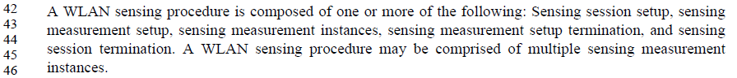

CID | Clause | Page | Comment | Proposed change
391 | 9.3.1.25.5 | 29.39 | The sentence writing can be improved | Add ', respectively' at the end of the sentence

Proposed resolution: Accepted

Note:

CID | Clause | Page | Comment | Proposed change
224 | 9.4.2.317 | 33.28 | In Figure 9-1002av, it is "Measurement Report Type" subfield without "Sensing", whereas all the other subfields are descbirbed with a "Sensing" prefix. | Change "Measurement Report Type" to "Sensing Measurement Report Type" in Figure 9-1002av on Page 33.

Proposed resolution: Accepted

Note: Proposed resolution is aligned with the one proposed in 0931r2 for CIDs 255/587/837/902/488.
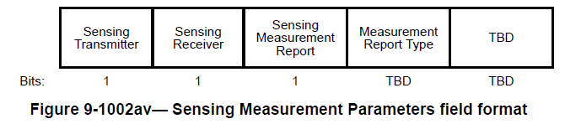
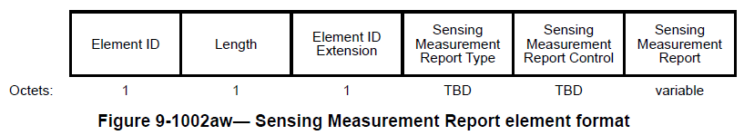

CID | Clause | Page | Comment | Proposed change
607 | 11.21.18.1 | 65.01 | The roles is one in the set of operational attributes, no need to state it specifically. Delete this whole paragraph since the MS subclause will explain it. | As commented.

Proposed resolution: Accepted

Note:
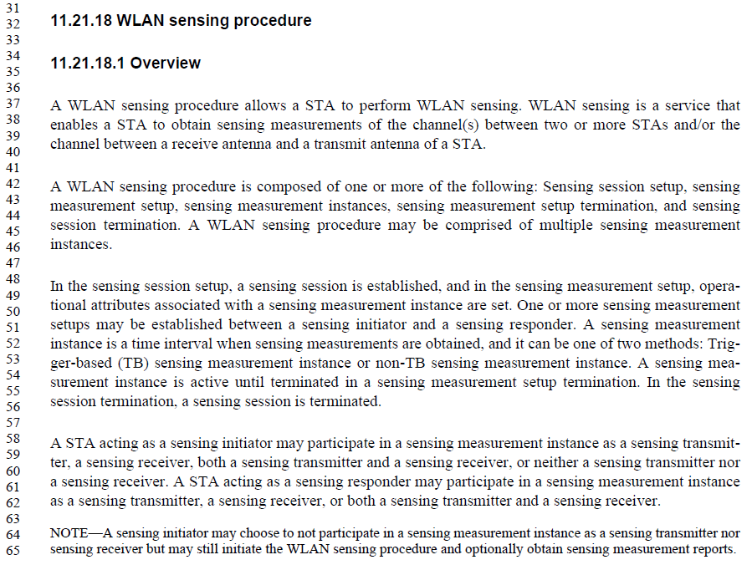

CID | Clause | Page | Comment | Proposed change
36 | 9.3.1.25.5 | 29.15 | The length of Measurement Setup ID, Measurement Burst ID and Sensing Instance Number is TBD. | Change the length of Measurement Setup ID, Measurement Burst ID and Sensing Instance Number to TBD.
37 | 9.3.1.25.6 | 30.14 | The length of Measurement Setup ID, Measurement Burst ID and Sensing Instance Number is TBD. Reserved bits should be TBD. | As in comment.
38 | 9.4.2.322 | 39.19 | The length of Measurement Setup ID is TBD. | Change the length of Measurement Setup ID to TBD.

Proposed resolution: Rejected

Discussion: There is no technical justification for changing the length of the identified fields to TBD at present.

Note:
- 29.15
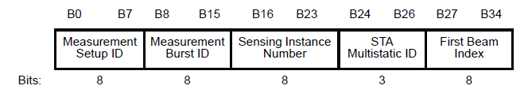
- 30.14
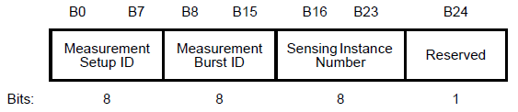
- 39.19
