IEEE P802.11
Wireless LANs
REVme LB258 CR for 1120 1121 1215 1216 (spatial reuse)
Date: 2022-07-06
Author(s):
Name | Affiliation | Address | Phone | email
Seán Coffey | Realtek |  |  | coffey (at) ieee.org
Abstract
This document contains proposed resolutions for CIDs 1120, 1121, 1215, 1216 from LB 258 on IEEE P802.11-REVme/D1.0.

References to page and line numbers are to D1.0.
Change history:
r0 (2022-07-06): Initial draft.

CID  (Commenter) | Clause/ Page | Comment | Proposed Change
1120  (Graham Smith) | 26.10.2.2 / 4232.25 | "If the PHY of a STA issues a PHY-CCA.indication(BUSY) followed by a PHY-RXSTART.indication due  to a PPDU reception, then the STA's MAC sublayer  a) May issue a PHY-CCARESET.request primitive before the end of the PPDU and not update its  basic NAV timer based on the PPDU, or  b) May not update its basic NAV timer based on the PPDU if all the following conditions are met:" Because it is "a) or b)" a STA may simply do a) and not bother with all the checking that b) requires. If it really is "or" then keep it simple and delete b) altogether. If this is not the intention, then when a) and when b) needs to be defined. | Delete b) in its entirety. Delete "a)" and line return after "sublayer"

Discussion:

The text indeed seems garbled. Looking back through various drafts, the text from ax/D2.0 was as follows:

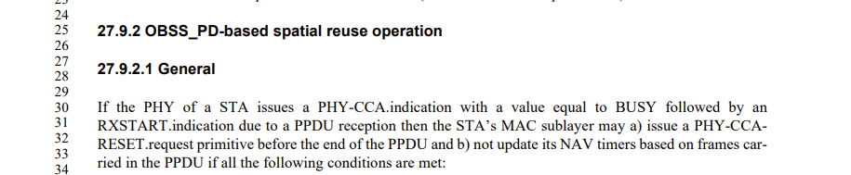

In ax/D3.0, this changed, and then remained stable though ax/D7.0, e.g., D7.0:

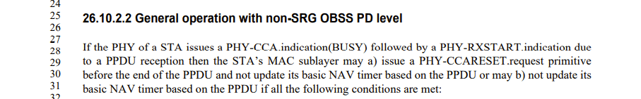

Note that the “not update” part from D2.0 (b) has been rolled into (D7.0) (a), and the conjunctive “and” has been changed to “or”.

In me/D0.1, the first draft that rolled in ax, this became:

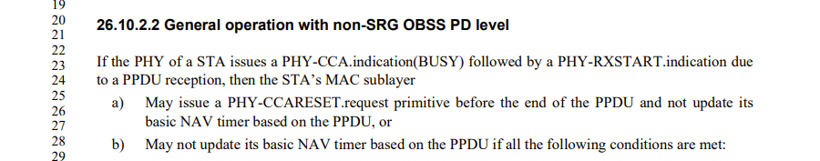

Note that the words remain the same, but the layout has changed. One consequence of the change is that the qualification (“if all of the following conditions are met”) now looks as if it applies to (b) alone, rather than both (a) and (b), as the previous text implied (though not that clearly).

It seems clear that the qualification should apply to both (a) and (b), so the commenter’s proposed resolution can’t be accepted.

The proposed resolution clarifies that the qualififcation applies to both (a) and (b), and also resolves CID 1215. CIDs 1121 and 1216 deal with the same issue in a different place and can likewise be resolved with a similar resolution.

Proposed resolution:

REVISED.

In D1.0/4232.25, in (b), add a comma and new line after “PPDU”. After “if”, add “(for either (a) or (b))”.

CID  (Commenter) | Clause/ Page | Comment | Proposed Change
1121  (Graham Smith) | 26.10.2.3 / 4233.51 | "If the PHY of a STA issues a PHY-CCA.indication(BUSY) followed by a PHY-RXSTART.indication due  to a PPDU reception, then the STA's MAC sublayer  a) May issue a PHY-CCARESET.request primitive before the end of the PPDU and not update its  basic NAV timer based on the PPDU, or  b) May not update its basic NAV timer based on the PPDU if all the following conditions are met:" This is identical to the previous Clause opening. Shouldn't something be different? True the conditions in b) are different, but as it is "a) or b) why do b)? | Delete b) in its entirety. Delete "a)" and line return after "sublayer"

Discussion:

As noted by the commenter, the text at issue is identical to the text at issue for CID 1120. (It’s repeated because the non-SRG case (CID 1120) and the SRG case (CID 1121) are dealt with separately.)

The history of the various revisions is the same as for CID 1120.

The proposed resolution is also the same as for CID 1120, and differs only in the referenced line number.

(The proposed resolution clarifies that the qualififcation applies to both (a) and (b), and also resolves CID 1216. CIDs 1120 and 1215 deal with the same issue in a different place and can likewise be resolved with a similar resolution.)

Proposed resolution:

REVISED.

In D1.0/4233.51, in (b), add a comma and new line after “PPDU”. After “if”, add “(for either (a) or (b))”.

CID  (Commenter) | Clause/ Page | Comment | Proposed Change
1215  (John Coffey) | 26.10.2.2 / 4232.28 | "May not" is confusing here: does this mean that the STA is not permitted to do X, or does it mean that the STA is permitted to do not-X? From context, it seems that the intended meaning is the latter, but if so, the wording should really be improved. | Change "May not update its NAV timer" to "Is not required to update its NAV timer".

Discussion:

“May not” is indeed confusing, and the intended meaning seems indeed to be “is permitted not to”.

The “may not” language came in in ax/D3.0, as discussed in the proposed resolution to CID 1120, and will disappear if the proposed resolution for that CID is accepted.

Similar changes are proposed for CIDs 1216 and 1121.

Proposed resolution: (same as for CID 1120)

REVISED.

In D1.0/4232.25, in (b), add a comma and new line after “PPDU”. After “if”, add “(for either (a) or (b))”.

CID  (Commenter) | Clause/ Page | Comment | Proposed Change
1216  (John Coffey) | 26.10.2.3 / 4233.57 | "May not" is confusing here: does this mean that the STA is not permitted to do X, or does it mean that the STA is permitted to do not-X? From context, it seems that the intended meaning is the latter, but if so, the wording should really be improved. | Change "May not update its NAV timer" to "Is not required to update its NAV timer".

Discussion:

The discussion and proposed resolution are the same as for CID 1121, for the same reasons as for CIDs 1120 and 1216.

Proposed resolution: (same as for CID 1121)

REVISED.

In D1.0/4233.51, in (b), add a comma and new line after “PPDU”. After “if”, add “(for either (a) or (b))”.

