IEEE P802.11
Wireless LANs
CC40 CR for Topic Threshold – Part 1
Date: 2022.07.28
Author(s):
Name | Company | Address | Phone | email
Mengshi Hu | Huawei Technologies | H3, Huawei Base, Bantian, Longgang, Shenzhen, Guangdong, China, 518129 |  | humengshi@huawei.com
Rui Du
Narengerile
Abstract
This submission contains the proposed comment resolutions for the following 10 CIDs in the Topic “Threshold” shown in 22/0820 IEEE 802.11bf CC40 comments.

CIDs 18, 97, 128, 200, 282, 499, 558, 562, 628, 910.

Revision Notes
R0 | Initial revision
R1 | Editorial changes, update CID 128
R2 | Editorial changes, add the SP text

CID 18 & 200 & 628
Page.  Line | Clause Number | Comment | Proposed Change | Resolution
70.54 | 11.21.18.6.5  (CID 18) | Threshold-based reporting is optional and applicable to TB sensing measurement instances in which the sensing initiator is the sensing transmitter. Why is this limited only to the case of sensing initator being sensing tramsitter? | Threshold based reporting can also be extended to cases when sensing initiator is a sensing recevier. | REVISED.  In the case that the sensing initiator is in the role of sensing receiver only, this reporting is not needed.  Note: The resolutions of CIDs 18, 200, and 628 are the same.  Instructions to the editor:  Please make the changes as shown under CID 18 & 200 & 628 in 11-22/0976r2.
70.52 | 11.21.18.6.5  (CID 200) | Reword the first paragraph to "Threshold-based reporting phase is optional and may be present in a TB sensing measurement instance that includes an NDPA sounding phase." | As in comment. | REVISED.  Note: The resolutions of CIDs 18, 200, and 628 are the same.  Instructions to the editor:  Please make the changes as shown under CID 18 & 200 & 628 in 11-22/0976r2.
70.54 | 11.21.18.6.5  (CID 628) | There may be other transmitters in the instance. | Change "the sensing transmitter" to "a sensing transmitter" | REVISED.  Note: The resolutions of CIDs 18, 200, and 628 are the same.  Instructions to the editor:  Please make the changes as shown under CID 18 & 200 & 628 in 11-22/0976r2.

Instructions to the editor: please make the following changes to Line 52, Page 70 in the subclause 11.21.18.6.5 Threshold-based reporting phase in D0.1 as shown below:

Threshold-based reporting is optional and may be present in a TB sensing measurement instance in which the sensing responder is in the role of sensing receiver.

CID 97
Page.  Line | Clause Number | Comment | Proposed Change | Resolution
71.24 | 11.21.18.6.5 | The note is not needed. It is clear that the three trigger frames will need to be defined. | Delete the Editor's Note. | ACCEPTED

CID 282
Page.  Line | Clause Number | Comment | Proposed Change | Resolution
70.50 | 11.21.18.6.5 | It's better to add some descriptions to show the relationship bewteen the Reporting phase and the Threshold-based Reporting pahse. Maybe the Reporting phase could be a more general description, and we can use basic reporting phase and threshold-based reporting phase to distinguish these two different types. | As in the comment. | REVISED.  Agree with the commenter. It is not clear whether the threshold-based reporting phase belongs to the reporting phase or they are on the same level.  The resolution is to use the “reporting phase” for both cases, and it has two variants: the basic reporting phase, and the threshold-based reporting phase.  Instructions to the editor:  Please make the changes as shown under CID 282 in 11-22/0976r2.

Instructions to the editor: please make the following changes to Line 18, Page 68 in the subclause 11.21.18.6 TB sensing measurement instance in D0.1 as shown below:

11.21.18.6 TB sensing measurement instance

TB sensing measurement instance is the trigger-based variant of a sensing measurement instance. It is applicable to scenarios where an AP is the sensing initiator, and one or more non-AP STAs are the sensing responders. It includes one or more of the following phases: Polling phase, NDPA sounding phase, Trigger frame (TF) sounding phase, and reporting phase.

The reporting phase of a TB sensing measurement instance has two variants: the basic reporting phase (see 11.21.18.6.4 (Basic reporting phase)), and the threshold-based reporting phase (see 11.21.18.6.5 (Threshold-based reporting phase)).

...

Instructions to the editor: please make the following changes to Line 23, Page 70 in the subclause 11.21.18.6.5 Threshold-based reporting phase in D0.1 as shown below:

11.21.18.6.4 Basic Reporting phase

The last phase of a TB sensing measurement instance is the reporting phase.

In the basic reporting phase of a TB sensing measurement instance, sensing measurement results are reported.

The transmission of Sensing Measurement Report frame is initiated by an MLME primitive. The sensing measurement reporting can be either immediate or delayed.

When negotiated, the sensing transmitter which is a sensing initiator shall send a Sensing Trigger Report frame during the basic reporting phase and assign RUs to the sensing receiver which is a sensing responder to obtain a Sensing Measurement Report frame containing sensing measurement results. The sensing receiver which is a sensing responder shall provide a Sensing Measurement Report frame in the assigned RUs with either results obtained from the I2R NDP of the current measurement instance, when negotiated to deliver immediate feedback reporting, or results obtained from the I2R NDP of the previous measurement instance, when negotiated to deliver delayed feedback reporting.

For delayed reporting, sensing measurement reports of multiple sensing measurement setups of a sensing responder may be included in a single Sensing Measurement Report frame. When negotiated, the sensing initiator may assign RUs to obtain more than one sensing measurement report in a single Sensing Measurement Report frame. A sensing responder may optionally transmit more than one delayed measurement results during the assigned RUs sent by the sensing initiator in the Sensing Trigger Report frame.

Instructions to the editor: please make the following changes to Line 33, Page 71 in the subclause 11.21.18.6.5 Threshold-based reporting phase in D0.1 as shown below:

Figure 11-41e – Threshold-based reporting phase in a TB sensing measurement instance

Discussion:
The following shows the Figure 11-41e in D0.1.
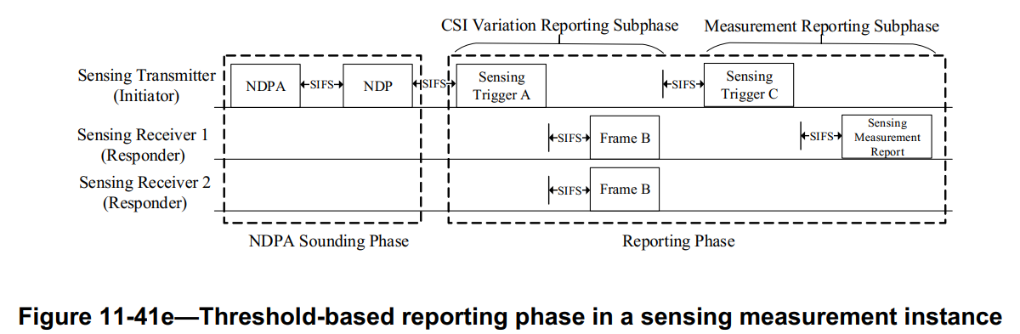
Discussion ends.

CID 128
Page.  Line | Clause Number | Comment | Proposed Change | Resolution
70.50 | 11.21.18.6.5 | "Threshold-based reporting phase" is not shown in any of the examples (Figure 11-41c). | include an example with Threshold-based reporting. | REVISED.  Add one sentence saying that the reporting phase can be the basic reporting phase or the threshold-based reporting phase.  Instructions to the editor:  Please make the changes as shown under CID 128 in 11-22/0976r2.

Instructions to the editor: please make the following changes to Line 34, Page 68 in the subclause 11.21.18.6.5 Threshold-based reporting phase in D0.1 as shown below:

Note that the reporting phase in the above five examples can be either a basic reporting phase or a threshold-based reporting phase. A basic reporting phase may also exist as the measurement reporting subphase of a threshold-based reporting phase for the STAs not participating in the CSI variation reporting.

Discussion:
The corresponding figure in 11.21.18.6 TB sensing measurement instance is shown below. I think the reporting phase already includes the basic one and the threshold-based one, as discussed in CID 282. Thus, there is no need to show an example with threshold-based reporting explictly. However, to make it clear, I suggest that sentences can be added to show that the reporting phase can be either the basic one or the threshold-based one if it is supported.
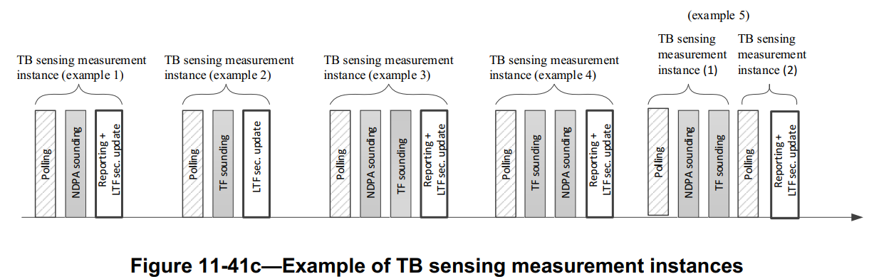
Discussion ends.

CID 499
Page.  Line | Clause Number | Comment | Proposed Change | Resolution
71.10 | 11.21.18.6.5 | The text from the line 10 to 22 should be moved after the Figure 11-41e--Threshold-based reporting phase in a sensing measurement instance, since the text is described as an examplary procedure rather than the general one. After moving that part, it might be helpful to add some general description at the front regarding how this procedure works. | As in comment. | REJECTED.  The text from 10 to 22 is a genral text instead of an exemplary procedure. Note that the text was initially located after the Figre 11-41e but suggested to move before the figure later. In addition, Frame A, B and C will be replaced by formal names once they are determined.

CID 558
Page.  Line | Clause Number | Comment | Proposed Change | Resolution
70.56 | 11.21.18.6.5 | Threshold-based reporting phase is based on the transmission of the Trigger frame. So, this reporting phase can not be used in the non-TB measurement instance. So,it does not need to consider the other cases the threshold-based reporting phase can be applied. | Delete the Editor's note | ACCEPTED.

Discussion:
The Editor’s Note is shown below:
Editor’s Note: Whether threshold-based reporting is applicable to other cases is TBD.
The main reason of having the above note is to indicate the SBP case is TBD, but I agree that this note can be deleted for simplicity, and the SBP case can be added later if it is needed.
Discussion ends.

CID 562
Page.  Line | Clause Number | Comment | Proposed Change | Resolution
71.12 | 11.21.18.6.5 | The CSI variation feedback value is transmitted by the PPDU solicited by the trigger frame. So, I think that frame B can be substituted with TB PPDU without an additional defined frame format. | Replace "Frame B " with " TB PPDU" | REJECTED.  Agree that the CSI variation feedback value is transmitted by a TB PPDU solicited by the trigger frame. However, it is not clear to use “TB PPDU” to describe the name of the frame conveyed by the PPDU. It is more accurate to describe it in the frame level instead of the PPDU level. Note that Frame B will be substituted when a formal frame name is given.

Discussion:
The following shows the Figure 11-41e in D0.1.
Discussion ends.

CID 910
Page.  Line | Clause Number | Comment | Proposed Change | Resolution
71.18 | 11.21.18.6.5 | It is not clear that why Frame B needs to be sent from the responder? If the CSI variation threshold is known by sensing receivers, then the sensing receiver may only report the sensing measurement report when the CSI variation is higher than the CSI variation threshold | Need to specify Frame B. No need to separate the transmissions of the sensing measurement report and the frame B in two subphases. | REJECTED.  This question was asked and discussed when the contribution threshold-based sensing measurement was being presented. The main reason of having two steps instead of one is that the feedback sizes of Frame B and Sensing Measurement Report frame are much different. In the two-step way, the AP is easy to allocate small-size resources for those devices to get the CSI variation results. However, if using the way suggested by the commenter, it is impossible for the AP to estimate the resources for those responders. Thus, Frame B and Sensing Measurement Report frames are separated.

Discussion:
The following shows the Figure 11-41e in D0.1.
Discussion ends.

SP

Do you support resolutions to the following CIDs and incorporate the text changes into the latest TGbf draft: 18, 200, 628, 97, 282, 128, 499, 558, 562, 910 in 11-22/0976r2 [10 CIDs]

Y/N/A

