IEEE P802.11
Wireless LANs
Proposed Resolution Text for EBCS Traffic Stream Mapper
Date: 2022-07-05
Author(s):
Name | Affiliation | Address | Phone | email
Hitoshi Morioka | SRC Software | Fukuoka, JAPAN |  | hmorioka@src-soft.com
Abstract
This document describes the text proposal addressing EBCS traffic stream mapper.

Proposed text

4.3.31.2.2 EBCS traffic stream mapper

The baseline is D3.0.

Modify Figure 5-1 as follows:

The EBCS traffic stream mapper is used to map inbound multicast traffic to EBCS traffic streams. The location of the EBCS traffic stream mapper is located at the entry of the DSAF (Figure 5-4 (Role-specific behavior block for a non-GLK AP)) shown in Figure 5-1 (MAC data plane architecture). It inspects the IP header and UDP header of the inbound multicast packets and assigns the content ID and the corresponding EBCS Content MAC address according to the configuration dot11EBCSTrafficStreamTable. The configuration for the EBCS traffic stream mapper defines each content ID and the corresponding source IP address, destination IP address and destination UDP port of the multicast traffic. The configuration of the EBCS traffic stream mapper is identical to that defined by dot11EBCSTrafficStreamTable of an EBCS AP in the DS.

4.3.31.2.4 Example of EBCS DL operation

The baseline is D3.0.

Modify the paragraph starting P26L31 as follows:
(Note to TGbc editor: these changes do not conflict with other changes)

An EBCS AP can receive multiple traffic streams from one or more EBCS DL content server(s). An EBCS AP can select traffic streams to be broadcast by setting dot11EBCSTrafficStreamTable and configurations for the EBCS traffic stream mapper. An EBCS AP broadcasts traffic streams as EBCS traffic streams. The SME in an EBCS AP selects traffic streams to be broadcasted by setting dot11EBCSTrafficStreamTable. An EBCS AP broadcasts the selected traffic streams as EBCS traffic streams. An EBCS AP can add authentication information to the streams.

5.1.5.1 General

The baseline is D3.0.

Modify Figure 5-1 as follows:

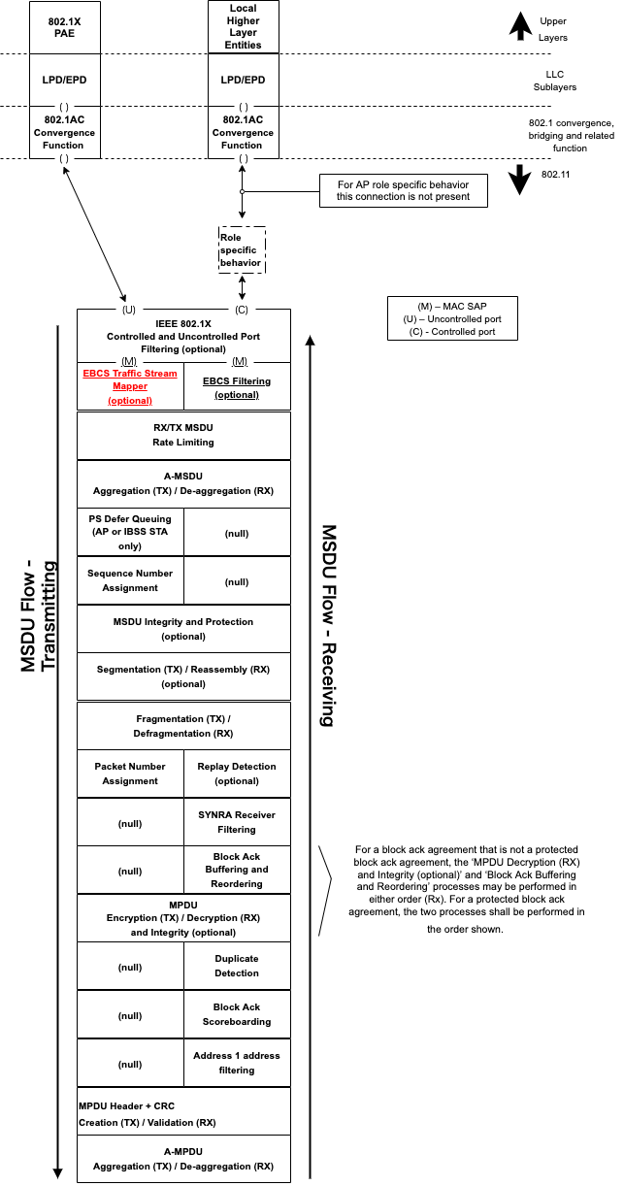

Figure 5-1—MAC data plane architecture

5.1.5.3 Non-GLK AP role

The baseline is D3.0.

Remove all changes to Figure 5-4.

Modify the second paragraph as follows

The assigned Content ID and the configured EBCS AP group ID are encoded into the Address fields in the MAC header by the EBCS traffic stream mapper according to Figure clause 11.55.2 (EBCS Addressing).

11.55.3.2 EBCS DL operation at an EBCS AP

The baseline is 11-22/746r5 (already approved).

Modify the 1st paragraph as follows:

EBCS DL operation is enabled in an EBCS AP if the length of the dot11EBCSTrafficStreamTable is greater than 0. The EBCS traffic streams to be transmitted are specified in dot11EBCSTrafficStreamTable. The EBCS traffic streams are handled differently than other traffic. An EBCS content ID and EBCS Content MAC address shall be assigned by the EBCS traffic stream mapper located at the entry of the DSAF to identify each different traffic stream of content. The EBCS traffic stream mapper shall be configured according to the EBCS content list. Each content ID shall be unique in the EBCS AP group if the EBCS AP belongs to an EBCS AP group, otherwise each content ID shall be unique in the EBCS certificate group. The content ID shall be nonzero.

