IEEE P802.11
Wireless LANs
Resolutions for Editorial Comments in CC40 - Part 4
Date: 2022-06-30
Author(s):
Name | Affiliation | Address | Phone | email
Claudio da Silva | Meta Platforms, Inc |  |  | claudiodasilva@fb.com
Abstract
This submission proposes resolutions to editorial comments submitted in CC40. The text used as reference is D0.1.

CIDs: 133, 199, 255, 392, 393, 488, 522, 587, 680, 681, 709, 710, 753, 837, 843, 844, 874, 881, 902

CID | Clause | Page | Comment | Proposed change
199 | 11.21.18.6.5 | 71.09 | Change "when" to "if". | As in comment.

Proposed resolution: Revise

Note:
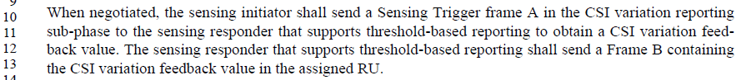

Discussion:
- Use “if” if the condition might occur (is not certain to occur).
- Use “when” if the condition is certain to occur.
- Almost always (in the 802.11 spec) the condition is not certain to occur and so “if” is appropriate. Certain things in 802.11 are pretty certain to occur (such as regular receipt of a beacon), but most things are not. When is currently overused in the .11 spec.

Modifications: Editor – Modify the following pages/lines as indicated:
- 33.44-46: The Sensing Measurement Report subfield is reserved when if the Sensing Receiver subfield is set to 0. When If the Sensing Receiver subfield is set to 1,
- 70.29-41:
The reporting phase is only present if the Sensing Measurement Report subfield within the Sensing Measurement Setup Request frame that resulted in the TB sensing measurement instance is set to 1. In this case, the The transmission of Sensing Measurement Report frame is initiated by an MLME primitive. The sensing measurement reporting can be either immediate or delayed.

When negotiated, the In the reporting phase, the sensing transmitter which is a sensing initiator shall send a Sensing Trigger Report frame during the reporting phase and assign RUs to the sensing receiver which is a sensing responder to obtain a Sensing Measurement Report frame containing sensing measurement results. The sensing receiver which is a sensing responder shall provide send a Sensing Measurement Report frame in the assigned RUs with either results obtained from the I2R NDP of the current measurement instance, when negotiated to deliver immediate feedback reporting, or results obtained from the I2R NDP of the previous measurement instance, when negotiated to deliver delayed feedback reporting.

CID | Clause | Page | Comment | Proposed change
392 | 9.4.2.317 | 33.38 | It is unclear where is the measurement setup ID is indicated | Clarify where the measurement setup ID is indicated
393 | 9.4.2.317 | 33.42 | It is unclear where is the measurement setup ID is indicated | Clarify where the measurement setup ID is indicated

Proposed resolution: Revise

Discussion: Both comments refer to the definitions of subfields within the Sensing Measurement Parameters field, which is sent within the Sensing Measurement Setup Request frame. There is no need to “tie” the definitions to the Measurement Setup ID.
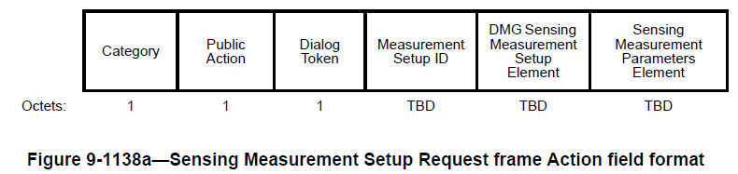
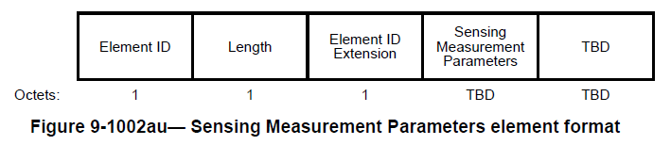
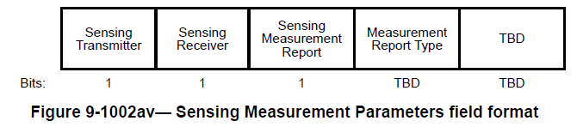

Modifications: Editor – Modify the following pages/lines as indicated:
- 33.36-38: The Sensing Transmitter subfield is set to 1 to indicate a sensing transmitter role for a the sensing responder corresponding to the measurement setup ID; and is set to 0 otherwise.
- 33.40-42: The Sensing Receiver subfield is set to 1 to indicate a sensing receiver role for a the sensing responder corresponding to the measurement setup ID; and is set to 0 otherwise.

CID | Clause | Page | Comment | Proposed change
255 | 9.4.2.317 | 33.57 | "what is difference the wording Measurement Report Type in figure 9-1002av and the sensing measurement report type in figure 9-1002aw." | please clarify
587 | 9.4.2.317 | 33.57 | What are the values of Measurement Report Type subfield? | Move the "Table 9-401s" here or add a reference.
837 | 9.4.2.317 | 33.57 | Improve precision of first sentence. It is not a "type of measurement result", it is a "type of measurement report". It is not "reported" but rather "to be sent during the reporting phase". | Change text to: "The Measurement Report Type subfield indicates the type of measurement report to be sent during the reporting phase of the sensing measurement instance(s) corresponding to the measurement setup ID."
902 | 9.4.2.317 | 33.57 | What does the measurement report type mean? It means the report format or others? Is this same as the Sensing Measurement Report type defined in Table 9-401s | Define the measurement report type
488 | 9.4.2.317 | 33.59 | Isn't this Measurement Report Type subfield same with the Sensing Measurement Report subfield in Sensing Measurement Report element where there is some definition on that as in Table 9-401s--Sensing Measurement Report Type field definition? We can improve the text as being consistency. | Add the related descirption or reference as in 9.4.2.318 Sensing Measurement Report element.

Proposed resolution: Revise

Discussion: Comments are on the first sentence of the following paragraph:

which refers to the Sensing Measurement Parameters field (that is sent within the Sensing Measurement Setup Request frame)

Field with the same meaning is found in the Sensing Measurement Report element (that is sent within the Sensing Measurement Report frame))
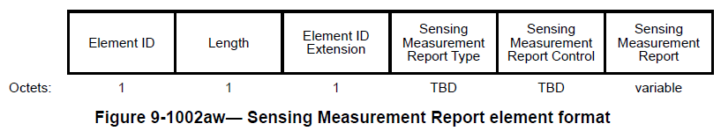
and is defined as
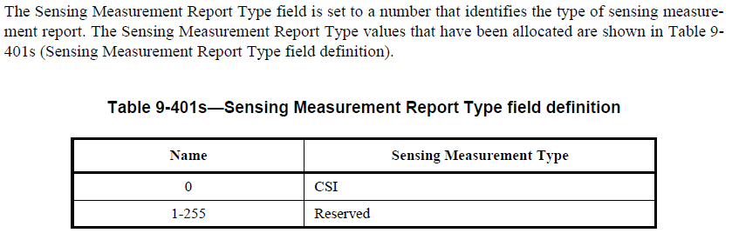

Modifications: Editor – Modify the following pages/lines as indicated:
- 33.29: Replace “Measurement Report Type” with “Sensing Measurement Report Type”
- 33.57-60: Replace
“The Measurement Report Type subfield indicates the type of measurement result reported in sensing measurement instance(s) corresponding to the measurement setup ID.”
with
“The Sensing Measurement Report Type subfield is set to a number that identifies the type of sensing measurement report being requested. The types of sensing measurement report that have been allocated are defined in Table 9-401s (Sensing Measurement Report Type field definition).”

CID | Clause | Page | Comment | Proposed change
843 | 9.6.7.54 | 60.61 | Editorial consistency - "an SBP Response frame" should read "a SBP Response frame" | Change text to: "The Measurement Setup ID field is present is a SBP Response frame only if the status code is equal to SUCCESS"
844 | 9.6.7.55 | 61.04 | Editorial consistency - "an SBP procedure" should read "a SBP procedure". | Change text to: "The SBP Termination frame allows a STA to terminate a SBP procedure. The format of the SBP Termination frame Action field is defined in ..."

Proposed resolution: Revise

Discussion: Agree with the commenter on the importance of being consistent on the choice of article (a/an SBP). Since the acronym (SBP) begins with a vowel sound, the article "an" should be used.

Modifications: Editor – Modify the following pages/lines as indicated:
- 60.4: The SBP Request frame allows a non-AP STA to invoke an SBP procedure (11.21.19 (SBP procedure))
- 60.31-33: The SBP Response frame is transmitted by an AP STA to accept or reject a request for an SBP procedure (11.21.19 (SBP procedure)).

CID | Clause | Page | Comment | Proposed change
709 | 9.6.7.53 | 60.04 | replace "a" with "an" | As in comment
710 | 9.6.7.53 | 60.31 | replace "a" with "an" | As in comment

Proposed resolution: Accept

CID | Clause | Page | Comment | Proposed change
133 | Introduction | 3.17 | The introduction indicates that the 11bf amendment defines modifications to the PHY service interface of HT, VHT, HE, and EHT. I do not think there are any modifications have been done to these interfaces in the current draft | Include the Clauses 19, 21, 27, and 36 to the draft as placeholders and Indicate that the changes to the mentioned service interfaces are TBD.

Proposed resolution: Reject

Discussion: While it is true that modification to Clauses 19, 21, 27, and 36 are in the scope of P802.11bf, the TG is yet to accept text that would modify any of these clauses. Clauses will be included into the draft as appropriate when approved by the TG.

CID | Clause | Page | Comment | Proposed change
680 | 9.4.1.9 | 31.17 | To make a request is not unacceptable. It be that it cannot be accepted that is another thing | change "is unacceptable" to ""cannot be fulfilled" or something similar.
681 | 9.4.1.9 | 31.20 | To make a request is not unacceptable. It be that it cannot be accepted that is another thing. In addition, it seems it should be allowed to propose another setup even in principle the original requested on could be met | change "is unacceptable" to ""cannot be fulfilled" or something similar. If it is allowed so propose an alternative even if the original proposal could be a fulfilled, the explanation needs to be updated accordingly.

Proposed resolution: Revise

Discussion:
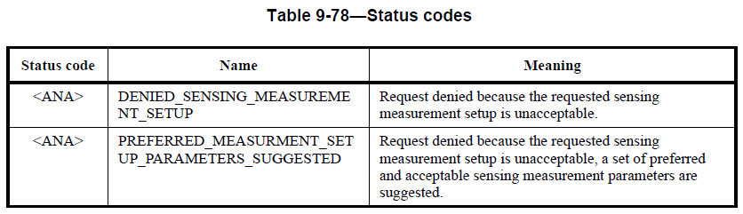

Examples (802.11-2020) of status codes that correspond to requests being declined/rejected:
- REQUEST_DECLINED The request has been declined.
- REJECTED_SPECTRUM_MANAGEMENT_REQUIRED Association request rejected because spectrum management capability is required.
- REFUSED_TEMPORARILY Association request rejected temporarily; try again later.

Also, for reference,
- REJECTED_WITH_SUGGESTED_CHANGES The allocation or TS has not been created because the request cannot be honored; however, a suggested TSPEC/DMG TSPEC is provided so that the initiating STA can attempt to set another allocation or TS with the suggested changes to the TSPEC/DMG TSPEC.

Modifications: Editor – Modify the following pages/lines as indicated:
In Table 9-78,
- Replace “DENIED_SENSING_MEASUREMENT_SETUP” with “DECLINED_SENSING_MEASUREMENT_SETUP”
- Replace “Request denied because the requested sensing measurement setup is unacceptable” with “The sensing measurement setup request has been declined”.
- Replace “Request denied because the requested sensing measurement setup is unacceptable, a set of preferred and acceptable sensing measurement parameters are suggested” with “The sensing measurement setup has not been established because the request cannot be honored; however, suggested sensing measurement setup parameters are provided.”

CID | Clause | Page | Comment | Proposed change
522 | 9.6.7.50 | 58.62 | Define the TBD for the status code of PREFERRED_MEASURMENT_SETUP_PARAMETERS_SUGGESTED by using the reserved values of the status code. | As in comment

Proposed resolution: Revised

Discussion:

Examples in Rev. me/D1.1: “the Anti-Clogging Token field is present if the Status Code field is ANTI_CLOGGING_TOKEN_REQUIRED” and “The RIC element is optionally present if the Status Code field is 0.”

Modifications: Editor – Modify the following pages/lines as indicated:
- 58.54 The Status Code field is defined in 9.4.1.9 (Status Code field).
- 58.62-64 Replace “It is present in the Sensing Measurement Setup Response frame if the Status Code is set to TBD (PREFERRED_MEASURMENT_SETUP_PARAMETERS_SUGGESTED)” with “It is present in the Sensing Measurement Setup Response frame if the Status Code field is set to TBD (PREFERRED_MEASURMENT_SETUP_PARAMETERS_SUGGESTED)”
- 67.22-25 Replace “The sensing responder may set the Status Code to TBD (PREFERRED_MEASURMENT_SETUP_PARAMETERS_SUGGESTED) and provide its preferred sensing measurement parameters in the Sensing Measurement Setup Response frame.” with “The sensing responder may set the Status Code field to TBD (PREFERRED_MEASURMENT_SETUP_PARAMETERS_SUGGESTED) and provide its preferred sensing measurement parameters in the Sensing Measurement Setup Response frame.”

CID | Clause | Page | Comment | Proposed change
753 | 11.21.18.4 | 67.43 | Add comma in the text as shown | Text would read as 'sensing receiver, or sensing transmitter and sensing receiver'
881 | 11.21.18.4 | 67.42 | This sentence is very confusing: "If a Sensing Measurement Setup Request frame assigns the role of either sensing receiver or sensing transmitter and sensing receiver to the sensing responder". Please rephrase. | delete "and sensing receiver" in the sentence

Proposed resolution: Revise

Discussion: Text referenced by both comments:
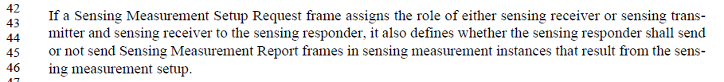
The role of “sensing transmitter and sensing receiver” actually correspond to two different roles: (1) sensing transmitter and (2) sensing receiver. (Sensing Measurement Parameters field, which is sent within the Sensing Measurement Setup Request frame, has two subfields: Sensing Transmitter and Sensing Receiver.) Thus, conditioning on “sensing receiver” only is sufficient.

Modifications: Editor - In 67.42-47, replace
“If a Sensing Measurement Setup Request frame assigns the role of either sensing receiver or sensing transmitter and sensing receiver to the sensing responder, it also defines whether the sensing responder shall send or not send Sensing Measurement Report frames…”
with
“If a Sensing Measurement Setup Request frame assigns the role of sensing receiver to the sensing responder, it also defines whether the sensing responder shall send or not send Sensing Measurement Report frames…”

In 85.54-56, replace
“The reporting phase is mandatory if the sensing responder is in the sensing receiver role and in the sensing transmitter and sensing receiver role.”
with
“The reporting phase is mandatory if the sensing responder is in the sensing receiver role.”

CID | Clause | Page | Comment | Proposed change
874 | 11.21.18.1 | 64.37 | This paragraph is identical to the paragraph in 4.3.21.25 (WLAN Sensing) after the first sentence. There is no need to repeat. | delete the paragraph

Proposed resolution: Revised

Discussion: Texts referenced by the commenter are:
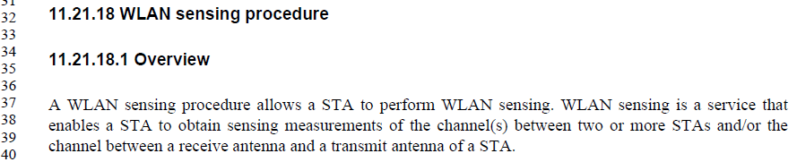
and
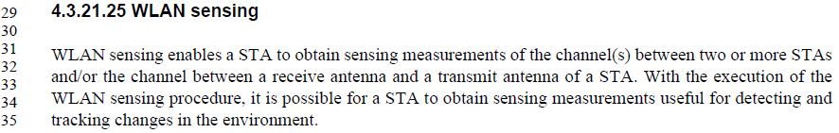
Agree with the author that repetition should be avoided. Suggest to keep “A WLAN sensing procedure allows a STA to perform WLAN sensing” since this definition is not found in 4.3.21.25.

Modifications: Editor – Modify the paragraph in 64.37-40 as indicated:

A WLAN sensing procedure allows a STA to perform WLAN sensing. WLAN sensing is a service that enables a STA to obtain sensing measurements of the channel(s) between two or more STAs and/or the channel between a receive antenna and a transmit antenna of a STA.

