IEEE P802.11
Wireless LANs
CC40 CR for CIDs 666, 672 and 734
Date: 2022.06.21
Author(s):
Name | Company | Address | Phone | email
Mengshi Hu | Huawei Technologies | H3, Huawei Base, Bantian, Longgang, Shenzhen, Guangdong, China, 518129 |  | humengshi@huawei.com
Rui Du
Narengerile
Abstract
This submission contains the proposed comment resolutions for the following CIDs in the Topic “Frames” shown in 22/0820 IEEE 802.11bf CC40 comments.

CIDs 666, 672 and 734.

Revision Notes

R0 | Initial revision

CID 666
Page.  Line | Clause Number | Comment | Proposed Change | Resolution
16.14 | 3.2 | The term "Measurement Setup ID" needs to be defined | add definition in clause 3.2 | REVISED.  Instructions to the editor:  Please make the changes as shown under CID 666 in 11-22/xxxxr0.

Instructions to the editor: please make the following changes to P16 in the subclause 3.2 Definitions specific to IEEE Std 802.11 in D0.1 as shown below:

measurement setup identifier (ID): An identifier that identifies the sensing measurement setup or DMG sensing measurement setup.

Discussion (Another description is shown below):
measurement setup identifier (ID): An identifier that identifies the prameters in a sensing measurement setup or DMG sensing measurement setup to be used in the corresponding instances.
Discussion ends.

CID 672
Page.  Line | Clause Number | Comment | Proposed Change | Resolution
0.0 | 0.0 | Many frame formats are not defined which makes reviewing the draft is not an easy task | define the missing frame formats. | REJECTED.  Agree in principle that many frames are not defined. However, because the specific TBD frames are not provided here, this comment is rejected.

CID 734
Page.  Line | Clause Number | Comment | Proposed Change | Resolution
32.52 | 9.4.2.26 | Table 9-10 includes bit 90 as 'WLAN Sensing' as it would be more suited to replace it with three bits indicating; 1) TB measurement instance sensing 2) NTB measurement instance sensing and 3) TB measurement instance with STA-to-STA sensing | As per comment | REVISED.  Instructions to the editor:  Please make the changes as shown under CID 734 in 11-22/xxxxr0.
Instructions to the editor: please make the following changes to P16 in the subclause 3.2 Definitions specific to IEEE Std 802.11 in D0.1 as shown below:

Table 9-190 - Extended Capabilities field
Bit | Information | Notes
90 | TB Sensing | A STA sets the TB Sensing field to 1 if dot11TBSensingImplemented is true, and sets it to 0 otherwise. See 11.21.18 (WLAN sensing procedure)
91 | Non-TB Sensing | A STA sets the Non-TB Sensing field to 1 if dot11NTBSensingImplemented is true, and sets it to 0 otherwise. See 11.21.18 (WLAN sensing procedure)
92 | STA To STA TB Sensing | A STA sets the STA To STA TB Sensing field to 1 if dot11STAToSTATBSensingImplemented is true, and sets it to 0 otherwise. See 11.21.18 (WLAN sensing procedure)
93 | SBP | A STA sets the SBP field to 1 if dot11SBPImplemented is true, and sets it to 0 otherwise. See 11.21.19 (SBP procedure).

Instructions to the editor: please make the following changes to P66 in the subclause 11.21.18.2 WLAN sensing dependencies in D0.1 as shown below:

Implementation of WLAN sensing is optional for a WNM STA.

A STA in which dot11TBSensingImplemented is true is defined as a STA that supports the WLAN sensing procedure with TB measurement instances.

A STA in which dot11TBSensingImplemented is true shall set the TB Sensing field of the Extended Capabilities element to 1. A STA in which dot11TBSensingImplemented is false shall set the TB Sensing field of the Extended Capabilities element to 0.

A STA in which dot11NTBSensingImplemented is true is defined as a STA that supports the WLAN sensing procedure with Non-TB measurement instances.

A STA in which dot11NTBSensingImplemented is true shall set the Non-TB Sensing field of the Extended Capabilities element to 1. A STA in which dot11NTBSensingImplemented is false shall set the Non-TB Sensing field of the Extended Capabilities element to 0.

A STA in which dot11TBSensingImplemented is true is defined as a STA that supports the WLAN sensing procedure with STA-to-STA TB measurement instances.

A STA in which dot11STAToSTATBSensingImplemented is true shall set the STA To STA TB Sensing field of the Extended Capabilities element to 1. A STA in which dot11STAToSTATBSensingImplemented is false shall set the STA To STA TB Sensing field of the Extended Capabilities element to 0.

Discussion:
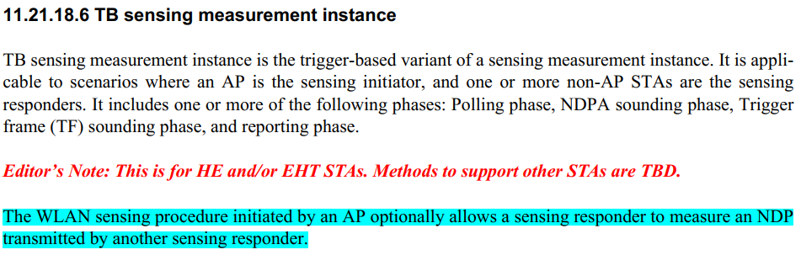

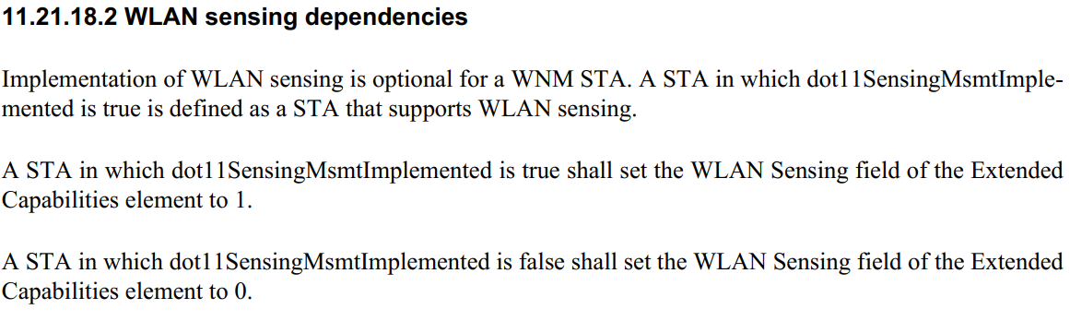
Discussion ends.

