IEEE P802.11
Wireless LANs
Proposed Resolution Text for Clause 4.3.31.2.4
Date: 2022-06-07
Author(s):
Name | Affiliation | Address | Phone | email
Hitoshi Morioka | SRC Software | Fukuoka, JAPAN |  | hmorioka@src-soft.com
Abstract
This document describes the text proposal for clause 4.3.31.2.4.

The baseline is D3.0.

Black texts are copied from D3.0.
Blue texts are modifications in r1.
Red texts are modifications from r1.

Proposed text

3.1 Definitions specific to IEEE Std 802.11

Modifiy the definition of “EBCS AP group” as follows:

enhanced broadcast services (EBCS) access point (AP) group: A group of one or more EBCS APs such that all EBCS APs in the group use common EBCS traffic stream IDs. An EBCS AP group is a subgroup of an EBCS certificate group if the member APs use AP certificate. [3002]

4.3.31.2.4 Example of EBCS DL operation

Figure 4-16a (Example of EBCS DL operation) provides an example of EBCS DL operation.

Replace Figure 4-16a as follows:

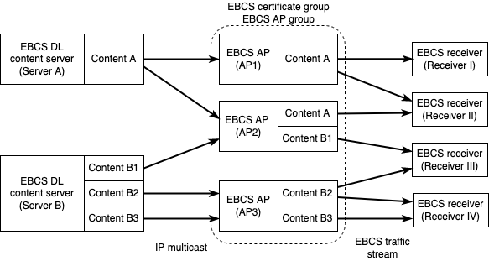

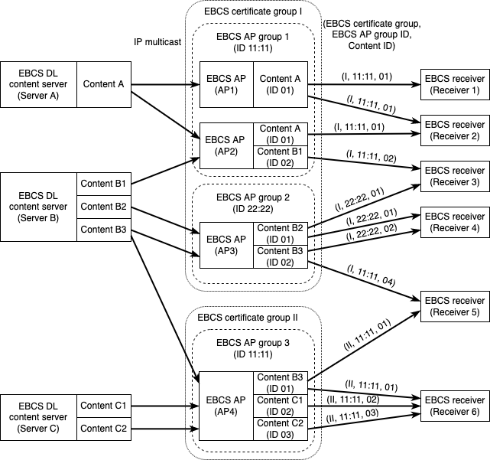

Figure 4-16a—Example of EBCS DL operation [3005, 3161, 3002]

EBCS DL content servers are distributing traffic streams by IP multicast on IP network. Each EBCS DL content server can distribute multiple traffic streams that can be identified by the source IP address, [3005] the destination IP address and the destination UDP port.

Server A in the Figure 4-16a distributes Content A. Server B distributes Content B1, Content B2 and Content B3. [3005] Server C distributes Content C1 and Content C2. [3002]

An EBCS AP can receive multiple traffic streams from one or more EBCS DL content server(s). An EBCS AP can select traffic streams to be broadcast by setting dot11EBCSTrafficStreamTable and configurations for the EBCS traffic stream mapper. An EBCS AP broadcasts traffic streams as EBCS traffic streams. An EBCS AP can add authentication information to the streams.

All EBCS APs, AP1, AP2 and AP3, belong to a single the EBCS certificate group I and EBCS AP group. AP1 and AP2 belong to the EBCS AP group 1 of which ID is 11:11. AP3 belongs to the EBCS AP group 2 of which ID is 22:22. AP4 belongs to the EBCS certificate group II and the EBCS AP group 3 of which ID is 11:11. Although both the EBCS AP group 1 and the EBCS AP group 3 use the EBCS AP group ID 11:11, they are different EBCS AP groups as they belong to different EBCS certificate groups. [3002]

AP1 in the Figure 4-16a receives and broadcasts Content A. AP2 receives and broadcasts Content A and Content B1. AP3 receives and broadcasts Content B2 and Content B3. [3005] AP4 receives and broadcasts Content B3, Content C1 and Content C2. [3002]

An EBCS receiver can receive multiple EBCS traffic streams from one or more EBCS AP(s). An EBCS receiver can select EBCS traffic streams to be consumed by setting dot11EBCSTrafficStreamEnabled in dot11TrafficStreamTable. An EBCS receiver filters EBCS traffic streams to be consumed using the EBCS filter. [3064] Each EBCS traffic stream can be authenticated if the transmitting EBCS AP add authentication information.

Receiver I 1 in the Figure 4-16a receives Content A from AP1. Receiver II 2 receives Content A from both AP1 and AP2. Receiver III 3 receives Content B1 from AP2 and Content B2 from AP3. Receiver IV 4 receives both Content B2 and Content B3 from AP3. [3005] Receiver 5 receives Content B3 from both AP3 and AP4. Receiver 6 receives Content B3, Content C1 and Content C2 from AP4. [3002]

Receiver 2 can complement Content A by receiving from 2 APs as both EBCS traffic streams from AP1 and AP2 belong to the same EBCS certificate group and the same EBCS AP group, and have the same Content ID.
Receiver 5 cannot complement Content B3 as the EBCS traffic streams from AP3 and AP4 belong to the different EBCS certificate groups and the different EBCS AP group. Receiver 5 has to treat them as different contents. [3002]

