IEEE P802.11
Wireless LANs
Proposed Resolution Text for Clause 4.3.31.2.4
Date: 2022-06-07
Author(s):
Name | Affiliation | Address | Phone | email
Hitoshi Morioka | SRC Software | Fukuoka, JAPAN |  | hmorioka@src-soft.com
Abstract
This document describes the text proposal for clause 4.3.31.2.4.

The baseline is D3.0.

Proposed text

4.3.31.2.4 Example of EBCS DL operation

Modify the second paragraph as follows:

Figure 4-16a (Example of EBCS DL operation) provides an example of EBCS DL operation.

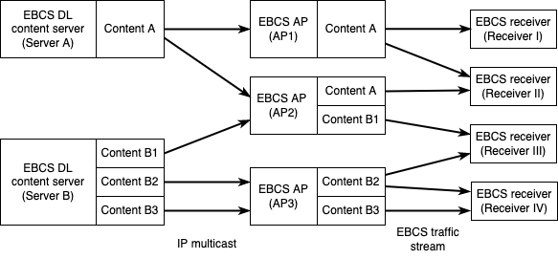

Figure 4-16a—Example of EBCS DL operation

EBCS DL content servers are distributing traffic streams by IP multicast on IP network. Each EBCS DL content server can distribute multiple traffic streams that can be identified by the source IP address, the destination IP address and the destination UDP port.

Server A in the Figure 4-16a distributes Content A. Server B distributes Content B1, Content B2 and Content B3.

An EBCS AP can receive multiple traffic streams from one or more EBCS DL content server(s). An EBCS AP can select traffic streams to be broadcast by setting dot11EBCSTrafficStreamTable and configurations for the EBCS traffic stream mapper. An EBCS AP broadcasts traffic streams as EBCS traffic streams. An EBCS AP can add authentication information to the streams.

AP1 in the Figure 4-16a receives and broadcasts Content A. AP2 receives and broadcasts Content A and Content B1. AP3 receves and broadcasts Content B2 and Content B3.

An EBCS receiver can receive multiple EBCS traffic streams from one or more EBCS AP(s). An EBCS receiver can select EBCS traffic streams to be consumed by setting dot11EBCSTrafficStreamEnabled in dot11TrafficStreamTable. Each EBCS traffic stream can be authenticated if the transmitting EBCS AP add authentication information.

Receiver I in the Figure 4-16a receives Content A from AP1. Receiver II receives Content A from both AP1 and AP2. Receiver III receives Content B1 from AP2 and Content B2 from AP3. Receiver IV receives both Content B2 and Content B3 from AP3.

