IEEE P802.11
Wireless LANs
Resolutions to Transmit specification to NGV receive procedure
Date: 2022-06-07
Author(s):
Name | Affiliation | Address | Phone | email
Yujin Noh | Senscomm |  |  | yujin.noh at senscomm.com
Abstract
This submission shows
- Comments from TGbd draft 4.0.
- Resolutions applied to TGbd draft 4.0.
- 8 CIDs:
5056, 5055, 5054, 5053, 5052, 5050, 5049, 5048

Revisions:
- Rev 0: Initial version of the document.
- Rev 1: CID5048 updated
- Rev 2: CID5050 and CID5049 updated based on the teleconferencall and e-mail discussion
- Rev 3: typo fixed

CID | P.L | Comment | Proposed Change | Resolution
5056 | 110.07 | Since this is addressing NGV-PPDUs, Table 21-24 should be changed to Table 32-14. | As in comment | Accepted
Discussion
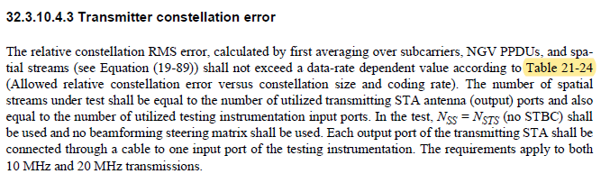
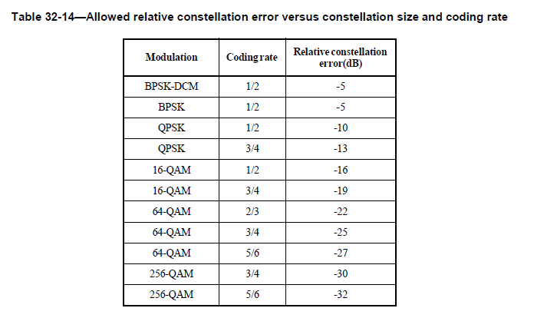

CID | P.L | Comment | Proposed Change | Resolution
5055 | 111.12 | Midamble is required in an NGV PPDU. | Remove "If midambles are present in the Data field of the PPDU" and fix the sentence. The change is applied to L21 on the same page. | Rejected.  The midamble feature shall be supported but it does not mean midamble is inserted in every NGV PPDU. For example, the number of OFDM symbol is small enough, there is a case that midamble is not existed in NGV PPDU. So “If present” is necessary under the condition with Equation (32-35)
Discussion
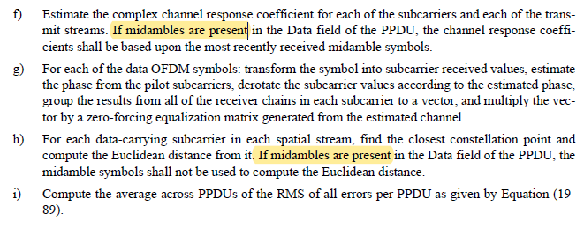
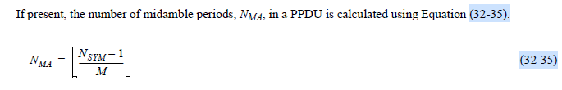
CID | P.L | Comment | Proposed Change | Resolution
5054 | 117.01 | In general, scrambling the input data prior to FEC encoding is performed to endure sufficient randomness for better decoding performance. | Suggest adding "scrambled and" to result in "The SERVICE field and PSDU are scrambled and encoded…" | Accepted.
5053 | 117.05 | According to the description in P103L40 of subclause 32.3.9.1, PHY padding to ensure integral number of octets in an OFDM data symbol. | change " … integer multiple of the number of coded bits per OFDM symbol" to "… integer multiple of the number of coded octets per OFDM data symbol." | Revised.  In original text, coded PSDU might mislead the intentsion that data field consists of an integer multiple of the OFDM symbols (N_SYM,init x N_DBPS).  To TGbd: change to “PHY padding bits are  appended to the PSDU to make the number of bits in the coded SERVICE field and PSDU an integer multiple of the number of coded bits per OFDM symbol.”
Discussion
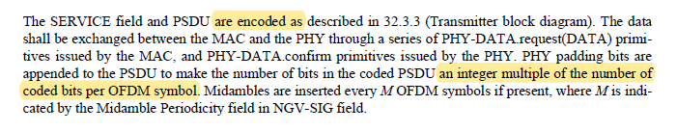
CID5054
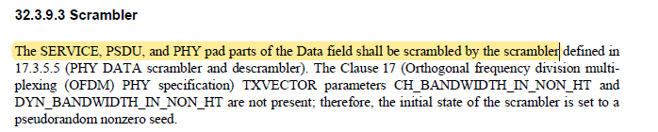

CID5053
Data field consists of N_{SERVICE} + 8 × PSDU_LENGTH + PHY padding wherein available octets is PSDU of 8 × PSDU_LENGTH.

At P103L40 as below.
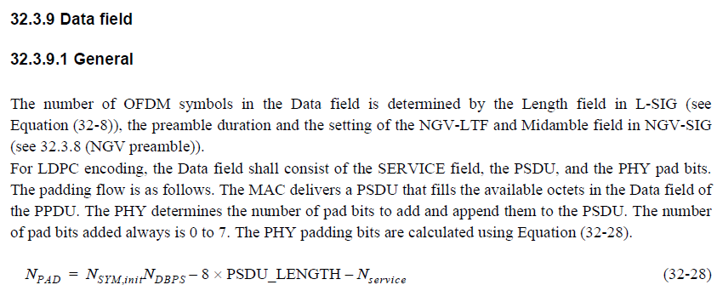

CID | P.L | Comment | Proposed Change | Resolution
5052 | 117.06 | Midamble is required in an NGV PPDU. | Change " … if present" to "… except for the last OFDM symbol if mod(N_SYM,M)=0 ." | Rejected.  The midamble feature shall be supported but it does not mean midamble is inserted in every NGV PPDU. For example, the number of OFDM symbol is small enough, there is a case that midamble is not existed in NGV PPDU. So “If present” is necessary under the condition with Equation (32-35) which covers the midamble not inserted after the last OFDM. “If present” deliver its intention clearly.

To be continued

CID | P.L | Comment | Proposed Change | Resolution
5050 | 120.16 | In NGV receive, "Detect SIG for non-NGV" is determined by not detecting RL_SIG. | The incoming arrow of the box "Detect SIG for non-NGV" from CS/CCA should be replaced by the arrow from the "Detect RL-SIG" box labeling "Repetition failed." The label is suggested changed to "RL_SIG detection failed" for clarity because the word "repetition" is used for other context as well like N_PPDU_REP and LTF_REP. | Revised.  Agreed in principle. For 11bd, there is no other types other than NGV and non-NGV(11p), there is no need to further determine preamble types if 11bd check fails (fails detecting RL-SIG).  1) delete the "Detect SIG for non-NGV" and point two arrows to the block “NON_NGV_10 repetition”  2) "Repetition failed" to "RL-SIG detection failed"  3) "Repetition detected" to "RL-SIG detected"  TGbd Editor: Incorporate the changes in 11-22-0815-03-00bd- Resolutions to Transmit specification to NGV receive procedure. The corresponding visio file is in DCN 22/0826.
Discussion
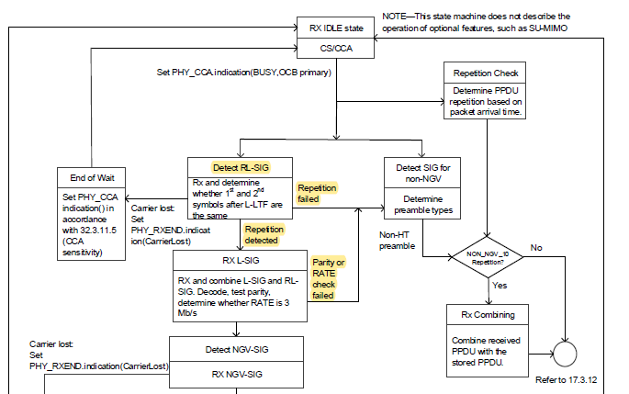

To TGbd Editor: P120L64 update the Figure 32-16 as below.
------------- Begin Text Changes ---------------
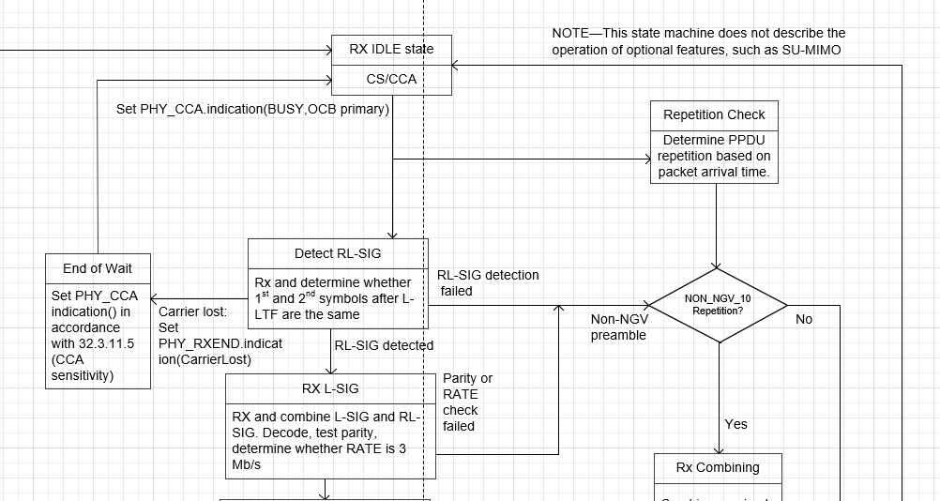
------------- End Text Changes ------------------

To TGbd Editor: P121L9 update the description as below.
------------- Begin Text Changes ---------------

After the PHY-CCA.indication(BUSY, channel-list) primitive is issued, the PHY entity shall begin receiving the training symbols and searching for the preambles for non-NGV and NGV PPDUs, respectively. For detecting the NGV preamble, the PHY entity shall search for L-SIG and RL-SIG in order to set the maximum duration of the data stream. If RL-SIG is detected, the PHY entity should check the parity bit and RATE fields in L-SIG and RL-SIG. If either RL-SIG detection is failed, the check of the parity bit is invalid or the RATE field is not equal to 3 Mb/s, a PHY-RXSTART.indication primitive is not issued, and the PHY should continue to detect the received signal using non-NGV receive procedure in Clause 17 (Orthogonal frequency division multiplexing (OFDM) PHY specification) and instead the PHY shall issue the error condition PHY-RXEND.indication(FormatViolation) primitive. If a valid parity bit and the RATE with 3 Mb/s are indicated in L-SIG and RL-SIG, the NGV PHY shall maintain PHY-CCA.indication(BUSY, channel-list) primitive for the predicted duration of the transmitted PPDU, as defined by RXTIME in Equation (32-40), for all supported modes, unsupported modes, Reserved NGV-SIG Indication, and invalid SIG CRC.

------------- End Text Changes ------------------

CID | P.L | Comment | Proposed Change | Resolution
5049 | 120.26 | The outgoing arrow "Parity or RATE check failed" is a fatal event and should not go back to Detect SIG for non-NGV. Instead, it should go to End of Wait with an error condition as stated in P121L15. | According to P121L15, the outgoing arrow should show PHY-RXEND.indication(FormatViolation) primitive and point to End of Wait to be consistent with other primitives in the figure. As such, need to add this error condition to the End of Wait box. | Revised.  Agreed in principle. However, if Parity or RATE check is failed, next step is to continue to detect the received signal using non-NGV receive procedure. This procedure is known common understanding on how to operate auto-dection when RL-SIG has been introduced back in 11ax. If RL-SIG detection is failed, or specific conditions in L-SIG(RL-SIG) are not correct then next step is recommended to check whether it is legacy PPDU.  Since the same modification in CID5050 has been applied, no further modification is required.

At P121L15,
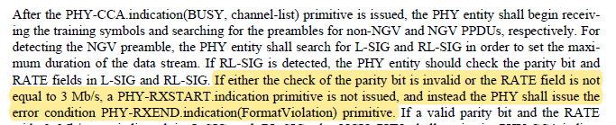

CID | P.L | Comment | Proposed Change | Resolution
5048 | 120.37 | Change "CRC fail" to "Invalid CRC or Reserved NGV-SIG indication" to be consistent with the paragraph description. | As in comment | Revised.  Agreed in principle. However, one modification should be the box for “Evaluate NGV-SIG” not “RX NGV-SIG” since Reserved NGV-SIG indication should be evaludated after CRC ok.  Further consideration is required as below.  Replace” CRC Fail” to Invalid CRC”  add "Reserved NGV-SIG Indication: Set PHY RXEND.indication(FormatViolation)" below the arrow from "Evaluate NGV-SIG" to "End of Wait"  TGbd Editor: Incorporate the changes in 11-22-0815-02-00bd- Resolutions to Transmit specification to NGV receive procedure. The corresponding visio file is in in 22/0826.
Discussion
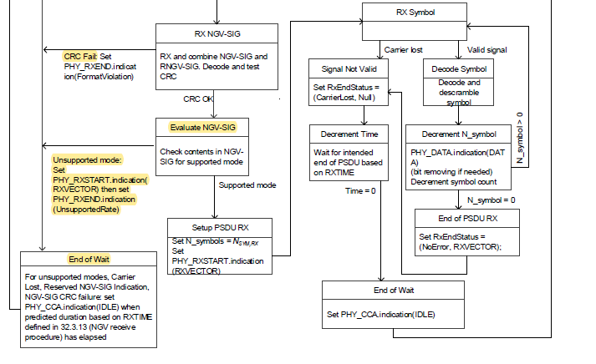
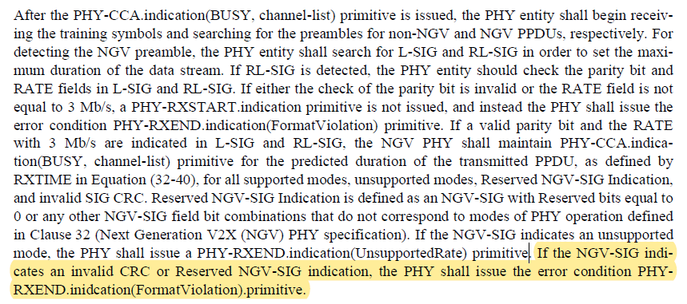

To TGbd Editor: P120L64update the description as below.
------------- Begin Text Changes ---------------
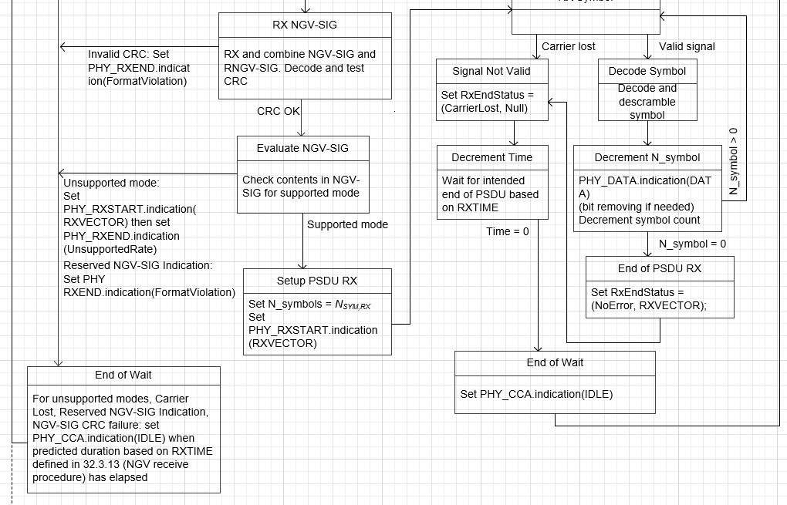
------------- End Text Changes ------------------

