IEEE P802.11
Wireless LANs
Resolutions to NGV PPDU format and Transmiter block diagram
Date: 2022-05-24
Author(s):
Name | Affiliation | Address | Phone | email
Yujin Noh | Senscomm |  |  | yujin.noh at senscomm.com
Abstract
This submission shows
- Comments from TGbd draft 4.0.
- Resolutions applied to TGbd draft 4.0.
- 3 CIDs:
5071, 5068, 5067

Revisions:
- Rev 0: Initial version of the document.
- Rev 1: update the resolution text of CID5068

CID | P.L | Comment | Proposed Change | Resolution
5071 | 75.47 | Change "PSDU_LENGTH" to "APEP_LENGTH" because PDSU_LENGTH (shown on P74L33) is not a TXVECTOR parameter. | As in comment | Acepted.
Discussion
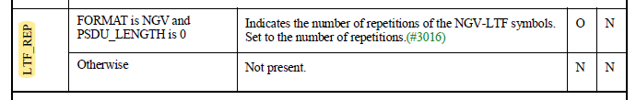

CID | P.L | Comment | Proposed Change | Resolution
5068 | 83.02 | Please add "CSD per chain is included in the Spatial Mapping block" to the end of the paragraph to account for item l) on P81L61. | As in comment | Rejected.  First of all, there is no paragraph corresponding to the l) CSD per chain insertion in the current specification since it is about the transmitter block diagram for the Data field. For some cases, Q (Spatial mapping) could be CSD per chain when it is not beamformed but Q is implementation depent, no reason to fix that CSD per chain is included in the Sptail Mapping block in 11bd.
5067 | 83.12 | Please remove the dotted vertical line on the left. NUM_SS is either 1 or 2 only for an NGV STA. The dotted vertical line on the right can be kept. | As in comment | Accepted.  To TGbd editor: location of the title of Figure 32-7 should be centered.
Discussion
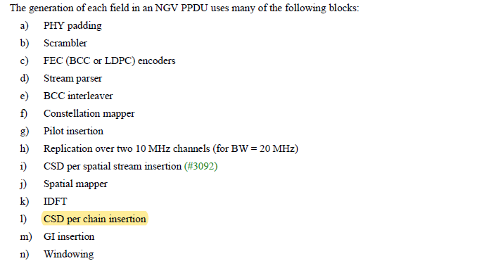
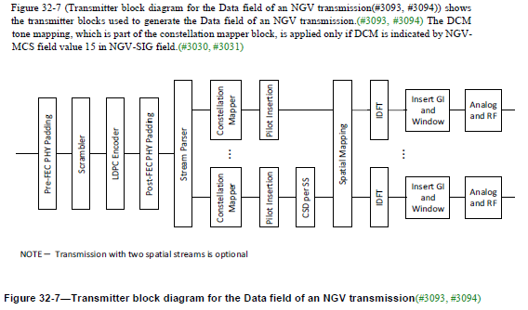

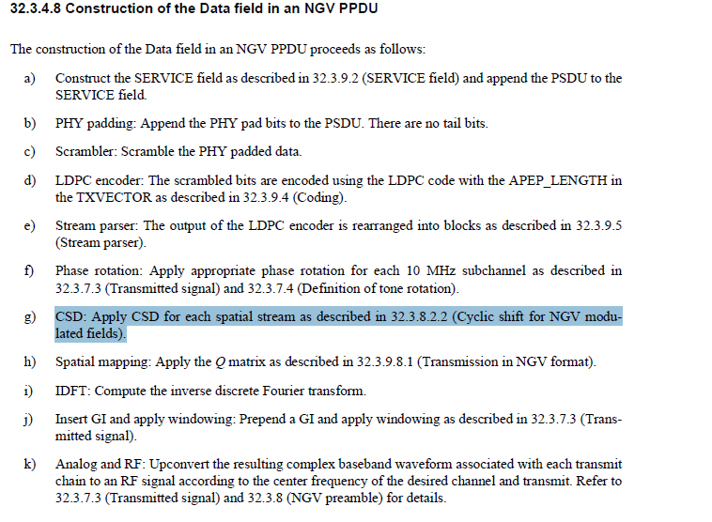

In 32.3.9.8.1 Transmission in NGV format,
