IEEE P802.11  
Wireless LANs

|  |  |  |  |  |
| --- | --- | --- | --- | --- |
| Resolutions to NGV preamble and Data field | | | | |
| Date: 2022-05-24 | | | | |
| Author(s): | | | | |
| Name | Affiliation | Address | Phone | email |
| Yujin Noh | Senscomm |  |  | yujin.noh at senscomm.com |
|  |  |  |  |  |

Abstract

This submission shows

* Comments from TGbd draft 4.0.
* Resolutions applied to TGbd draft 4.0.
* 8 CIDs:   
  5064, 5062, 5029, 5028, 5060, 5027, 5058, 5057

Revisions:

* Rev 0: Initial version of the document.
* Rev 1: updated CID during teleconference call.

|  |  |  |  |  |
| --- | --- | --- | --- | --- |
| **CID** | **P.L** | **Comment** | **Proposed Change** | **Resolution** |
| 5064 | 95.28 | Remove "pilot" from the sentence. It is the first value of the pn sequence not a pilot value. Similarly, please also remove "pilot" from L64 on the same page and on P98L5. | As in comment | Rejected.  Since this description has been used in common and its meansing is well understood for IEEE 2020 specification, better to keep it as it is to be consistent with IEEE 2020 specification. |

***Discussion***

At 95.26 of 11bd D4.0,

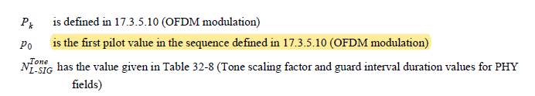

In 17.3.5.10 (OFDM modulation)

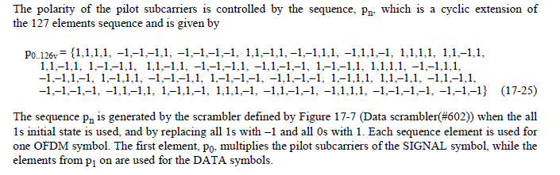

However, in 11ac, 11ax, and other amendments, since it is still using the same description as the first pilot value *p0* in the sequence and commonly used this way, better to keep as it is.

In 11ac as below,

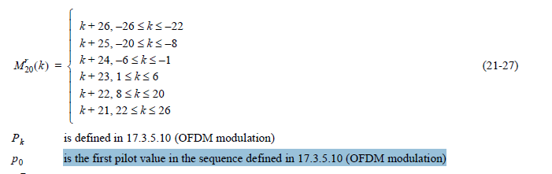

|  |  |  |  |  |
| --- | --- | --- | --- | --- |
| **CID** | **P.L** | **Comment** | **Proposed Change** | **Resolution** |
| 5062 | 101.38 | The caption of Figure 32-10 shows NGV-LTF. N_SS is either 1 or 2 in an NGV PPDU. | Remove one extra box of "CSD per SS" and the dotted vertical lines associated with it. This proposed change is applied to Figure 32-11 as well. | Accepted. |

***Discussion***

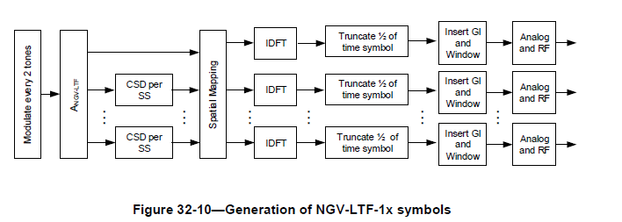

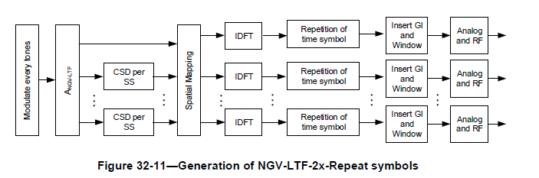

|  |  |  |  |  |
| --- | --- | --- | --- | --- |
| **CID** | **P.L** | **Comment** | **Proposed Change** | **Resolution** |
| 5029 | 104.14 | The sentence does not read well and can be improved. In addition, the last part "and the LDPC Extra Symbol filed setting in NGV-SIG" seems irrelavent. | Suggest to change to "The Data field of an NGV PPDU shall use LDPC coding. The LDPC code and encoding process shall follow the same definition as described in 21.3.10.5.4 (LDPC coding) for a VHT SU PPDU with parameter m_STBC set to 1". | Revised.  Agreed in principle. One long sentence is better to be split. However, NGV-SIG is required because the value of LDPC Extra Symbol field in NGV-SIG (not VHT-SIG-A) needs to be used.  TGbd Editor: change to “The Data field of an NGV PPDU shall be encoded using LDPC coding. The LDPC code and encoding process shall follow as described in 21.3.10.5.4 (LDPC coding) for a VHT SU PPDU with parameter m_STBC set to 1 and the LDPC Extra Symbol field setting in NGV-SIG. |

***Discussion***

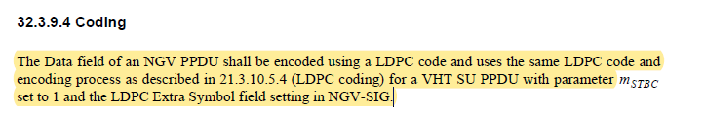

|  |  |  |  |  |
| --- | --- | --- | --- | --- |
| **CID** | **P.L** | **Comment** | **Proposed Change** | **Resolution** |
| 5028 | 104.21 | "FEC encoders" shall be changed to "FEC encoder" as there is only one encoder for LDPC. | as in the comment. | Accepted. |

***Discussion***

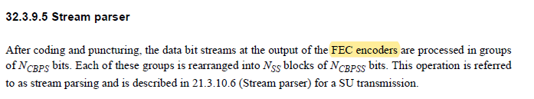

|  |  |  |  |  |
| --- | --- | --- | --- | --- |
| **CID** | **P.L** | **Comment** | **Proposed Change** | **Resolution** |
| 5060 | 104.41 | The symbol d'k appears once and not used elsewhere. | Please clarify and complete its usage or delete it if not needed. | Revised.  Agreed in principle.  TGbd Editor: Incorporate the changes in 11-22-0813-01-00bd-Resolutions to Resolutions to NGV preamble and Data field. |

***Discussion***

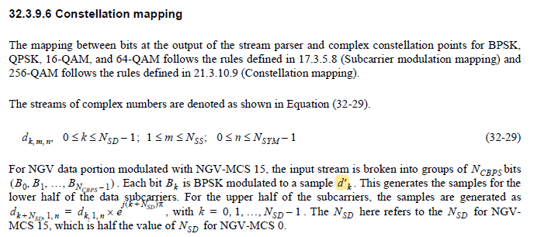

***To TGbd Editor:*** ***P104L40*** *update the description as below.*

***------------- Begin Text Changes ---------------***

For NGV data portion modulated with NGV-MCS 15, the input stream is broken into groups of bits . Each bit  is BPSK modulated to a sample . This generates the samples for the lower half of the data subcarriers. For the upper half of the subcarriers, the samples are generated as $d_{k+N_{SD}, 1,n}^{'}=d_{k, 1,n}^{'}×e^{j(k+N_{SD})π}$, with . The  here refers to the  for NGV-MCS 15, which is half the value of  for NGV-MCS 0.

***------------- End Text Changes ------------------***

|  |  |  |  |  |
| --- | --- | --- | --- | --- |
| **CID** | **P.L** | **Comment** | **Proposed Change** | **Resolution** |
| 5027 | 105.15 | NGV-LTF-2x-Repeat format is not included, suggest to either remove "for NGV-LTF-1x and NGV-LTF-2x" or add "NGV-LTF-2x-Repeat" to the list. | as in the comment. | Revised.  Agreed in principle.  TGbd Editor: add "NGV-LTF-2x-Repeat" to the list. Change “NGV-LTF-1x and NGV-LTF-2x” to “NGV-LTF-1x, NGV-LTF-2x, and NGV-LTF-2x-Repeat” |

***Discussion***



|  |  |  |  |  |
| --- | --- | --- | --- | --- |
| **CID** | **P.L** | **Comment** | **Proposed Change** | **Resolution** |
| 5058 | 107.35 | The use of midamble is required in the NGV PPDU. | Remove "If present" and fix the sentence. | Rejected.  The midamble feature shall be supported but it does not mean midamble is inserted in every PPDU. For example, the number of OFDM symbol is small enough, there is a case that midamble is not existed in PPDU. So “If present” is necessary under the condition with Equation (32-35) |

***Discussion***

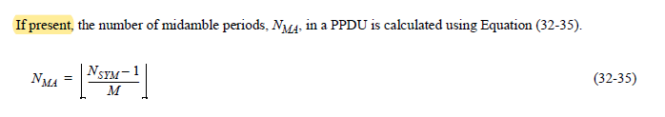

|  |  |  |  |  |
| --- | --- | --- | --- | --- |
| **CID** | **P.L** | **Comment** | **Proposed Change** | **Resolution** |
| 5057 | 107.63 | The NON_NGV_10 duplicate PPDU may be received by a non NGV STA. For the backward compatibility, the modulation dependent power scaling factor in the L-STF and L-LTF fields is not applied. | Add "the modulation dependent power scaling factor in the L-STF and L-LTF fields is set to 1 and that" immediately following except that. | Revised.  Agreed in principle. However, power scaling factor squre root (2) is applied under the specified condition which are found at 91.13 and 93.16. This value is not applicable to NON_NGV_10 duplicate PPDU for 20MHz transmission. Adding Note could make the text clear.  TGbd Editor: Incorporate the changes in 11-22-0813-01-00bd-Resolutions to NGV preamble and NGV receive procedure. |

***Discussion***

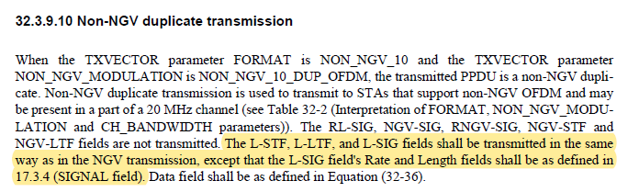

In 32.3.7.3 (Transmitted signal), power scaling factor is applied under the specified conditions as below.

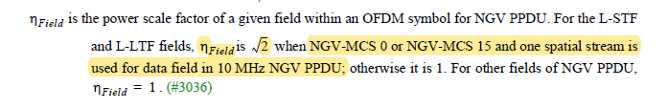

***To TGbd Editor:*** ***P107L54*** *update the description as below.*

***------------- Begin Text Changes ---------------***

When the TXVECTOR parameter FORMAT is NON_NGV_10 and the TXVECTOR parameter NON_NGV_MODULATION is NON_NGV_10_DUP_OFDM, the transmitted PPDU is a non-NGV duplicate. Non-NGV duplicate transmission is used to transmit to STAs that support non-NGV OFDM and may be present in a part of a 20 MHz channel (see Table 32-2 (Interpretation of FORMAT, NON_NGV_MODULATION and CH_BANDWIDTH parameters)). The RL-SIG, NGV-SIG, RNGV-SIG, NGV-STF and NGV-LTF fields are not transmitted. The L-STF, L-LTF, and L-SIG fields shall be transmitted in the same way as in the NGV transmission, except that the L-SIG field's Rate and Length fields shall be as defined in 17.3.4 (SIGNAL field). Data field shall be as defined in Equation (32-36).

NOTE — For L-STF and L-LTF fields, the power scale factor is 1 in 20 MHz non-NGV duplicate PPDU.

***------------- End Text Changes ------------------***