IEEE P802.11
Wireless LANs
Resolutions to Editorial Comments Part 3
Date: 2022-05-11
Author(s):
Name | Affiliation | Address | Phone | email
Yujin Noh | Senscomm |  |  | yujin.noh at senscomm.com
Abstract
This submission shows
- Comments from TGbd draft 4.0.
- Resolutions applied to TGbd draft 4.0.
- 9 CIDs:
5051, 5026, 5017, 5014, 5034, 5013, 5063, 5061, 5059

Revisions:
- Rev 0: Initial version of the document.
- Rev 1: updated based on the teleconference call.

CID | P.L | Comment | Proposed Change | Resolution
5051 | 118.37 | Change "space-time stream" to "spatial streams." | As in comment | Accepted.
Discussion

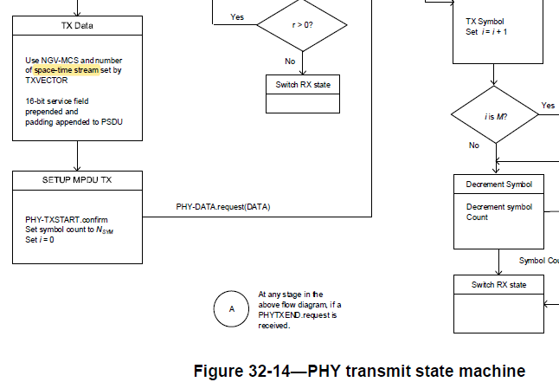

CID | P.L | Comment | Proposed Change | Resolution
5026 | 122.41 | To follow other amendment, suggest to move 32.3.15 (NGV ranging NDP) forward and before "Transmit specification". | as in the comment. | Rejected.  There is no technical reason to reorganize the subclause.
Discussion
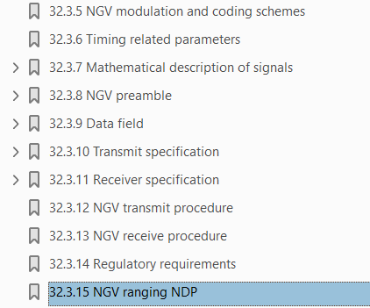

CID | P.L | Comment | Proposed Change | Resolution
5017 | 80.62 | "per NGV-LTF symbols" should be "per NGV-LTF symbol". | As in comment | Accepted.
Discussion

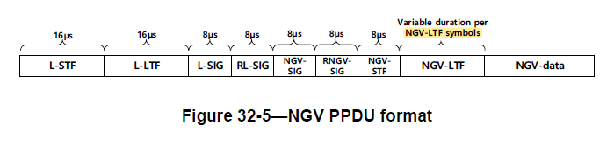

CID | P.L | Comment | Proposed Change | Resolution
5014 | 82.44 | BPSK-DCM is one of the modulation type, but not DCM. | Change DCM to BPSK-DCM. Other places in the document should be changed as well. | Revised.  To TGbd editor:  Change DCM to BPSK-DCM at P82L44.  Change “dualcarrier  modulation (DCM)” to “BPSK- dualcarrier modulation (DCM)” at P69L22
5013 | 86.64 | Change DCM to BPSK-DCM, which is one of the modulation type. | Delete the first sentence and change the second sentence to "The use of BPSK-DCM on the Data field of an NGV PPDU is indicated…" | Accepted

Discussion
At P82L44,
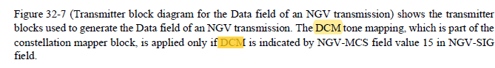

At P69L22,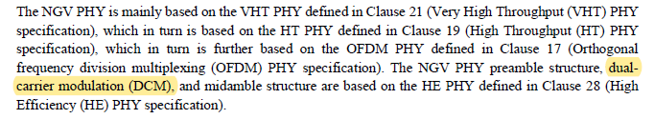

At P86L64,

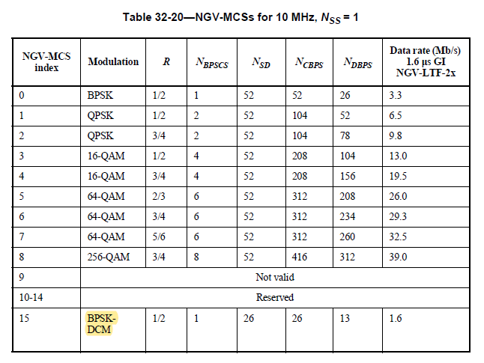

CID | P.L | Comment | Proposed Change | Resolution
5034 | 84.62 | In step a), a space is missing between "LTF_REP" and "Add". | as in the comment. | Accepted
Discussion

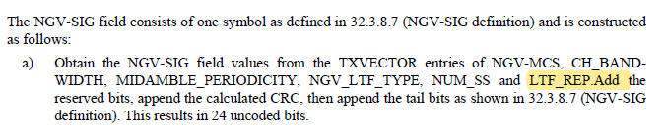

CID | P.L | Comment | Proposed Change | Resolution
5063 | 96.60 | Make a space immediately following the 2nd period on this line. | As in comment | Accepted.
Discussion

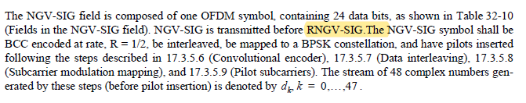

CID | P.L | Comment | Proposed Change | Resolution
5061 | 104.34 | It would be more clear for dk,m,n in equation (32-29) by adding "out of constellation mapping" immediately following "The streams of complex numbers." | As in comment | Accepted
Discussion

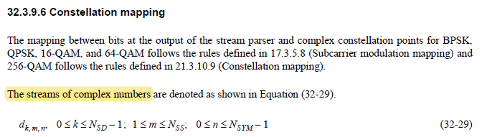

CID | P.L | Comment | Proposed Change | Resolution
5059 | 107.12 | Suggest unifying the style of nth (L12 & L13) and M-th (L50) on this page. | As in comment | Revised.  Agreed in principle.  TGbd Editor:  Change n^th to n-th at P107L12 and P107L13
Discussion

