IEEE P802.11
Wireless LANs
Resolutions to Editorial Comments Part 2
Date: 2022-05-11
Author(s):
Name | Affiliation | Address | Phone | email
Yujin Noh | Senscomm |  |  | yujin.noh at senscomm.com
Abstract
This submission shows
- Comments from TGbd draft 4.0.
- Resolutions applied to TGbd draft 4.0.
- 15 CIDs:
5095, 5016, 5009, 5015, 5036, 5037, 5021, 5022, 5023, 5024,
5018, 5073, 5075, 5077, 5078

Revisions:
- Rev 0: Initial version of the document.
- Rev 1: updated based on teleconference call

CID | P.L | Comment | Proposed Change | Resolution
5095 | 61.15 | Please add comma after "If ... is true" | As in the comment | Accepted
Discussion
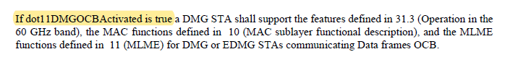

CID | P.L | Comment | Proposed Change | Resolution
5016 | 61.44 | Change "transmit either of a non-NGV PPDU or an NGV PPDU" to "transmit either a non-NGV PPDU or an NGV PPDU" | as in comment | Accepted.
Discussion
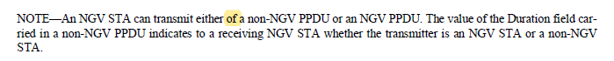

CID | P.L | Comment | Proposed Change | Resolution
5009 | 67.14 | The sentence starting with "For ranging on IEEE Std. 802.11 bands ..." should not be part of the last bullet but a new paragraph as in D3.0. | As in comment | Accepted.
Discussion
At P67L14,
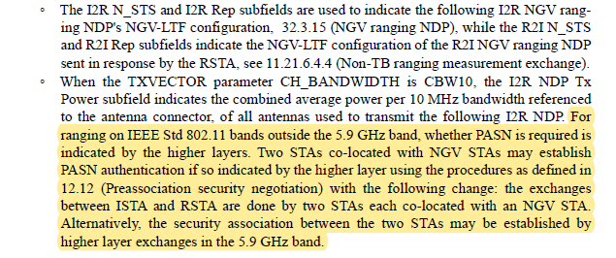

In 11bd D3.0,
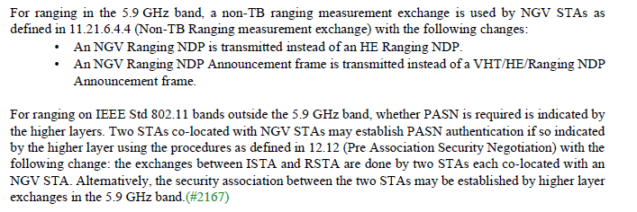

CID | P.L | Comment | Proposed Change | Resolution
5015 | 66.01 | The sentence is confusing. | Change to "Fine timing measurement procedures, including negotiation and termination, for non-TB ranging …" | Revised  Agreed in principle. 11.21.6.3 (Fine timing measurement procedure negotiation) is only the FTM procedure negotiation. The FTM session termination is in 11.21.6.6 (Fine Timing Measurement session termination).  To TGbd editor:  Change the sentence at P66L01 to “Fine timing measurement procedures, including FTM procedure negotiation and FTM session termination for non-TB ranging as defined in 11.21.6.3 (Fine timing measurement procedure negotiation) and in 11.21.6.6 (Fine Timing Measurement session termination), with the modifications specified in this  subclause.”
Discussion
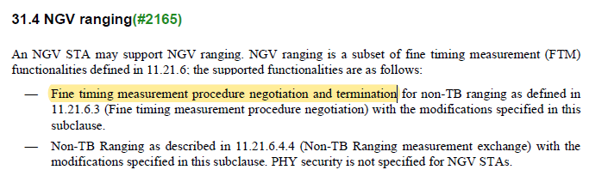

CID | P.L | Comment | Proposed Change | Resolution
5036 | 68.23 | "(The SME is notified of the status …)" should be linked to a reference, rather than the text. | as in the comment. | Revised.  Its reference should be “6.3.129 (NGV radio environment measurement)”  TGbd Editor:  Change "(The SME is notified of the status …)" to “6.3.129 (NGV radio environment measurement)”
5037 | 68.17 | "(The SME is notified of the status …)" should be linked to a reference, rather than the text. | as in the comment. | Revised.  Its reference should be “6.3.129 (NGV radio environment measurement)”  TGbd Editor:  Change "(The SME is notified of the status …)" to “6.3.129 (NGV radio environment measurement)”
Discussion
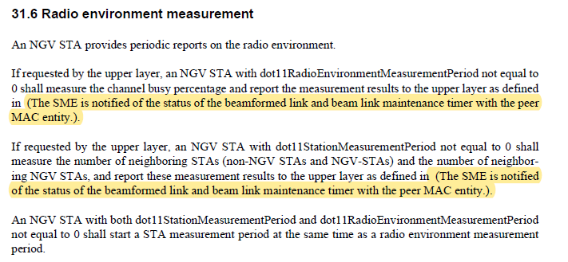
In 11bd D3.0
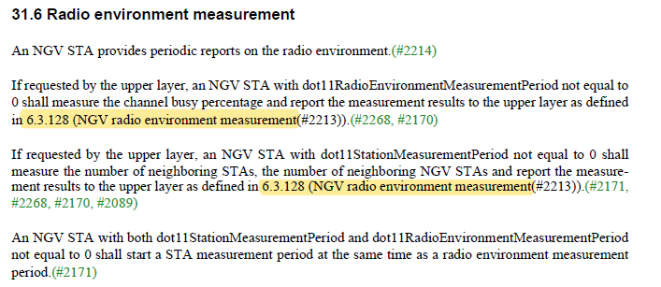
In 11bd D4.0
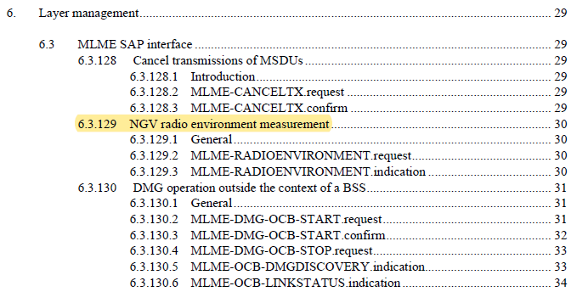

CID | P.L | Comment | Proposed Change | Resolution
5021 | 69.59 | "An NGV PHY may support the following features" should be "An NGV STA may support the following PHY features" | As in comment | Accepted.
5022 | 69.41 | "An NGV PHY shall support the following features" should be "An NGV STA shall support the following PHY features" | As in comment | Accepted
Discussion
…

In 11ax,
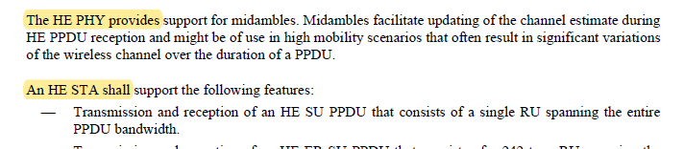
…
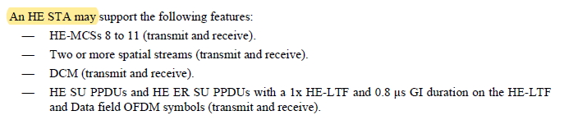

CID | P.L | Comment | Proposed Change | Resolution
5023 | 69.56 | All CID tags should be removed. | As in comment | Accepted.

CID | P.L | Comment | Proposed Change | Resolution
5024 | 70.28 | The title of this subclause should be "PHY layer management entity (PLME)". | As in comment | Accepted
Discussion
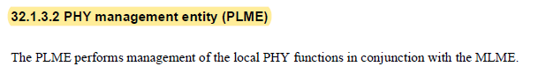
In 11ac,
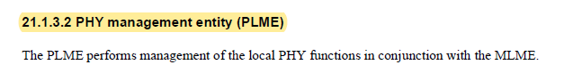

CID | P.L | Comment | Proposed Change | Resolution
5018 | 75.19 | Remove space between "CBW" and "20". | As in comment | Accepted.
5073 | 75.19 | Remove the space between CHW and 20 for consistency with CHW10. | As in comment | Accepted
Discussion

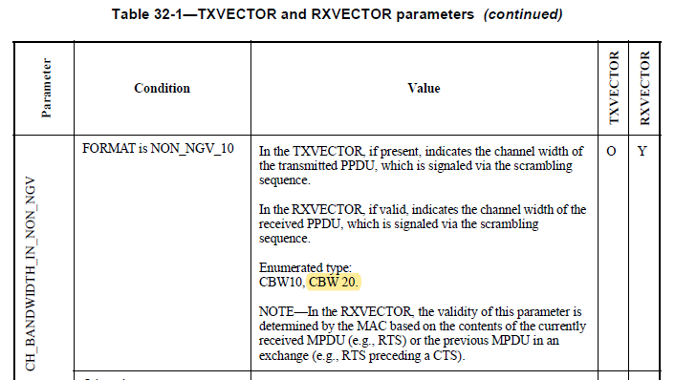

CID | P.L | Comment | Proposed Change | Resolution
5075 | 74.28 | in subclause 11.21.6.4.6 (Transmission of a ranging NDP), the APEP_LENGTH parameter is set to 0 to indicate a ranging NDP. Need to keep consistency here. | Add "The value of 0 indicates an NGV ranging NDP." at the end of the description. Also, need to change the starting value to 0 from 1. | Revised.  Agreed in principle.  TGbd Editor:  Replace the description as below.  If 0, indicates an NGV ranging NDP.  Otherwise, indicates the number of octets in the range 1 to …. that is carried in the PSDU”
Discussion

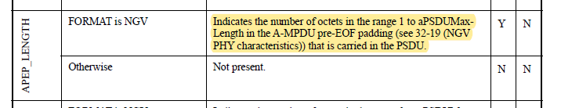

CID | P.L | Comment | Proposed Change | Resolution
5077 | 73.24 | Suggest changing "the type of NGV-LTF" to "the NGV-LTF format." LTF "format" seems used more frequently than LTF "type" in this amendment. | As in comment | Rejected.  In the different amendments, same descriptions have been used without any technical issues. It is good to have consistent descriptions through different amendments for better understandings.
Discussion
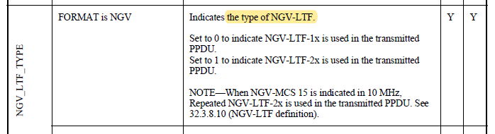

In 11ax,
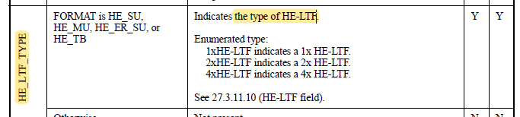

In 11be,
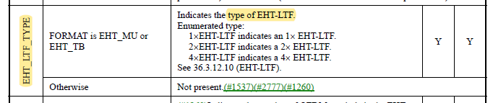

CID | P.L | Comment | Proposed Change | Resolution
5078 | 72.44 | Suggest adding "Note: Set to 0 for NGV ranging NDP" as required in 32.3.15 (NGV ranging NDP) at the bottom of the Value description. | As in comment | Revised.  Agreed in principle.  TGbd Editor:  Add “Note: Set to 0 for NGV ranging NDP. See 32.3.15 (NGV ranging NDP)” below the value description.
Discussion
