IEEE P802.11
Wireless LANs
Resolutions to Editorial Comments Part 1
Date: 2022-05-11
Author(s):
Name | Affiliation | Address | Phone | email
Yujin Noh | Senscomm |  |  | yujin.noh at senscomm.com
Abstract
This submission shows
- Comments from TGbd draft 4.0.
- Resolutions applied to TGbd draft 4.0.
- 10 CIDs:
5002, 5096, 5010, 5105, 5012, 5042, 5011, 5104, 5097, 5094

Revisions:
- Rev 0: Initial version of the document.
- Rev 1: CID5094 updated.

CID | P.L | Comment | Proposed Change | Resolution
5002 | 0.00 | Check for typos: "inset" used instead "insert", "subcaluse" used instead "subclause", "a NGV..." used instead of "an NGV..." | see comment | Revised.  Agreed in principle.  TGbd Editor:  Change “inset” to “insert” at P47L40.  Change " subcaluse” to "subclause" at P53L9 and  P53L21  Change “a NGV” to “an NGV” at P45L23, P67L28, P84L24, P125L42.
Discussion

At P47L40,
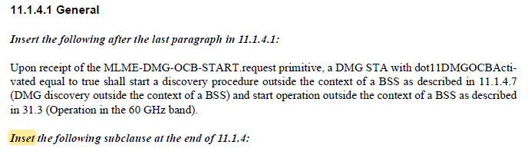
At P53L9 and P53L21,
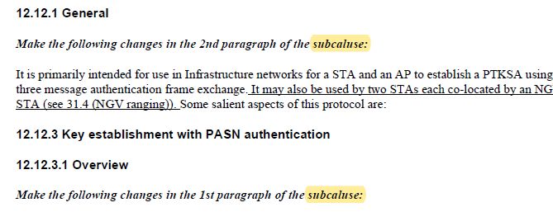
At P47L40, and additional four locations.
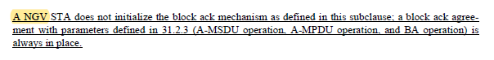

CID | P.L | Comment | Proposed Change | Resolution
5096 | 43.46 | "a beam link is not maintained" - "a beamformed link" should be consistent to description in 11.27.1.1. | Change to "a beamformed link is not maintained" | Revised.  Agreed in principle. Additional editorial fix is required.  To TGbd editor  Change to "a beamformed link is not maintained"  Add space between “maintained” and “If”
Discussion

At P43L46,
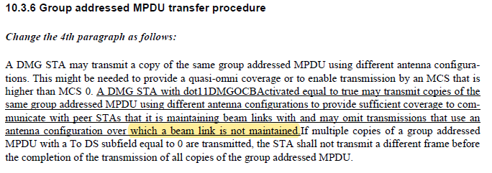
At 11.27.1 (Beamformed link maintenance)
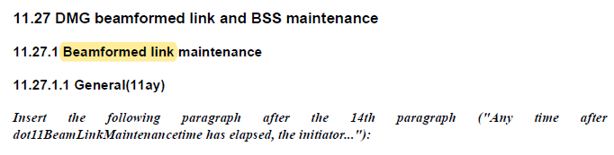

CID | P.L | Comment | Proposed Change |  | Resolution
5010 | 52.30 | "a A DMG STA" should be "a DMG STA" |  | As in comment | Accepted.
Discussion

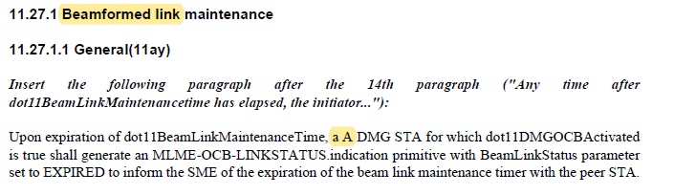

CID | P.L | Comment | Proposed Change | Resolution
5105 | 19.14 | "Clause" is missing before "10" and "11". Note: same comment as CID4012 (for subclause 31.1), but please apply the same for subclause 4.3.17. | As in the comment | Revised.  Agreed in principle. Additional location should be fixed as well.  TGbd Editor:  Add “Clause” to 10 and 11 at P19L14  Add “Clause” to 10 and 11 at P19L14 and P61L12, P61L17
Discussion

At P19L14
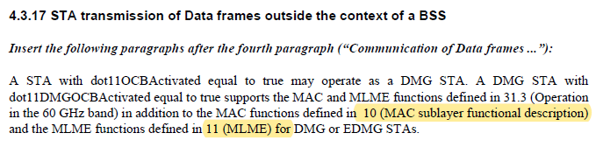

At P61L12 and P61L17
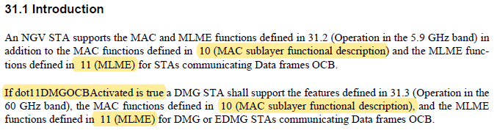

CID | P.L | Comment | Proposed Change | Resolution
5012 | 19.27 | "An Next " should read "A Next" since the pronounciation is a consonant | Replace "An" with "A" since the pronounciation following is a consonant | Accepted
Discussion
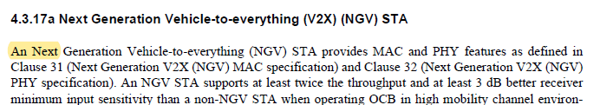

CID | P.L | Comment | Proposed Change | Resolution
5042 | 20.31 | Plural needed | In "primary and ... secondary channel" replace "channel" with "channels". | Accepted
Discussion
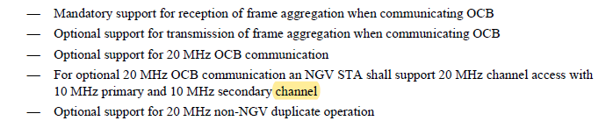

CID | P.L | Comment | Proposed Change | Resolution
5011 | 20.62 | Before it read "for which dot11OCBActivated is true". Now it is changed to "with dot11OCBActivated is true", which is grammtically incorrect. Please rephrase, e.g. "with dot11OCBActivated equal to true" | As in comment | Accepted.
Discussion

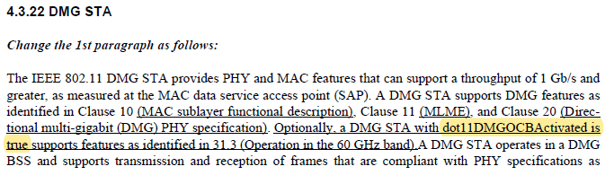

CID | P.L | Comment | Proposed Change | Resolution
5104 | 24.22 | Please remove unnecessary space between "NGV-" and "MCS" | As in the comment | Accepted.
Discussion
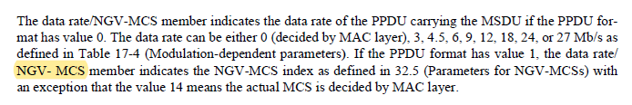

CID | P.L | Comment | Proposed Change | Resolution
5097 | 39.57 | Instruction for 9.4.2.298 is incorrect. Subclause 9.4.2.298 (Ranging Parameters element) exists in 11az already, while 9.4.2.308 (DMG OCB element) is new. | Remove the instruction "Insert the following after the last subclause of 9.4.2:" for 9.4.2.298, and insert it before 9.4.2.308. | Accepted
Discussion
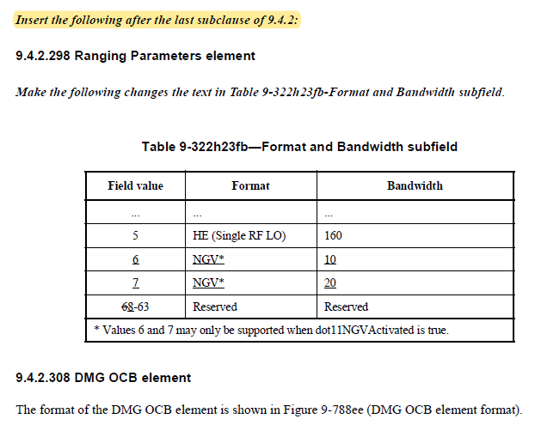

CID | P.L | Comment | Proposed Change | Resolution
5094 | 133.20 | Some error in the reference for NGVE1.1 (unnecessary text "(The SME is notified ... MAC entity.)") | Please fix the cross reference. | Revised.  To TGbd editor  Delete "The SME is notified ... MAC entity.”, and add the proper cross-reference “6.3.129 (NGV radio environment measurement)”
Discussion
In 11bd D4.0,
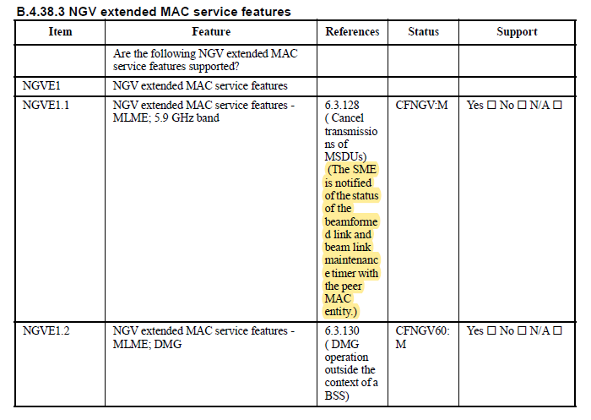

In 11bd D3.0,
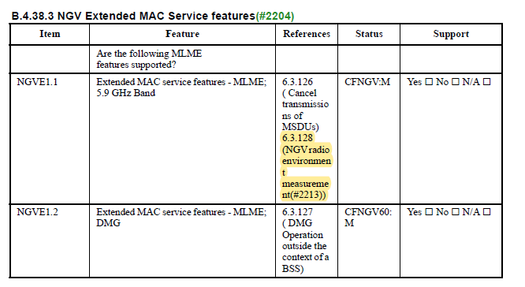
In 11bd D4.0,
