IEEE P802.11
Wireless LANs
EHT-MCS And NSS Set Fix
Date: 2022-05-06
Author(s):
Name | Affiliation | Address | Phone | email
Kanke Wu | Qualcomm, Inc. | 5775 Morehouse Dr.  San Diego, CA 92121 |  | kankew@qti.qualcomm.com
Bin Tian
Youhan Kim

Abstract
This submission provides text update to fix the Supported EHT-MCS And NSS Set field for EHT APs which supports only 20 MHz channel width in the 2.4 GHz band.

Revision History:

R0: Initial version.

Background:

In a previous contribution 11-21/1003r0, an updated spec text was proposed to clarify MCS and Nss support in 2.4GHz. The proposed change was included in D1.2. However, we found there is an error introduced by the updated text. This document proposes a change to fix such error.

The “Supported EHT-MCS And NSS Set” field is used to convey what the number of spatial streams and MCS’s are supported for different PPDU bandwidths by a STA, and has different format depending on the bandwidth capability of the STA – see Figure 9-1002ah (11be D1.5 P216).

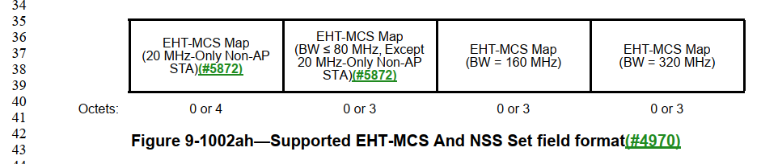

An EHT AP that supports only 20MHz channel width in the 2.4 GHz band (referred to as “20 MHz EHT AP” for the remainder of this document) sets B0 of the “Supported Channel Width Set” in the “HE PHY Capabilities Information” field of the EHT Capabilities element to 0 (see REVme D1.2 P1690L24).

Note that the subfield “EHT-MCS Map (BW<=80MHz, Except 20 MHz-Only Non-AP STA)” does not exist for an AP as indicated in the highlighted section below (D1.5 P218L18).
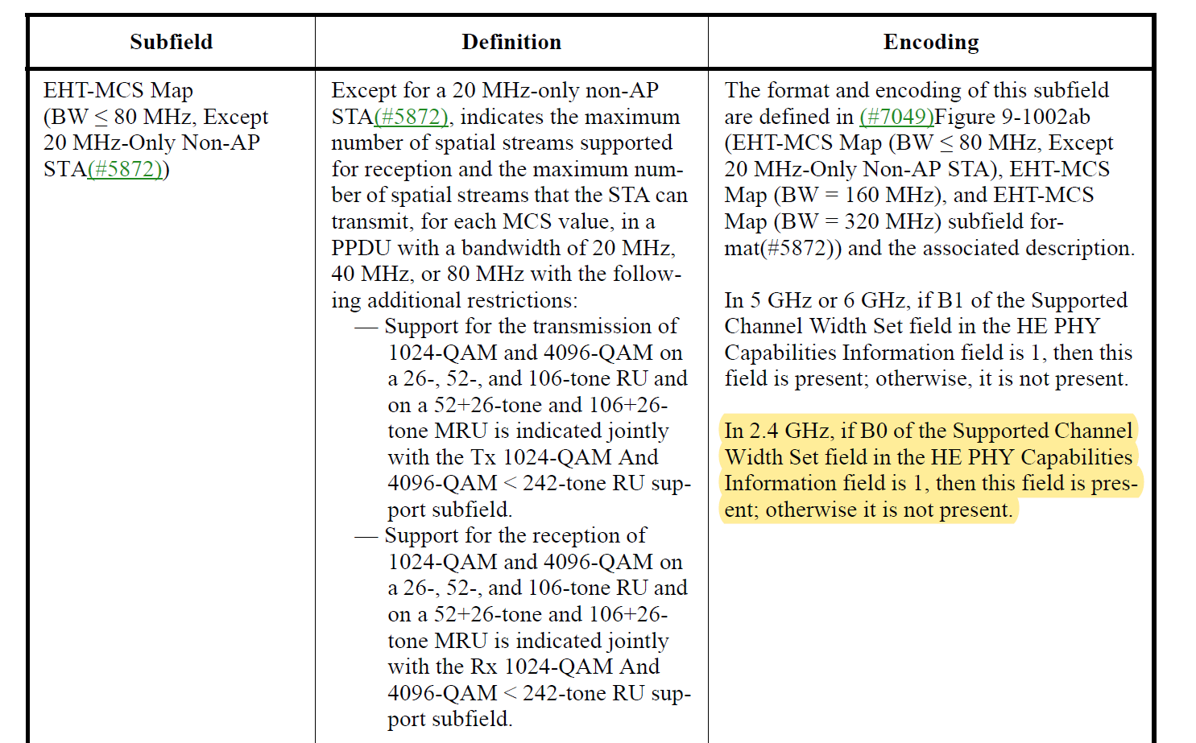

Furthermore, “EHT-MCS Map (20 MHz-Only Non-AP STA)” is used only by 20 MHz-Only Non-AP STA, hence is not present for an AP.
This results in a situation where a 20MHz EHT AP will not have any subfields in the EHT-MCS And NSS Set field.

Note that it is mandatory for an EHT AP to support MCS0-9. And the EHT-MCS Map (20 MHz-Only Non-AP STA)” is designed to allow indicating no support for MCS 8-9 (for the 20 MHz-only non-AP STA). Hence, it is not appropriate to be used by the 20 MHz EHT AP.

The proposed fix, therefore, is to have the 20 MHz EHT AP to use the “EHT-MCS Map (BW ≤ 80 MHz, Except 20 MHz-Only Non-AP STA)” subfield to indicate its Nss and MCS capabilities.

Proposed text change

Instruction to TGbe Editor: Update Table 9-401m at D1.5 P218L12 as shown below.

Table 9-401m—Subfields of the Supported EHT-MCS And NSS Set field

Subfield | Definition | Encoding
EHT-MCS Map  (BW ≤ 80 MHz, Except 20 MHz-Only Non-AP STA) | Except for a 20 MHz-only non-AP STA, indicates the maximum number of spatial streams supported for reception and the maximum num- ber of spatial streams that the STA can transmit, for each MCS value, in a PPDU with a bandwidth of 20 MHz, 40 MHz, or 80 MHz with the follow- ing additional restrictions:  - Support for the transmission of 1024-QAM and 4096-QAM on  a 26-, 52-, and 106-tone RU and on a 52+26-tone and 106+26- tone MRU is indicated jointly with the Tx 1024-QAM And 4096-QAM < 242-tone RU sup- port subfield.  - Support for the reception of 1024-QAM and 4096-QAM on  a 26-, 52-, and 106-tone RU and on a 52+26-tone and 106+26- tone MRU is indicated jointly with the Rx 1024-QAM And 4096-QAM < 242-tone RU sup- port subfield.  For a 20 MHz or 80 MHz operating non-AP STA, additionally indicates the maximum number of spatial streams supported for reception and the maximum number of spatial streams that the non-AP STA can transmit, for each MCS value, in a PPDU with a bandwidth of 160 MHz or 320 MHz with the following addi- tional restrictions:  - Support for the reception of 1024-QAM in a 160 MHz, or 320 MHz EHT DL OFDMA is  indicated jointly with the Rx 1024-QAM In Wider Bandwidth DL OFDMA Support subfield.  - Support for the reception of 4096-QAM in a 160 MHz, or 320 MHz EHT DL OFDMA is  indicated jointly with the Rx 4096-QAM In Wider Bandwidth DL OFDMA Support subfield. | The format and encoding of this subfield are defined in Figure 9-1002aj (EHT-MCS Map (BW ≤ 80 MHz, Except 20 MHz-Only Non-AP STA), EHT-MCS Map (BW = 160 MHz), and EHT-MCS  Map (BW = 320 MHz) subfield format) and the associated description.  For an AP, this field is always present.  For a non-AP STA:  - In 5 GHz or 6 GHz, if B1 of the Supported Channel Width Set field in the HE PHY Capabilities Information field is 1, then this field is present; otherwise, it is not present.  - In 2.4 GHz, if B0 of the Supported Channel Width Set field in the HE PHY Capabilities Information field is 1, then this field is present; otherwise it is not present.

