IEEE P802.11
Wireless LANs
Proposed text for Annex B
Date: 2022-04-20
Author(s):
Name | Affiliation | Address | Phone | email
Chong Han | pureLiFi |  |  | Chong.han@purelifi.com
Nikola Serafimovski | pureLiFi |  |  | nikola.serafimovski@purelifi.com
Robert Stacey | Intel |  |  | Robert.stacey@intel.com
Edward Au | Huawei
Jon Rosdahl | Qualcomm
Nancy Lee | Signify
Abstract
Proposed text for LC Annex B

Discussion: Highlighted text preceded by “Discussion” are not to be copied into the TGbb Draft. Such text provides rationale for the proposed changes.

History
R0: proposal of the text for Annex B.
R2: Captures group edits during discussion on the May 12 telecons

Annex B

B.4 PICS proforma—IEEE Std 802.11-2020
B.2.2 General abbreviations for Item and Support columns

Editor: Insert the following acronym:

LC Light communications

B.4.3 IUT configuration
According to P4924L40-42 in P802.11REmeD1.0:
‘If feature F1 is required if feature F2 is supported, is optional if feature F3 is supported, and is not relevant otherwise, this can be represented in the PICS in one way:
— The status for conditional item F1 is “F2:M” and “F3:O”.’

Here, the HT is F1, LC is F3. In the P802.11bb, HT (F1) is optional if feature LC (F3) is supported. So is VHT and HE. Hence, changes need to be made on existing line for HT, VHT and HE.

For the new line for LC (CFLC), since no standard is working on top of LC yet, it is purely an Optional status. See the examples on P4930L39 and P4931L51 in P802.11REmeD1.0.

Reference of P4924 in P802.11REmeD1.0 regarding the examples for the Status column:
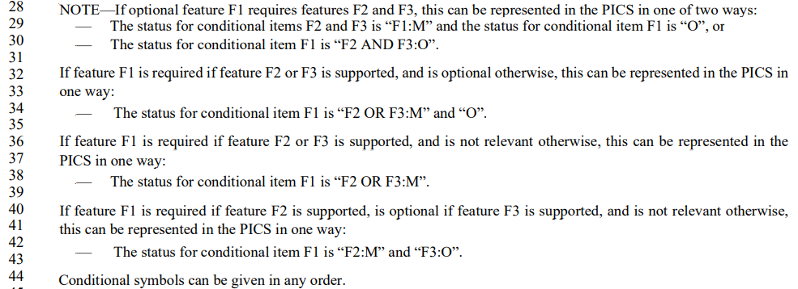
the examples for the Status column

Editor: Change the unnumbered table as follows:
Item | IUT configuration |  | References | Status | Support
*CFLC | Light communications |  | 4.3.31 (Light Communications (LC) STA) | CFHT OR CFVHT OR CFHE: O | Yes □ No □

Editor: change the title of B.4.37 as follows:

B.4. 37 Light communications (LC) features
Editor: Delete the entire subclause B.4.37.1 and the subclause title B.4.37.2.

Editor: Change the unnumbered table as follows:

Item | Protocol capability | References | Status | Support
 | Are the following PHY protocol features supported?
LCP1 | LC PHY operating modes
*LCP1.1 | LC PHY HT mode | 32.3.3.2 LC High Throughput (LC HT) mode | CFHT5G: O.1 | Yes □ No □ N/A □
*LCP1.2 | LC PHY VHT mode | 32.3.3.3 LC Very High Throughput (LC VHT) mode | CFVHT: O.1 | Yes □ No □ N/A □
*LCP1.3 | LC PHY HE mode | 32.3.3.4 LC High Efficiency (LC HE) mode | CFHE5G OR CFHE6G: O.1 | Yes □ No □ N/A □
LCP2 | LC PPDU format | 32.1.2 (Physical protocol data (PPDU) formats)
LCP2.1 | HT PPDU format | 32.1.2 (Physical protocol data (PPDU) formats) | LCP1.1: M | Yes □ No □ N/A □
LCP2.2 | VHT PPDU format | 32.1.2 (Physical protocol data (PPDU) formats) | LCP1.2: M | Yes □ No □ N/A □
LCP2.3 | HE PPDU format | 32.1.2 (Physical protocol data (PPDU) formats) | LCP1.3: M | Yes □ No □ N/A □
LCP3 | Channel numbering and channelization | 32.3.4 (Channel numbering)
LCP3.1 | 5 GHz band mapping | 32.3.4 (Channel numbering) | CFLC: O.2 | Yes □ No □ N/A □
LCP3.2 | 6 GHz band mapping | 32.3.4 (Channel numbering) | CFLC: O.2 | Yes □ No □ N/A □
LCP4 | Multiple transmit and receive chains | 32.3.5 (Multiple transmitters and receivers)
LCP4.1 | More than one transmit chain | 32.3.5 (Multiple transmitters and receivers) | CFLC: O | Yes □ No □ N/A □
LCP4.2 | More than one receive chain | 32.3.5 (Multiple transmitters and receivers) | CFLC: O | Yes □ No □ N/A □
LCP5 | LC CCA requirements | 32.3.6.1 (CCA requirements) | CFLC: M | Yes □ No □ N/A □
LCP6 | LC repetition mechanism | 32.3.6.2 (LC repetition) | CFLC: O | Yes □ No □ N/A □

