IEEE P802.11
Wireless LANs
Proposed text for Annex B
Date: 2022-04-20
Author(s):
Name | Affiliation | Address | Phone | email
Chong Han | pureLiFi |  |  | Chong.han@purelifi.com
Abstract
Proposed text for LC Annex B

Discussion: Highlighted text preceded by “Discussion” are not to be copied into the TGbb Draft. Such text provides rationale for the proposed changes.

History
R0: proposal of the text for Annex B.

Annex B

B.4 PICS proforma—IEEE Std 802.11-2020

B.4.3 IUT configuration
According to P4924L40-42 in P802.11REmeD1.0:
‘If feature F1 is required if feature F2 is supported, is optional if feature F3 is supported, and is not relevant otherwise, this can be represented in the PICS in one way:
— The status for conditional item F1 is “F2:M” and “F3:O”.’

Here, the HT is F1, LC is F3. In the P802.11bb, HT (F1) is optional if feature LC (F3) is supported. So is VHT and HE. Hence, changes need to be made on existing line for HT, VHT and HE.

For the new line for LC (CFLC), since no standard is working on top of LC yet, it is purely an Optional status. See the examples on P4930L39 and P4931L51 in P802.11REmeD1.0.

Reference of P4924 in P802.11REmeD1.0 regarding the examples for the Status column:
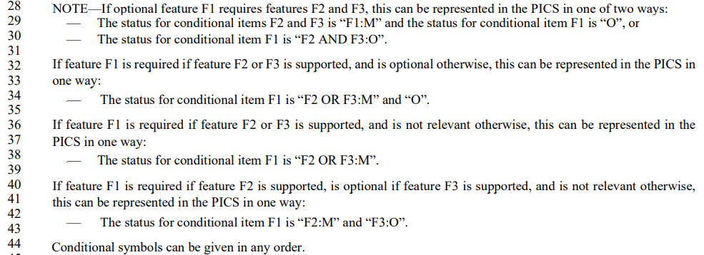
the examples for the Status column

Insert the following rows:
Item | IUT configuration |  | References | Status | Support
*CFLC | Light communications |  | 4.3.30 (Light Communications (LC) STA) | At least one of CFHT, CFVHT CFHE: O | Yes o No o N/A o

Insert a new subclause at the end of B.4.3 as follows:

B.4. 37 Light communication (LC) features

B.4. 37.1 LC MAC features

Item | Protocol capability | References | Status | Support

B.4.37.2 LC PHY features

Item | Protocol capability | References | Status | Support
 | Are the following PHY protocol features supported?
LCP1 | PHY operating modes
LCP1.1 | Operation according to Clause 19 (High-throughput (HT) PHY specification), Clause 21 (Very high throughput (VHT) PHY specification), and/or Clause 27 (High-efficiency (HE) PHY specification (11ax)) | 32.3.3 (LC PHY modes) | CFLC: M | Yes o No o N/A o
LCP1.2 | LC PPDU format | 32.1.2 (Physical protocol data (PPDU) formats) | CFLC: M | Yes o No o N/A o
LCP3 | Channel numbering and channelization | 32.3.4 (Channel numbering) | CFLC:M | Yes o No o N/A o
LCP4 | Multiple transmitters and receivers | 32.3.5 (Multiple transmitters and receivers) | CFLC: O | Yes o No o N/A o
LCP5 | CCA requirements for LC | 32.3.6.1 (CCA requirements) | CFLC: M | Yes o No o N/A o
LCP6 | LC repetition mechanism | 32.3.6.2 (LC repetition) | CFLC: O | Yes o No o N/A o
LCP7 | LC Regulatory Requirements | 32.3.7 (Regulatory Requirements) | CFLC: M | Yes o No o N/A o

