IEEE P802.11  
Wireless LANs

|  |  |  |  |  |
| --- | --- | --- | --- | --- |
| Proposed resolution for REVme LB258 CID 2245 | | | | |
| Date: 2022-04-19 | | | | |
| Author(s): | | | | |
| Name | Affiliation | Address | Phone | email |
| Rui Yang | InterDigital |  |  | [Rui.yang@interdigital.com](mailto:Rui.yang@interdigital.com) |
| Zinan Lin | InterDigital |  |  | Zinan.lin@interdigital.com |

Abstract

##### This submission present proposed resolutions for the following CIDs: 2245

##### The proposed changes are based on REVme/D1.0.

##### Revision history:

##### R0 – initial version

R1 – Fixed some typos

R2 – Changed the figure and text based on the discussions during the meeting

|  |  |  |  |  |  |
| --- | --- | --- | --- | --- | --- |
| CID | Clause | Page | Comment | Proposed Change | Resolution |
| 2245 | 26.10.3.2 | 4241.20 | It would be better to show which STAs transmit and receive those PPDUs based on the texts in this subcalus. | As in comment. | Revised:  Agree in principle with comments.  TGm editor: please incorporate changes shown in 11-22/0655r2 |

***Discussion:***

This CID is about associating the notations in Figure 26-13 with the description in the paragraph above it. Figure 26-13 doesn’t show which STAs mentioned in the paragraph transmit those frames in the figure. In addition, the existing texts in the paragraph above the figure is not sufficient to make the association clear. The resolution, which revises the comment, includes changes in Figure 26-13 and the paragraph above it.

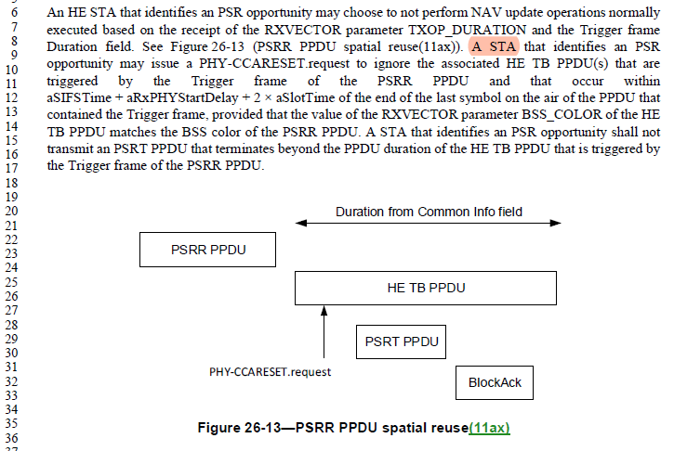

***CID2245***

***TGm Editor: Please make changes 802.11REVme D1.0 on P4241L6 and Figure 26-13 on P4241:***

An HE STA that identifies an PSR opportunity may choose not to perform NAV update operations normally executed based on the receipt of the RXVECTOR parameter TXOP_DURATION and the Trigger frame Duration field. An OBSS STA, shown as STAOBSS-A in Figure 26-13 (PSRR PPDU spatial reuse(11ax)), that identifies an PSR opportunity to transmit a PSRT PPDU to another OBSS STA, shown as STAOBSS-B in the same figure, may issue a PHY-CCARESET.request to ignore the associated HE TB PPDU(s) that are triggered by the Trigger frame of the PSRR PPDU and that occur within aSIFSTime + aRxPHYStartDelay + 2 × aSlotTime of the end of the last symbol on the air of the triggering PPDU (which is also the PSRR PPDU) , provided that the value of the RXVECTOR parameter BSS_COLOR of the HE TB PPDU matches the BSS color of the PSRR PPDU. An OBSS STA that identifies an PSR opportunity shall not transmit a PSRT PPDU that terminates beyond the PPDU duration of the HE TB PPDU that is triggered by the Trigger frame of the PSRR PPDU.

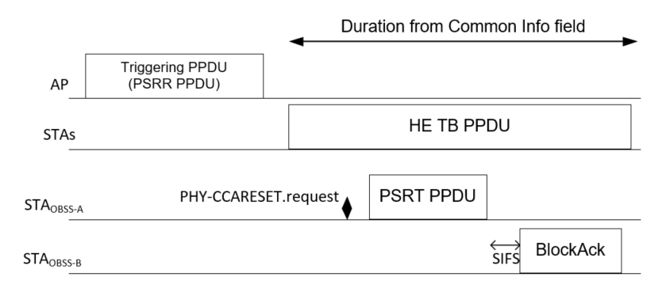

|  |
| --- |
|  |
| * PSRR PPDU spatial reuse(11ax) |