Minutes IEEE P802.11
Wireless LANs
IEEE 802.11 TGbh Meeting Minutes, April 12, 2022
Randomized and Changing MAC addresses (RCM)
Date: 2022-3-29
Author(s):
Name | Affiliation | Address | Phone | email
Graham SMITH | SR Technologies | Sunrise, Florida |  | gsmith@srtrl.com
Abstract
This document contains the minutes of the IEEE 802.11bh telecom meeting April 12, 2022.

Note: Highlighted text are action items.
Q- proceeds a question asked at the meeting
A- proceeds an answer
C- proceeds a comment

Rev 1 – On checking post meeting, one vote was deemed invalid. Corrected count on Motions. Results of motions are unchanged.

Meeting April 12, 2022 9.00 to 11.00 ET

Chair: Mark Hamilton (Ruckus/CommScope)
Vice Chair: Peter Yee (NSA-CSD/AKAYLA)
Vice Chair: Stephen Orr (Cisco)
Secretary: Graham Smith (SRT Wireless)
Editor: Carol Ansley (Cox)

The teleconference was called to order by Chair 9.02 hrs. EDT,

Agenda slide deck 11-22/0630r1

- Policies and procedures were presented by the chair. (Slides 4 to 14)
There were no Patent declarations.
Copyright policy slides were presented (Slides 10 and 11)

- Agenda:
- Attendance, noises/recording, meeting protocol reminders
- Policies, duty to inform, participation rules
- Organization topics (see Backup slides)
- Issues Tracking: 11-21/0332r30
- Motions (slides 16-21)
  - Discussion on motions
    - 11-22/0560r0: Cover all use cases (Graham Smith)
  - Run Motions
- Contributions (slide 22)
- Timeline review
- Review of Issues Tracking uncovered items (margin comments, etc.) 11-22/0435r0
- WBA liaison response
- Next meetings:
  - April 22, 19:00 ET, May interim (4 slots)

Chair intends to take the Motions early in the meeting.
Any comments? None
Any objections to agenda? - None
Agenda accepted unanimously.

- Issues Tracking
Chair noted that the Issues Tracking document is at r30 but there is a new contribution

- Motions
Graham Smith presented 560r0. Proposes that Network Generated ID and MAAD would cover all Use Cases. MAAD is only proposal covering pre-association Use Cases.
C - NGID only cover post association. MAAD solution STA provides MAC address, after association STA could use another MAC address. Security issue with NGID. Post association if STA probes when associated using same MAC address.
A – Post association if STA probes it uses the appropriate TA, depends if want to be identified or not. Do not understand the problem.
C – Do not understand any security issue with NGID. There is no security issue.
C – Presentation point is that this covers all cases efficiently.
C – You are saying hypothetical could have a problem, so don’t do that.
C – Concern keeping that MAC address to steer. Is that the concern?
A – STA need to keep same MAC address otherwise has problem. STA needs to know how far STA is away so network can select best AP.
C – Could add which MAC address to use for probing.
C – Both proposals carry device ID in a KDE NGID defines a new device ID also MAAD defines a MAC address. For MAC KDE already exists, why not use that?
A – Don’t know that KDE
C – On next association STA send the new MAC. Each association needs more, should we limit associations?
A – Could add a requirement to use this MAC address for say, next 3 associations.
C – MAC address KDE does exist in Clause 12. Should be looked at.

Note that these motions are not the ‘end of the path’ and the door is always open for new submissions.

Chair – Should we add combined solutions to the motions?
No response
C – Would like to see Motions 4 and 5 combined.
C – Perfectly reasonable
C – That’s fine. If motion failed could still run separate motions.
C – Could incorporate 3 and 4? Some networks where user may want to be in control, grocery store for example.
C – Keep in mind these are not designed to be combined.
C – Should keep it simple, look at each motion on its own merits and if like the idea of combinations then simply support both or more
C – Back to 3 and 4 combination. Should not be concerned with a bunch of devices identifying themselves to the network. Think this use case is problematic and have some concerns.
C – Motion uses no action frames, STA provides the ID in the 4-way HS exchange. ID has nothing to do with MAC address.
C – Have not come to consensus, but did present a document that combined the 3 so wanted to point out it was a start. Needed some technical work. If we agreed that we want a set, then could take work on how to glue them together.
C – As long as IDs are in secured frames then we are OK. Network of STA generated.
C – Motion 6, also uses ID. ID is not defined, implementation specific. Could combine 4 and 6.
C – Could combine any of these.
C – Be clear Opaque is only for the network generated ID.
C – Could combine 3, 4 and 6. STA could generate it
C – Had polls that had combinations, no objection to combining, but much better to have individual topics and move forward.
C – Motion 4, AP must generate the ID not the ‘network’
C – Don’t use the title but read the proposal. This is just a name, the ID comes from the AP.
C – Proposals must cover user cases, motion 4 only covers some.
C – That was gist of proposal by Graham that we cover all the Use Cases.
C – Not sure what the use case is for the STA generated ID?
C – Principle benefit is that this covers most use cases and lets the STA control the ID it exchanges. If network provides ID then STA must have trust in AP.
C – Being remembered by the network is a service that the network provides. This is conceptionally similar to cookies. Could be more information that the network may require.

Anything else? None

Motion 3
Move to incorporate the text changes into the P802.11bh draft as indicated in the following document:
    - 11-22/0158r3 (STA generated device ID)
  - Moved: Jon Rosdahl
  - Seconded: Stephen McCann
Any discussion, none
  - Results: 11/7/5 Motion Fails
The details of the voting are provided in Annex A
On checking post meeting, one vote was deemed invalid. Corrected result is 10/7/5 Motion Fails (59%)

Motion 4
Move to incorporate the text changes into the P802.11bh draft as indicated in the following document:
    - 11-22/0187r2 (Network generated device ID)
    - 11-22/0482r1 (Annex Text for Opaque Device ID)
  - Moved: Dan Harkins
  - Seconded: Stephen McCann
Any discussion, none
  - Results: 14/4/4 Motion Passes
The details of the voting are provided in Annex A
On checking post meeting, one vote was deemed invalid. Corrected result is 13/4/4 Motion Passes (76.5%)

Motion 5
Move to incorporate the text changes into the P802.11bh draft as indicated in the following document:
    - 11-21/1379r3 (Proposed text for ID Query Action frame)
  - Moved: Kurt Lumbatis
  - Seconded: Carol Ansley
Any discussion, none
  - Results: 7/7/8 Motion fails
The details of the voting are provided in Annex A
On checking post meeting, one vote was deemed invalid. Corrected result is 6/7/8 Motion Fails (46%)

Motion 6
Move to incorporate the text changes into the P802.11bh draft as indicated in the following document:
    - 11-22/0427r5 (MAAD MAC 2 text)
  - Moved: Graham Smith
  - Seconded: Jon Rosdahl
Any discussion, none
  - Results: 11/5/7 Motion fails
The details of the voting are provided in Annex A
On checking post meeting, one vote was deemed invalid. Corrected result is 10/5/7 Motion Fails (66.6%)

Chair – That concludes the motions. We have one proposal that can be used for the first draft.
C – Note that the Draft does not get posted to Mentor. Need to delay minutes until attendance is verified.

- Issues Tracking Document updates
Jay Yang presented 0332r35
Use Case 4.1 VBSS solution standardized by WFA so change to “in-scope”
4.8 Using identifiable probes for client steering has other problems. Change to in-scope.
C – You reference VBSS, is that from Easy Mesh?
A – Yes
C – Need a reference to that standard.
https://www.wi-fi.org/downloads-registered-guest/Wi-Fi_EasyMesh_Specification_v4_0.pdf/35509
C – Need a presentation on VBSS and also on the pre-association clearing “problem” before we can understand if these are acceptable solutions or statements.
C – Against any sort of probe request change. Might be interested for recommendations on MAC address usage.
C – Need presentations that led to these changes and need to concentrate on the Use Cases, then maybe might be in support of a presentation that did not pass today. This may be way forward.
C – Yes agree, would welcome a presentation and then we should be done with this document.
- Timeline
Need decision at May meeting. We finally have first text. Do we have any hope of Draft 1.0 at May session?
C – Would like to see a draft 0.1? before May meeting.
Chair - Can we get a Draft 0.1 ready before May session?
Probably but might be a little rough, just incorporating the submission. Really short.
Chair – Do not need to write new material, just the surrounding boilerplate.
C – Short and rough is fine. Can work on the proposal document. Comment collection can be made on 0.1.
- Review document
Chair – Did create document 22/0435 to review issues. Need to work on this.
C – Must talk about Use Cases, but Issues Tracking document has more than Use Cases including terms and definitions. Nothing about MAC Address changes in association, probing etc.
C – Yes, contributions welcome.
- WBA
Still not ready to respond
- AOB
C – As votes were recorded votes, should the Minutes record the details of the voting?
A – Yes

Out of agenda
Meeting adjoined at 10.48 ET.
ANNEX A - Motion Voting Details:
Motion 3
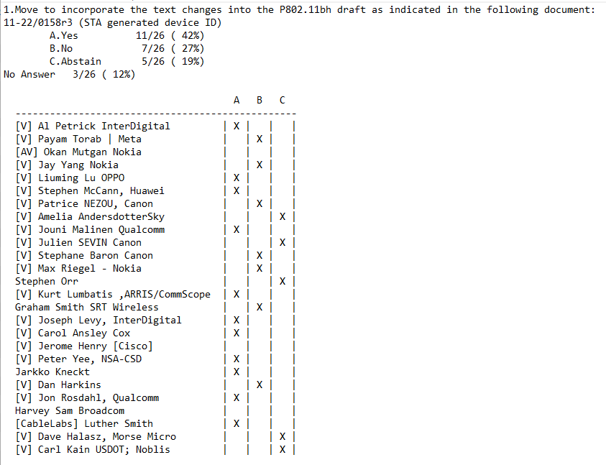

Motion 4
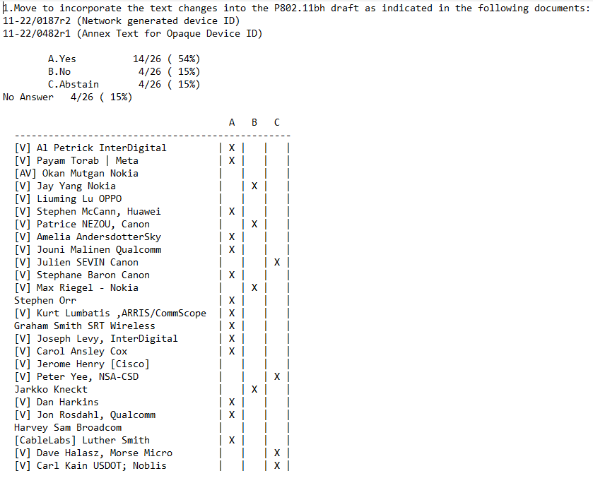
Motion 5
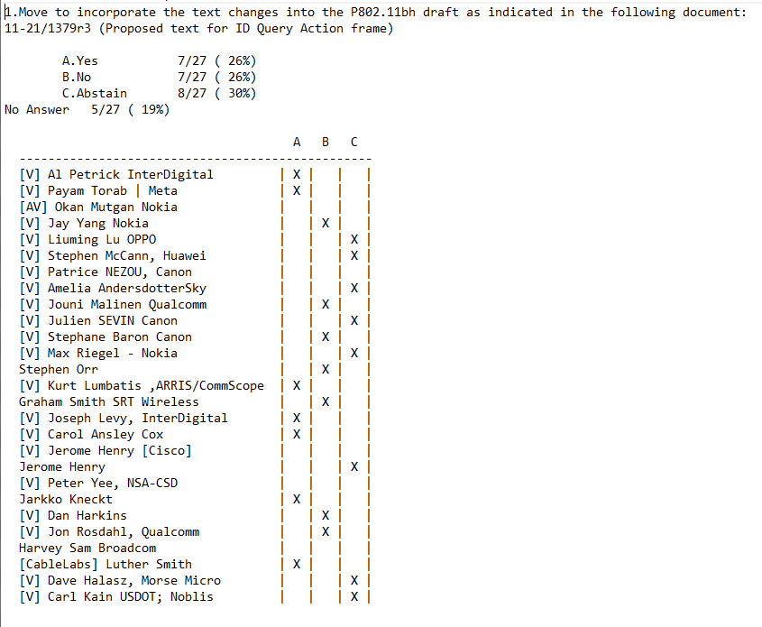
Motion 6
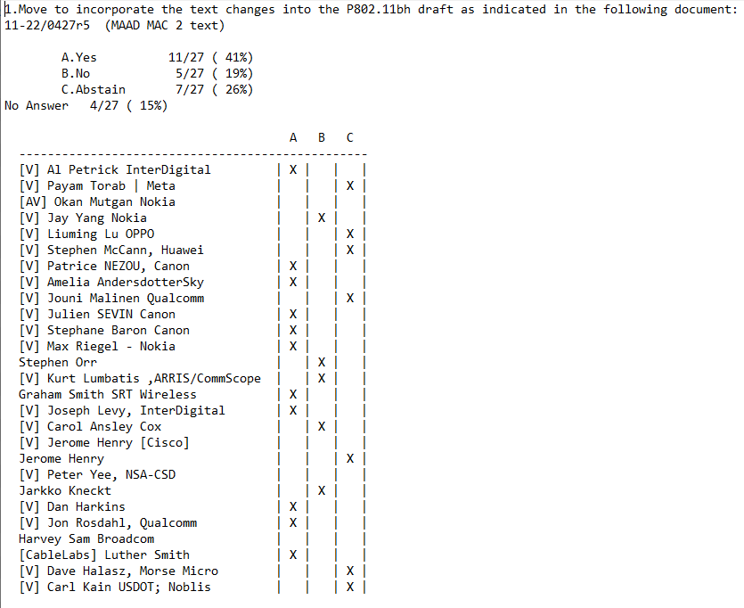
Attendance
Breakout | Timestamp | Name | Affiliation
TGbh | 4/12 | Andersdotter, Amelia | Sky UK group
TGbh | 4/12 | Ansley, Carol | Cox Communications Inc.
TGbh | 4/12 | baron, stephane | Canon Research Centre France
TGbh | 4/12 | Halasz, David | Morse Micro
TGbh | 4/12 | Hamilton, Mark | Ruckus/CommScope
TGbh | 4/12 | Harkins, Daniel | Hewlett Packard Enterprise (Aruba Networks)
TGbh | 4/12 | Henry, Jerome | Cisco Systems, Inc.
TGbh | 4/12 | Kain, Carl | USDoT; Noblis Inc.
TGbh | 4/12 | Kneckt, Jarkko | Apple, Inc.
TGbh | 4/12 | Levy, Joseph | InterDigital, Inc.
TGbh | 4/12 | Lu, Liuming | Guangdong OPPO Mobile Telecommunications Corp.,Ltd
TGbh | 4/12 | Lumbatis, Kurt | CommScope, Inc.
TGbh | 4/12 | Malinen, Jouni | Qualcomm Incorporated
TGbh | 4/12 | McCann, Stephen | Huawei Technologies Co., Ltd
TGbh | 4/12 | Mutgan, Okan | Nokia
TGbh | 4/12 | Nezou, Patrice | Canon Research Centre France
TGbh | 4/12 | Orr, Stephen | Cisco Systems, Inc.
TGbh | 4/12 | Petrick, Albert | InterDigital
TGbh | 4/12 | Riegel, Maximilian | Nokia
TGbh | 4/12 | Rosdahl, Jon | Qualcomm Technologies, Inc.
TGbh | 4/12 | Sam, Harvey | Broadcom Corporation
TGbh | 4/12 | Sevin, Julien | Canon Research Centre France
TGbh | 4/12 | Smith, Graham | SRT Wireless
TGbh | 4/12 | Smith, Luther | Cable Television Laboratories Inc. (CableLabs)
TGbh | 4/12 | Srivatsa, Veena | Synaptics
TGbh | 4/12 | Torab Jahromi, Payam | Facebook
TGbh | 4/12 | Yang, Jay | Nokia
TGbh | 4/12 | Yee, Peter | NSA-CSD

