3IEEE P802.11
Wireless LANs
Resolution for Miscellaneous CIDs related to TDLS (CC36)
Date: March 15th, 2022
Author(s):
Name | Affiliation | Address | Phone | Email
Ahmed Ibrahim | Samsung Research America | 6625 Excellence Ave., Plano, TX, 75023 | 469-456-9824 | ahmed1.i@samsung.com
Rubayet Shafin
Boon Loong Ng
Vishnu Ratnam
Peshal Nayak

Abstract
This submission proposes resolutions for following 3 comments received for TGbe CC36:
- 3 CIDs: 4033, 4590, 4593

Revisions:
- Rev 0: Initial version of the document.

TGbe editor: Please note Baseline is REVmd D5.0, 11ax D8.0, and 11be D1.4

Interpretation of a Motion to Adopt
A motion to approve this submission means that the editing instructions and any changed or added material are actioned in the TGbe Draft. This introduction is not part of the adopted material.

CID | Clause | Page | Page and Line in D1.4 | Comment | Proposed Change | Resolution
4033 | 11.20 | 206 | 275 | When a STA affiliated with an nSTR non-AP MLD or an (e)MLSR non-AP MLD is involved in a single link TDLS direct link, additional rules would be required to manage the transmissions between the AP MLD and the non-AP MLD in the intra-BSS and TDLS link. Investigate and provide necessary rules. | The commenter will provide a contribution to address the issues | Revised  Agree with the commenter and added one rule in Clause 11.20 to handle this case.
4593 | 35.3.6.1.2  (35.3.7.1.2 in D1.4) | 258 | 363 | By TID-to-link mapping negotiation, an AP-MLD can intend to enable a setup link that may form a NSTR link pair to the off-channel TDLS direct link, as the AP MLD is not involved in TDLS channel switch and is unaware of the off-channel TDLS direct link. The potential NSTR link pair between the off-channel TDLS direct link and any link that is intended to be enabled in TID-to-link mapping negotiation should be avoided. If TID-to-link mapping negotiation is unsuccessful, default mapping will be applied, which will cause the NSTR link pair or congestion. | Update the sentence "A non-AP MLD and an AP MLD that performed multi-link setup shall operate under this mode if a TID-to-link mapping negotiation for a different mapping did not occur or was unsuccessful or torn down." based on the comment. | Revised  Same resolution as CID#4033 by adding a rule in Clause 11.20 and Clause 9.6.12
4590 | 11.20 | 206 | 275 | A wideband TDLS off-channel TDLS direct link is a 40 MHz, 80 MHz, 160 MHz, or 80+80 MHz off-channel TDLS direct link for VHT STAs or a 2 MHz, 4 MHz, 8 MHz, or 16 MHz off-channel TDLS direct link for S1G STAs. 320MHz bandwidth for EHT STAs supporting 6GHz band may need to be considered in 11.20.6.5.1, 11.20.6.5.2, 11.20.6.5.5. | Update the description in 11.20.6.5.1, 11.20.6.5.2, 11.20.6.5.5 to include 320MHz bandwidth for EHT STAs supporting 6GHz band. | Revised  Extended TDLS operation to 320MHz in Clause 11.20

Discussion

TDLS procedure in multi-link operation has some open issues that needs to be addressed. One of those issues is that the TDLS link has not been allowed the same extension to 320MHz that is introduced in 11be. Extension to 320MHz needs to be added for TDLS operation. Another issue is that NSTR and eMLSR operation along with TDLS operation needs added rules to guarantee that TDLS operation does not break NSTR rules or violate eMLSR constraints. The reason is that AP MLD is not aware of the nature of the traffic in the TDLS link. Also, the channel of TDLS link may form NSTR link-pair if a new TID-to-Link mapping is negotiated causing a link that forms NSTR link pair with TDLS link to be active.

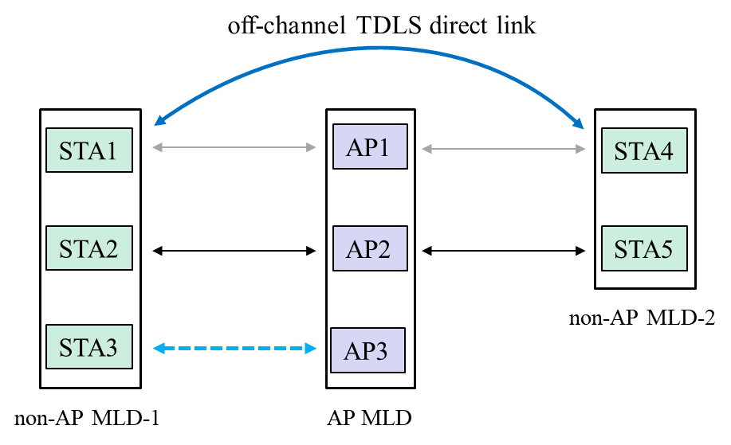
The following figure shows the operation of TDLS in multi-link setup.

For MLDs, unaware of the TDLS channel switching, the AP MLD may enable other links forming a NSTR link pair to the off-channel TDLS direct link or overlapping to the off-channel. In this scenario, either the enabled link or the off-channel TDLS direct link becomes essentially ineffective. For example, AP3 intends to enable the link to STA3, which potentially form a NSTR link pair to the off-channel TDLS direct link. These situations need to be handled in 11be specifications.

11.20.6.5 Setting up a wide bandwidth off-channel direct link (#4590)

TGbe editor: please update the following paragraphs in clause 11.20.6.5.1 as follows:

11.20.6.5.1 General

A wideband TDLS off-channel TDLS direct link is a 40 MHz, 80 MHz, 160 MHz, or 320 MHz off-channel TDLS direct link for EHT STAs, a 40 MHz, 80 MHz, 160 MHz, or 80+80 MHz off-channel TDLS direct link for VHT and HT STAs or a 2 MHz, 4 MHz, 8 MHz, or 16 MHz off-channel TDLS direct link for S1G STAs.

A wideband off-channel TDLS direct link may be started if both TDLS peer STAs indicated wideband support in the EHT Capabilities element, wideband support in the VHT Capabilities element or S1G Capabilities element included in the TDLS Setup Request frame or the TDLS Setup Response frame.

Switching to a wideband off-channel direct link is achieved by including any of the following information in the TDLS Channel Switch Request frame:

— An Operating Class element indicating 40 MHz Channel spacing and a Secondary Channel Offset element indicating SCA or SCB

— A Wide Bandwidth Channel Switch element indicating 80 MHz, 160 MHz, or 320 MHz channel width for EHT STAs

— A Wide Bandwidth Channel Switch element indicating 80 MHz, 160 MHz, or 80+80 MHz channel width for VHT STAs

— A Wide Bandwidth Channel Switch element indicating 4 MHz, 8 MHz, or 16 MHz channel width for S1G STAs

For VHT STAs, the operating class in TDLS Channel Switch Request frame shall have a value representing 5 GHz for the channel starting frequency.

TGbe editor: please update the following paragraphs in clause 11.20.6.5.2 as follows:
11.20.6.5.2 Basic wideband functionality

TDLS peer STAs may transmit up to 40 MHz, 80 MHz, 160 MHz, 80+80 MHz, or 320 MHz PPDUs on a 40 MHz, 80 MHz, 160 MHz, 80+80 MHz, or 320 MHz direct link, respectively. A TDLS peer STA shall not transmit a 20 MHz PPDU in the nonprimary channel of its 80 MHz, 160 MHz, 80+80 MHz, or 320 MHz direct link.

A TDLS peer STA shall not transmit a 40 MHz PPDU that does not use the primary 40 MHz channel of its 80 Hz, 160 MHz, 80+80 MHz, or 320 MHz direct link. A TDLS peer STA shall not transmit an 80 MHz PPDU that does not use the primary 80 MHz channel of its 160 MHz 80+80 MHz, or 320 MHz direct link.

TGbe editor: please update the title and the subsequent paragraphs in clause 11.20.6.5.5 as follows:

11.20.6.5.5 CCA sensing and NAV assertion in a 20 MHz, 40 MHz, 80 MHz, 160 MHz, 80+80 MHz, 320 MHz, 1 MHz, 2 MHz, 4 MHz, 8 MHz, or 16 MHz direct link

TDLS peer EHT and VHT STAs shall follow the CCA rules defined in 10.3.2.7, 10.23.2.8, and 10.23.3 and the NAV rules defined in 11.38.5.

