IEEE P802.11
Wireless LANs

+HTC subfield and HT Control field clarifications for DMG
Date: 2022-04-01
Author(s):
Name | Affiliation | Address | Phone | email
Payam Torab | Meta Platforms, Inc. |  |  | torab@ieee.org

Abstract

Clarify the HT Control field definition for DMG. Submitted as proposed resolution to CID 2219. Proposed text changes are relative to 11me Draft 1.1.

CID | Clause | Page | Line | Comment | Proposed Change
2219 | 9.2.4.6 | 922 | 25 | The format of HT Control for DMG and EDMG is not clear from REVme text (11ax additions do not help either). | Clarify the HT Control format for DMG and EDMG.

Discussion

The HT Control filed of the MAC header for DMG is the same as what was defined for HT (802.11n). The 802.11ad standard (amendment to the 802.11-2012 standard) just added a NOTE to the clause where HT Control had been defined,

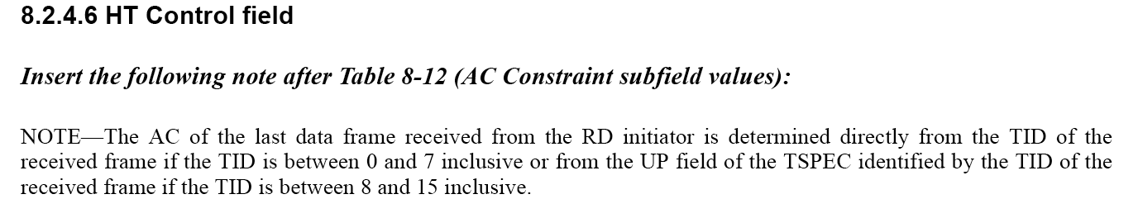

802.11ac and 802.11ax standards introduced two new forms of the HT Control field, referred to as VHT and HE variants, and the original form is called HT variant. As far as we could tell, it is not clear from the 802.11-2020 standard or the 11me Draft 1.1 that DMG uses the HT variant of the HT Control field, and we suggest edits to make that clear.

The proposed edits also improve the definitions of +HTC subfield and HT Control field and fix inconsistencies.

Editor: Please modify 9.2.4.1.10 as follows:

9.2.4.1.10 +HTC subfield
The +HTC subfield, when set to 1, indicates the presence of the HT Control field (see 9.2.4.6 (HT Control field)) in all frames transmitted by non-DMG STAs. It is set as follows:

— It is set to 1 in a QoS Data or Management frame transmitted with the FORMAT parameter of the
TXVECTOR set to HT_GF, HT_MF, VHT or S1G to indicate that the frame contains an HT
Control field.
— It is set to 1 in an RTS frame transmitted with the FORMAT parameter of the TXVECTOR set to
S1G to indicate that the intended recipient of the frame has permission to extend the TXOP as
described in 10.54.5.4 (Relay-shared TXOP protection mechanisms).
— It is set to 1 in a QoS Data or Management frame transmitted by a CMMG STA to indicate that the
frame contains a CMMG variant HT Control field.
— It is set to 1 in a QoS Data, QoS Null, or Management frame transmitted by an HE STA to another
HE STA to indicate that the frame contains an HT Control field.

Otherwise, the +HTC subfield is set to 0.

Editor: Please modify the first paragraph in 9.2.4.6.1 as follows:

9.2.4.6 HT Control field
9.2.4.6.1 General
The HT Control field is present in the following cases:

— It is always present in a Control Wrapper frame.
— It is always present in QoS Data, QoS Null, and Management frames transmitted by a DMG STA.
— It is present in QoS Data, QoS Null, and Management frames transmitted by a non-DMG STA that have the +HTC subfield of the Frame Control field (see 9.2.4.1.10 (+HTC subfield)) set to 1.

The HT Control field is not present otherwise.

Editor: Please modify the first paragraph in 9.3.2.1 as follows:

9.3.2 Data frames
9.3.2.1 Format of Data frames
9.3.2.1.1 General
The format of a Data frame is defined in Figure 9-111 (Data frame format). The Frame Control, Duration, Address 1, Address 2, Address 3, and Sequence Control fields are present in all data frame subtypes. The presence of the Address 4 field is determined by the setting of the To DS and From DS subfields of the Frame Control field (see below). The presence of the QoS Control field is indicated by the QoS subfield of the Subtype subfield (see 9.2.4.1.3 (Type and Subtype subfields) of the Frame Control field. The presence of the HT Control field is indicated by the +HTC subfield of the Frame Control field (see 9.2.4.1.10 (+HTC subfield)).

Editor: Please modify the first paragraph in 9.3.2.1 as follows:

9.3.2.1.3 Other MAC Header fields
The Sequence Control field is defined in 9.2.4.4 (Sequence Control field).

The QoS Control field is defined in 9.2.4.5 (QoS Control field). The presence of the QoS Control field is determined by the Subtype subfield of the Frame Control field, as specified in 9.2.4.1.3 (Type and Subtype subfields).

The HT Control field is defined in 9.2.4.6 (HT Control field).

Editor: Please modify the first paragraph in 9.3.3.1 as follows:

9.3.3 (PV0) Management frames
9.3.3.1 Format of (PV0) Management frames
The format of a Management frame is defined in Figure 9-120 (Management frame format). The Frame Control, Duration, Address 1, Address 2, Address 3, and Sequence Control fields are present in all management frame subtypes. The maximum size of an MMPDU that is not carried in a VHT or S1G PPDU is defined in Table 9-34 (Maximum data unit sizes (in octets) and durations (in microseconds)(#1327)). The presence of the HT Control field is indicated by the +HTC subfield of the Frame Control field (see 9.2.4.1.10 (+HTC subfield). The maximum size of an MMPDU that is carried in one or more VHT or S1G PPDUs (in whole or in part) is the maximum MPDU size supported by the recipient or, if there is more than one recipient, the smallest of the maximum MPDU sizes supported by the recipients less the shortest Management frame MAC header and FCS.

Editor: Please modify this sentence in 9.3.3.1 (P1017L8) as follows:

The HT Control field is defined in 9.2.4.6 (HT Control field).

Editor: Please modify the third paragraph in 10.8 as follows:

10.8 HT Control field operation
…
An HT variant HT Control field shall not be present in a frame addressed to a STA unless that STA declares support for +HTC-HT in the HT Extended Capabilities field of its HT Capabilities element (see 9.4.2.55 (HT Capabilities element)), or the STA is a DMG STA.

