IEEE P802.11  
Wireless LANs

|  |  |  |  |  |
| --- | --- | --- | --- | --- |
| CC36 Resolution for CID 5882 | | | | |
| Date: March 24, 2022 | | | | |
| Author(s): | | | | |
| Name | Affiliation | Address | Phone | email |
| Liangxiao Xin | Sony |  |  | Liangxiao.Xin@sony.com |
| Li-Hsiang Sun |  |  | Li-Hsiang.Sun@sony.com |
|  |  |  |  |  |
|  |  |  |  |  |

Abstract

This submission proposes resolutions for following 1 CID received for TGbe CC36:

5897

**Revisions:**

* Rev 0: Initial version of the document.
* Rev 1: Add simulation results

Interpretation of a Motion to Adopt

A motion to approve this submission means that the editing instructions and any changed or added material are actioned in the TGbe Draft. This introduction is not part of the adopted material.

***Editing instructions formatted like this are intended to be copied into the TGbe Draft (i.e. they are instructions to the 802.11 editor on how to merge the text with the baseline documents).***

***TGbe Editor: Editing instructions preceded by “TGbe Editor” are instructions to the TGbe editor to modify existing material in the TGbe draft. As a result of adopting the changes, the TGbe editor will execute the instructions rather than copy them to the TGbe Draft.***

**PART A: Signaling length of Common Info field and STA Info field**

|  |  |  |  |  |  |
| --- | --- | --- | --- | --- | --- |
| **CID** | **Commenter** | **Clause** | **Comment** | **Proposed Change** | **Resolution** |
| 5897 | Liangxiao Xin | 35.3.14.6 | 11be D1.0 says an MLD shall wait for expiration of the largest number of backoff counters of STAs. This may cause long delay to start transmission of the PPDUs and may lead STA to loose its transmission opportunity. | Add a note: when a non-STR MLD invokes backoff procedures with the same CW on different links at the same time, it may generate one random value to initialize the backoff counters on those links. | **Revised**  Agree with the commenter. The theoretical analysis and simulation results shows that the same backoff counts for the two new backoff procedures on the two links can reduce the contention delay and increase the throughput of start time sync PPDUs medium access in some cases.  **TGbe editor, please incorporate changes as shown in 11-22/0554r0 tagged 5897** |

**Discussion**

According to the current start time sync PPDUs medium access, when the two STAs affiliated with one MLD on two different links perform new backoff procedures at the same time, each STA generates a random backoff counter to count down, e.g., rv1 on link1 and rv2 on link2. The backoff counters on both links have to count down to zero to access channel for start time sync PPDUs. The average number of backoff slots to count down is max(rv1, rv2). If only the STA on link1 generates a random backoff counter that both STAs use to count down on link1 and link2, then the average number of backoff slots to count down is rv1 < max(rv1, rv2). Less number of backoff slots means faster channel access and higher success rate of start time sync PPDUs.

The simulation results in IEEE 802.11-20/0577r0 show the throughput increased by multiple STAs affiliated with a same MLD starting multiple new backoff procedures simultaneously with one same random backoff value on different links.

Multiple new backoff procedures with one same random backoff value on different links when

1. data arrives at the shared empty buffer of those links and those links are not counting down backoff.
2. the TXOP ends or transmission failure occurs on those links with PPDU end time alignment

We run simulations by comparing throughput of using same backoff counter plus waited EDCA and using waited EDCA only on NSTR MLD. In the simulation, one NSTR MLD and one STR MLD are associated with an AP MLD. The NSTR MLD transmits AC0 traffic to AP MLD through both links of the NSTR link pair. The STR MLD transmits AC0 interference traffic to AP MLD through the same links.

Simulation Results shows that the throughput gain of using same backoff counter is between 2.2% to 4.1% by using the same backoff counter. The number of the start time sync PPDUs is increased by 2.3% to 38.2% by using the same backoff counter.

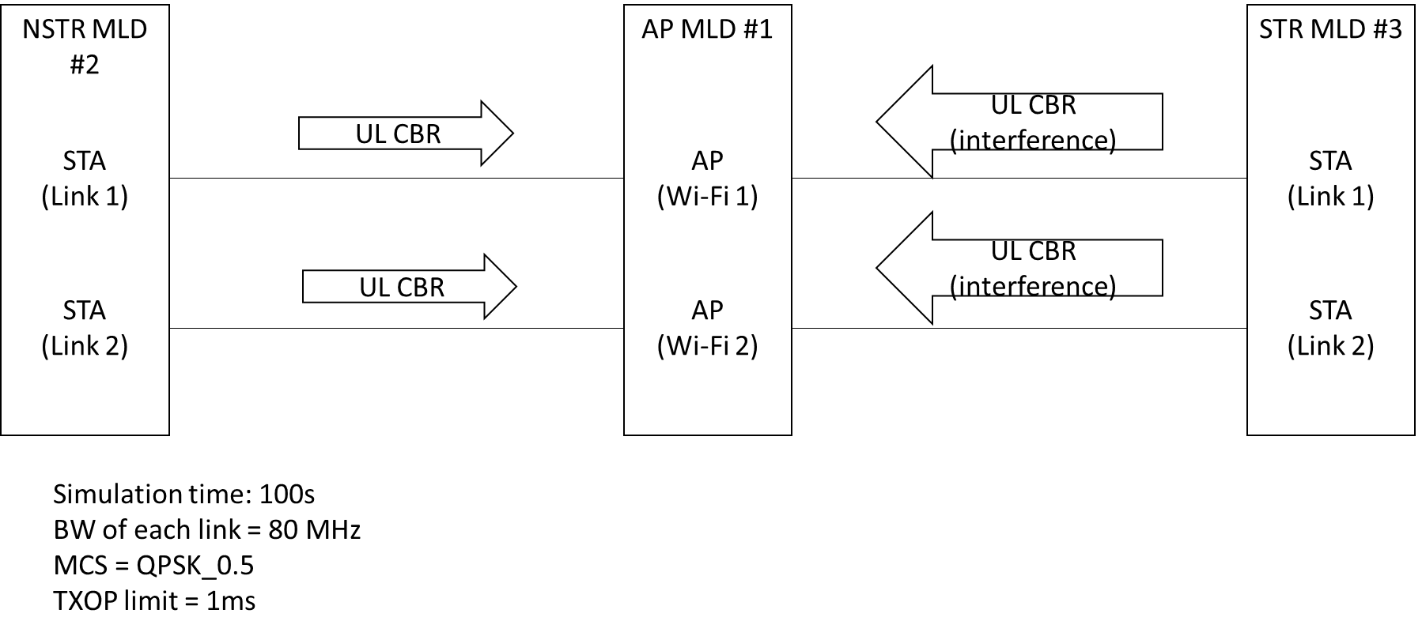

Figure 1: Simulation setup

Figure 2: Throughput gain of using same backoff



Table 1: increasing number of the start time sync PPDUs

***TGbe editor: The baseline for this document is 11be D1.5***

**35.3.16.6 Start time sync PPDUs medium access**

***TGbe editor: please add NOTE3 to the end of NOTE 2***

(#3398)(#2435)(#2718)(#1772)A STA of an MLD operating on a link that is part of an NSTR link pair for that MLD shall follow the channel access procedure described below:

* + - * 1. (#1510)The STA may initiate transmission on a link when the medium is idle as indicated by the physical and virtual CS mechanism and one of the following conditions is met:

(#1757)The STA obtained an EDCA TXOP following the procedure in

10.23.2.4 (Obtaining an EDCA TXOP).

(#1757)The backoff counter of the STA is already zero, and the STA operating on the other link of NSTR link pair of the affiliated MLD obtains an EDCA TXOP following the procedure in 10.23.2.4 (Obtaining an EDCA TXOP).

* + - * 1. When the backoff counter of the STA reaches zero, it may choose to not transmit and keep its backoff counter at zero.
        2. (#1349)(#1509)If the backoff counter of the STA has already reached zero, it may perform a new backoff procedure following deferral procedures as described in 10.23.2.4 (Obtaining an EDCA TXOP) and 10.3.4.3 (Backoff procedure for DCF). CW[AC] and QSRC[AC] are left unchanged.

(#3399)NOTE 2—A STA with backoff counter that has already reached zero and there is a frame available for transmission performs a new backoff procedure before being allowed to initiate a link following condition a).

(#5897) NOTE 3— when multiple STAs affiliated with a same MLD invoke backoff procedures with the same CW on different links at the same time, they can generate one random value to initialize the backoff counters on those links.