IEEE P802.11
Wireless LANs
LB258 CID 2368 – STBC in UL MU-MIMO
Date: 2022-03-29
Author(s):
Name | Affiliation | Address | Phone | email
Youhan Kim | Qualcomm |  |  | youhank@qti.qualcomm.com

Abstract
This submission proposes resolutions for the following comments from comment collection on P802.11-REVme D1.0:

2368

NOTE – Set the Track Changes Viewing Option in the MS Word to “All Markup” to clearly see the proposed text edits.

Revision History:

R0: Initial version.

CID 2368

CID | Clause | Page.Line | Comment | Proposed Change
2368 | 26.5.2.2.1 | 4158.29 | STBC cannot be used together with UL MU-MIMO.  For example, see P4295L32, where the TXVECTOR parameter STBC can be set to 1 in an HE TB PPDU only when the number of users in each RU is no more than 1 user.  But there is no normative statement in Clause 26 regarding not using STBC together with UL MU-MIMO. | Add the following at P4158L29:  "An AP shall not set the UL STBC subfield in the Common Info field in a Trigger frame it transmit if any of the RUs allocated in that Trigger frame is assigned to more than 1 user."

Discussion

MU-MIMO is a spatial multiplexing technique, while STBC is a spatial diversity technique. Hence, using STBC together with MU-MIMO does not make much sense as STBC ends up using more spatial dimensions to send a given number of spatial streams, hence increases the chance of creating inter-spatial stream interference. This was well understood among the 11ax contributors, and there are many places in the IEEE 802.11 standard which reflect that STBC is not used together with UL MU-MIMO. For example,

REVme D1.1 P994
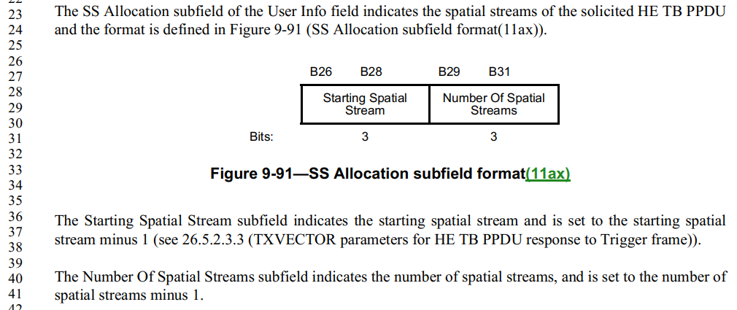
Above is the spatial stream allocation for UL MU-MIMO in the Trigger frame. If STBC were to be allowed in the UL MU-MIMO, the standard should have been written in terms of space-time stream, not spatial stream.

Also,
REVme D1.1 P4297
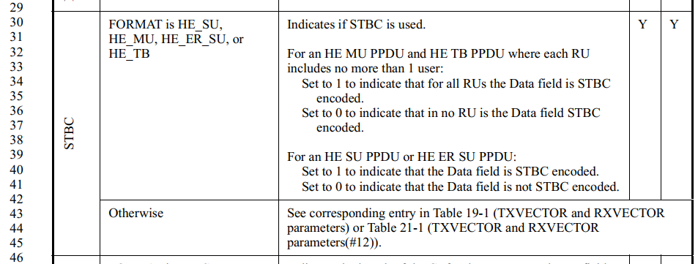
Above is the TX/RXVECTOR for HE PHY. And it only talks about setting the TX/RXVECTOR parameter STBC to 1 only when the RU has no more than 1 user – i.e. not MU-MIMO.

However, the IEEE 802.11 standard unfortunately lacks a clear normative statement clarifying an AP shall not trigger UL MU-MIMO using STBC.

The proposed change by the comments adds the normative text at the end of the General section for Rules for soliciting UL MU frames.

REVme D1.0 P4156-4158
26.5.2.2 Rules for soliciting UL MU frames
26.5.2.2.1 General

An HE AP shall not allocate an RU for a 40 MHz HE TB PPDU to a 20 MHz operating non-AP HE STA in the 2.4 GHz band, unless the AP has received from the 20 MHz operating non-AP HE STA an HE Capabilities element with the 20 MHz In 40 MHz HE PPDU In 2.4 GHz Band subfield in the HE PHY Capabilities Information field in its HE Capabilities element equal to 1.

…

An AP shall not transmit a Trigger frame with a User Info field addressed to a non-AP STA in an HT or VHT PPDU, unless the AP has received from the non-AP STA an HE Capabilities element with the HT And VHT Trigger Frame Rx Support subfield in HE MAC Capabilities Information field equal to 1.

An AP shall not use the short guard interval for an HT or VHT PPDU that carries a Trigger frame. A Trigger frame shall not be carried in a DSSS or HR/DSSS PPDU. An AP shall not use STBC encoding for a PPDU that carries a triggering frame.

An AP shall not set the UL STBC subfield in the Common Info field in a Trigger frame it transmit if any of the RUs allocated in that Trigger frame is assigned to more than 1 user.

26.5.2.2.2 Requirements for allocating resources

This is the right place to add such normative text. Unfortunately, there is a grammar error, hence the resolution is a REVISED.

Proposed Resolution: CID 2368
REVISED

Note to commenter:
Agree that STBC shall not be used with UL MU-MIMO. The proposed text below adopts the change suggested by the commenter, correcting a grammar error.

Instruction to TGme Editor:
Add the following at the end of 26.5.2.2.1 (REVme D1.1 P4160L32):

"An AP shall not set the UL STBC subfield in the Common Info field in a Trigger frame it transmits if any of the RUs allocated in that Trigger frame is assigned to more than 1 user."

[End of File]

