IEEE P802.11
Wireless LANs
Resolution for LB258 CIDs 2195, 2196, 2198, 2199, 2200, 2201
Date: 2021-03-24
Author(s):
Name | Affiliation | Address | Phone | email
Nancy Lee | Signify | HTC7, Eindhoven, 5656 AE The Netherlands |  | nancy.lee@signify.com
Matthew Fischer | Broadcom | 250 Innovation Drive, San Jose, CA 95134 |  | Matthew.fischer@broadcom.com
Abstract
This contribution proposes resolutions to CIDs 2195, 2196, 2198, 2199, 2200, 2201 related to A-MSDU fragmentation/defragmentation.

Baseline document: REVme D1.0.

r1: changes made during 2022-04-22 conf call. Revised resolutions for 2198, 2199, 2200, 2201 ready for motion.

Introduction
As shown in the following cited text, 11ax added support for A-MSDU fragmentation/defragmentation, but only for HE STAs in the form of dynamic fragmentation. However this is not clearly stated in Clause 10 and some text relevant to A-MSDU fragmentation/defragmentation was not updated to include A-MSDU.

Cited text REVme D1.0 C.3 (MIB detail), p. 5530
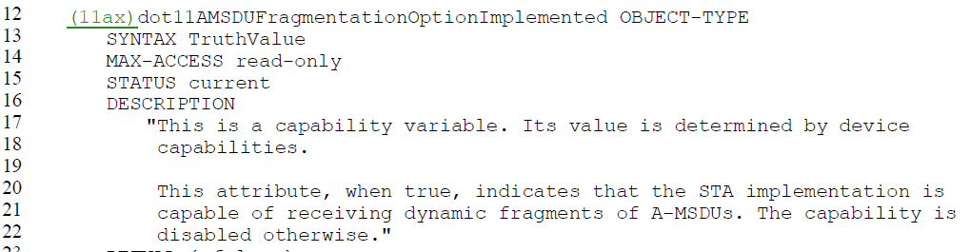
Cited text 802.11ax-2021 10.11 (A-MSDU operation), p. 251:
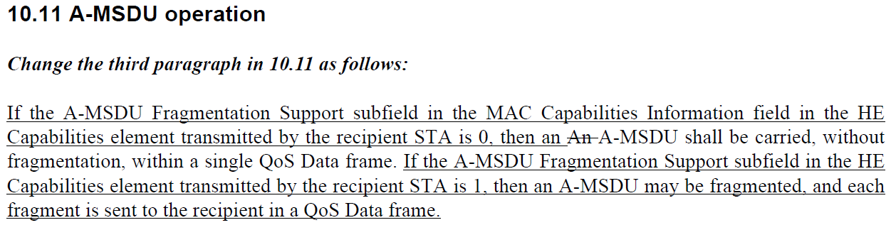
Cited text REVme D1.0 26.3.2.1 (General), p. 4137:
Discussion and proposed resolutions for related CIDs follow.

Resolution of CIDs

CID | Commenter | Clause | Pg/Ln | Comment | Proposed Change
2195 | Nancy Lee | 10.2.7 | 2081/61 | Overview section doesn't mention that A-MSDUs can be fragmented and defragmented | change to "The process of partitioning an MSDU, A-MSDU, or an MMPDU into smaller MAC-level frames, MPDUs, is called fragmentation. Fragmentation creates MPDUs smaller than the original MSDU, A-MSDU, or MMPDU length to increase reliability, by increasing the probability of successful transmission as defined in 10.2.2 (DCF) of the MSDU, A-MSDU, or  MMPDU when channel characteristics limit reception reliability for longer frames. A STA may use fragmentation to use the medium efficiently in consideration of the duration available in granted TXOPs, as long as the rules in 10.4 (MSDU, (11ax)A-MSDU, and MMPDU fragmentation) are followed. Fragmentation is accomplished at each immediate transmitter. The process of recombining MPDUs into a single MSDU, A-MSDU, or MMPDU is defined as defragmentation. Defragmentation is accomplished at each immediate recipient.

Discussion:
11ax added support for A-MSDU fragmentation to 10.11 under specified conditions (see cited text in the Introduction of this contribution). 10.2.7 needs to be updated to allow A-MSDU fragmentation and reference the conditions specified in 10.11, and 10.11 needs clarification that there is no A-MSDU fragmentation if no HE Capabilities element is present.

Proposed resolution of CID2195: REVISED – proposal needs further work

TGm editor: Change subclauses 10.2.7 and and 10.11 as follows (CID 2195):
10.2.7 Fragmentation/defragmentation overview
The process of partitioning an MSDU, A-MSDU, or an MMPDU into smaller MAC-level frames, MPDUs, is called fragmentation. Fragmentation creates MPDUs smaller than the original MSDU, A-MSDU, or MMPDU length to increase reliability, by increasing the probability of successful transmission as defined in 10.2.2 (DCF) of the MSDU, A-MSDU, or MMPDU when channel characteristics limit reception reliability for longer frames. A STA may use fragmentation to use the medium efficiently in consideration of the duration available in granted TXOPs, as long as the rules in 10.4 (MSDU, (11ax)A-MSDU, and MMPDU fragmentation) and 10.11 (A-MSDU operation) are followed. Fragmentation is accomplished at each immediate transmitter. The process of recombining MPDUs into a single MSDU, A-MSDU, or MMPDU is defined as defragmentation. Defragmentation is accomplished at each immediate recipient.

An MSDU transmitted under an HT-immediate block ack agreement shall not be fragmented even if its length exceeds dot11FragmentationThreshold. An MSDU or MMPDU transmitted within an A-MPDU that does not contain an S-MPDU (see 10.12.8 (Transport of S-MPDUs)) shall not be fragmented even if its length exceeds dot11FragmentationThreshold. MSDUs or MMPDUs carried in a group addressed MPDU shall not be fragmented even if their length exceeds dot11FragmentationThreshold.

NOTE 1—A fragmented MSDU or MMPDU transmitted by an HT STA to another HT STA can be acknowledged only
using immediate acknowledgment (i.e., transmission of an Ack frame after a SIFS).

NOTE 2—A fragmented MSDU or MMPDU transmitted by an S1G STA(#371) can be acknowledged either using immediate
…

10.11 A-MSDU operation
…
If the A-MSDU Fragmentation Support subfield in the MAC Capabilities Information field in the HE Capabilities element transmitted by the recipient STA is 0 or if no HE capabilities element is present, then an A-MSDU shall be carried, without fragmentation, within a single QoS Data frame. If the recipient STA has transmitted an HE Capabilities element, and the A-MSDU Fragmentation Support subfield in the HE Capabilities element transmitted by the recipient STA is 1, then an A-MSDU may be fragmented, and each fragment is sent to the recipient in a QoS Data frame.(11ax)
...

============

CID | Commenter | Clause | Pg/Ln | Comment | Proposed Change
2196 | Nancy Lee | 10.2.7 | 2082/24 | Unclear when to apply fragmentation to A-MSDUs | specify whether dot11FragmentationThreshold applies to A-MSDUs

Proposed resolution of CID2196: WITHDRAWN/REJECTED (no changes needed)

============

CID | Commenter | Clause | Pg/Ln | Comment | Proposed Change
2198 | Nancy Lee | 10.4 | 2136/55 | The subclause adds A-MSDU fragmentation but doesn't state that A-MSDUs can be fragmented | change to "The MAC may fragment and reassemble MSDUs, A-MSDUs, or MPPDUs"
2199 | Nancy Lee | 10.4 | 2137/22 | Missing rules for A-MSDU fragmentation | update paragraphs regarding length of each fragment, retransmission, and timer on p 2136 line 60 and p 2137 lines 22-39 for the case of A-MSDU fragmentation

Cited text REVme D1.0 26.3 (Fragmentation and defragmentation), p.4135:
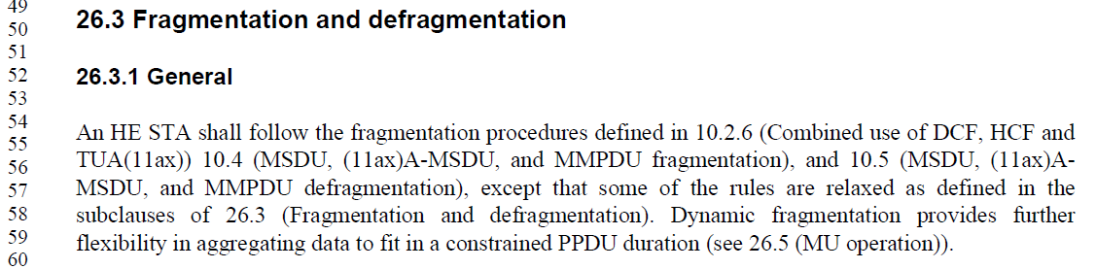
Cited text REVme D1.0 26.3.2.1 (General), p.4137:
Cited text REVme D1.0 26.3.2.1 (General), p.4137:
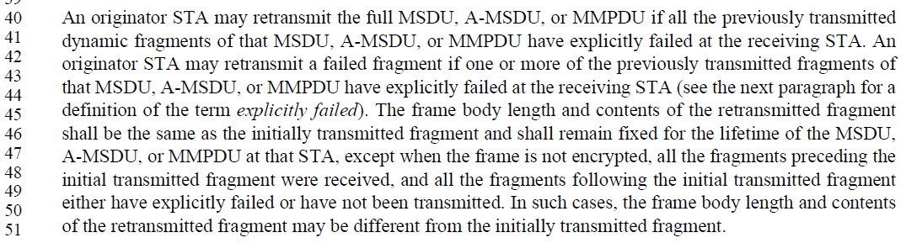Discussion of CID2198: The last paragraph in 10.4 states that dynamic fragmentation can be used if the conditions in 26.3.1 (General) are met, but the condition for allowing A-MSDU fragmentation (i.e., A-MSDU Fragmentation Support subfield in the HE Capabilities element transmitted by the recipient is 1) is specified in 26.3.2.1. So the reference should be changed from 26.3.1 to 26.3.2.1. To improve logical flow, reword 11ax text about dynamic fragmentation and move to after the first paragraph and before the procedure information.

Discussion of CID2199: Some rules for transmitting A-MSDU fragments are given in 26.3.1 and subclauses of 26.3.2, with a reference to 10.4 for the rest as shown in the cited text above. 10.4 needs to state that its rules apply to fragments of A-MSDUs, except where superseded by subclauses of 26.3. The following aspects of 10.4 are not addressed in subclauses of 26.3 so their use for dyamically fragmented A-MSDUs needs to be addressed in 10.4: sequence number, More Fragments bit, and dot11MaxTransmitMSDULifetime.

Proposed resolutions of CID2198 and CID2199: REVISED and ready for motion

TGm editor: Change subclause 10.4 as follows:
10.4 MSDU, (11ax)A-MSDU, and MMPDU fragmentation
The MAC may fragment and reassemble MSDUs or MMPDUs that are carried in individually addressed
MPDUs. The fragmentation and defragmentation mechanisms allow for fragment retransmission.

Dynamic fragmentation allows A-MSDUs to be fragmented. An HE STA may use dynamic fragmentation as defined in 26.3.2 (Dynamic fragmentation) if the conditions in 26.3.2.1 (General) are met. Transmission and retransmission of A-MSDU fragments shall follow the procedures defined in this subclause except where superseded by 26.3.

The length of each fragment shall be an equal number of octets for all fragments except the last, which may be smaller. The length of each fragment shall be an even number of octets, except for the last fragment of an MSDU or MMPDU, which may be either an even or an odd number of octets. The length of a fragment shall never be larger than dot11FragmentationThreshold unless security encapsulation is invoked for the MPDU. If security encapsulation is active for the MPDU, then the MPDU shall be expanded by the encapsulation overhead and this may result in a fragment larger than dot11FragmentationThreshold.
…
If a fragment requires retransmission, its frame body content and length shall remain fixed for the lifetime of the MSDU or MMPDU at that STA. Each fragment contains a Sequence Control field, which comprises a sequence number and fragment number. When a STA is transmitting a fragmented MSDU or MMPDU or dynamically fragmented A-MSDU, the sequence number shall remain the same for all fragments of that MSDU, A-MSDU, or MMPDU. The fragments shall be sent in order of lowest fragment number to highest fragment number, where the fragment number value starts at 0, and increases by 1 for each successive fragment. The Frame Control field also contains a bit, the More Fragments bit, that is equal to 0 to indicate the last fragment of the MSDU, A-MSDU, or MMPDU (or that the MSDU, A-MSDU or MMPDU was not fragmented, if the Fragment Number subfield is also equal to 0).

The source STA shall maintain a transmit MSDU/MMPDU timer for each MSDU/MMPDU being transmitted. The attribute dot11MaxTransmitMSDULifetime specifies the maximum amount of time allowed to transmit an MSDU/MMPDU. The timer starts on the initial attempt to transmit the MSDU/MMPDU, or first fragment of the MSDU/MMPDU if the MSDU/MMPDU is fragmented. If the timer exceeds dot11MaxTransmitMSDULifetime, then any remaining fragments are discarded by the source STA and no attempt is made to complete transmission of the MSDU/MMPDU.
…

============

CID | Commenter | Clause | Pg/Ln | Comment | Proposed Change
2200 | Nancy Lee | 10.5 | 2137/51 | The subclause adds A-MSDU defragmentation but doesn't state that A-MSDUs can be defragmented | change to "Each fragment contains information to allow the complete MSDU, A-MSDU, or MMPDU to be reassembled"
2201 | Nancy Lee | 10.5 | 2137/61 | Missing rules for A-MSDU defragmentation | update paragraphs regarding length of sequence control field, more fragments indicator, reconstruction, concurrent reception, receiver timer, and duplicate fragment acknowlegment on p 2137 line 61 and p 2138 lines 3-44 for the case of A-MSDU defragmentation

Discussion of CID2200: The last paragraph in 10.5 states that dynamic defragmentation can be used if the conditions in 26.3.1 (General) are met, but the condition for allowing A-MSDU (de)fragmentation (i.e., A-MSDU Fragmentation Support subfield in the HE Capabilities element transmitted by the recipient is 1) is specified in 26.3.2.1. So the reference should be changed from 26.3.1 to 26.3.2.1. To improve logical flow, reword 11ax text about dynamic fragmentation and make it a separate paragraph before the procedure information.

Discussion of CID2201: Some rules for A-MSDU defragmentation are given in 26.3.1 and subclauses of 26.3.3, with a reference to 10.5 for the rest. 10.5 needs to state that its rules apply to fragments of A-MSDUs except where superseded by subclauses of 26.3 (e.g., concurrent reception of fragments text in 10.5 is superseded by text in 26.3.3.1).
The following aspects are not addressed in subclauses of 26.3 so their use for dynamically fragmented A-MSDUs needs to be addressed in 10.5: Sequence Control field, More Fragments indicator, dot11MaxReceiveLifetime, and Receive Timer.

Proposed resolutions of CID2200 and CID2201: REVISED and ready for motion

TGm editor: Change subclause 10.5 as follows:
10.5 MSDU, (11ax)A-MSDU, and MMPDU defragmentation
Each fragment contains information to allow the complete MSDU, A-MSDU, or MMPDU to be reassembled from its constituent fragments.

Dynamic fragmentation allows A-MSDUs to be fragmented. Reception and reassembly of A-MSDU fragments shall follow the procedures defined in this subclause except where superseded by 26.3.

The header of each fragment contains the following information that is used by the destination STA to reassemble the MSDU, A-MSDU, or MMPDU:
- Frame type
- Address of the sender, obtained from the Address 2 field
- Destination address
- Sequence Control field: This field allows the destination STA to check that all incoming fragments belong to the same MSDU, A-MSDU, or MMPDU, and the sequence in which the fragments should be reassembled. The sequence number within the Sequence Control field remains the same for all fragments of an MSDU, A-MSDU, or MMPDU, while the fragment number within the Sequence Control field increments for each fragment.
- Traffic identifier, for frames with a QoS Control field.
- More Fragments indicator: Indicates to the destination STA that this is not the last fragment of a fragmented MSDU, A-MSDU, or MMPDU. Only the last fragment of a fragmented MSDU, A-MSDU, or MMPDU shall have this bit set to 0. All other fragments of a fragmented MSDU, A-MSDU, or MMPDU shall have this bit set to 1.

The destination STA shall reconstruct the MSDU or MMPDU by combining the fragments in order of fragment number subfield of the Sequence Control field. If security encapsulation has been applied to the fragment, it shall be deencapsulated and decrypted before the fragment is used for defragmentation of the MSDU, A-MSDU, or MMPDU. If the fragment with the More Fragments bit equal to 0 has not yet been received, then the destination STA knows that the MSDU, A-MSDU, or MMPDU is not yet complete. As soon as the STA receives the fragment with the More Fragments bit equal to 0, the STA knows that no more fragments will be received for the MSDU, A-MSDU, or MMPDU.

A STA shall support the concurrent reception of fragments of at least three MSDUs or MMPDUs. A STA should support the concurrent reception of fragments of at least one MSDU per access category. An AP should support the concurrent reception of at least one MSDU per access category per associated STA. Note that a STA receiving more than three fragmented MSDUs or MMPDUs concurrently might experience a significant increase in the number of frames discarded.

NOTE—The three MSDUs or MMPDUs might be from different peers (e.g., in an IBSS or MBSS).

The destination STA shall maintain a Receive Timer for each MSDU or MMPDU being received, for a minimum of three MSDUs or MMPDUs. The STA may implement additional timers to be able to receive
additional concurrent MSDUs or MMPDUs. The receiving STA shall discard all fragments that are part of an MSDU or MMPDU for which a timer is not maintained. There is also dot11MaxReceiveLifetime, that specifies the maximum amount of time allowed to receive an MSDU. The receive timer starts on the reception of the first fragment of a fragmented MSDU or MMPDU. If the receive timer exceeds dot11MaxReceiveLifetime, then all received fragments of this MSDU or MMPDU shall be discarded by the destination STA. If additional fragments of this MSDU or MMPDU are subsequently received, those fragments shall be acknowledged and discarded.

To properly reassemble MPDUs into an MSDU, A-MSDU, or MMPDU, a destination STA shall discard any duplicated fragments received. A STA shall discard duplicate fragments as described in 10.3.2.14 (Duplicate detection
and recovery). However, a duplicate fragment of an individually addressed MSDU, A-MSDU, or MMPDU shall be acknowledged.

