IEEE P802.11  
Wireless LANs

|  |  |  |  |  |
| --- | --- | --- | --- | --- |
| CID2377 CID2379 CID2374 in 11ax resolution | | | | |
| Date: 2022-04-04 | | | | |
| Author(s): | | | | |
| Name | Affiliation | Address | Phone | email |
| Yujin Noh | Senscomm |  |  | yujin.noh at senscomm.com |
| Graham Smith |  |  |  |  |
|  |  |  |  |  |

Abstract

This submission proposes resolutions for the following comments from comment collection on P802.11-REVme D1.0

* Modification is applied to P802.11-REVme D1.1
* 3 CIDs: 2374, 2379, and 2377

Revisions:

* Rev 0: Initial version of the document.
* Rev 1: CID2374 updated based on the comment during the teleconference call.

|  |  |  |  |  |
| --- | --- | --- | --- | --- |
| **CID** | **P.L** | **Comment** | **Proposed Change** | **Resolution** |
| 2379 | 4235.8 | In Equation (26-5), log10(PPDU_BW/20 MHz) should be 10xlog(PPDU_BW/20 MHz). | as in comment | Revised.  Agreed in principle. Equation and its description are improved.  TGm Editor: Incorporate the changes according to 11-22-0480-01-00m-CID2377-CID2379-CID2374 resolution.  Note: editorial modification by TGm editor is applicable to the resolution text. For example, do not subscript the "10" in "log10".  <https://mentor.ieee.org/802.11/dcn/22/11-22-0480-01-000m-CID2377-CID2379-CID2374 resolution.docx> |

***Discussion***

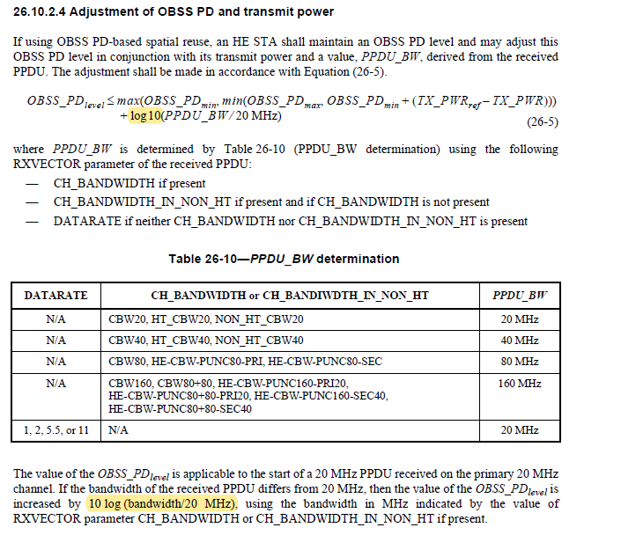

There is discrepancy between the Equation (26-5) and its corresponding description as highlighted above. The original intension is by following equations: This was well understood among the OBSS PD contributors in 11ax.

* *OBSS_PDlevel*(40 MHz)= *OBSS_PDlevel* + 3 dB
* *OBSS_PDlevel*(80 MHz)= *OBSS_PDlevel* + 6 dB
* *OBSS_PDlevel*(160 MHz or 80+80 MHz) = *OBSS_PDlevel* + 9 dB

***To TGme Editor: P4237L08 update the description as below.***

***------------- Begin Text Changes ---------------***



*OBSS_PDlevel* ≤ *max*(*OBSS_PDmin*,  *min*(*OBSS_PDmax, OBSS_PDmin* + (*TX_PWRref* –*TX*_*PWR*)))

+ $10\log_{10}(PPDU_BW/20 MHz )$

(26-5)

….

The value of the *OBSS_PDlevel* is applicable to the start of a 20 MHz PPDU received on the primary 20 MHz channel. If the bandwidth of the received PPDU differs from 20 MHz, then the value of the *OBSS_PDlevel* is increased by ~~10 log (bandwidth/20 MHz)~~, using the bandwidth in MHz indicated by the value of RXVECTOR parameter CH_BANDWIDTH or CH_BANDWIDTH_IN_NON_HT if present.

***------------- End Text Changes ------------------***

|  |  |  |  |  |
| --- | --- | --- | --- | --- |
| **CID** | **P.L** | **Comment** | **Proposed Change** | **Resolution** |
| 2377 | 2317.34 | delete the leftover of BA Ack Policy subfield. | as in comment | Rejected.  PSMP is deprecated, so no changes are made. |

***Discussion***

According to 20/650r4, the tables of BAR Ack Policy subfield and BA Ack Policy subfield were deleted as below.



However, there are locations with BA Ack Policy subfield and BAR Ack Policy subfield as below

At P2319L32 in REVme D1.1,

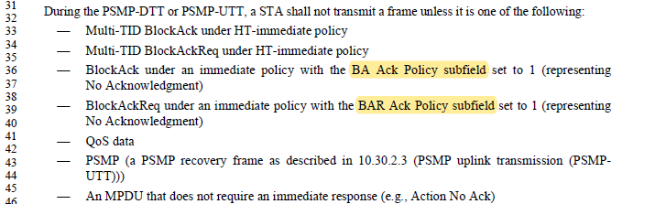

At P2046L1 in REVme D1.1,

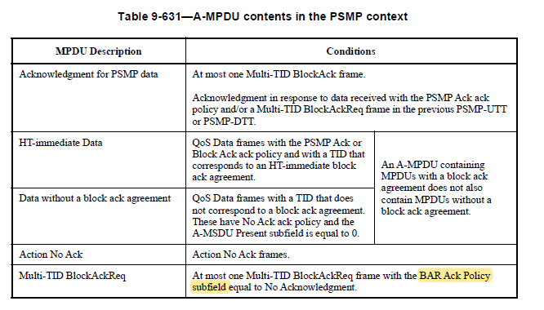

At P916L9 in the Table 9-13 (Ack policy), the Ack Policy Indicator subfield idenitifes the ack policy.

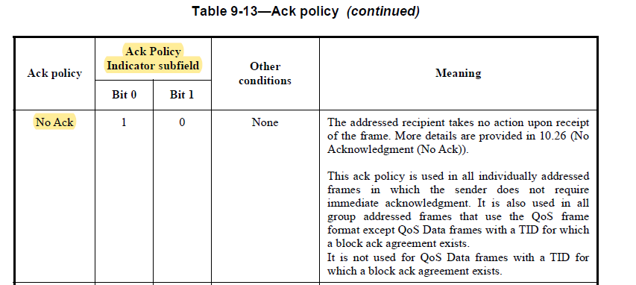

***To TGme Editor: P23190L36 update the description as below.***

***------------- Begin Text Changes ---------------***

During the PSMP-DTT or PSMP-UTT, a STA shall not transmit a frame unless it is one of the following:

* Multi-TID BlockAck under HT-immediate policy
* Multi-TID BlockAckReq under HT-immediate policy
* BlockAck under an immediate policy with the ~~BA~~ Ack Policy Indicator subfield set to 1 (representing

No Acknowledgment)

* BlockAckReq under an immediate policy with the ~~BAR~~ Ack Policy Indicator subfield set to 1 (representing

No Acknowledgment)

* QoS data
* PSMP (a PSMP recovery frame as described in 10.30.2.3 (PSMP uplink transmission (PSMPUTT)))
* An MPDU that does not require an immediate response (e.g., Action No Ack)

***------------- End Text Changes ------------------***

***To TGme Editor: P2046L01 update the description as below.***

***------------- Begin Text Changes ---------------***

|  |  |  |
| --- | --- | --- |
| * A-MPDU contents in the PSMP context | | |
| MPDU Description | Conditions | |
| Acknowledgment for PSMP data | At most one Multi-TID BlockAck frame.  Acknowledgment in response to data received with the PSMP Ack ack policy and/or a Multi-TID BlockAckReq frame in the previous PSMP-UTT or PSMP-DTT. | |
| HT-immediate Data | QoS Data frames with the PSMP Ack or Block Ack ack policy and with a TID that corresponds to an HT-immediate block ack agreement. | An A-MPDU containing MPDUs with a block ack agreement does not also contain MPDUs without a block ack agreement. |
| Data without a block ack agreement | QoS Data frames with a TID that does not correspond to a block ack agreement.  These have No Ack ack policy and the A‑MSDU Present subfield is equal to 0. |
| Action No Ack | Action No Ack frames. | |
| Multi-TID BlockAckReq | At most one Multi-TID BlockAckReq frame with the ~~BAR~~ Ack Policy Indicator subfield set to 1 (representing No Acknowledgment)~~equal to No Acknowledgment~~. | |

***------------- End Text Changes ------------------***

|  |  |  |  |  |
| --- | --- | --- | --- | --- |
| **CID** | **P.L** | **Comment** | **Proposed Change** | **Resolution** |
| 2374 | 1702.14 | Even though the description in the spec that "Within a set of PPET16 and PPET8 subfields corresponding to a single value of NSTS, lower numbered PPE Thresholds Info field bits contain PPET16 and PPET8 subfields corresponding to lower numbered RU index values", Figure 9-875 may lead to  misinterpretation the order of NSTSn and RUb such as which one starts increasing index first in order between NSTSn and RUb.  The intension is PPET16NSTS1RUx,  PPET8NSTS1RUx, PPET16NSTS1RUy,  PPET8NSTS1RUy , ..., PPET16NSTS1RUm,  PPET8NSTS1RUm,  PPET16NSTS2RUx,  PPET8NSTS2RUx, PPET16NSTS2RUy,  PPET8NSTS2RUy , ..., PPET16NSTS2RUm,  PPET8NSTS2RUm, ...., PPET16NSTS(NSTS+1)RUm,  PPET8NSTS(NSTS+1)RUm. However, this figure seems to open the different order such as PPET16NSTS1RUx,  PPET8NSTS1RUx, PPET16NSTS2RUx,  PPET8NSTS2RUx, .... | Make it clear to reflect the intension in the spec. For example, append PPET16NSTS1RUy, PPET8NSTS1RUy to PPET8NSTS1RUx in the Figure 9-875. | Revised.  Agreed in principle.  TGm Editor: Incorporate the changes according to 11-22-0480-01-00m-CID2377-CID2379-CID2374 resolution.  <https://mentor.ieee.org/802.11/dcn/22/11-22-0480-01-000m-CID2377-CID2379-CID2374 resolution.docx> |

***Discussion***

There are two parts to explain on PPE Thresholds Info field of HE Capabilities element. For example, the STA supports 242-RU/484-RU with up to NSTS=2.

Following part 1, Opt 1 seems to show the order such as (PPET16NSTS1RU0 PPET8NSTS1RU0), (PPET16NSTS2RU0 PPET8NSTS2RU0), (PPET16NSTS1RU1 PPET8NSTS1RU1), (PPET16NSTS2RU1 PPET8NSTS2RU1) due to the expresson “6 x (NSTS+1) bits for every bit in the RU Index Bitmask subfield”. Intention of the “6 × (NSTS + 1) bits, where NSTS is the value in the NSTS field, for every bit in the RU Index Bitmask subfield” is to provide the total number of bits for PPE Thresholds Info field. However, it might mislead as the order for readers.

Following part 2, Opt 2 seems to show the order such as (PPET16NSTS1RU0 PPET8NSTS1RU0), (PPET16NSTS1RU1 PPET8NSTS1RU1), (PPET16NSTS2RU0 PPET8NSTS2RU0), (PPET16NSTS2RU1 PPET8NSTS2RU1), due to the expression “Lower numbered PPE Thresholds Info field bits contain PPET16 and PPET8 subfields corresponding to lower numbered NSTS values.” And “Within a set of PPET16 and PPET8 subfields corresponding to a single value of NSTS, lower numbered PPE Thresholds Info field bits contain PPET16 and PPET8 subfields corresponding to lower numbered RU index values.”



Moreover, the Figure 9-875 does not help to understand the order correctly, because it can cover two options due to the mark “…” as below.

Probably if the description of the total number of bits in this field is needed then improving the Figure 9-875 (PPE Thresholds Info field format) could be enough.

***To TGme Editor: P1701L487 update the description as below.***

***------------- Begin Text Changes ---------------***

The NSTS subfield contains an unsigned integer that is the number of NSTS values minus 1 for which PPE threshold values are included in the PPE Thresholds ~~List~~Info subfield.

The RU Index Bitmask subfield contains a bitmask that indicates whether the PPE Thresholds Info field contains PPET16 and PPET8 values for the four possible RU sizes indicated in Table 9-370 (RU allocation index(11ax)). The PPET16 and PPET8 values for RU allocation index k is present in the PPE Thresholds Info field only if bit k of the RU Index Bitmask subfield (bit 3 + k of the PPE Thresholds field) is 1. For example, if B0 of the RU Index Bitmask subfield (B3 of the PPE Thresholds field) is 1, PPET16 and PPET8 values are present in the PPE Thresholds Info field for the RU allocation size corresponding to RU allocation index 0 (242-tone RU). If B0 of the RU Index Bitmask subfield is 0, PPET16 and PPET8 values are not present in the PPE Thresholds Info field for the RU allocation size corresponding to RU allocation index 0. The RU Index Bitmask subfield is nonzero.

~~The PPE Thresholds List field contains 6 × (~~*~~NSTS~~*~~+ 1) bits, where~~ *~~NSTS~~* ~~is the value in the NSTS field, for every bit in the RU Index Bitmask subfield that is nonzero.~~ The format of the PPE Thresholds Info field is defined in Figure 9-875 (PPE Thresholds Info field format(11ax)).

|  |  |  |  |  |  |  |  |  |  |  |  |
| --- | --- | --- | --- | --- | --- | --- | --- | --- | --- | --- | --- |
|  | B0      B2 | B3      B5 |  |  |  |  |  |  |  |  |  |
|  | PPET16 NSTS1 RU*x* | PPET8 NSTS1 RU*x* | … | PPET16 NSTS1 RU*m* | PPET8 NSTS1 RU*m* | … | PPET16 NSTS*n* RU*x* | PPET8 NSTS*n* RUx | … | PPET16 NSTS*n* RU*m* | PPET8 NSTS*n* RU*m* |
| Bits: | 3 | 3 |  | 3 | 3 |  | 3 | 3 |  | 3 | 3 |
| * PPE Thresholds Info field format(11ax) | | | | | | | | |  |  |  |

The PPET16 and PPET8 subfields for various NSTS and RU values appear in increasing NSTS value and increasing RU index value order. Lower numbered PPE Thresholds Info field bits contain PPET16 and PPET8 subfields corresponding to lower numbered NSTS values. Within a set of PPET16 and PPET8 subfields corresponding to a single value of *NSTS*, lower numbered PPE Thresholds Info field bits contain PPET16 and PPET8 subfields corresponding to lower numbered RU index values. The PPET16 NSTS*n* RU*b* and PPET8 NSTS*n* RU*b* subfields are present for all values of *n* and *b* where 1 ≤ *n* ≤ (*NSTS* + 1) and where *b* = [*x*, …, *m*] is the set of integers equal to the ordered list of bit positions of all bits that are set to 1 in the RU Index Bitmask subfield, with *x* being the lowest value.

***------------- End Text Changes ------------------***