IEEE P802.11
Wireless LANs
Proposed changes to the table of supported channel width
Date: 2022-03-10
Author(s):
Name | Affiliation | Address | Phone | email
Xiaogang Chen | Intel | 2111 NE 25th Ave, Hillsboro, OR, 97124 |  | Xiaogang.c.chen@Intel.com

Abstract
This submission proposes text changes to:
- Table Table 35-6 – Indication of supported channel widths by an EHT STA.
- Rx procedure of EHT-SIG portion.
- EHT-SIG portion

Interpretation of a Motion to Adopt

A motion to approve this submission means that the editing instructions and any changed or added material are actioned in the TGbe Draft 1.4. This introduction is not part of the adopted material.

Editing instructions formatted like this are intended to be copied into the TGbe Draft (i.e. they are instructions to the 802.11 editor on how to merge the text with the baseline documents).

TGbe Editor: Editing instructions preceded by “TGbe Editor” are instructions to the TGbe editor to modify existing material in the TGbe draft. As a result of adopting the changes, the TGbe editor will execute the instructions rather than copy them to the TGbe Draft.

Discussions related to supported channel width: Although spec saying reserved bits are set to 0, it was identified few vendors don’t follow in HE STA. Propose to add text and make sure EHT STA set reserved to 0.

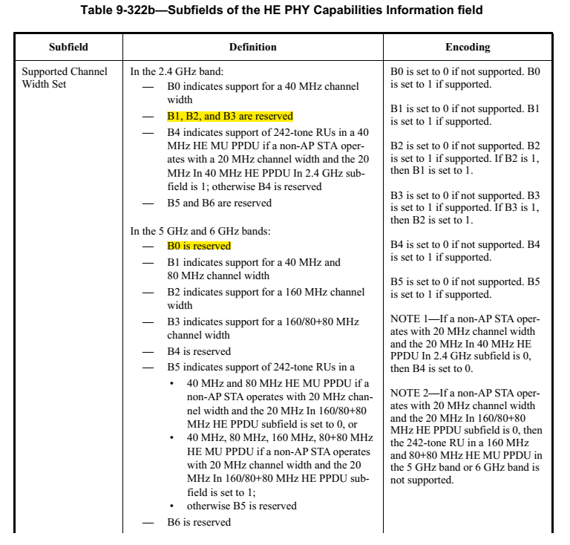

To TGbe editor: please change Table 35-6 as following (changes to the table are on top of the changes to the same table in DCN 1220r1):

Table 35-6 – Indication of supported channel widths by an EHT STA
Operating Band | Maximum supported channel width | Supported Channel Width Set subfield in the HT Capabilities element | Supported Channel Width Set and the Extended NSS BW Support subfields in the VHT Capabilities element  (See Table 9-311) | Supported Channel Width Set subfield in the HE Capabilities element | Support For 320 MHz in 6 GHz subfield in the EHT Capabilities element
2.4 GHz | 20 MHz | 0 | N/A | Set B0 to 0,  B1 to 0,  B2 to 0,  B3 to 0 | 0
2.4 GHz | 40 MHz | 1 | N/A | Set B0 to 1,  B1 to 0,  B2 to 0,  B3 to 0 | 0
5 GHz | 20 MHz  (See NOTE) | 0 | Set to indicate support for up to 80 MHz | Set B1 to 0, B2 to 0, B3 to 0,  B0 to 0 | 0
5 GHz | 80 MHz | 1 | Set to indicate support for up to 80 MHz | Set B1 to 1,  B2 to 0, B3 to 0,  B0 to 0 | 0
5 GHz | 160 MHz | 1 | Set to indicate support for up to 160 or 80+80 MHz | Set B1 to 1,  B2 to 1,  B0 to 0 | 0
6 GHz | 20 MHz (See NOTE) | N/A | N/A | Set B1 to 0, B2 to 0, B3 to 0, B0 to 0,  B0 to 0 | 0
6 GHz | 80 MHz | N/A | N/A | Set B1 to 1,  B2 to 0, B3 to 0,  B0 to 0 | 0
6 GHz | 160 MHz | N/A | N/A | Set B1 to 1,  B2 to 1,  B0 to 0 | 0
6 GHz | 320 MHz | N/A | N/A | Set B1 to 1,  B2 to 1,  B0 to 0 | 1
NOTE – This corresponds to the 20 MHz-only non-AP EHT STA. An EHT AP does not use this setting.

Discussions related to STA-ID:
Existing text in Rx procedure and Table 36-40—(User field format for a non-MU-MIMO allocationin EHT-SIG) assume receiver is non-AP STA, and require receiver to match STA-ID in EHT-SIG of the PPDU with its own STA-ID. Need to create exception for UL PPDU addressed to AP.

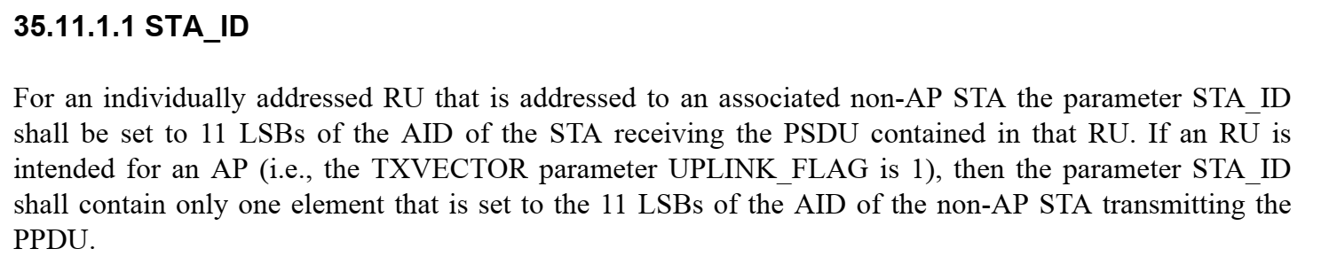

To TGbe editor: please make the following changes based on D1.4:

P.L. 697.3

If the received PPDU is EHT MU PPDU, the PHY entity shall begin receiving the EHT-SIG, EHT-STF, and EHT-LTF for EHT MU PPDU as shown in Figure 36-83 (PHY receive procedure for an EHT MU
PPDU). The PHY entity shall check the CRC of the Common field of EHT-SIG.
— (#5485)If the CRCs protecting the Common field of EHT-SIG are valid, for all supported modes,
unsupported modes and Validate indication, the PHY entity shall maintain PHYCCA.indication(BUSY, channellist) primitive for the predicted duration of the transmitted PPDU, as
defined by RXTIME in Equation (36-109)(#7274)(#2624), unless it receives a PHYCCARESET.request primitive before the end of the PPDU for instance during spatial reuse
operation as described in 35.10 (EHT Spatial reuse operation(#5444))(#5495). A Validate EHT-SIG
indication is defined as (#7274)a field value of a subfield either in the EHT-SIG common field or in
the receiver’s own user field being set to a Validate state.
— (#5485)If the CRCs protecting the Common field of the EHT-SIG are valid, the PHY entity shall
search for intended STA-ID in each User field. If an intended STA-ID is detected in a user encoding
block(#7280) or in the common encoding block of EHT-SIG (For non-OFDMA transmission, STA-ID can be present in the common encoding block of EHT-SIG) with valid CRC, and an unsupported mode or a Validate EHT-SIG
indication is not indicated, the PHY entity shall continue receiving the EHT-STF right after the
EHT-SIG.
— (#5485)If the CRCs protecting the Common field of the EHT-SIG are valid and no intended STA-ID
is detected in all the User fields, the PHY entity shall issue a PHYRXSTART.indication(RXVECTOR) then issue a PHY-RXEND.indication(Filtered).
— (#5485)If the CRCs protecting the Common field of the EHT-SIG are valid and an intended STA-ID
is detected, but an unsupported mode or a Validate EHT-SIG indication is indicated in EHT-SIG field, the PHY shall issue a PHY-RXSTART.indication(RXVECTOR) then issue a PHYRXEND.indication(UnsupportedRate) primitive.

Note: if the UL/DL subfield and PPDU Type And Compressionn Mode subfield in U-SIG are all set to 1, which indicate an MU PPDU is transmitted to AP, receiver (the EHT AP STA) shall disregard the STA-ID subfield in the user field of the EHT-SIG and continue parsing the rest fields in the EHT-SIG.

— (#5485)If the CRCs protecting the Common field of the EHT-SIG are not valid, the PHY shall issue
the error condition PHY-RXEND.indication(FormatViolation) primitive and maintain PHYCCA.indication(BUSY, channellist) primitive for the predicted duration of the transmitted PPDU
derived from the LENGTH field in L-SIG as defined in Equation (36-108)(#2625) unless it receives
a PHY-CCARESET.request primitive before the end of the PPDU for instance during spatial reuse
operation as described in 35.10 (EHT Spatial reuse operation(#5444))(#5495).

P.L. 595.5: Make the following changes to table 36-40

Table 36-40—User field format for a non-MU-MIMO allocation

Bit | Subfield | Number of bits | Description
B0–B10 | STA-ID | 11 | (#2198)(#7222)Set to a value of the TXVECTOR parameter STA-ID (see 35.11.1.1 (STA_ID)).
B11–B14 | MCS | 4 | (#5426)If the STA-ID subfield is not equal to 2046, this subfield indicates the following modulation and coding scheme:  Set to n for EHT-MCS n, where n = 0, 1, …, 15 .  Set to an arbitrary value if the STA-ID subfield is equal to 2046.  (#5426)For a PPDU addressed to non-AP EHT STA:  - If the value of STA-ID subfield matches the user’s STA-ID and if dot11EHTBaseLineFeaturesImplementedOnly equals true, the value of EHT-MCS 14 or EHT-MCS 15 is Validate if the condition described in 36.1.1 (Introduction to the EHT PHY) is not met.  - If the value of STA-ID subfield does not match the user’s STA-ID and if dot11EHTBaseLineFeaturesImplementedOnly equals true, all values are Disregard.
B15 | Reserved | 1 | Reserved and set to 1.  (#1353)(#1355)(#5426)  For a PPDU addressed to non-AP EHT STA:  - If the value of STA-ID subfield matches the user’s STA-ID and if dot11EHTBaseLineFeaturesImplementedOnly equals true, the Reserved subfield is Validate.  - If the value of STA-ID subfield does not match the user’s STA-ID and if dot11EHTBaseLineFeaturesImplementedOnly equals true, the Reserved subfield is Disregard.

Table 36-40—User field format for a non-MU-MIMO allocation (continued)

Bit | Subfield | Number of bits | Description
B16–B19 | NSS | 4 | (#1566)(#2644)(#5426)If the STA-ID subfield is not equal to 2046, it indicates the number of spatial streams for up to eight spatial streams.  (#5426)Set to the number of spatial streams minus 1.  (#5426)Set to an arbitrary value if the STA-ID subfield is equal to 2046.  (#5426) For a PPDU addressed to non-AP EHT STA:  - If the value of STA-ID subfield matches the user’s STA-ID and if dot11EHTBaseLineFeaturesImplementedOnly equals true, other values are Validate.  - If the value of STA-ID subfield does not match the user’s STA-ID and if dot11EHTBaseLineFeaturesImplementedOnly equals true, all values are Disregard.
B20 | Beamformed | 1 | (#7225)If the STA-ID subfield is not 2046, this subfield is used to indicate transmit beamforming:  Set to 1 if a beamforming steering matrix is applied to the waveform in a non-MU-MIMO allocation.  Set to 0 otherwise.  Set to an arbitrary value if the STA-ID subfield is 2046.
B21 | Coding | 1 | (#5426)If the STA-ID subfield is not equal to 2046, this subfield indicates whether BCC or LDPC is used: Set to 0 for BCC.  Set to 1 for LDPC.  Set to an arbitrary value if the STA-ID subfield is 2046.  (#5426) For a PPDU addressed to non-AP EHT STA, if the value of STA-ID subfield does not match the user’s STA-ID and if dot11EHTBaseLineFeaturesImplementedOnly equals true, all values are Disregard.

