IEEE P802.11
Wireless LANs
Proposed changes to the table of supported channel width
Date: 2022-03-10
Author(s):
Name | Affiliation | Address | Phone | email
Xiaogang Chen | Intel | 2111 NE 25th Ave, Hillsboro, OR, 97124 |  | Xiaogang.c.chen@Intel.com

Abstract
This submission proposes text changes to table Table 35-6 – Indication of supported channel widths by an EHT STA.

Interpretation of a Motion to Adopt

A motion to approve this submission means that the editing instructions and any changed or added material are actioned in the TGbe Draft 1.4. This introduction is not part of the adopted material.

Editing instructions formatted like this are intended to be copied into the TGbe Draft (i.e. they are instructions to the 802.11 editor on how to merge the text with the baseline documents).

TGbe Editor: Editing instructions preceded by “TGbe Editor” are instructions to the TGbe editor to modify existing material in the TGbe draft. As a result of adopting the changes, the TGbe editor will execute the instructions rather than copy them to the TGbe Draft.

Discussions: Although spec saying reserved bits are set to 0, it was identified few vendors don’t follow in HE STA. Propose to add text and make sure EHT STA set reserved to 0.

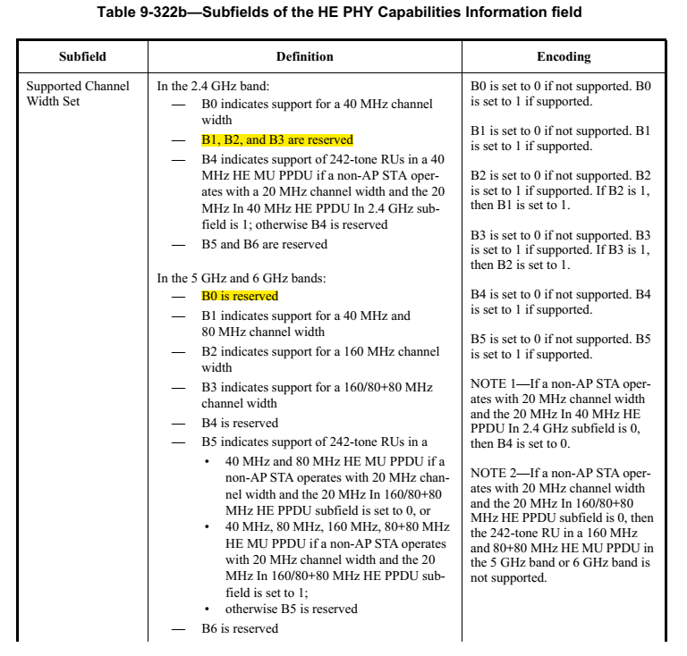

To TGbe editor: please change Table 35-6 as following (changes to the table are on top of the changes to the same table in DCN 1220r1):

Table 35-6 – Indication of supported channel widths by an EHT STA
Operating Band | Maximum supported channel width | Supported Channel Width Set subfield in the HT Capabilities element | Supported Channel Width Set and the Extended NSS BW Support subfields in the VHT Capabilities element  (See Table 9-311) | Supported Channel Width Set subfield in the HE Capabilities element | Support For 320 MHz in 6 GHz subfield in the EHT Capabilities element
2.4 GHz | 20 MHz | 0 | N/A | Set B0 to 0,  B1 to 0,  B2 to 0,  B3 to 0 | 0
2.4 GHz | 40 MHz | 1 | N/A | Set B0 to 1,  B1 to 0,  B2 to 0,  B3 to 0 | 0
5 GHz | 20 MHz  (See NOTE) | 0 | Set to indicate support for up to 80 MHz | Set B1 to 0, B2 to 0, B3 to 0,  B0 to 0 | 0
5 GHz | 80 MHz | 1 | Set to indicate support for up to 80 MHz | Set B1 to 1,  B2 to 0, B3 to 0,  B0 to 0 | 0
5 GHz | 160 MHz | 1 | Set to indicate support for up to 160 or 80+80 MHz | Set B1 to 1,  B2 to 1,  B0 to 0 | 0
6 GHz | 20 MHz (See NOTE) | N/A | N/A | Set B1 to 0, B2 to 0, B3 to 0, B0 to 0,  B0 to 0 | 0
6 GHz | 80 MHz | N/A | N/A | Set B1 to 1,  B2 to 0, B3 to 0,  B0 to 0 | 0
6 GHz | 160 MHz | N/A | N/A | Set B1 to 1,  B2 to 1,  B0 to 0 | 0
6 GHz | 320 MHz | N/A | N/A | Set B1 to 1,  B2 to 1,  B0 to 0 | 1
NOTE – This corresponds to the 20 MHz-only non-AP EHT STA. An EHT AP does not use this setting.

