IEEE P802.11
Wireless LANs
Proposed Text for Clause 5
Date: 2022-03-05
Author(s):
Name | Affiliation | Address | Phone | email
Hitoshi Morioka | SRC Software | Fukuoka, JAPAN |  | hmorioka@src-soft.com
Abstract
This document describes the text proposal for clause 5.

The baseline is D2.2.

Proposed text

5.1.5.1 General

Replace the Figure 5-1 as follows:

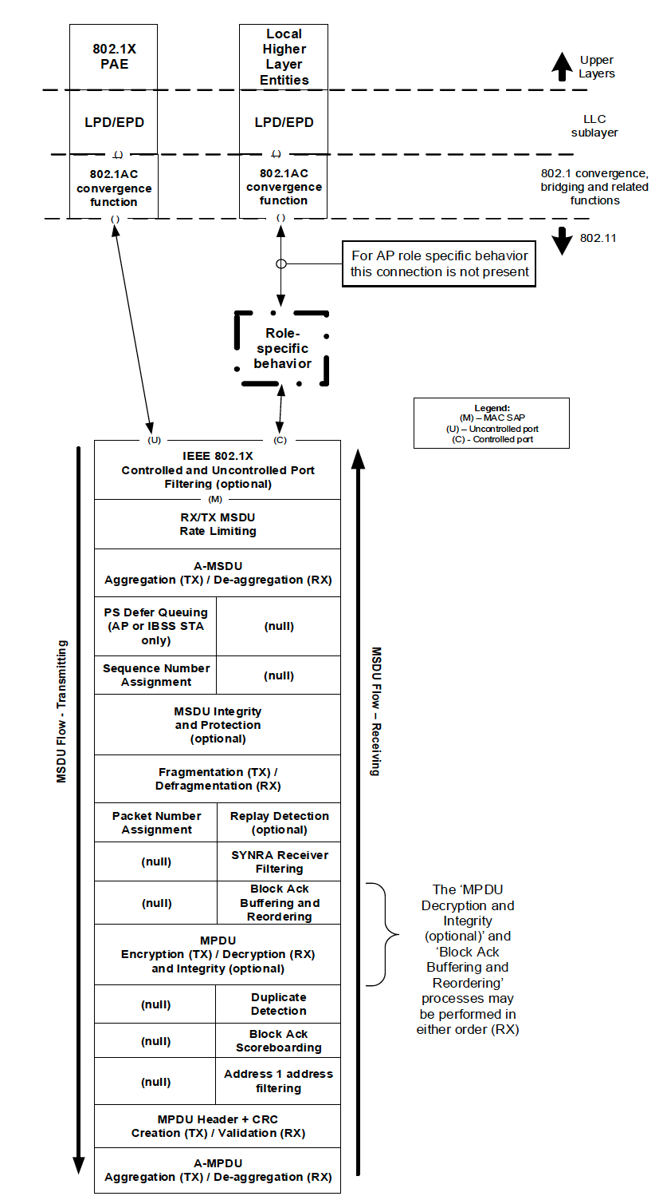
To TGbc editor: EBCS Filtering block is only applied to RX flow.
Corresponding block for TX flow is (null).
Add (M) (2 locations).
[2141, 2142]
(M)
(M)
(null)
EBCS Filtering (optional)
(U)
(C)
IEEE 802.1X Controlled and Uncontrolled Port Filtering (optional)
Figure 5-1---MAC data plane architecture

5.1.5.3 Non-GLK AP role

Modify Figure 5-4 as follows: [2145, 2171, 2117, 2116]

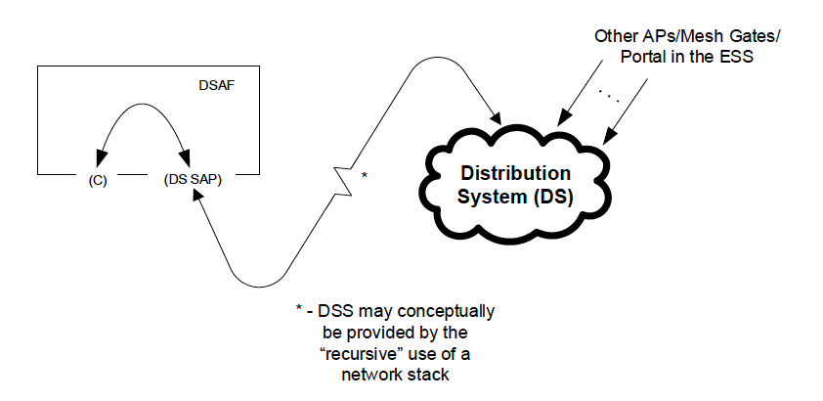
EBCS traffic stream mapper
(only exist for EBCS DL)
Figure 5-4---Role-specific behavior block for a non-GLK AP

Remove line at P28L29: [2145, 2171, 2117, 2116]

In the context of EBCS, an EBCS traffic stream mapper, located at the entry of the DS, assigns the EBCS content ID for frames of EBCS traffic stream according to the configuration.

