IEEE P802.11
Wireless LANs
Proposed Text for Clause 4
Date: 2022-03-10
Author(s):
Name | Affiliation | Address | Phone | email
Hitoshi Morioka | SRC Software | Fukuoka, JAPAN |  | hmorioka@src-soft.com
Abstract
This document describes the text proposal for clause 4 and related clauses.

The baseline is D2.2.

Proposed text

4.3.31 Enhanced broadcast services

Add the subclause title for 4.3.31.1:

4.3.31.1 General

Enhanced broadcast services (EBCS) provide transmission and reception of broadcast data in an
infrastructure BSS, both in cases where there is an association between the transmitter and the receiver(s)
and in cases where there is no association between transmitter and receiver(s). Further, EBCS provides a
service in which an EBCS proxy affiliated with an EBCS STA can relay the contents of a higher layer
payload received from an EBCS non-AP STA to a destination typically within an external network. The
relaying EBCS proxy can embed additional information into the higher layer payload.

When there is an association, EBCS provides additional means for protecting broadcast traffic and the
privacy of the stations receiving that traffic, including data origin authenticity.

Add the following subclause 4.3.31.2: [2214]

4.3.31.2 EBCS DL

4.3.31.2.1 General

EBCS DL provides a mechanism for an EBCS AP to broadcast one or more EBCS traffic streams to EBCS receivers with origin authenticity whether or not there is an association between the EBCS AP and the EBCS receivers.

4.3.31.2.1 EBCS traffic stream mapper [2145, 2171, 2117, 2116, 2280]

The EBCS traffic stream mapper is used to map inbound multicast traffic to EBCS traffic streams. The EBCS traffic stream mapper is located at the entry of the DSAF (Figure 5-4 (Role-specific behavior block for a non-GLK AP)). It inspects the IP header and UDP header of the inbound multicast packets and assigns the content ID and the corresponding EBCS Content MAC address according to the configuration. The configuration for the EBCS traffic stream mapper defines each content ID and the corresponding source IP address, destination IP address and destination UDP port of the multicast traffic. The configuration of the EBCS traffic stream mapper is identical to that defined by dot11EBCSTrafficStreamTable of an EBCS AP in the DS.

4.3.31.2.2 EBCS filter [2270, 2114, 2143, 2116, 2256]

The EBCS filter is located in the MAC data plane as shown in Figure 5-1 (MAC data plane architecture). It filters the received EBCS traffic streams by their EBCS Content MAC address according to dot11EBCSTrafficStreamTable and reconstructs the MAC header. Details are described in 11.55.2.3 (EBCS DL operation at an EBCS receiver).

4.3.31.2.3 Example of EBCS DL operation

Figure 4-bc1 provides an example of EBCS DL operation.

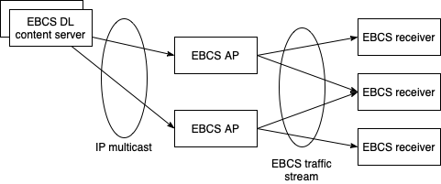
Figure 4-bc1---Example of EBCS DL operation

EBCS DL content servers are distributing contents by IP multicast on IP network. Each EBCS DL content server can distribute multiple contents that can be identified by the destination IP address and the destination UDP port.

An EBCS AP can receive multiple contents from one or more EBCS DL content server(s). An EBCS AP can select contents to be broadcasted by setting dot11EBCSTrafficStreamTable and configurations for the EBCS traffic stream mapper. An EBCS AP broadcasts contents as EBCS traffic streams. An EBCS AP can add authentication information to the contents.

An EBCS receiver can receive multiple EBCS traffic streams from one or more EBCS AP(s). An EBCS receiver can select EBCS traffic streams to be consumed by setting dot11EBCSTrafficStreamEnabled in dot11TrafficStreamTable. Each EBCS traffic stream can be authenticated if the transmitting EBCS AP add authentication information.

Move clause 4.5.12 under 4.3.31:

4.5.12 4.3.31.3 EBCS relaying service

5.1.5.1 General

Replace the Figure 5-1 as follows:

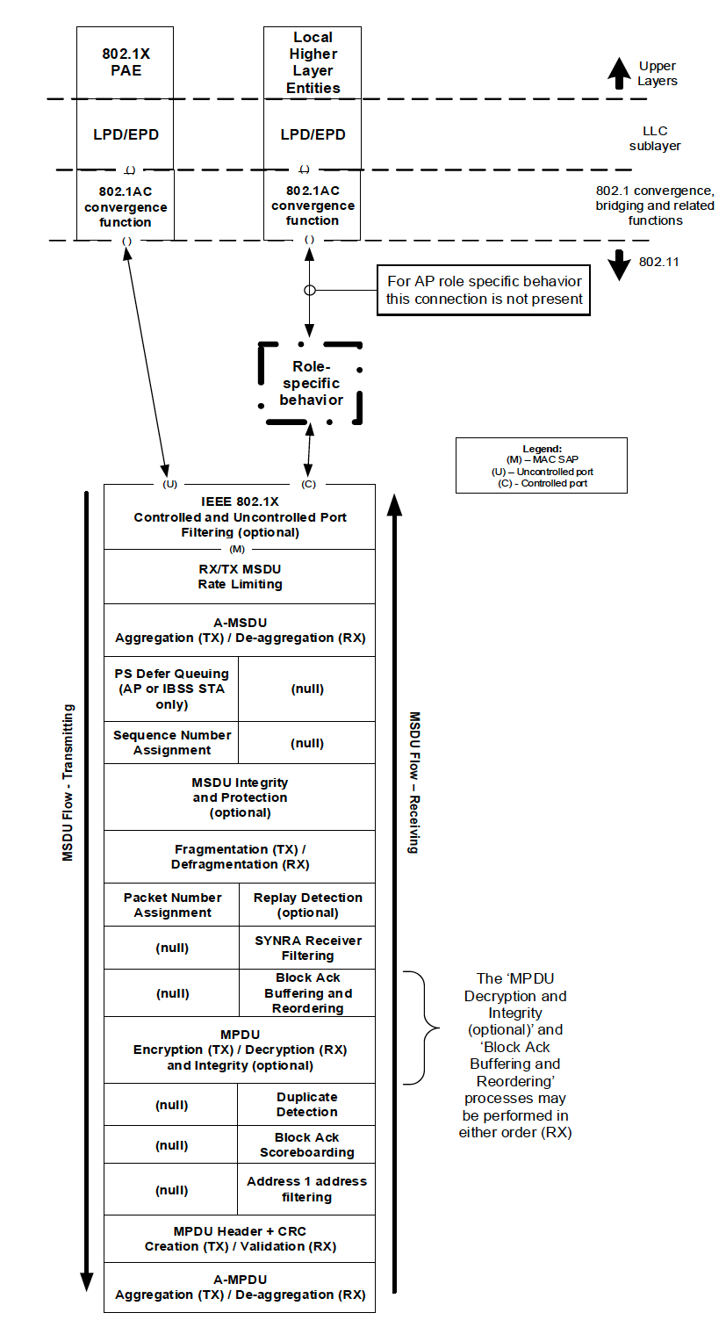
To TGbc editor: EBCS Filtering block is only applied to RX flow.
Corresponding block for TX flow is (null).
Add (M) (2 locations).
[2141, 2142]
(M)
(M)
(null)
EBCS Filtering (optional)
(U)
(C)
IEEE 802.1X Controlled and Uncontrolled Port Filtering (optional)
Figure 5-1---MAC data plane architecture

5.1.5.3 Non-GLK AP role

Modify Figure 5-4 as follows: [2145, 2171, 2117, 2116]

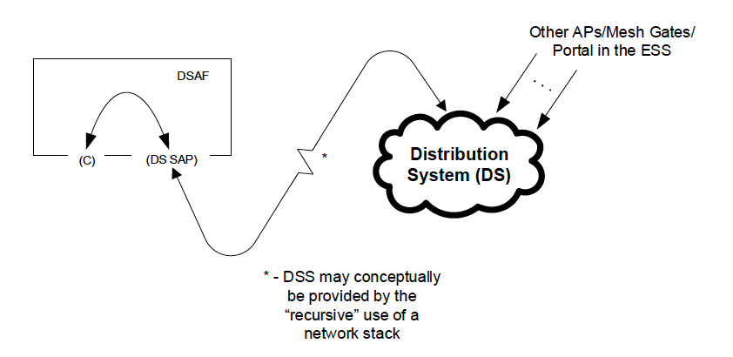
EBCS traffic stream mapper
(only exist for EBCS DL)
Figure 5-4---Role-specific behavior block for a non-GLK AP

Remove line at P28L29: [2145, 2171, 2117, 2116]

In the context of EBCS, an EBCS traffic stream mapper, located at the entry of the DS, assigns the EBCS content ID for frames of EBCS traffic stream according to the configuration.

11.55.1 Overview [2224]

Add the following sentence at the end of 11.55.1:

EBCS is not supported for MBSS or GLK.

11.55.2.2 EBCS DL operation at an EBCS receiver (baseline: 11-22/0298r2) [2126, 2280]

Modify the first paragraph in 11.55.2.2 as follows:

EBCS DL operation is enabled in an EBCS AP if the length of the dot11EBCSContentList greater than 0. The EBCS traffic streams to be transmitted are specified in dot11EBCSContentList. The EBCS traffic streams are handled differently than other traffic. An EBCS content ID and EBCS Content MAC address shall be assigned by the EBCS traffic stream mapper located at the portal entry of the DSAF to identify each different traffic stream of content. The EBCS traffic stream mapper shall be configured according to the EBCS content list. Each content ID shall be unique to the AP certificate.

11.55.2.3 EBCS DL operation at an EBCS receiver (baseline: 11-22/0298r2) [2270, 2114, 2143, 2116, 2256]

Modify the second paragraph in 11.55.2.3 as follows:

The SME of an EBCS receiver obtains an EBCS content list from set dot11EBCSTrafficStreamTable according to the Content Information field of the EBCS Info frame or Enhanced Broadcast Services ANQP-element. The SME selects one or more EBCS contents to receive, then set dot11EBCSTrafficStreamEnabled and configures its dot11GroupAddressesTable the MAC to filter on the EBCS Content MAC addresses corresponding to the content of interest. If the HLP destination address is an IPv4 address or an IPv6 address, the DA is assumed to be mapped according to IETF RFC 1112 and IETF RFC 2464 respectively.

C.3 MIB detail (baseline: 11-22/0089r8) [2270, 2114, 2143, 2116, 2256]

Modify Dot11EBCSTrafficStreamEntry as follows:

Dot11EBCSTrafficStreamEntry ::=
SEQUENCE {
dot11EBCSTrafficStreamID Unsigned32,
dot11EBCSTrafficStreamAuthenticationAlgorithm INTEGER,
dot11EBCSTrafficStreamAddressType INTEGER,
dot11EBCSTrafficStreamAddress OCTET STRING,
dot11EBCSTrafficStreamTitle OCTET STRING,
dot11EBCSTrafficStreamPHYType Unsigned32,
dot11EBCSTrafficStreamTXRate OCTET STRING,
dot11EBCSTrafficStreamNegotiationMethod INTEGER,
dot11EBCSTrafficStreamNextTXSchedule Unsigned32,
dot11EBCSTrafficStreamTimeToTermination Unsigned32,
dot11EBCSTrafficStreamBufferable TruthValue,
dot11EBCSTrafficStreamEnabled TruthValue
}

Insert following dot11EBCSTrafficStreamEnabled after dot11EBCSTrafficStreamBufferable:

dot11EBCSTrafficStreamEnabled OBJECT-TYPE
SYNTAX TruthValue
MAX-ACCESS read-write
STATUS current
DESCRIPTION
“This is a control variable.
It is written by an external entity or the SME. Changes take effect as soon as practical in the implementation.
This variable is used by the EBCS receiver.
This variable, when false, the EBCS receiver filters the EBCS traffic stream.”
::= { dot11EBCSTrafficStreamEntry 12 }

