IEEE P802.11
Wireless LANs
CC36 remaining PHY introduction related CRs
Date: 2022-03-04
Author(s):
Name | Affiliation | Address | Phone | email
Kanke Wu | Qualcomm, Inc. | 5775 Morehouse Dr.  San Diego, CA 92121 |  | kankew@qti.qualcomm.com
Bin Tian

Abstract
This submission proposes resolutions for the following comments from CC36 in P802.11be D1.4:

Revision History:

R0: Initial version.

CID 4941

CID | Clause | Page.Line | Comment | Proposed Change | Resolution
4941 | 36.1.1 | 311.40 | "total across all users not exceeding eight spatial streams" | change to 16 | REJECTED  The current decision of supporting to up to 8 spatial streams is made based on compromise between performance and implementation difficulty. To support to up to 16 spatial streams, more study need to be done and details for transmission up to 16 spatial streams need to be added to the standard. As a result, we think it is better to keep the maximum spatial streams to be 8 right now.

Background
D1.4 P457
36.1 Introduction
36.1.1 Introduction to the EHT PHY
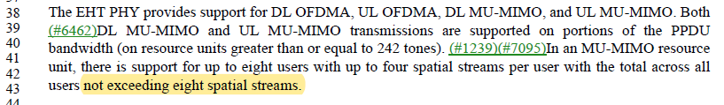

CID 5443

CID | Clause | Page.Line | Comment | Proposed Change | Resolution
5443 | 9.4.2.295c.3 | 138.13 | The number of bits of Beamformee SS and Number Of Sounding Dimensions should be extended from 3bits to 4 bits for future extension. And any reserved values (larger than 8 later in R2) should be interpreted as more than 8 by R1 devices. By doing so R1 devices can still do sounding with R2 devices. | as in comment | REJECTED  The maximum number of supported spatial streams is currently 8.  The current decision of supporting to up to 8 spatial streams is made based on compromise between performance and implementation difficulty. To support to up to 16 spatial streams, more study need to be done and details for transmission up to 16 spatial streams need to be added to the standard.  We think it is better to keep these fields as is for now and expand them when needed in the future.

